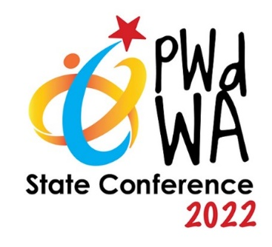
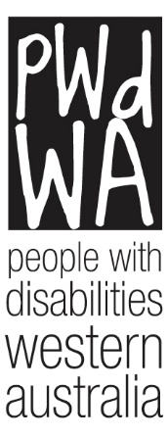

PWdWA

Newsletter

September 2022
- Message from PWdWA
- Current Issues
- PWdWA Profile
- PWdWA in Action
- Upcoming
- Board Nomination Form

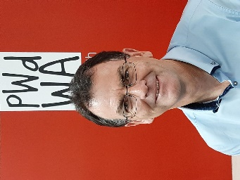
Message from our CEO Brendan Cullinan

Lifting Accessibility Standards – Time for WA to adopt
In Western Australia, one in five people live with a disability, and our ageing population continues to grow. Despite this, we continue to accept that a significant proportion of our population must either reside in homes they cannot easily enter, move around in, or be forced to move into alternative accommodation. These accessibility issues could be addressed by the adoption of the accessibility standards for new residential homes in the National Construction Code (NCC).
The McGowan Government has previously indicated that it supports increasing the number of accessible houses and accepts the arguments for mandated standards but wasn’t ‘in a position to adopt the standards in the short-term.’

PWdWA has been working in collaboration with local disability and aged care organisations lobbying the McGowan Government to change its position and adopt the updated accessibility requirements for residential buildings in the NCC 2022 and to commit to a 12-month transition period to ensure time for industry training and education. A PDF of the Open Letter sent to Minister Cook is available on our website. If you would like this letter in another format for your accessibility, please contact Vanessa at vanessa@pwdwa.org or 9420 7279 ext. 717.

Following the Building Ministers Meeting on August 26, the governments of Victoria, Queensland, the ACT, Northern Territory, South Australia and Tasmania all agreed to adopt these new standards that are in the NCC. That leaves Western Australia alongside New South Wales as the only two states not to adopt the standards.
The economic and well-being cost of not having accessible housing options is significant, with research highlighting the significant benefits in increasing the availability of accessible housing options across all communities.
PWdWA will work with our partner organisations and engage with the building sector to continue to lobby the McGowan Government to change its position and bring national unity on this issue for the benefit of all people with disability, the ageing, their carers and families in Western Australia.

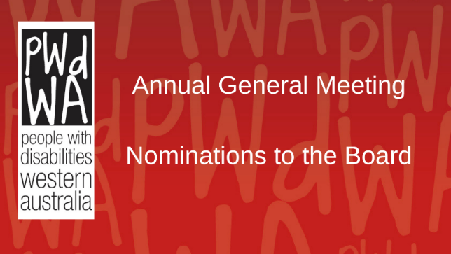
Current Issues

PWDWA Board Nomination Form – 2022
In accordance with the Rules of Association of People with Disabilities Inc (WA), nominations are hereby called for election to the Board members at the 2022 Annual General Meeting. There are two positions for election. The nominee must be a full member of PWdWA. Full membership of PWdWA is only available to people with a disability and is free of charge.
A nomination form can be found at the end of this newsletter. Nominations must be received at the PWdWA’s office by 5:00 pm Wednesday, 28 September 2022. Please contact vanessa@pwdwa.org if you want to receive the nomination form in an alternative format.

PWdWA Annual General Meeting.
PWdWA’s Annual General Meeting will be held at 5:30 pm on 26 October 2022. The AGM will be held in the Conference Room at the City West Lotteries House 2 Dehli Street, West Perth. You can register to attend in person or participate virtually using ZOOM or contact Vanessa on 9420 7279.

Free Royal Show Tickets
Lotterywest and the Royal Agricultural Society of WA have given PWdWA free tickets to this year’s Perth Royal Show.
Tickets are available to PWdWA full and associate members only, there is a maximum of 4 tickets per member, and support workers will need to be included in your ticket count. Tickets can be issued as PDFs or must be collected from our office in West Perth.
Tickets will be drawn at random. To register for tickets, you must go to Survey Monkey or phone Vanessa on 9420 7279 to have your name added to the list. Registrations close at midnight on Friday, 16 September.

​PWdWA Profile

Chris Chambers – Community Disability Advocate
Before joining PWdWA, Chris worked in community services supporting families experiencing separation and has worked with young people in out-of-home care. Chris received his Bachelor of Social Work from Curtin University and is passionate about human rights issues and supporting people to navigate systemic disadvantage to achieve social justice.
Chris is working alongside community members and groups to develop a Community Disability Advocacy Network in their local community. These Networks will meet to collaborate with local people with disabilities to help find solutions to local issues they face. Issues ranging from access and inclusion, local education, and employment to discrimination and developing community connections.
If members are interested in learning more, please reach out to Chris by emailing chris@pwdwa.org or by phone at 9420 7279 ext. 706.

PWdWA in Action

Disability Royal Commission (DRC) Perth Visit
PWdWA collaborated with DRC to offer the opportunity for a group of people to meet with staff from the DRC. Participants shared what they thought could improve inclusion and how we can stop people with disability from being poorly treated.
The DRC will publish a report of recommendations to the Australian Government in September 2023. Your experiences, ideas and recommendations will help inform the Disability Royal Commission (DRC) work.

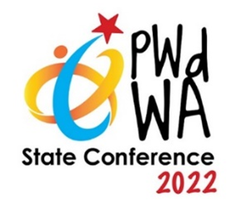
PWdWA State Conference 2022 – Inclusive Communities

Wednesday 7 December and Thursday 8 December

Bendat Centre, Wembley
Early bird registrations close soon; get your registration in by 15 September to get our early bird price, and remember, PWdWA Full members can get a discount on their tickets.

Keynote Speaker – Wayne Herbert

Wayne is a prominent, in-demand, and outspoken international public speaker, presenter, comedian, and author promoting the rights of and opportunities for people with disability and people in the LGBTIQ community.

In his career to date, Wayne has undertaken a number of speaking opportunities throughout Australia and internationally on issues of disability, diversity, and human resources. Wayne’s entire career is focused on assisting people with disability in employment and training.

He has a keen interest in social and employment policy that ensures the talents and expertise of people with disability are more broadly recognised in the workforce and community.

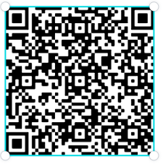
Upcoming

PWdWA’s Eventbrite Home Page
Do you want to know what events PWdWA has coming up? Hold your phone camera over the QR code, then click on the link. This will take you to our Eventbrite home page.

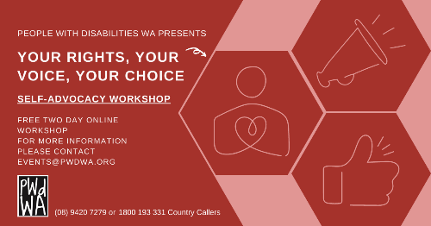
PWdWA Your Rights, Your Voice, Your Choice Workshop

Wednesday 14 September and Thursday 15 September, 10:00 am – 2:00 pm.
This workshop will introduce attendees to Self-Advocacy and build the necessary self-advocacy skills. This workshop is a two-day commitment, and a certificate will be awarded upon completion.

- Understand your rights and the different types of advocacy
- Learn the key steps to becoming a successful self-advocate
- Explore ways to communicate and how to be more assertive
- Share real experiences and learn from others
You can register for this event through Eventbrite or call Vanessa on 9420 7279 ext. 717, or email vanessa@pwdwa.org.

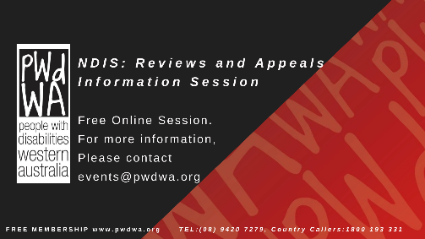
PWdWA’s NDIS Reviews and Appeals Online Information Session

Monday 19 September 2022, 1:00 pm – 3:00 pm
- Do you want to know more about NDIS reviews and appeals?
- Do you want to understand when and how you can ask the NDIS to change their decisions?
We have produced this information session in response to requests from our membership.
This session is for Western Australians living with disability, their families, friends and carers assisting them.
You can register for this event through Eventbrite or call Vanessa on 9420 7279 ext. 717, or email vanessa@pwdwa.org.

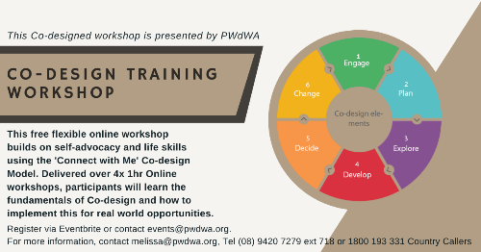
PWdWA Co-Design Workshop
Monday 26 September, Wednesday 28 September, Thursday 29 September and Friday 30 September, 12:30 pm – 1:30 pm.
This free online workshop builds on self-advocacy and life skills using the 'Connect with Me' Co-design Model.
Delivered over 4 x 1-hour lunch and learn workshops, participants will learn the fundamentals of Co-design and how to implement this for real-world opportunities.
A certificate will be awarded to participants upon completion for those who attend all four sessions.
This training is a prerequisite for participating in future paid Co-design opportunities within the Empowered and Connected project.
You can register for this event through Eventbrite or call Vanessa on 9420 7279 ext. 717, or email vanessa@pwdwa.org.
PWdWA
PWdWA is funded by the Western Australian Department of Communities and the Australian Department of Social Services.

PWdWA is run BY and FOR people with disabilities and aims to be the voice for all people with disabilities in Western Australia.
Free Membership
Being a member of PWdWA gives you the opportunity to be involved in shaping our organisation through our planning and evaluation processes. As a member, you can make sure the issues that matter to you are heard by being involved with our submissions and advocacy campaigns. Voting is restricted to full members aged 15 years and above.
Full Membership is available to persons living in Western Australia, with a disability, over 15 years who are Australian citizens or permanent residents of Australia.

Nomination Form for Board on Next page.

PWDWA Board Nomination Form – 2022
In accordance with the Rules of Association of People with Disabilities Inc (WA), nominations are hereby called for election to the Board members at the 2022 Annual General Meeting. There are two positions for election. The nominee must be a full member of PWdWA. Full membership of PWdWA is only available to people with a disability and is free of charge.
Name of Nominee:
Address:
Telephone No:
Email:

Skills & Experience
Please give details below of your skills & experience and indicate why you wish to be a PWdWA Board member. (No more than 200 words. Please see the following Guide for Nominees for more information). You can attach a separate statement if preferred.

You may wish to include any experience you have being on a Board, Committee or other form of representation, and any qualifications or skills you bring to the Board.

…………………………………………………………………………………….……………

…………………………………………………………………………………………….……

…………………………………………………………………………………………………

…………………………………………………………………………………………………

…………………………………………………………………………………………………

…………………………………………………………………………………………………

…………………………………………………………………………………………………

…………………………………………………………………………………………………
Nomination Supported by:
The person making the nomination must be a full member of PWdWA.
Nominated by:
Name:
Address:
Telephone No:
Email:

I confirm I have gained the nominee’s consent for their name and details to go forward.
Signed:
Date:

Conditions of Election
- Only Full Members may nominate and vote at the AGM.
- This nomination and election are subject to the Rules of Association of PWdWA.

Declaration:
- I understand and agree that if elected, my position as a Board member is subject to any relevant checks and approvals being cleared (e.g., National Police Clearance).

- I understand and agree that if elected I will need to sign an agreement saying that I will abide by all relevant PWdWA policies and procedures.

- I understand that if elected I will be required to attend a Board induction and any required training.

- I am eligible to stand as a Board member and stand for election as outlined in the Guide for Nominees.

- I confirm that I am a Full PWdWA member.

Signature of Nominee:
Date:

Please Return Your Nomination Form to the Returning Officer

- By mail - People with Disabilities WA Inc.
City West Lotteries House, 23/2 Delhi Street, West Perth WA 6005

- Or by email to info@pwdwa.org - Attention Returning Officer

- Nominations must be returned by no later than 5:00pm Wednesday 28 September 2022.

Guide for Nominees
Any Full Member of People with Disabilities WA (PWdWA) who wishes to nominate for a position on the Board should be aware of the following:
- PWdWA Rules of Association require that PWdWA is governed by an Executive Committee consisting of the following office holders:
  - A Chairperson
  - Vice-Chairperson
  - Secretary
  - Treasurer
  - and no more than seven (7) members.

- A Board member holds office for two years.

- Only Full Members of PWdWA can be members of the Board. Your nomination must be proposed by a Full Member.

- All nominees for positions on the Board should support the aims and objectives of the organisation. PWdWA encourages nominees from throughout WA.

- Participation on the Board is voluntary. Reasonable costs will be reimbursed in accordance with the Rules of the Association.

- The Board meeting schedule is approximately every 4 weeks.

- Working groups may be organised to discuss specific systemic or operational issues. These are optional, and a further commitment of time will be required.

- When nominating for the position of Board Member, you must complete the form entitled PWdWA Board Nomination Form 2022.

- You can contact the PWdWA office on (08) 9420 7279 to check whether you or the person who proposes your nomination is a Full Member

- If nomination forms are required in alternate formats, or assistance is required please contact PWdWA and a member of staff will make the necessary arrangements.

