People With Disabilities (WA) Inc. Annual Report 2016 – 2017

Contents
People With Disabilities (WA) Inc. Annual Report 2016 – 2017 2
Acronyms and Abbreviations 3
Our Vision 5
Our Mission 5
We Value 5
Guiding Principles 5
PWdWA Presidents Report 6
Committee of Management 2016 - 2017 8
PWdWA Executive Director Report 9
Treasurers Report 12
Membership 13
Individual Advocacy 14
DSC Standards Audit 24
Projects 25
Self Advocacy WA (SAWA) 27
Systemic advocacy 27
Submissions and Reports 32
Representation and participation 33
Community Education & Promotion 35

Acronyms and Abbreviations

AAT | Administrative Appeals Tribunal
AFDO | Australian Federation of Disability Organisations
AHRC | Australian Human Rights Commission
ASID | Australasian Society for Intellectual Disability
CALD | Culturally and Linguistically Diverse
COAG | Council of Australian Governments
CoMHWA | Consumers of Mental Health Western Australia
DAIP | Disability Access and Inclusion Plan
DANA | Disability Advocacy Network Australia
DDA | Disability Discrimination Act
DDWA | Developmental Disability Western Australia
DoH | Department of Housing
DSAWA | Down Syndrome Association of WA
DSC | Disability Services Commission
DSP | Disability Support Pension
DSS | Department of Social Services
EDAC | Ethnic Disability Advocacy Centre
EOC | Equal Opportunity Commission
FPDN | First Peoples Disability Network
FSHMD | Facio Scapula Humeral Muscular Dystrophy
HACC | Home and Community Care
HaDSCO | Health and Disability Services Complaints Office
HCC | Health Consumers Council
ILC | Information, Linkages, and Capacity Building
LAC | Local Area Co-ordinator
MPT | Multi-Purpose Taxi
NDAP | National Disability Advocacy Program
NDCO | National Disability Coordination Officer
NDS | National Disability Services
NDSt | National Disability Strategy
NDIA | National Disability Insurance Agency
NDIS | National Disability Insurance Scheme

NSDS National Standards for Disability Services
OPA Office of the Public Advocate
PA5 Perth Autistic and Aspergers Association
PWDA People With Disability Australia
PWdWA People With Disabilities (WA) Inc.
SACS Social and Community Services Award
SARC Sexual Assault Referral Centre
SAPS Self Advocacy and Peer Support WA
SAWA Self Advocacy WA
SECCA Sexuality Education Counselling Consultancy Agency
SAT State Administrative Tribunal
SSCLS Sussex Street Community Law -Service
TUSS Taxi Users' Subsidy Scheme
WACOSS WA Council of Social Service
WAAMH Western Australian Association of Mental Health
WAIS WA Individualised Services
WA NDIS Formerly My Way NDIS trial, run by WA
WWDWA Women With Disabilities Western Australia
YDAN Youth Disability Advocacy Network

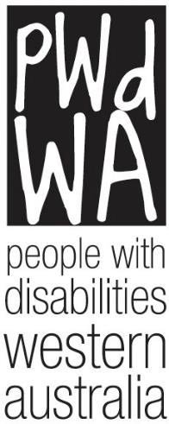
Our Vision
People with disability are equal and valued citizens.

Our Mission
Advocating for the rights and empowering the voices of people with disability in WA

We Value
- Human rights
- The voices and unique experiences of people with disabilities

Guiding Principles
We will:
- Be passionate, innovative and fearless in defending and promoting the rights and interests of people with disability.
- Be accessible, responsive to and inclusive of our diverse community.
- Be mindful, flexible, agile, responsive and innovative in a rapidly changing sector and world.
- Value and facilitate the involvement of people with disability in our governance and management.
- Collaborate with the disability and mental health sector.
- Maintain supportive relationships with advocacy and support organisations.
- Be transparent and accountable in everything we do.
- Act with honesty and integrity.
- Be resourceful and efficient regarding the resources we need to do our work.
- Recognise and value everyone who works with us to achieve our vision, including our committee, staff and volunteers.

PWdWA is funded by the Department of Communities Disability Services WA (formerly DSC) and the Department of Social Services (DSS)

PWdWA Presidents Report

Greg Madson
It has been another busy year for People with disabilities WA (PWdWA). Continuing work undertaken by the PWdWA Committee of Management, employees and volunteers has been extensive and I will touch on some of the governance work in this President’s report.
The consortium arrangement between PWdWA, Advocacy South West and Sussex Street Community Law Service has provided increased opportunity for people with a
disability in WA to access advocacy services within Western Australia. This year a National Standards for Disability Services Quality Evaluation assessment was undertaken, looking at the three organisations in the consortium, with the independent evaluator finding that all standards have been met.
Over the past year PWdWA Committee of Management members have continued their work on the strategic goals of the organisation through systemic advocacy, providing advice to government, submission and policy development, and engagement of members and the wider disability community. Regarding our strategic goal of “Be more widely recognised as the peak disability rights and advocacy organisation in WA” that work includes the following;
- Holding a forum regarding changes to on-demand transport
- Attending forums and workshops on WANDIS and NDIS
- Providing advice on access for people with a disability for the new Airport Link train line
- Representation on the Perth Stadium Access and Inclusion Working Group
- Representation on the Vulnerable Road Users Advisory Group
- Representation on the East Perth Redevelopment Access and Inclusion Working Group
- Regular attendance at Disability Sport and Recreation Forums – run by Department of Sport and Recreation
- Regular attendance at Disability Services Commission Board Chairs forums
- Holding peer support forums
- Attendance at ASID Research Forum
- Media representations on issues for people with a disability.
The PWdWA Committee of Management is made up of some very talented and passionate individuals. Their disability experience is invaluable in ensuring that the organisation stays focused on its values and mission.
The Committee of Management also remains focused on growth of its governance skills as stated in our Strategic Plan, constantly reviewing strategic and governance policies. Representatives of PWdWA and Consumers of Mental

Health WA (CoMHWA) attended an Australian Institute of Company Directors finance course, giving those present the opportunity to fill in any gaps in their financial literacy.
I would like to thank the Committee of Management; Ryan Gay, Mallika Macleod, Ingrid Moore, Lisa Burnette, Adam Hewber, Elizabeth Edmondson, Pru Hawkins, Jordon Steele-John and Ian Mansfield, who have willingly given their time, commitment and advice in governing the organisation. Both Ian and Jordon retired during the year, Ian due to health issues and Jordon due to other commitments. I wish them both well and thank them for their input to the Committee of Management.
I would like also to thank those organisations we have worked with throughout the year. Organisations such as Developmental Disability WA and Consumers of Mental Health WA have worked alongside PWdWA to develop submissions and advice to government regarding issues face by people with disability.
Late last year at its AGM, the members of Fairholme Disability Support Group voted to wind up the organisation after many decades of service. Fairholme and PWdWA had met several times prior to the wind-up to develop a process to ensure that Fairholm members had access to continuing advocacy services. I would like to recognise the outstanding effort of the Fairholme Disability Support Group and its decades of support of the disability community in Western Australia. In particular, I would like to thank Bevan Dellar and Rachel Ivic for seeing PWdWA as an organisation that can continue to support advocacy for people with disability in group accommodation.
Throughout the year Samantha and I continued our strong working relationship; Sam's extensive experience in the disability sector and management skills have provided the organisation with supportive leadership, a stable workplace for employees, and opportunity for people with a disability to engage at all levels with the organisation. I would like to formally thank Samantha Jenkinson for her leadership and support throughout the year.
Our PWdWA employees strive to ensure our members and Western Australians with a disability have access to good reliable advocacy advice, a listening ear, or support if needed. I would like to thank our terrific advocates, administration people, and volunteers for their dedication to the organisation. Our strategic goal of providing high quality advocacy across all areas is being met.
The membership of PWdWA is increasing, giving us opportunity to engage more people with a disability, canvas their views, and use those views to give clear direction as to where our organisation could best use our resources. I would like to thank PWdWA members for their ongoing support, their engagement in member forums, participation on disability advisory groups, membership on the

Committee of Management and many other supporting aspects that ensures PWdWA is a relevant voice for Western Australians with a disability.
The lack of a decision on which way Western Australia will go regarding a local WANDIS or a national NDIS system is making life for people with a disability more frustrating. Our members face ongoing confusion as to how to navigate constantly changing disability systems. The Committee of Management grappled with how to address this as an organisation due to the issues in both trial sites and decided to keep raising the benefits and challenges in both models, as well as be involved in providing feedback to both models.
Finally, this will be my last President’s report, I am standing down to allow others the opportunity to lead the organisation. I would like to thank all involved in PWdWA, and the wider disability sector, for the support I have received during my Presidency.
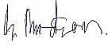

Greg Madson President

Committee of Management 2016 - 2017
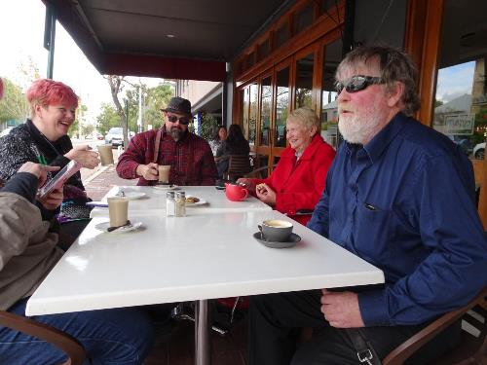
President Greg Madson Vice President Ryan Gay Treasurer Mallika Macleod
Secretary Elizabeth Edmondson Ordinary Member Ingrid Moore
Ordinary Member Lisa Burnette Ordinary Member Adam Hewber Ordinary Member Pru Hawkins
Ordinary Member Jordon Steele-John (retired) Ordinary Member Ian Mansfield (retired)

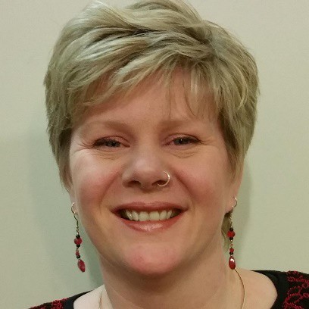PWdWA Executive Director Report

Samantha Jenkinson
This year started with a federal election in July 2016 and then we had a state election in March 2017. Both elections bought changes to the political landscape we work in and provided opportunities for us to highlight issues affecting people with disability. It also heightened the issues of the two trials of the National Disability Insurance Scheme (NDIS) with a result that people with
Samantha Jenkinson
disability are still trying to understand three different systems, and at the writing of this report there is still uncertainty as to which system will deliver the NDIS in WA.
PWdWA staff have worked very hard while we have been supporting people across the three systems of Disability funding and services. It was a relief when in August 2017 Minister Porter announced that the National Disability Advocacy Program (NDAP) funding is secure until 2020, which provides just under half our funding. Our state based individual advocacy funding is also now secure until December 2018, which accounts for the rest of our core funding.
Through our state funding, this was our first full year working as a consortium to deliver Individual Advocacy with Advocacy South West and Sussex St Community Law Service. All of the individual advocates across the three organisations have benefited from joint training in NDIS, mental health, welfare rights, and in sharing experiences. I would like to thank Annette Dix from Advocacy South West, and Jane Timmermanis from Sussex St Community Law Service who have worked with me to make this successful. This partnership is providing a stronger, more consistent and collaborative approach to advocacy for people with disability in Western Australia. Our partnership has enabled us to see clear trends in issues of access to the Disability Support Pension and issues on maintaining housing, particularly in regional areas.
In April and May this year the state funded consortium underwent Quality Evaluation assessment under the National Standards for Disability Services as a requirement of our DSC funding. The independent evaluator commended the consortium for authentically involving people with disability in its governance and the critical role it plays in empowering people with a disability to have an equal voice and valued status as citizens.
Just under half of our core funding comes from Department of Social Services (DSS) through the NDAP. A key issue we have seen with our DSS advocacy is an increasing number of clients with mental health issues (dual diagnosis) requesting support. For many people a service coordination type service is required to support their complex needs in a changing environment. It has been identified that many services designed to support people with mental health issues are refusing access to certain people that have been labelled ‘challenging’ and consequently this makes advocacy difficult for such clients. Mental Health Advocates in WA only

support hospital in patients and not those experiencing mental health issues in the community.
PWdWA advocates supported over 500 people with advocacy through the 2016 - 17 financial year, thanks to our state and Commonwealth funding. This year for the first time the agency had a period where we took no new referrals for two weeks due to the advocacy team being at capacity.
Around half of our DSS funding is for systemic advocacy and this year we have continued our work on the issues of abuse and neglect, housing, health, transport, and of course the NDIS. As the peak body that represents people with disability, we are approached by many government departments, local governments and parliamentary committees and advisory groups inviting us to make submissions, be on advisory or co-design groups, or take part in consultations. We have continued to build our systemic advocacy on the real experiences of people with disability that we see through individual advocacy issues and from feedback in surveys and focus groups. The long term proactive projects need a significant time and staff investment that means we must prioritise and seek other funding to support projects and campaigns.
We have actively been involved in co-design with the NDIA on the Commonwealth scheme approach to self-management, housing, and Information, Linkages and Capacity Building. With WA NDIS we have worked with partner organisations through the Disability Coalition to complete a second NDIS Experiences report, engage people with disability on WA self-management policy, and lead the NDIS in WA Conversations event. This representational work is extremely important in ensuring the voice of people with disability is heard at the policy and decision making levels. We expect that NDIS will continue to be a significant part of our individual and systemic advocacy work for many years to come.
Apart from our core funding for individual and systemic advocacy from DSC and DSS, we have also had project funding for work in specific areas. These projects are detailed further in the report and include support for leadership and peer support by and for people with disabilities (Releasing Our Capacity) funded by the NDIA; and advocacy for those people and their families transitioning from DSC Accommodation to providers in the non-government sector.
PWdWA thank Lotterywest for providing funding for Disability Safe Week. This project crosses into the 2017-18 financial year, however a brief report is provided further on. This was important funding to keep moving forward on the work of preventing and responding to the abuse and neglect of people with disability in WA.
The PWdWA team experienced a number of changes and staff transitions over the last year. In December 2016 we said goodbye to Carmen Pratts-Hincks and Debra Sommerfeld, both who had been with the organisation for many years. Individual Advocate Carol Franklin retired in March 2017 after many years of providing

advocacy to people with disabilities in Western Australia, and she will be missed by many of our clients. Both Maggie Visser and Nicole Ikin have moved to other work in the sector and we still see them often and know they are still focused on people with disabilities as equal and valued citizens.
We have welcomed Anabelle May as our new Senior Advocate, with Gary Marsh and Elisha Johnson recently starting as new Individual Advocates although both have experience with advocacy and the sector. When there is a change in key staff, who have been with an organisation for a long time, it can take a little while for the team to come together again. It has been great seeing all of the team put in extra effort to work together and form a new team, even through some rocky patches. In particular Anabelle May and Faye Hicks have provided great support to the whole team and to me in my role as Executive Director.
The Peel office of PWdWA closed in November last year as one of the changes that we have made to maximise our funding to individual advocacy. Our advocates still provide advocacy and outreach services to people with disability in the Peel region and have specifically provided information forums on advocacy in the area.
Our condolences go to the friends and family of John Fentiman, a founding and life member of PWdWA, who passed away in 2016.
It was also sad to see the winding up of Fairholme Disability Support Group in 2016, but we thank them for passing on their assets to us. Our increased membership has been partially due to members from Fairholme joining, and we have provided advocacy to Fairholme members.
The Executive acknowledge and thank all the staff within the organisation for their hard work. It is our pleasure to work with this group of committed and passionate people. Thanks also to our Committee of Management and our other volunteers who all play a part in keeping PWdWA strong. In particular, I thank Greg Madson our President who has worked hard on the organisations governance and I wish him well for the future. He has given PWdWA sound governance foundations to build on.
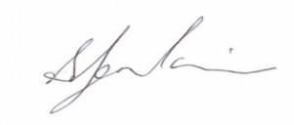
It is always busy at PWdWA as advocacy is needed by many people. We will continue to provide individual advocacy and advocate for the rights and empower the voices of all people with disability in WA.

Samantha Jenkinson Executive Director

Treasurers Report

Mallika MacLeod
In the 2016-2017 financial year, PWdWA operated within its budget and fulfilled the contractual requirements of service level agreements with our core funding agencies, the Western Australian Department of Communities Disability Services (formerly DSC), and the DSS.
PWdWA received funding from the DSS as supplementation to fulfil obligations to our staff employed under the SACS award scheme.
PWdWA and the WA Advocacy consortium had carried forward funds from DSC in 2016 financial year, which were to assist with consortium set up costs such as database and IT adjustments. These funds were expended this financial year with a minimal amount unspent.
Non-recurrent funds were received for DSC Accommodation Transition advocacy. This funding started in December 2014 and ended in June 2017.
Sustainability funding from DSC in 2013–14 is slowly being used and carried forward each year with a small amount still remaining.
PWdWA finished the two-year project grant for our Releasing Our Capacity Peer Support project from the National Disability Insurance Agency in January 2017, receiving an extra six months funding under the NDIA CICD program to take the project to June 2017. In June 2017 we received a further 12 months funding for the project under NDIA sponsorship which has been carried forward into the 2017- 2018 financial year.
In April 2017 we were successful in receiving Lotterywest funds for our Disability Safe Week Project which will conclude in October 2017 with funds carried forward to the 2017-2018 financial year.
In June 2017 we were successful in receiving a Department of Finance grant for Peak Body Capacity Building which has all been carried into the 2017- 2018 year for our Connect with me Project.
The Committee of Management has remained active in overseeing the financial operation of the association. The audited accounts demonstrate that the organisation remains financially stable.
The Committee of Management and operational staff express thanks to Nulsen Independent Administration for payroll support and Patricia Loh Accounting for financial management services throughout the year. We also sincerely thank Debra Sommerfeld, Roshnee Nunkoo, and Sonya who have provided Administration Support to PWdWA.

Mallika MacLeod 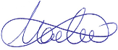 Treasurer

Membership
During the year, PWdWA has sent out four member updates to keep our members informed, as well sending out information on events. We have held information forums on advocacy and on-demand transport. In December we had a “sausage sizzle” to celebrate International Day of People with Disability.
Full Membership – is available to people with disability living in Western Australia, who are over the age of 18 years and are Australian citizens or permanent residents.
Associate Membership – is available to persons who identify with the aims of the Organisation, but who are ineligible to be full members, including family and friends of people with disability. Associate members can support a full member.
Organisational Membership - incorporated organisations within Australia where the membership and governing body are each comprised of at least 75% of persons with a disability, or the parents of children with a disability, or which have a substantial involvement in representing the interests of persons with a disability from the consumer perspective.

August 2017
10 Life Members
236 Full Members
176 Associate Members
6 Organisations
428 Members
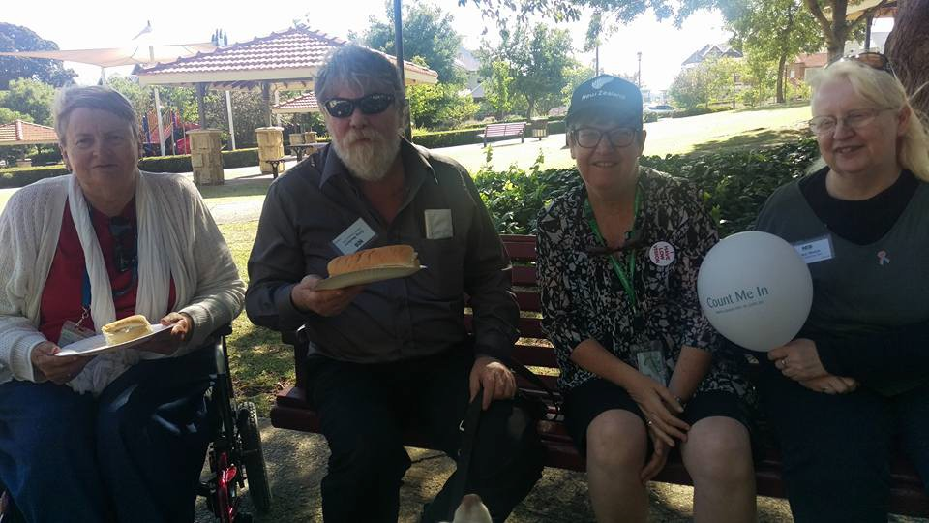
IDPWD BBQ

Individual Advocacy

Our individual advocacy staff for 2016 - 2017 included Carmen Pratts-Hincks and Anabelle May as Senior Advocate, and Carol Franklin, Lisa Hook, Natalie Turner, Rachael Cox, Nick Wilson, Nicole Ikin, Maggie Visser and Tanya Sinclair as Individual Advocates.
In 2016-2017 PWdWA provided independent, non-legal Individual Advocacy that is issue-based and confidential to people with disability living in Western Australia. Individual Advocates work alongside people with disability when they feel they have been treated unfairly or they seek a solution to a specific problem or issue. PWdWA focuses on advocating with those who are most vulnerable or at risk, with an empowerment based model of advocacy.

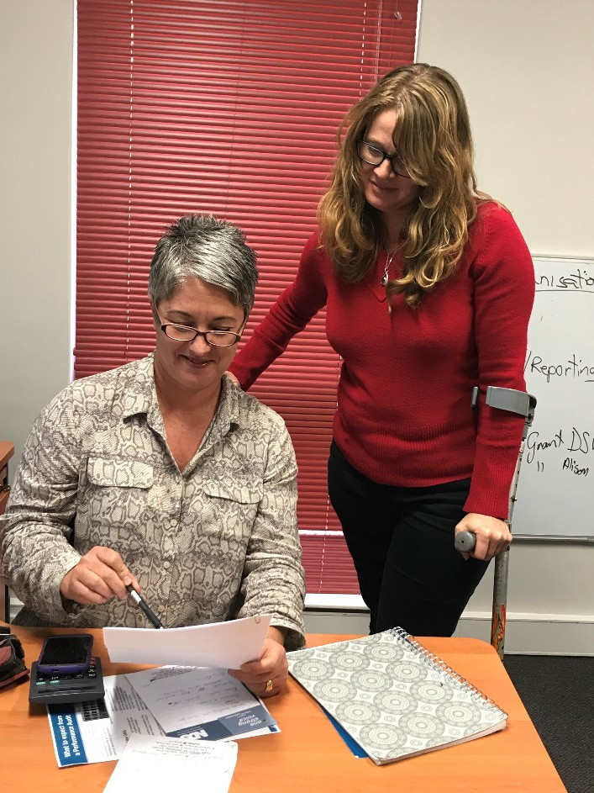As part of our services, advocates provide information to individuals, family members and others who want to know more about the services that PWdWA and other agencies in the community can offer. Information is made available by phone, face-to-face, email and social media, which includes Facebook and Twitter.
Advocates Natalie and Rachael
From 1 July 2016 to 30 June 2017 PWdWA was funded by the Disability Services Commission (DSC) with two other advocacy organisations, Advocacy South West and the Individual Disability Advocacy Service (part of SSCLS) to provide Individual Advocacy state-wide and in regional areas. As a consortium
covering the majority of the state, we provided 445 information requests, and support for 663 advocacy requests. Direct Advocacy takes on average 18 hours of staff time per issue, with some complex issues taking a significantly longer.
The Department of Social Services (DSS) provided funding for Individual Advocacy statewide and specifically for the Peel region. This year PWdWA closed it’s office in Mandurah to allow more flexibility in providing outreach services for advocacy across the Peel region. In line with changes in our funding agreement, we are reporting on all individual advocacy. The funding allowed us to provide information sessions on advocacy and work on a broad range of issues that are faced by people with disabilities in Western Australia.

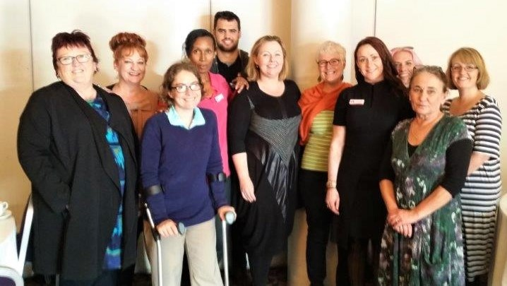
Staff Consortium training

Individual Advocacy on NDIS Issues

Our advocates have supported people in all of the NDIS trial sites (state and Commonwealth run) with a doubling of the number of people seeking advocacy for NDIS related issues in the last 6 months of the year. PWdWA provided advocacy with the planning process; the review of plans, instances where people were not ready to sign plans; and engaging with service providers in the trial site areas. Many of the issues related to the review of plans were on transport issues. People often sought information around the NDIS and an independent person to support and guide them through the NDIS trial and process. Where specific support was required on appeals of NDIS, clients in the NDIA trial were referred to agencies specifically funded for such work. eg MIDLAS, and PWdWA worked in partnership to avoid duplication. Our advocates also supported people through complaints and appeals in the WA NDIS trial areas.

In WA because we have two separate systems, WANDIS and NDIA, our staff have to be across two systems and our representation and feedback from people with disability is through to two systems. This has meant a doubling of workload as staff keep up to date and engage with people and organizations in both trials. We have been in advisory groups as the consumer peak in both trials. We have been part of co-design groups in both trials. We have attended information sessions and briefings in both trials.

In both trial sites, clients have identified that they felt they were excluded from the decision making process that determined what is ‘reasonable and necessary’ in

terms of funding and planning. Clients felt that the ‘reasonable and necessary’ principles are largely constructed to support the bureaucracy rather than them as people who are central to the planning. This is further exacerbated by the lack of transparency in justification of the application of 'reasonable and necessary' principles. As both systems have been evolving and changing there has been confusion and misinformation on policy that advocates are supporting people to navigate.

Case Study

Owen’s Local Coordinator had told him that despite him self-managing his WA NDIS plan, Owen did not have the right to hire his own support workers. Owen did not understand why so he contacted PWdWA for advocacy. The advocate provided Owen with information such as the relevant DSC Self- Managing policy and guide to hiring your own support workers (from My Place) to ensure Owen understood his rights and obligations under his decision to self-manage. The advocate also supported Owen’s self- advocacy, suggesting that he attempt to gain written responses from DSC and reference the relevant WA NDIS policy. Owen made enquires to relevant DSC staff who informed him that he did in fact have the authority under self- management to hire support workers of his choice. This meant Owen had greater control over the services he receives and how it affects his life.

Individual Advocacy funded by DSC

PWdWA advocated with 302 individuals across Western Australia on 357 issues. We provided information to 142 individuals. The individuals contacting PWdWA seeking advocacy included people from a range of age groups, backgrounds, disabilities, geographical areas, as well as those participating in the NDIS and WA NDIS (formerly My Way) Trial Sites. The majority of people contacting PWdWA come from the metropolitan area of Perth. Of these, most live in the Perth Metro non-NDIS area. In terms of age, the majority of people were in the 31 to 54 range.
In this reporting year, individuals with physical disability make up the main disability type of those people contacting PWdWA. This includes people with cerebral palsy, quadriplegia, though many of the people contacting us have dual diagnosis with other disability or health conditions. People with intellectual disability, is the next highest category, followed by people with autism, and then psychosocial disability.

The majority of people contacting us were self-referred. A small number were from service providers, family members, friends, DSC staff and by word of mouth. At all times, the advocates ensured they contacted and communicated with the person with the disability to gain their consent and clarification of their wishes before taking any action.
The major issues experienced by people contacting our service during this period include:
- Disability and Mental Health Services, and Equipment provision – In this category we are advocating with people to get funding for equipment, or are trying to access programs of support and having difficulty. We also provide advocacy where people are changing providers, and supporting people to speak up when they are not getting the service they require from providers.
- Housing and Accommodation – We work with people at risk of eviction to maintain their housing, or to move if they are in inappropriate housing. Advocacy and information support is provided to people looking for accommodation or housing, which could be moving from hospital, the family home, or supported accommodation to independent living.
- Financial issues and Income support – This year saw an increase in advocacy provided to people forced into reassessments of their DSP. We also advocated with people applying for income support, dealing with credit card debt, or who had issues with the public trustee and access to their money.
100
80
60
40
20
0
DSC Advocacy Issues
Other/ eligibility NDIS / Trial site issues
Rights / Discrimination issues Risk of abuse / neglect Community Access / Inclusion
Health / Medical Employment / Education
Disability / Mental Health service / equipment… Financial / Income support & Subsidies
Accommodation / housing/ Independent living support

Legal / Justice

250
200
150
100
50
0
228
Perth Metro Non NDIS
11
Non-Metro Non NDIS
30
NDIA NDIS Hills
25
WANDIS Cockburn
9
WANDIS Lower South
9
WA NDIS Armadale / Shire of Murray
DSC : Residence of clients accessing service

DSC 2016/2017 : Disability Type
Sensory, 3%
Learning, 1%

Psychosocial, 14%

Physical, 29%

Autism, 16%

Intellectual, 18%
Neurological, 13%

ABI, 6%

Physical Intellectual ABI Neurological Autism Psychosocial Sensory Learning D.D

Advocacy support and collaboration promotes choice and control

Banou is a woman in her fifties who has lived with Dystonia (a neurological movement disorder) for many years. Despite her permanent disability and associated medical conditions, she has continued to live a purposeful life, living independently in her own home in metropolitan Perth.

Recently due to unfortunate circumstances in her care regimen, Banou was admitted to a Perth hospital for treatment of acute respiratory distress and complications resulting from a dystonic episode.

Banou's disabling and chronic health condition precludes her from being actively engaged in the workforce. Her disability requires special individualised care, which to date had been provided by personal carers in her own home with minimal funding support.

Following the recent acute hospital admission, it became clear that with the current disability funding available to Banou, her options for discharge were either an institutionalised setting or being at home again with inadequate support, and high risk of readmission to hospital.

Banou's ultimate wish and goal has always been to go back to her own home. Banou sought the assistance of an advocate from People with Disabilities WA (PWDWA). With advocacy support through PWDWA, Banou was able have her voice heard, argue for increased funding and gain adequate supports to keep her out of an inappropriate institutionalised setting where she would have little control over own daily life.

Banou's rights to choice and control over her life have become a reality. Working together with Banou and her advocate, the hospital and health professionals with representatives from the Disability Not for Profit sector worked on a discharge plan that has met Banou’s goal of going back home.

She is now happily back in her own home supported by My Place, a registered disability service provider.

DSC Client Accommodation Transition Independent Advocate Project

During 2016-2017 PWdWA continued to provide independent advocacy to raise concerns about issues that could be affecting residents during the handover period of the transition from DSC accommodation services to alternative service providers. This project’s funding ended in June 2017 with only a few houses still to transition. A change in policy by the new state government has meant that those residents who do not wish to, do not have to transition to non-government.
During the project period from January 2015 to June 2017 PWdWA met with the Transition team, the relevant Union, and the Commission’s Strategy Directorate numerous times to raise issues that were occurring. Advocates gave 34 presentations at houses commencing transition. As the project matured, the number of meeting with Unions and transition teams decreased, however, there were more requests for presentations to family groups leading to more cases of direct advocacy support for families and residents to ensure that their issues were addressed. From the project we provided advocacy to 6 families, and did 3 presentations to family groups.
A number of concerns were raised during the term of the project including:

- Transparency of the process and engagement with the person with disability directly affected in planning and decision-making.
- The effect of change that could trigger an increase in challenging behaviours for some of the people with disabilities.
- Possibility of missing information for hand over to new service providers.
- Siblings in particular were concerned about who is making decisions for their brother or sister without parents.
- Some families felt bullied into the transition process and into making a decision in a fixed time frame.
Some of the positive outcomes noted from an advocate’s perspective were that families valued the support of an advocate at the early stages in the transition particularly with help in preparing questions for meetings with the non-government services. One of our advocates also had the opportunity to visit a house after transition and saw positive outcomes for residents with increased engagement in day-to-day decisions.
PWdWA involvement in this project has provided an additional safeguard for residents and families involved in the transition. The project provided the opportunity for all stakeholders to gain a better understanding of Individual Advocacy and its role in improving and empowering the lives of people with disabilities. We hope that into the future there will continue to be promotion of advocacy services to people with disabilities who are living in group home situations and to their families.

Individual Advocacy funded by the DSS

In 2016-2017 PWdWA provided advocacy to 207 people with disability on 215 separate issues. Most of the people we supported came from the metropolitan area of Perth, with around 40 from the Peel region specifically.
In regards to their age, the majority of people were in the 40 to 54 age range, followed by families with children under 15 years of age. The majority of people contacting our DSS State-Wide services were individuals with autism and their families, followed by people with physical disability, then people with intellectual disability. Many of the families with autistic children had issues with schools and the Department of Education. A total of 57 people had a co-occurring disability.
As with our state funded advocacy just over half of people requesting advocacy are self-referred or referred by family members. This year we did information sessions on advocacy in Pinjarra, Armadale, Bayswater and Bassendean to ensure people in NDIS roll out areas were aware of advocacy.
The top issues during the reporting period included:

  - Service provision – The services category comprised a variety of issues, from access to complaints about service providers or requesting change of staff supporting people with disabilities in the community (such as Local Co-ordinators).
  - Education system issues - Issues that come under the Education category were access to Education assistants or lack of discussion with families around Individual Educational plans. Behaviour management and access to mainstream learning for children with autism were the other key issues under Education.
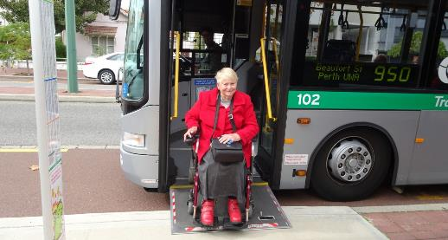
  - Legal processes – Access to Legal Aid and Community legal services, appeared to impact many clients. PWDWA does not provide legal advocacy, but many clients sought advocacy support to access legal services. Legal Aid has confirmed that limited resources meant fewer people could be supported and grants of aid were made on strict criteria.

Sensory & Speech
Psychiatric
ABI, 4%
Sensory & Speech,
4% ABI
Neurological
Developmental
Delay, 1%
Intellectual Autism Developmental Delay Physical
Physical, 20%
Autism, 26%
Neurological, 14%
Intellectual, 16%
Psychiatric, 14%
DSS : Disability Type 2016/2017
60
50
40
30
20
10
0
Other
Health/ Mental Health
Vulnerable Transport Services Recreation Physical/ Access
Legal NDIS
Finances Equipment/ Aids Employment Education
Discrimination & Rights
Accomodation Abuse / Neglect
DSS 2016/2017 : Advocacy Issues

Case Study

Sally contacted PWdWA as she was experiencing difficulties at her workplace, and wanted advocacy to address the problems she was facing. Sally had had a stroke a number of years prior and was competent and capable of doing her job as a courier, however her line manager was not willing to deliver information to her in a way that she could read and understand. Sally felt she was being discriminated against in her workplace by her line manager, as they were unwilling to modify their work practice to accommodate for Sally’s requirements even though Sally had expressed what she needed to do her job effectively.
An advocate met with Sally and with her consent arranged for her to meet with a Disability Discrimination Lawyer. It was confirmed that Sally was discriminated against in her workplace, and Sally was given options of what to do next. Sally decided to put in a complaint through the Equal Opportunity Commission and an advocate assisted her through the conciliation process. As an outcome of the conciliation process Sally was able to ask for the assistive equipment she needed to do her job effectively and read information at her workplace independent of her line manager. Sally’s employer agreed to implement the recommendations from the EOC including workplace modifications through Job Access.
6 months after the EOC recommendations were given, Sally returned to PWdWA as she was increasingly frustrated that her employer had not taken action to implement the workplace modifications agreed through the EOC conciliation process. An advocate worked alongside Sally to connect her with her union and attend meetings with her workplace, and Sally requested that her workplace modifications be put in place. Sally is now using her assistive equipment in her job role as a courier (provided through Job Access), has received training on how to use her equipment, and reports greater independence in her job role. In addition, her employer has a much clearer understanding on what is required to modify the workplace for one of their employees with a neurological disability.

All examples and case studies have been de-identified or have consent provided.

DSC Standards Audit
PWdWA and our Consortium partners, Advocacy South West and Sussex St Community Law Service underwent our Quality Evaluation against the National Standards for Disability Services for the Disability Services Commission in April 2017. The consortium’s individual advocacy services met all the standards. The following positive comments were noted from the evaluator.
Person-centred practice/s
- The Consortium has a very strong rights ethos and is clearly committed to working towards their combined vision, mission and values.
- The Consortium plays a critical role in endorsing people with disability and their valued status.
Business practice/s
- People with disability are authentically involved with the governance of the Consortium.
- There is a culture of continuous improvement, with staff and members very aware of pressing issues and challenges in delivering their services.
Other good practices noted
- Individual plans are streamlined and effective, consistently using an issues-based model of advocacy that is focused and responsive to the client.
- Well-connected networks and collaboration with a wide range of local agencies and organisations is evident.
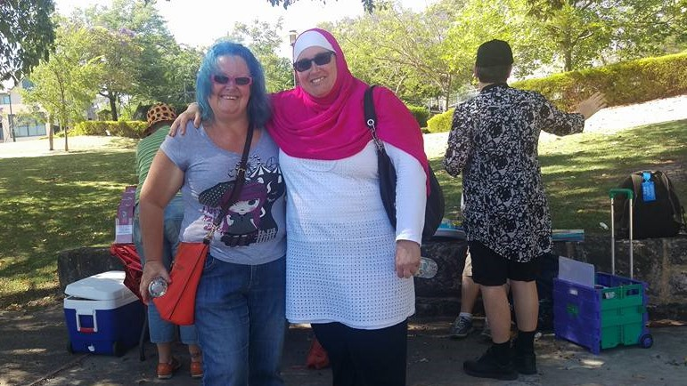A couple of minor improvements were noted such as updating our language in policy documents to reflect safeguarding, and having more consistency across the consortium on feedback and complaints mechanisms. The evaluator also noted that there was a strong response from clients in wanting to see issues from individual advocacy raised at a systemic level.
Members Sandra and Samia

Projects

Releasing our Capacity – National Disability Insurance Agency Disability Support Organisation Project, Project Officer and Peer Leader Samantha Connor.
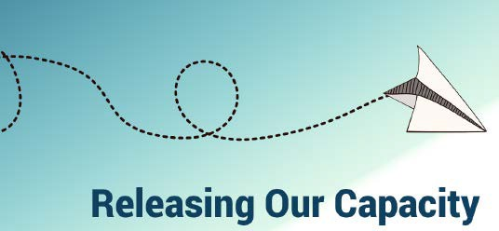

This project has been running for two and a half years and there are now 18 groups that have been supported by PWdWA. Our project partners Consumers of Mental Health WA. have worked to support 5 additional groups of people with psychosocial disability.

To date through this project we have funded and supported the following groups;
  - ABI Peer Support
  - Access Toodyay
  - Amputees WA
  - Blind Citizens WA
  - Carers with Disability
  - Community Hub Leaders
  - First Peoples Disability Advocacy Network WA
  - FSHMD Support Group Australia
  - Inside Out (Quadriplegic Centre)
  - NDIS Grassroots Discussion Group
  - Perth Autistic and Asperger’s Association (PA5)
  - Self Advocacy and Peer Support WA
  - Self Advocacy WA
  - Spinal Chatter
  - WA NDIS My Way online peer group
  - Wheatbelt Disability Action Group
  - Women with Disabilities WA
  - Youth Disability Advocacy Network

The project has bought direct benefit to people with disability involved in the peer support groups. Some peer group members are now working in the disability sector because of opportunities that have arisen throughout the course of the project. Members have a thorough knowledge of the disability sector, of government processes, and an expertise in understanding complicated policies and procedures

which has developed due to the two trials in WA. Group members have developed strong relationships between other peer groups – many of the group members belong to multiple groups. In addition, there are a number of mainstream organisations that are either formal ‘partner organisations’ (Limbs 4 Life, Muscular Dystrophy WA, Youth Affairs Council WA) or informal partnerships. Well over 85% of local peer group members reported an increased knowledge of choice and control and understanding of where to access services and supports.

One of the key objectives of this project is to increase people’s confidence to engage in the NDIS. This objective has not been acheived in WA because of having uncertainty around the NDIS and the confusion between two different schemes. In an evaluation survey of the peer groups, only seven of forty five people surveyed reported that they were confident in navigating their local scheme, and the majority said that they experienced significant anxiety around the scheme differences and eventual result.

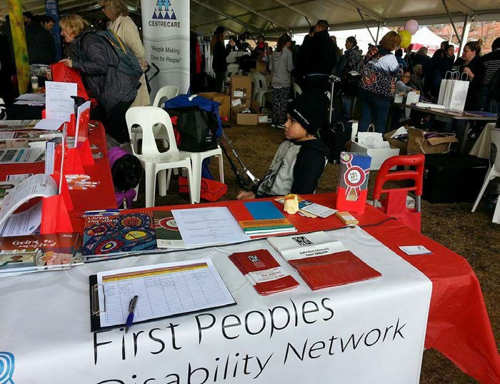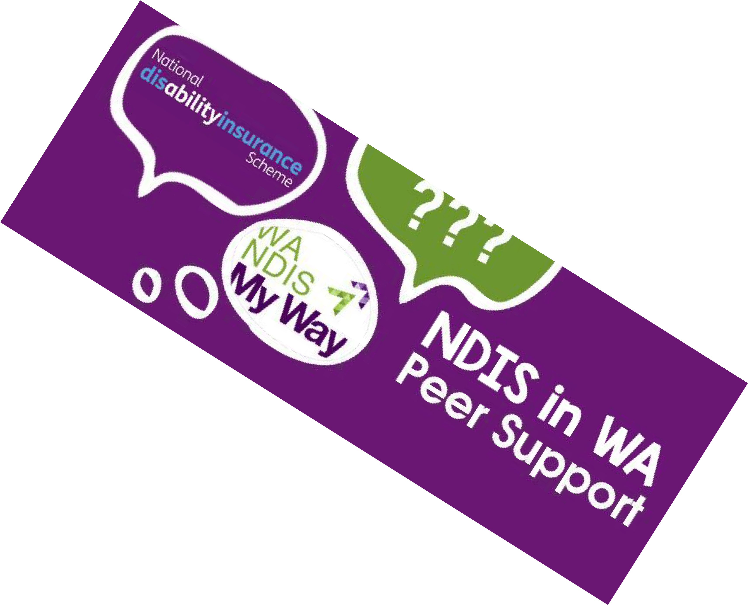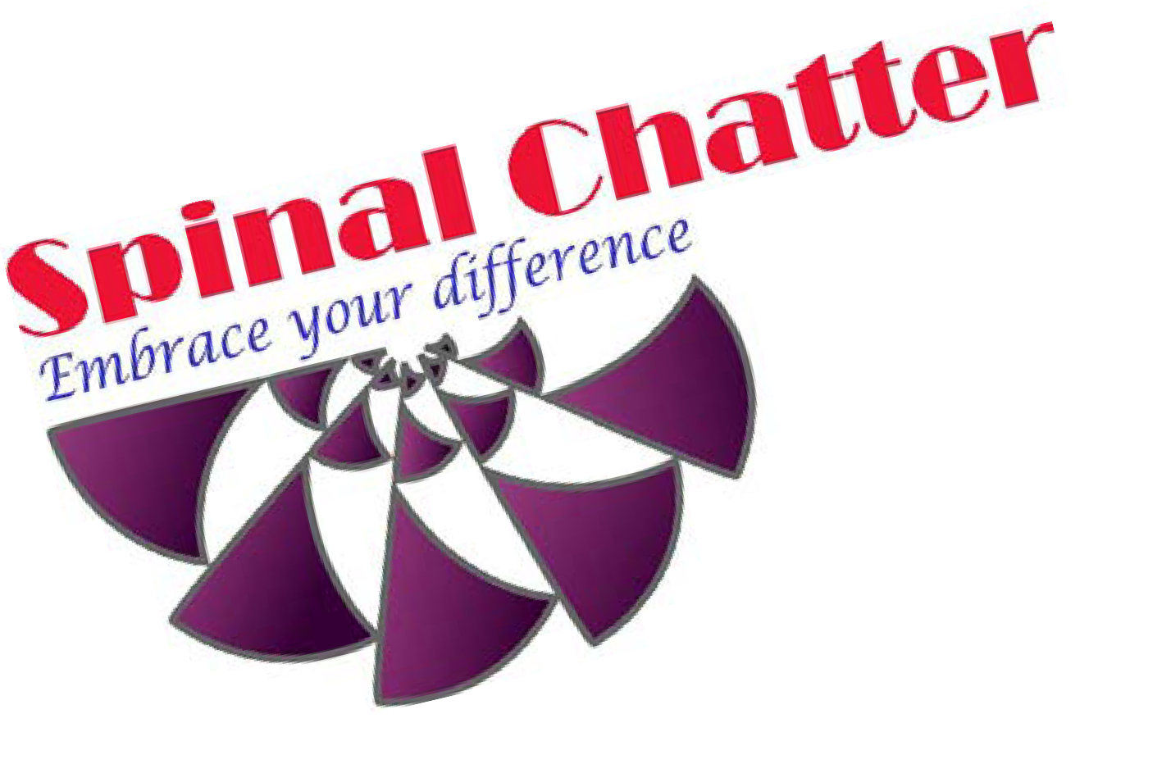PWdWA thanks the NDIA for continuing to fund this project for 2017-18. We remain committed to providing in kind support wherever possible to peer groups after the project has been completed. Our thanks to Samantha Connor, Project Officer, the Community Hub Leaders, and all the peer group leaders for their time and effort in making peer support in WA successful.

Self Advocacy WA (SAWA)
Despite an unfortunate loss of
ongoing funding, SAWA has been able to continue and expand, thanks in a large part to a grant from the NDIA as part of the ‘Releasing Our Capacity’ Project. This year SAWA decided to expand their membership to include all people with disabilities. This has resulted in new members joining the group, including younger members. The group is now working on a Facebook Page and a new Pamphlet, to help further expand their membership, and increase awareness about SAWA and the importance of the group. The group continues to provide feedback to various community organisations and researchers including; NDS and the Changing Places Bathroom Accessibility in Public and Private Places program; and information handouts about abuse developed by Curtin University for people with disabilities.
SAWA also met with representatives from the Victorian Self Advocacy Resource Unit, and participated in the National Approach to Self-Advocacy consultations, as well as Disability Safety Week. Representatives from SAWA, have now been invited to Melbourne, to participate in a National Self Advocacy Forum, and meet with advocates from around Australia to discuss and strategise about issues that are important to people with disabilities. Members of SAWA thank Miranda McReynolds and PWdWA for their support over the last year.
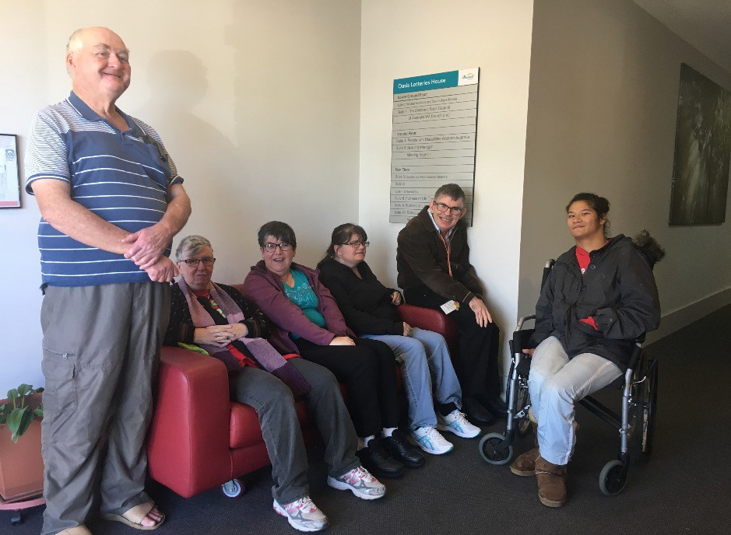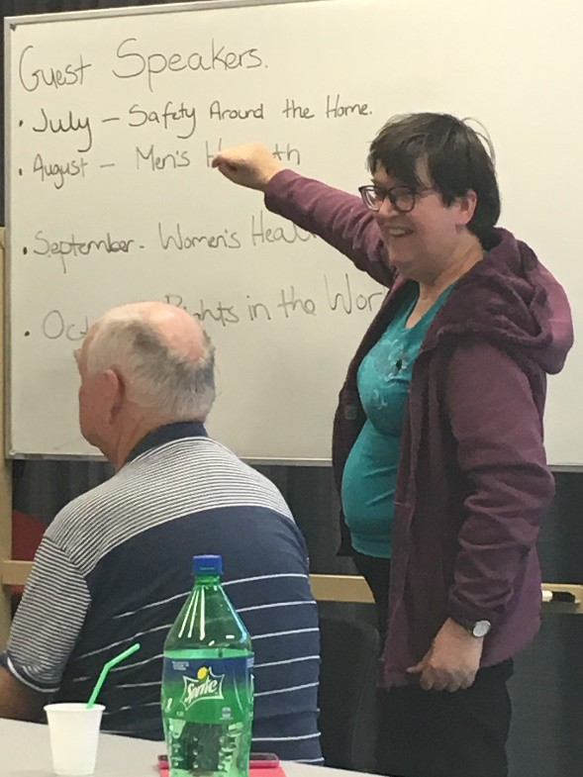
SAWA Members Planning Meeting

Systemic advocacy

Our systemic advocacy is undertaken by our Project Manager Faye Hicks and our Executive Director Samantha Jenkinson with funding from DSS.

Abuse and Neglect
The cross sector Abuse and Neglect Taskforce established in 2015 continues to bring together stakeholders to lobby for change in their respective organisations. Stakeholders from across multiple government departments are engaged and contributing to public forums on staying safe and appropriate response and prevention of abuse. PWdWA staff supported the Safer Services Safeguarding workshops run by National Disability Services WA. The taskforce also discussed specific areas which could be influenced such as education policy and the NDIS Safeguarding Commission.
PWdWA, working with the taskforce, has been successful in obtaining grant funding to run 'Disability Safe Week' in collaboration with taskforce Members. Lotterywest provided funding for the ‘Disability Safe Week’ project to take place from 11 September to 15 September 2017 with easy read resources, website, fact sheets and posters. Developmental Disability WA, Sexual Assault Resource Centre, My Place, National Disability Services WA, and staff from the Schools of Special Educational Needs: Disability, have supported PWdWA in the project.
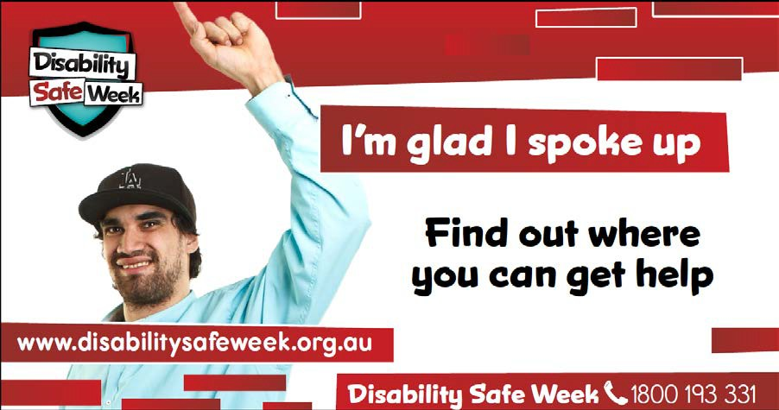

Housing
PWdWA has seen housing as a priority issue with a lack of affordable housing generally and limited options available for people with disability. The Housing Advisory Roundtable was reinvigorated in 2016, with PWdWA as a continuing member having input into exploration of social return on investment in social housing, priority areas with a new state government, and income eligibility levels and exemptions.

The Executive Director was invited to participate in the NDIA Independent Advisory Council Housing Innovation Working Group. This group provided input into the Specialist Disability Accommodation policy and guidelines of the NDIA. It is also exploring how to provide more information and support for people with disability to have greater options in accessing housing.

National Disability Insurance Scheme
In 2015 we collaborated with a number of disability advocacy organisations, consumer, and carer led groups to assess the benefits and shortcomings of NDIS based on peoples’ direct experiences in all WA trial site areas. The findings formed our 2015 NDIS Experiences Report. From June to October 2016 PWdWA took the lead in doing a second survey of NDIS trial site participants in WA in collaboration with other advocacy and consumer groups. A report with survey results and analysis was written and distributed to stakeholders in all levels of government. This showed many similar results to the first survey and was not clearly indicating one model over the other, however the direct experiences assisted us in raising issues with both trials.
PWdWA holds positions on both the NDIA and WA NDIS/My Way Advisory Groups as the peak body representing people with disability in WA, and as a user led organisation. PWdWA has raised issues from consumers in the NDIS trials through both groups with input from peer and other advocacy groups. We have also met with Managers of both the NDIA and WA NDIS trial sites to discuss broad issues surrounding things like the holder of funds for equipment, appeals processes, engagement with hard to reach groups, the My First Plan process, and consistency in interpretation of ‘reasonable and necessary’ principles.
Our Executive Director has provided expert advice to the NDIA Independent Advisory Council at meetings on Housing Innovation, and Self-Management policy and processes. She has also participated in the expert advisory workshops of the ILC Outcomes Framework.
In WA NDIS we have contributed to development of Self-Management policy and been a key organiser in engagement events to bring together people with disability, their families and carers to share ideas and gain information on the NDIS in WA. The push for WA NDIS to use the national AAT process for appeals came from PWdWA.
The NDIS in WA Conversations event in June 2017 required a lot of planning in a short time period. The Disability Coalition co-produced the event with the then Disability Services Commission. This was the first event of its size specifically for people with disabilities, their families and carers in WA on the NDIS. PWdWA was heavily involved in the topic selection, planning, running and evaluation of the event. At the event our staff were available to answer questions and our Executive Director ran the housing workshop and assisted in the advocacy workshop. Although the event wasn’t able to involve everyone who expressed an interest,

there were many people from regional areas and people with disability who came along to have input, meet peers, and gain information. It was clear that access to good information and the opportunity to discuss options and choices with peers is a major issue in the changing environment.

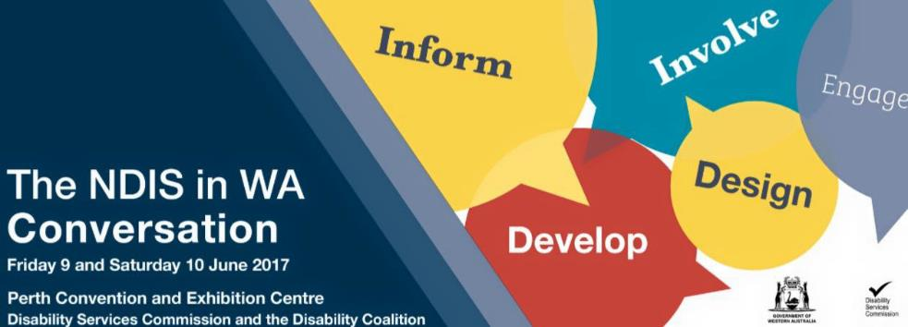

Beyond the Quad Centre
In February 2016 our Executive Director, Samantha Jenkinson and our committee member Mallika MacLeod, both of whom have spinal cord injury, were invited to be members of the “Enhanced Spinal Cord Injury Services Steering Committee”. This committee continued to meet in the second half of 2016 and government supported the business case for a new model of care for people with Spinal Cord Injury. The next stage of the project is now underway with detailed planning taking place and a Consumer Advisory Group for the new model to be implemented.

Transport
A previous past president and member of PWdWA, Monica McGhie, has been PWdWA representative on the Department of Transport On-demand Transport advisory Group which involved policy and reviews of Taxis, Coaches, Limousines and Uber. During this time PWdWA participated in the consultation process for the Taxi User Subsidy Scheme (TUSS) Review. The TUSS Review has progressed substantially with the report close to being finalised. The review was comprehensive and looked at the foundation policy framework, administration of payments and memberships and community expectations. There will be further consultation with disability groups as the report findings are considered and implemented.
Both Monica and Greg Madson have represented PWdWA on the up-grade of the East Perth Train Station overpass and platform. The group is working very closely with the developers and project managers on access for all.

Greg sits on the Vulnerable Road Users Advisory Group as a representative of PWdWA providing advice on road, footpaths and cycleways access issues for people with a disability. He has also been providing advice on disability access requirements during the design of the Forrestfield Airport Link Project. The airport link will be a train line from Perth to Forrestfield, including train stations at Forrestfield, Belmont and Perth Airport.

Other systemic issues
There are a variety of ways by which PWdWA obtains information to inform systemic issues. These include:
  - Consulting with individuals to inform submission process, through focus groups, surveys, and case studies.
  - Collaboration with groups on issues such as other peaks, advocacy groups and peer groups..
  - Research and literature reviews for evidence.
There are also a variety of ways PWdWA has used to advocate for change on issues:
  - Media Releases on NDIS, and interviews with the media on access issues, potential abuse and NDIS.
  - Meeting with policy makers and politicians on NDIS, housing, transport, health, de-institutionalisation, and abuse and neglect issues. Presenting models of contemporary practice and research evidence wherever possible.
  - Meetings with stakeholders to discuss issues and recommendations.
  - Writing submissions, and letters with case studies and direct input from people with disability.
  - Presenting at Senate and Parliamentary hearings.
  - Presenting at forums and organising Public forums.
  - Social media.
There are many more issues we have raised or been consulted on than those highlighted specifically above in our priority areas. Relationships have been built with key staff at the Department of Communities Disability Services that has enabled us to raise issues on NDIS, their engagement policy, inclusion of a paid participation policy, and co-design. We have also raised issues of contemporary policy on land use for housing related to disability, young people in nursing homes, and access to schools, with politicians. The development of our state election policy platform shows the broad range of areas that still require advocacy and change to enable people with disability to be equal and valued citizens.
Monica McGhie has represented PWdWA on the Disability Health Network, Executive Advisory Group, which has developed a Framework for an inclusive West Australian Health system that empowers people with disability to enjoy the highest attainable standard of health and wellbeing throughout their lives.

PWdWA was a key member of the new Perth Stadium Access and Inclusion Users Group. The stadium has adopted best practice for large stadium accessibility and has multiple accessible toilets and seating. The process used by the Department of Sport and Recreation of keeping the Access User Group engaged throughout the project lifetime is to be commended. PWdWA also provided input into the Scarborough redevelopment playground and Perth Stadium universal access playground.
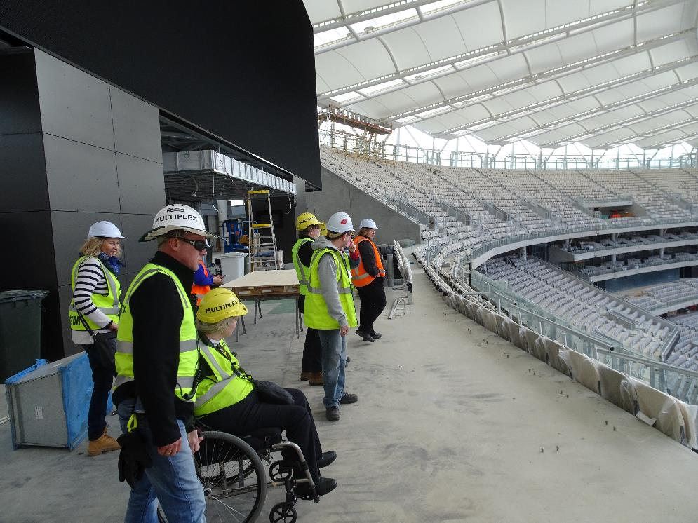
Perth Stadium tour of Access User Group

Submissions and Reports
As part of PWdWA’s systemic work we provide written submissions on a variety of issues that affect people with disability. All our submissions are based on evidence from people with disability whether it is our clients or members experience. The recommendations we provide in our submissions are based on a wide consultation with people with disability. We also publish reports or documents for our members or to raise specific issues with relevant Government Departments or Ministers.

During 2016 – 17 PWdWA provided written reports and submissions on:
  - Disability Employment Services
  - National Disability Insurance Scheme Savings Bill Senate Community Affairs Inquiry
  - Joint Parliamentary Inquiry into Qualifying for the Disability Support Pension
  - Mobility Allowance Senate Community Affairs Inquiry
  - Feedback on Accessibility of Polling places to the Australian Electoral Commission
  - NDIS Experiences Report 2016
  - State Election 2017 Priorities for People with Disability
  - Centrelink Robodebt Senate Community Affairs Inquiry Statement
  - Impact of the National Disability Strategy Senate Community Affairs Inquiry
  - WA NDIS Information, Linkages and Capacity Building Framework
  - National Disability Insurance Scheme Code of Conduct

Representation and participation
In 2016-17 PWdWA staff and members contributed to committees, reference groups, and consultations covering a broad range of issues affecting the lives of people with disability.
These included;
  - Working with MIDLAS, EDAC, SSCLS IDAS and others to connect individual advocates to the NDIS trial sites and collect information to feedback to the NDIS Perth Hills Advisory group, and WA NDIS Advisory Group.
  - NDIS Perth Hills Advisory group
  - WA NDIS/My Way Advisory Group
  - NDIA Planning Alliance Steering Committee
  - Commonwealth Ombudsmen NDIS review
  - MACD WA NDIS Consultation
  - NDIA Independent Advisory Council Housing Innovation Working Group
  - NDIA Independent Advisory Council Self-Management Policy Co-design group
  - NDIA Measuring ILC Outcomes Framework workshops
  - NDS Pre-budget Submission Reference Group
  - NDAP Reform Review Meetings
  - NDS WA Safer Services Steering Group
  - Doors to Safety Project Reference Group
  - Disability Coalition WA
  - DSC Focus groups on prioritisation of funding and self-management policy
  - Housing Advisory Roundtable
  - Housing Authority Social Return on Investment workshop
  - Disability Health Network Executive Advisory Group

- Health Clinical Senate on Interpersonal Violence
- Domestic Violence Training Consultation
- Enhanced Spinal Cord Injury Services Steering Group
- Spinal Cord Injury Consumer Advisory Group
- On-demand Transport Advisory Group
- Airport Link train line consultation
- Vulnerable Road Users Advisory Group
- East Perth Redevelopment Access and Inclusion Working Group
- Disability Sport and Recreation Forums
- Taxi User Subsidy Scheme Consultation
- Perth Airport Universal Access Consultative Group
- MRA Access Consultancy Scarborough
- Department of Sport and Recreation Stadium Access Users Group
- City of Perth Share to Shape workshops
- NDIS in WA Conversations Planning
- Auditor General Preliminary meeting on Serious Incident Reporting
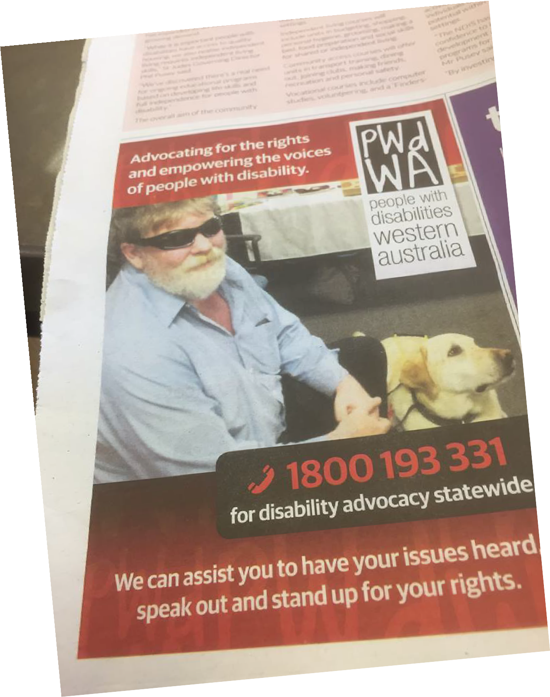
PWdWA Newspaper Ad

Community Education & Promotion
All staff contribute to our community education and promotion of advocacy in various ways. This year specific promotion was done via:
  - On-demand Transport Q&A Session
  - NDIA Midland Expo
  - Abilities Expo
  - RUOK Day Halls Head Senior High
  - NDS Safeguarding workshops for service providers
  - Curtin University Thai Disability Sector forum
  - Members BBQ for IDPWD
  - Meeting Peer to Peer Network Perth Hills
  - Advocacy Workshops in Armadale, Pinjarra and Bayswater/Bassendean
  - NDIS in WA Conversations

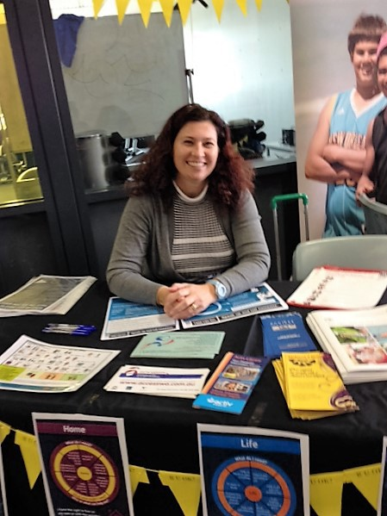
Maggie at Expo

PEOPLE WITH DISABILITIES (WA) INC
SPECIAL PURPOSE FINANCIAL STATEMENTS
FOR THE YEAR ENDED
30 June 2017

 | PEOPLE WITH DISABILITIES (WA) INC
 | FINANCIAL STATEMENTS FOR THE YEAR ENDED
 | 30 June 2017
 | INDEX
1 | Auditor's Report
2 | Statement by President
3 | Income Statement
4 | Balance Sheet
5 | Statement of Cashflows
6 | Notes to and forming part of the accounts
 | Notes 1 - 9

RAY WOOLLEY PTY LTD ACN 30 056 227 297

CHARTERED ACCOUNTANTS

PRINCIPAL:RAY WOOLLE Y FCA (UK) BSc (Hons)
ray@raywoolleyaccounting.com.au

PEOPLE WITH DISABILITIES (WA) INC

INDEPENDENT AUDIT REPORT TO THE MEMBERS OF PEOPLE WITH DISABILITIES (WA) INC
17 RUSSLEY GROVE YANCHEP
WA 6035
PH: (08) 95616146

Opinion
We have audited the accompanying financial report, being a special purpose financial report, of People with Disabilities (WA) Inc (the incorporation), which comprises the board’s report, the balance sheet and statement of changes in equity as at 30 June 2017, the income statement and the cash flow statement for the year then ended and notes comprising a summary of significant accounting policies and other explanatory information, and the statement by the Board of Management.
In our opinion, the financial report presents fairly, in all material respects, the financial position of People with Disabilities (WA) Inc as at 30 June 2017 and its financial performance for the year then ended in accordance with the accounting policies described in Note 1 to the financial statements, and the requirements of the Associations Incorporation Act of WA. and the Australian Charities and Not-for-profits Commission Act 2012 (ACNC Act 2012).
Basis of Opinion

We conducted our audit in accordance with Australian Auditing Standards. Our responsibilities under those standards are further described in the Auditor’s Responsibilities for the Audit of the Financial Report section of our report. We are independent of the association in accordance with the ethical requirements of the Accounting Professional and Ethical Standards Board’s APES 110: Code of Ethics for Professional Accountants (the Code) that are relevant to our audit of
the financial report in Australia. We have also fulfilled our other ethical responsibilities in accordance with the Code.
We believe that the audit evidence we have obtained is sufficient and appropriate to provide a basis for our opinion.
Emphasis of Matter – Basis of Accounting
We draw attention to Note 1 to the financial report, which describes the basis of accounting. The financial report has been prepared to assist the incorporation to meet the requirements of the Associations Incorporation Act of WA and the Australian Charities and Not-for-profits Commission Act 2012 (ACNC Act 2012). As a result, the financial report may not be suitable for another purpose. Our opinion is not modified in respect of this matter.
Board’s Responsibility for the Financial Report
The board of People with Disabilities (WA) Inc is responsible for the preparation of the financial report, and has determined that the basis of preparation described in Note 1 is appropriate to meet the requirements of the Associations Incorporation Act of WA and the Australian Charities and Not-for-profits Commission Act 2012 (ACNC Act 2012) and is appropriate to meet the needs of the members. The board’s responsibility also includes such internal control as the board determines is necessary to enable the preparation of a financial report that is free from material misstatement, whether due to fraud or error.
In preparing the financial report, the board is responsible for assessing the incorporation’s ability to continue as a going concern, disclosing, as applicable, matters relating to going concern and using the going concern basis of accounting unless the board either intends to liquidate the incorporation or to cease operations, or has no realistic alternative but to do so.

PEOPLE WITH DISABILITIES (WA) INC

INDEPENDENT AUDIT REPORT TO THE MEMBERS OF PEOPLE WITH DISABILITIES (WA) INC

continued

Auditor’s Responsibilities for the Audit of the Financial Report
Our objectives are to obtain reasonable assurance about whether the financial report as a whole is free from material misstatement, whether due to fraud or error, and to issue an auditor’s report that includes our opinion. Reasonable assurance is a high level of assurance, but is not a guarantee that an audit conducted in accordance with the Australian Auditing Standards will always detect a material misstatement when it exists. Misstatements can arise from fraud or error and are considered material if, individually or in the aggregate, they could reasonably be expected to influence the economic decisions of users taken on the basis of this financial report.
As part of an audit in accordance with Australian Auditing Standards, we exercise professional judgement and maintain professional scepticism throughout the audit. We also:
- Identify and assess the risks of material misstatement of the financial report, whether due to fraud or error, design and perform audit procedures responsive to those risks, and obtain audit evidence that is sufficient and appropriate to provide a basis for our opinion. The risk of not detecting a material misstatement resulting from fraud is higher than for one resulting from error, as fraud may involve collusion, forgery, intentional omissions, misrepresentations, or the override of internal control.
- Obtain an understanding of internal control relevant to the audit in order to design audit procedures that are appropriate in the circumstances, but not for the purpose of expressing an opinion on the effectiveness of the association’s internal control.
- Evaluate the appropriateness of accounting policies used and the reasonableness of accounting estimates and related disclosures made by the board.
- Conclude on the appropriateness of the board’s use of the going concern basis of accounting and, based on the audit evidence obtained, whether a material uncertainty exists related to events or conditions that may cast significant doubt on the association’s ability to continue as a going concern. If we conclude that a material uncertainty exists, we are required to draw attention in our auditor’s report to the related disclosures in the financial report or, if such disclosures are inadequate, to modify our opinion. Our conclusions are based on the audit evidence obtained up to the date of our auditor’s report. However, future events or conditions may cause the association to cease to continue as a going concern.
- Evaluate the overall presentation, structure and content of the financial report, including the disclosures, and whether the financial report represents the underlying transactions and events in a manner that achieves fair presentation.
We communicate with the board regarding, among other matters, the planned scope and timing of the audit and significant audit findings, including any significant deficiencies in internal control that we identify during our audit.

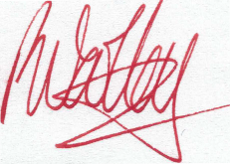
Ray Woolley Pty Ltd Ray Woolley
Registered Auditor No 16396 24 August 2017

17 Russley Grove Yanchep
WA 6035

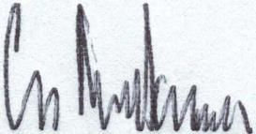
 | PEOPLE WITH DISABILITIES (WA) INC
 | STATEMENT BY PRESIDENT
 | For The Year Ended 30 June 2017
The Board of Management declare that:
a) | The attached financial statements and notes thereto comply with accounting
 | standards
b) | The attached financial statements and notes thereto give a true and fair view of
 | the financial position and performance of the association; and
c) | In the Board of Management's opinion, there are reasonable grounds to believe
 | that the Association will be able to pay its debts as and when they become due
 | and payable.
Signed on behalf of the Board of Management
Gregory Madson
President
Date: 22 Sept | ember 2017
PERTH, WA

PEOPLE WITH DISABILITIES (WA) INC
Income Statement
For the financial year ended 30/06/2017
Notes | 2017 |  | 2016
 | $ |  | $
Revenue from Ordinary Activities
Grants
- Disability Services Commission | 986,950 |  | 758,788
- Department of Social Services | 309,805 |  | 276,374
- NDIA ( Named as Other Grant in 2016) | 210,177 |  | 148,261
- Lotterywest | 12,751 |  | 0
- Other Grant ( Named as Other Grant - Lotterywest in 2016) | 1,637 |  | 14,680
Interest | 13,468 |  | 16,430
Donations & fundraising | 2,835 |  | 20
Membership | 0 |  | 0
Sundry Income & reimbursements | 9,322 |  | 14,310
Total Revenue from Ordinary Activities | 1,546,946 |  | 1,228,863
Expenses from Ordinary Activities
Accounting and Audit fees | 31,169 |  | 35,758
Advertising and recruitment | 163 |  | 2,386
Office and Staff amenities | 1,172 |  | 1,645
Depreciation | 4,272 |  | 23
Furniture & Equipment, Computer Expenses | 1,776 |  | 500
Insurances - General & Motor Vehicle | 6,357 |  | 6,895
I.T. Expenses | 49,405 |  | 37,904
Postage | 1,299 |  | 2,250
Printing and Stationery | 8,202 |  | 8,670
Rent | 29,920 |  | 29,069
Repairs and Maintenance | 1,115 |  | 3,249
Salary and wages costs | 701,247 |  | 743,519
Subscriptions | 5,659 |  | 2,624
Telephones | 5,333 |  | 5,725
Transport Costs | 15,693 |  | 18,314
Workshops/consultants | 98,738 |  | 36,620
Other Expenses | 531,489 |  | 276,084
Total Expenses from Ordinary Activities | 1,493,006 |  | 1,211,235
Operating surplus/(deficit) | 53,940 |  | 17,627
Non-Operating Income
Profit/ Loss on Sale of Assets | 0 |  | 7,727
Transfer of Provision | 0 |  | 14,000
 | 0 |  | 21,727
Total surplus/(deficit) | 53,940 |  | 39,355

STATEMENT OF CASH FLOWS
 | 2017 |  | 2016
 | $ | $ | $ | $
 | Inflows |  | Inflows
 | (Outflows) |  | (Outflows)
Cash flows from operating activities
Grant Income | 1,478,102 |  | 1,351,469
Interest Received | 13,468 |  | 16,430
Membership and Donations | 2,835 |  | 20
Other Income | 9,322 |  | 28,310
Payments to Suppliers and Employees | (1,483,708) | (1,237,790)
Net cash provided by/(used in) operating activities | 20,019 |  |  | 158,439
Cash flows from investing activities
Non-operating income/loss | 0 |  | 0
Proceeds from sale of property, plant and equipment | 0 |  | 7,727
Payment for property, plant and equipment | 0 |  | (21,383)
Net cash provided by/(used in) or from investing activities | 0 |  |  | (13,656)
Net increase/decrease in cash held | 20,019 |  |  | 144,783
Cash at beginning of the financial year | 913,640 |  |  | 768,857
Cash at the end of the financial year | 933,659 |  |  | 913,640

STATEMENT OF CASH FLOWS
(a) Reconciliation of Cash |  | 2017 | 2016
 |  | $ | $
For the purposes of the statement of cash flows, cash includes cash on
hand and in banks and investments in money market instruments, net of
 | outstanding bank overdrafts. Cash at the end of the financial year as
shown in the statement of cash flows is reconciled to the related items in
 | the balance sheet as follows:
 | Cash | 584,310 | 568,505
 | Deposits at Call | 349,349 | 345,135
 |  | 933,659 | 913,640
b) | Financing Facilities
 | No facilities are in place as at 30 June 2017
c) | Reconciliation of net cash provided by operating | 2017 | 2016
 | activities to operating surplus. | $ | $
 | Operating surplus/(deficit) | 53,940 | 39,355
 | Profit/Loss on disposal of non-current assets
 | Depreciation and amortisation of non-current assets
 | Non operating income
 | Changes in net assets and liabilities
 | Decrease/(Increase ) in current receivables | (9,546) | (5,852)
 | Increase / (decrease) in current creditors | 10,712 | 11,502
 | Increase/ (decrease) in current provisions | 3,861 | (32,229)
 | Increase /(decrease) in income in advance | (43,219) | 153,366
 | (Increase )/decrease in Fixed assets | 4,272 | (21,360)
 | Net Cash provided by/(used in) operating activities | 20,019 | 144,783

PEOPLE WITH DISABILITIES (WA) INC
STATEMENT OF CHANGES IN EQUITY
As at 30th June 2017
 | General
 | $
RESERVES
Balance as at 30th June 2014 | 331,863
Surplus /(Deficit) for the year | 64,077
Balance as at 30 June 2015 | 395,940
Surplus /(Deficit) for the year | 39,355
Balance as at 30 June 2016 | 435,295
Surplus /(Deficit) for the year | 53,940
Balance as at 30 June 2017 | 489,235

PEOPLE WITH DISABILITIES (WA) INC
Balance Sheet
As at 30/06/2017
 | Note | 2017 |  | 2016
 |  | $ |  | $
Current Assets
Cash at Bank and on Hand | 3 | 933,659 |  | 913,640
GST - Input Tax credits |  | 22,852 |  | 15,662
Accrued Income and Prepayments |  | 11,174 |  | 8,817
Total Current Assets |  | 967,685 |  | 938,119
Non-current Assets
Plant/Equipment |  | 76,130 |  | 76,130
Less Accumulated Depreciation |  | (76,130) |  | (76,130)
Motor Vehicle |  | 21,383 |  | 21,383
Less Accumulated Depreciation |  | (4,295) |  | (23)
Total Non-current Assets |  | 17,088 |  | 21,360
Total Assets |  | 984,773 |  | 959,479
Liabilities
Sundry Creditors and Accrued Expenses | 4 | 45,324 |  | 45,508
Income Received in Advance | 5 | 327,797 |  | 371,016
GST - collected |  | 38,100 |  | 27,204
Provisions - Annual Leave & Sick Leave | 6 | 46,811 |  | 40,415
Long Service Leave | 6 | 37,506 |  | 40,041
Total liabilities |  | 495,538 |  | 524,184
Net Assets |  | 489,235 |  | 435,295
Accumulated funds |  | 489,235 |  | 435,295

 |  |  | PEOPLE WITH DISABILITIES (WA) INC
 |  |  | Notes to and Forming Part of the Accounts
 |  |  | For the year ended 30/06/2017
1 | Summary of Accounting Policies
This financial report is a special purpose financial report prepared in order to satisfy the financial reporting
requirements of the Association Incorporated Acit of WA, and the Australian Charities and Not-for-profits
Commision Act 2012 (ACNC Act 2012). The Board has determined that the incorporation is not a reporting
 | entity
The financial report has been prepared on an accrual basis and is based on historical costs and
does not take into account changing money values or, except where specifically stated, current
valuations of non-current assets
The following significant accounting policies, which are consistent with previous period unless
stated otherwise, have been adopted in the preparation of this financial report.
(a) | The provision for long service leave is calculated at current rates of pay for all staff
from their date of commencement. Long service leave entitlement is due after 7 years
service for the first and subsequent terms.
The Association’s Performance Agreement with the Disability Services Commission now
requires it to make provision for Long Service Leave as per its employee entitlement policy.
(b) | Holiday pay is accrued based upon holiday entitlement and pro-rata at current rates of
pay plus 17.5% loadings, Superannuation and Workers Compensation liabilities for
 | applicable staff.
(c) | Provision for Sick Leave has been accrued on the basis of 50% of the outstanding
 | balance as at | 30 June 2017 | , plus superannuation and workers compensation liabilities
for applicable staff.
(d) | Depreciation is calculated on a straight line basis so as to write of the net cost of each
 | fixed asset during its expected life. The depreciation rates used are:
 | Plant and Equipment |  | 20%
 | Furniture & Fittings |  | 20%
 | Motor Vehicles |  | 20%
 | Computers |  | 33%
 | Since June 2000 it has been the policy of the Association to not capitalise items less than
 | $5,000 in value. These amounts are written off wholly in the year of purchase. The
 | Association is not funded for capital replacement within it's current grant structure and
 | does not have the capacity to put aside cash reserves to cover these expenses.
 | Component parts will be grouped together to determine the value to be used in determining
 | the $5,000 limit.

PEOPLE WITH DISABILITIES (WA) Inc
NOTES TO AND FORMING PART OF THE ACCOUNTS
For the year ended 30/06/2017
2 | Plant/Equipment and Vehicles
 | Gross Carrying Amount | Plant/equip |  | Vehicles |  | Total
 | Balance as at 30 June 2016 | 76,130 |  | 21,383 |  | 97,513
 | Prior Year adjustment | 0 |  | 0 |  | 0
 | Additions | 0 |  | 0 |  | 0
 | Disposals | 0 |  | 0 |  | 0
 | Balance as at 30 June 2017 | 76,130 |  | 21,383 |  | 97,513
 | Accumulated Depreciation
 | Balance as at 30 June 2016 | (76,130) |  | (23) |  | (76,153)
 | Prior Year adjustment | 0 |  | 0 |  | 0
 | Disposals | 0 |  | 0 |  | 0
 | Depreciation Expense | 0 |  | (4,272) |  | (4,272)
 | Balance as at 30 June 2017 | (76,130) |  | (4,295) |  | (80,425)
 | Net Book Value
 | Balance as at 30 June 2016 | 0 |  | 21,360 |  | 21,360
 | Balance as at 30 June 2017 | 0 |  | 17,088 |  | 17,088
 |  | 2017 |  | 2016
 |  | $ |  | $
3 | Cash at bank and on hand
 | Cash on hand | 192 |  | 370
 | Cash at bank - Bankwest General Account | 86,705 |  | 1,105
 | Gold Cash Management Account | 430,298 |  | 556,259
 | Bankwest - Term Deposits | 349,349 |  | 345,135
 | ANZ - Cheque | 6 |  | 6
 | ANZ - Interest Bearing | 7 |  | 7
 | NH Trust Account | 67,102 |  | 10,758
 |  | 933,659 |  | 913,640
4 | Sundry Creditors
 | Creditors general | 19,354 |  | 18,989
 | Accrued expenses | 25,970 |  | 26,520
 |  | 45,324 |  | 45,509
5 | Income Received in Advance
 | Disability Services Commission | 48,000 |  | 281,200
 | National Disability Insurance Agency | 125,000 |  | 89,816
 | NDIA - Peer Support | 10,139 |  | 0
 | Grant In Advance - Others | 144,658 |  | 0
 |  | 327,797 |  | 371,016
6 | Current Provisions
 | Employee Entitlements:
 | Long Service Leave - Current | (1,661) |  | 270
 | Long Service Leave - Non Current | 39,167 |  | 39,771
 |  | 37,506 |  | 40,041
 | Annual Leave | 40,571 |  | 31,679
 | Sick Leave | 6,240 |  | 8,736
 |  | 46,811 |  | 40,415

PEOPLE WITH DISABILITIES (WA) Inc
Notes to and forming part of the accounts
For the year ended 30/06/2017
 |  |  | 2017 |  | 2016
 |  |  | $ |  | $
7 | Non Operating Income
 | Gain/(Loss) on Sale of Assets |  | 0 |  | 7,727
 | Transfer of Provision |  | 0 |  | 14,000
 |  |  | 0 |  | 21,727
8 | Related Party Disclosure
Greg Madson (President)
Ryan Gay (Vice President)
Mallika Macleod (Treasurer)
Elizabeth Edmondson (Secretary)
 | Ingrid Moore
 | Adam Hewber
 | Prudence
 | Hawkins
 | Ian Mansfield
 | Lisa Burnette
 | Jordon Steel-John
Samantha Jenkinson (non-voting member)
Erika Webb (Secretarial support)
9 | Superannuation
 | The Association sponsors the following superannuation plan for employees, the details
 | of which are set out below:
 | Funds Vary based on personal choice.
 | Type of Benefits | Accumulation of contributions of employee and employer.
 |  | Covering all employees earning in excess of $450 per calendar
 |  | month and providing benefits on retirement, death or permanent
 |  | disability.
 | Contributions by :
 | Employee | Nil to Unlimited based on personal cho |  | ice
 | Employer | 9.5% based on Government Legislatio |  | n.
 |  | The Association has a legal obligation to contribute as set out in the
 |  | Superannuation guarantee legislation, but has the right to vary the
 |  | rate of, or terminate, contributions upon giving notice as
 |  | prescribed in the deed, subject to superannuation
 |  | guarantee conditions.
 | Each fund is self administered by the Superannuation Compan |  |  | y

PEOPLE WITH DISABILITIES (INC)
STATEMENT OF INCOME AND EXPENDITURE FOR PURCHASED SERVICES

For the year ended 30/06/2017
Form5A

Income Funding/Grants

DSC Recurrent
DSC Non-Recurrent (Operational) DSS
NDIA
Other

Other Income

Interest Donations/Fundraising Other

Expenditure

Total Funding/Grants

Total Other Income
DSC |  |  | DSS |  |  | NDIA |  |  |  | Lotterywest |  |  | Non-Operating |  |  | Whole Association
 |  |  |  | Last Year  276,374 |  | NDIA This | NDIA CICD | Last Year  148,261 |  | This Year  12,751
This Year | Last Year |  | This Year |  |  | Year | This Year |  |  |  | Last Year |  | This Year | Last Year |  | This Year | Last Year
805,350 | 652,215 |  |  |  |  |  |  |  |  |  |  |  |  |  |  | 805,350 | 652,215
181,600 | 106,573 |  | 309,805 |  |  | 147,677 | 62,500 |  |  |  | 14,680 |  |  |  |  | 181,600  309,805  210,177  12,751 | 106,573  276,374  148,261  14,680
986,950 | 758,788 |  | 309,805 | 276,374 |  | 147,677 | 62,500 | 148,261 |  | 12,751 | 14,680 |  | 0 | 0 |  | 1,519,683 | 1,198,103
 | 20 |  |  |  |  |  |  |  |  |  |  |  | 13,468  2,835 | 16,430 |  | 13,468  2,835 | 16,430  20
661 | 14,118 |  |  | 147 |  |  |  |  |  |  |  |  | 10,299 | 45 |  | 10,960 | 14,310
661 | 14,138 |  | 0 | 147 |  | 0 | 0 | 0 |  | 0 | 0 |  | 26,602 | 16,475 |  | 27,263 | 30,760
987,611 | 772,926 |  | 309,805 | 276,521 |  | 147,677 | 62,500 | 148,261 |  | 12,751 | 14,680 |  | 26,602 | 16,475 |  | 1,546,946 | 1,228,863
373,673 | 472,468 |  | 248,862 | 194,257 |  | 40,361 | 38,350 | 76,794 |  |  |  |  |  |  |  | 701,247 | 743,519
588,641 | 298,782 |  | 73,523 | 63,425 |  | 92,948 | 23,897 | 72,183 |  | 12,751 | 17,512 |  |  | 502 |  | 791,760 | 467,693
 | 23 |  |  |  |  |  |  |  |  |  |  |  |  |  |  | 0 | 23
962,314 | 771,273 |  | 322,385 | 257,682 |  | 133,309 | 62,248 | 148,978 |  | 12,751 | 17,512 |  | 0 | 502 |  | 1,493,006 | 1,211,235
25,297 | 1,653 |  | (12,580) | 18,839 |  | 14,368 | 252 | (717) |  | 0 | (2,832) |  | 26,602 | 15,974 |  | 53,940 | 17,628
 | 7,727 |  |  |  |  |  |  |  |  |  |  |  |  |  |  | 0 | 7,727
 | 14,000 |  |  |  |  |  |  |  |  |  |  |  |  |  |  | 0 | 14,000
0 | 21,727 |  | 0 | 0 |  | 0 | 0 | 0 |  | 0 | 0 |  | 0 | 0 |  | 0 | 21,727
25,297 | 23,379 |  | (12,580) | 18,839 |  | 14,368 | 252 | (717) |  | 0 | (2,832) |  | 26,602 | 15,974 |  | 53,940 | 39,355

Total Income

Salaries and related costs (includes entitlements) Administration & Operation cost
Depreciation and amortisation
- Depn other items
Total Expenditure Net Surplus/Deficit
Other non operating Income/(Expense)
Profit/(Loss) On Sale Asset Transfer of Provision
Total Other Income

Net Surplus/Deficit after non operating

