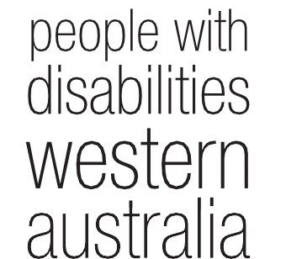wd Annual Report
2014 - 2015

People With Disabilities (WA) Inc Annual Report 2014 – 2015

Contents
Our Vision 3
Our Mission 3
We value 3
Guiding principles 3
PWdWA Presidents Report 4
Committee of Management 2014 - 2015 6
PWdWA Executive Director Report 7
Treasurers Report 10
Membership 11
Individual Advocacy 12
Information, Communication and social media 20
Self Advocacy WA (SAWA) 20
Projects 21
Systemic advocacy 23
Submissions 27
Representation and participation 28
Community Education & Promotion 29

PWdWA Audit Report and Audited statements 2014-2015 .....................................

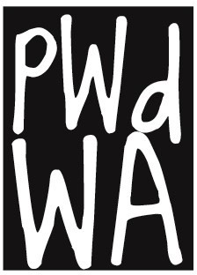

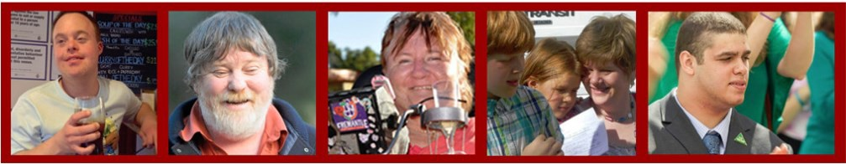

Our Vision
People with disability are equal and valued citizens.

Our Mission
Advocating for the rights and empowering the voices of people with disability in WA

We value
Human rights
The voices and unique experiences of people with disabilities

Guiding principles

We will:
- Be passionate, innovative and fearless in defending and promoting the rights and interests of people with disability.
- Be accessible, responsive to and inclusive of our diverse community.
- Be mindful, flexible, agile, responsive and innovative in a rapidly changing sector and world.
- Value and facilitate the involvement of people with disability in our governance and management.
- Collaborate with the disability and mental health sector.
- Maintain supportive relationships with advocacy and support organisations.
- Be transparent and accountable in everything we do.
- Act with honesty and integrity.
- Be resourceful and efficient regarding the resources we need to do our work.
- Recognise and value everyone who works with us to achieve our vision, including our committee, staff and volunteers.

PWdWA is funded by the Disability Services Commission WA (DSC) and the Department of Social Services (DSS)

Annual Report 2014 – 2015
Page 3

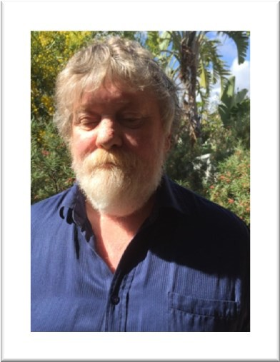
PWdWA Presidents Report
At the end of my 2nd year as President I remain proud to be part of an inclusive organisation with an embedded culture of rights for people with a disability at its heart. The work undertaken by the PWdWA Committee of Management, employees and volunteers is extensive and I hope to provide an impression of that work in this report.
Since my report last year we have been fortunate to bring on board a new Executive Director,
Samantha Jenkinson. With her extensive experience in the disability sector and strong management skills, Sam has lead the organisation through a process of review, leveraging the feedback from quality assurance assessments, completing significant work on improving our practises, policies and procedures, ensuring the quality of service to people with disability in WA is the very best we can provide.
Over the past year PWdWA has continued its work of systemic and individual advocacy, information dissemination, peer support, advice to government, submission and policy development, and engagement of members and the wider disability community. That work includes the following which will be presented in more detail in later pages of this annual report;
- Working alongside a Family Leadership group;
- Australian Housing Urban Research Institute Research Project;
- NDIA peer connect project;
- Working alongside Self Advocacy WA;
- Working on multiple transport issues;
- Housing issues;
- Significant work around abuse and neglect;
- Work on people living in inappropriate institutional and residential care settings;
- Partnerships and collaborations;
- Media representations on issues for people with a disability.
I would like to thank our fantastic advocates, communication and administrative people for their on-going enthusiasm, compassion, and work ethic which give the organisation its strength and ability to undertake this work.
A strong working relationship between the Executive Director and President is crucial for any organisation; I would like to formally thank Samantha Jenkinson for her leadership and support throughout the year.

Annual Report 2014 – 2015
Page 4

Committee of Management
It has been my privilege to work with a team of such calibre as makes up the PWdWA Committee of Management.
Over the past year the Committee of Management has focused on reviewing governance policies, a 2015-18 strategic plan, amendments to the PWdWA Business Rules (constitution), and strategic direction of the organisation in a changing disability sector. We are fortunate to have such a breadth of knowledge, youth and experience to call upon.
I would like to thank, Kerrie Duff, Mallika MacLeod, Monica McGhie, Kelly-Anne Blanch, Ryan Gay, Jordon Steele-John, Prue Hawkins (seconded) and Ryen Songhourst (retired), who have willingly given their time, commitment and advice in governing the organisation.

Our Members and Partnerships
A strong membership organisation needs strong engagement with its members. Throughout our strategic plan development member engagement was a prime focus, ensuring that a new strategic plan would meet the needs of PWdWA members. The Membership and engagement sub-committee reviewed our membership categories and process, recommending several changes that would improve membership and the way potential members could join and participate.
We have continued working alongside self-advocacy, leadership and peer support groups such as; Self-Advocacy WA, Spinal Chatter and Diverse Leadership (Inc.).
During the year PWdWA has entered into Memorandums of Understanding with Connectgroups Support Groups Association, Advocacy South West, Sussex Street Community Law Service, and renewed our Memorandum of Understanding with People with Disability Australia.

Funding
PWdWA is funded at the state level by the Disability Services Commission (DSC). I would like to thank the WA Disability Services Commission for their ongoing support throughout the year. Access to DSC run forums, meetings and events has given us opportunity to assist in directing the right change for the sector.
Federally, PWdWA receives funding from the Department of Social Services (DSS); we thank DSS for that support.
Over the past few years the disability sector has been one of great change; the need for a strong, reliable, and flexible disability advocacy organisation has never been greater. With the NDIS, My Way, a changing service sector and changes to

Annual Report 2014 – 2015
Page 5

how the state and federal government funds disability advocacy, we remain focused on our task to ensure that people with a disability have their voices heard, and are not locked out of decision processes that effect their lives.
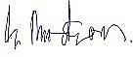
Greg Madson

Committee of Management 2014 - 2015
President Greg Madson Vice President Kerrie Duff Treasurer Monica McGhie
Secretary Mallika Macleod Ordinary Member Jordan Steele-John Ordinary Member Ryan Gay
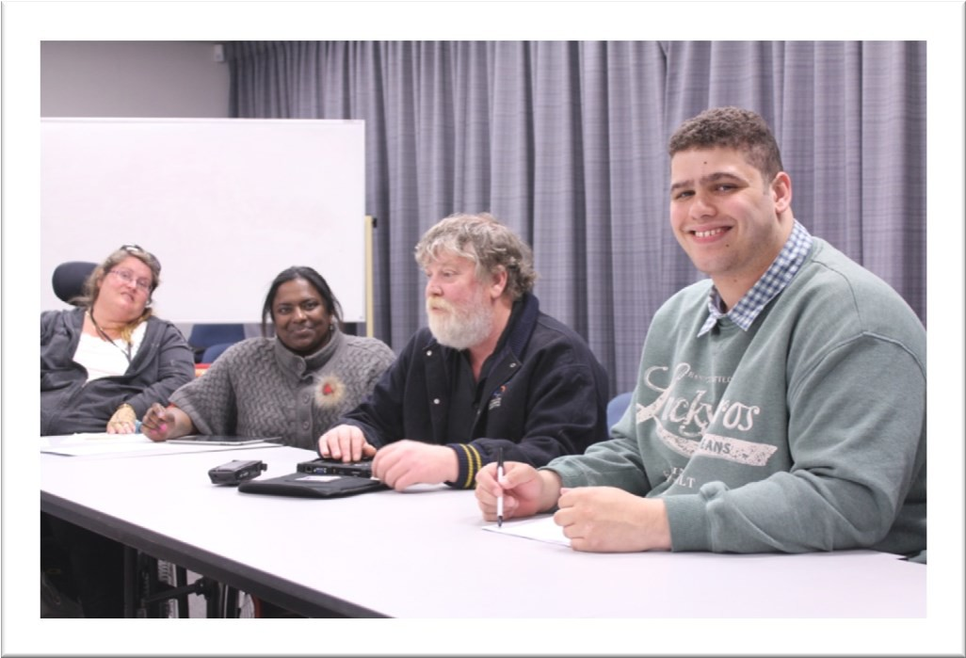
Ordinary Member Kelly-Anne Blanch Ordinary Member Ryen Songhurst (Retired) Ordinary Member Pru Hawkins (seconded)
(L-R) Kelly-Anne Blanch, Mallika Macleod, Greg Madson and Jordan Steele-John
Annual Report 2014 – 2015
Page 6

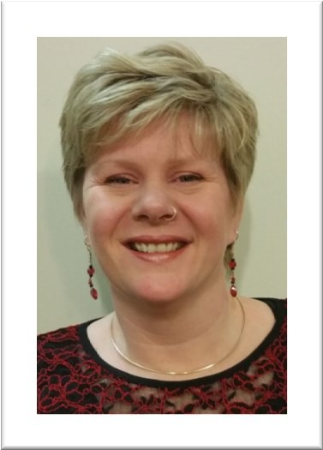PWdWA Executive Director Report
The 2014-15 year has been a time of change for People With Disabilities (WA) Inc as well as continuing change for the disability sector. We have had new staff and a number of systemic projects as well as an exciting peer support project that have started this year.
I took on the role of Executive Director in mid November 2014. I would like to thank Andrew Jefferson, the previous Executive Director for his commitment to PWdWA and his passion to see this organisation put into practice the values that it stands
for. I would also like to thank Carmen Pratts-Hincks, the Senior Advocate, who took on the added responsibility of Executive Director after Andrew's resignation and ensured that the organisation was ready for me to have a smooth start in November. The staff and the Committee of Management have made me welcome and supported me to ensure that PWdWA is doing the best job that it can in representing people with disability and providing high-quality advocacy services.
In 2014 our previous strategic plan ended and so with a new Executive Director, the timing was perfect for developing a new strategic plan. Our strategic plan for 2015 to 2018 was developed with the assistance of Jackie Softly Consulting who also mentored Ryan Gay, one of our Committee of Management members, on the process of consultation and development of strategic planning. Ryan and Jackie engaged our members, committee of Management, staff, and other stakeholders to gather information on what direction we should be taking over the next 3 to 5 years. Our new strategic plan has a much stronger focus on human rights and citizenship for people with disability. Our new strategic objectives confirm our core business of being an advocacy organisation providing individual and systemic advocacy services, as well as being a representative organisation and peak body for people with disabilities here in Western Australia. I would encourage our members and stakeholders to look at our new strategic plan.
PWdWA has been vigorous in its advocacy at both the individual and systemic levels this year. This report highlights the type of issues our advocates work with people on, and provides examples to show the outcomes advocacy can achieve. This year we have also empowered people with disability from our individual advocacy to speak and share their experiences at Senate Inquiries and the inquiry by the Joint Parliamentary Standing Committee on the NDIS. Our individual advocacy is very important to informing the submissions we make and the systemic advocacy issues we undertake.
At an organisational level our individual advocates have had a chance to review procedures and raise practice issues through supervision and in staff meetings to ensure a continuous improvement of our advocacy practice. Our audit of services against the National Standards for Disability Services highlighted the great job of

Annual Report 2014 – 2015
Page 7

our individual advocates. I would like to take this opportunity to thank the team of advocates, both our permanent and casual staff, and the Senior Advocate for their understanding and value of our empowerment based model of advocacy, and their resilience and hard work. They are a great team.
At the systemic level we work in a number of different ways. It is often a matter of prioritising what issues we are working on proactively and what we are responding to from others. This year there were a number of important discussion papers and inquiries that it was important we responded to, which meant our proactive work was limited. However, I am proud to say that our strategic move to do the WA Disability Abuse Inquiry at the beginning of 2015 both informed submissions to the NDIS safeguarding discussion and Senate Inquiry into abuse and neglect, as well as provided us with a platform to proactively discuss those issues with service providers, HADSCO, DSC and others. This project and its recommendations will continue as many of the system changes and education required will take time.
Writing submissions in response to government papers on policy proposals does take up a large part of our systemic advocacy time. With uncertainty about advocacy funding it is of concern that the coordinated voice of people with disability that can draw on the experiences of those most vulnerable will be lost if systemic advocacy funding is reduced. Our report on systemic advocacy highlights the many submissions we have made as well as other systemic issues we have proactively pursued. I would like to take this opportunity to thank our systemic team for their hard work, and the consultants we have engaged to support our work. We are very lucky to have passionate advocates with the skills and experience to undertake this work.
An important theme that has come through our systemic advocacy work this year is the need for independent formal individual advocacy. In the Senate Inquiry into the Adequacy of Existing Residential Care Arrangements Available for Young People with Severe Physical, Mental or Intellectual Disability in Australia the need for individual advocacy was highlighted by many submissions, as it was with the Senate Inquiry on Abuse and Neglect of People with Disability. The importance of individual advocacy was also highlighted in the National Safeguarding Framework consultation.
We have also done a lot of work in collaboration this year as can be seen in our systemic and project reports. The WA Disability Abuse Inquiry was done in collaboration with Developmental Disability WA as were a number of submissions and work in the education issues space. We worked with National Disability Services and Headwest on the No Fault Third Party Insurance Campaign. We have built a strong relationship with Consumers of Mental Health WA and are working with them on the “Releasing Our Capacity” Project. We have also developed MOU’s with a number of agencies to maintain a strong advocacy sector and help achieve sustainability for advocacy and peers support groups. Thank you to the staff and Boards of the agencies we have worked with, it is

Annual Report 2014 – 2015
Page 8

important to know we are working together to ensure that people with disability are empowered and active citizens.
Apart from our core funding for individual and systemic advocacy from DSC and DSS, we have also had project funding for work in specific areas. When applying for project funding it is always consistent with our strategic direction. These projects are detailed further in the report and include support for leadership and peer support by and for people with disabilities, and bringing the voice and experience of people with disability into research.
There is also an element of our work which is unfunded. Our role as the peak body representing people with disability means we are often sought out by government and other bodies to be involved with advisory groups or make comments on policy. Although this often crosses over into systemic advocacy work it is not considered as advocacy by our funding bodies, but rather representational work. This representational work is extremely important in ensuring the voice of people with disability is heard at the policy and decision making levels. We also work to support people with disability to be leaders through support and encouragement of leadership groups, programs and mentoring as well as peer groups. Where possible it is the leaders from these groups and the Committee of Management that do the representational work and ensure it is people with disability who are speaking and being heard.
As previously mentioned the future funding of advocacy is uncertain and part of the 2015 year has been spent strengthening our partnership with advocacy organisations and working on our future funding opportunities. We have put in a consortium bid for the DSC Individual Advocacy Tender with Advocacy South West and Sussex St Community Law Service. I am confident this will be successful and we will continue to provide advocacy from DSC funding after December 2015.
Finally I would like to thank our Committee of Management. We are a unique organisation to have a Committee of Management with 100% people with disability, and the work they put in to keep our organisation focused and centred on the voice of people with disability is crucial. Putting into practice our values has seen an increase in the employment of people with disability and family members of people with disability this year up to over 75% of our staff.
It has been a busy but fulfilling year here at PWdWA and the future holds possibilities for us to provide more advocacy and continue advocating for the rights and empowering the voices of people with disability in WA. I hope our members, partners, stakeholders and supporters will continue to value PWdWA and the role we play as we value their support and input.
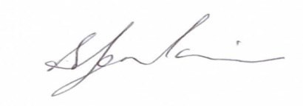
Samantha Jenkinson
Annual Report 2014 – 2015
Page 9

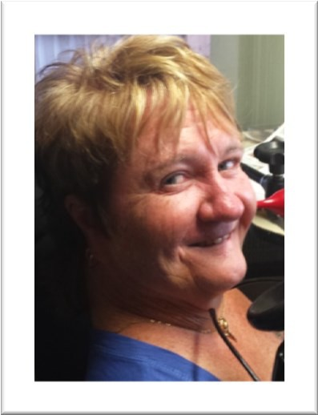Treasurers Report
In the 2014 - 2015 financial year, PWdWA operated within its budget and fulfilled the contractual requirements of service level agreements with our core funding agencies, the West Australian Disability Services Commission, and the Department of Social Services.
PWdWA received funding from the Department of Social Services to assist with the cost of our Audit and supplementation to fulfil obligations to our staff employed under the SACs award scheme.
PWdWA was the grateful recipient of additional non recurrent funds from Disability Service Commission in the final quarter of the 2013 – 2014 financial year. These funds are slowly being used to assist with the sustainability of our organisation.
PWdWA has received one off grant funding for small projects, but was also successful in securing a two year project grant from the National Disability Insurance Agency in December 2014.
The Committee of Management has remained active in overseeing the financial operation of the association. The audited accounts demonstrate that the organisation remains financially stable.
The Committee of Management and operational staff would like to express thanks to Nulsen Independent Administration who have supported us with payroll and Patricia Loh Accounting who have assisted with our financial management throughout the year. We would also like to take this opportunity to thank Debra Sommerfeld, PWdWA Administration Assistant who keeps everything organised.

Monica McGhie

Annual Report 2014 – 2015
Page 10

Membership
This year the Committee of Management has focused on membership, with a recognition that although we work with hundreds of people with disability in our advocacy, our membership base needs to improve. A big change in our membership application process is that all individual memberships are now free. There is also a strong emphasis on people with disabilities being full members to reflect that PWdWA is a consumer based organisation and to encourage more individuals with disability to join the organisation.

2015
12 Life Members
122 Individuals
5 Organisations
139 members

The membership is increasing slowly. With targeted advertising and brand awareness we will see the membership increase steadily.
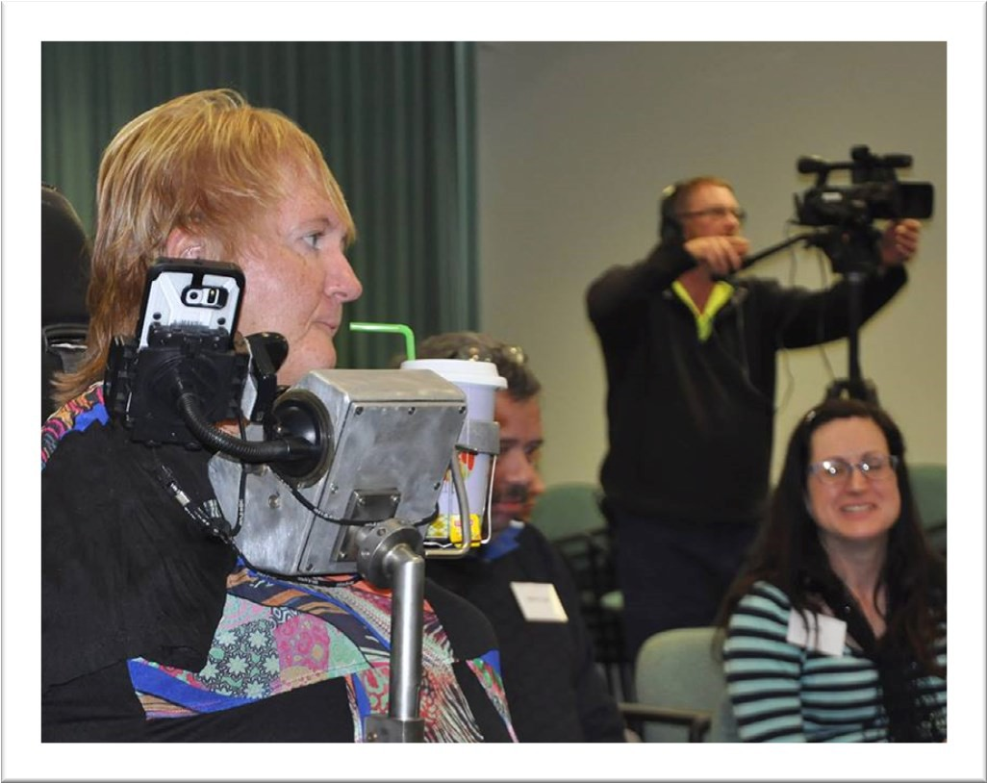
Monica McGhie and Lisa Burnette at a peer forum

Annual Report 2014 – 2015
Page 11

Individual Advocacy

Our individual advocacy staff for 2014 - 2015 included Carmen Pratts- Hincks as Senior Advocate, and Carol Franklin, Lisa Hook, Christina Wright, Natalie Turner, Judy Russell, Gio Terni, Rachael Cox, Bronwyn Lines, Nicole Wooldridge and Stacey Sheridan as Individual Advocates.
PWdWA’s Individual Advocacy team provides free, independent, issue based and confidential non-legal advocacy for people with disabilities living in Western Australia. PWdWA focus on advocating alongside people with disabilities who are most vulnerable or at risk, with an empowerment based model of advocacy.
Working with people with disabilities to achieve positive outcomes is the priority of PWdWA. Advocates research relevant and up-to-date information so people make their own informed decisions. Information is provided to individuals, family members and others that want to know more about the services that PWdWA and other agencies in the community can offer. Information is made available by phone, face to face, email and social media. Information and supported referrals are provided to around 300 people each year on top of our complex advocacy.
With each issue, advocates work closely with the person to develop an individualised action plan which outlines the roles and responsibilities of all stakeholders involved and actions to be followed. As part of their role, individual advocates communicate with relevant stakeholders and attend meetings. They also do pre-meeting preparation and ensure agreements are reached. With the support of their individual advocate, the person with a disability learns about their rights, services that are available to them, and develops self-advocacy strategies they can use in the future.
In 2014-2015 PWdWA provided Individual Advocacy with funding from the Disability Services Commission (DSC) and the Department of Social Services (DSS). The funding allowed us to work on a broad range of issues that are faced by people with disabilities in Western Australia.

Individual Advocacy funded by DSC
PWdWA advocated with 177 individuals across Western Australia most of them being complex issues. The areas of major concern were complaints in regards to service provision (individuals raising concerns to disability service providers), discrimination or rights (non-legal advocacy at the Equal Opportunities Commission, Human Rights Commission and work with the Disability Discrimination Unit) and housing or accommodation (link people with tenant advocates). Most of the people that received our services had a physical, neurological or psychiatric disability.
Individual Advocates work with people with disability to ensure that they are able to raise their concerns to their service providers without fear of retribution and
Annual Report 2014 – 2015
Page 12

reach outcomes that meet their expectations and improve the quality of services received.
An example of our advocacy work in partnership can be seen where in collaboration with the Health Consumers’ Council one of our advocates travelled to Broome to meet with people with disabilities and their families to discuss their issues and look at ways to advocate together in order to achieve their goals. The work was continued from Perth via teleconferences, emails and ongoing communication.

Case Study

Jane is a vulnerable woman with no family or friends support. She has a high-level physical disability and is non-verbal with limited literacy skills. She has been living in a group home since her mother died. The situation with the service provider was at crisis point due to communication breakdowns between Jane and the service provider. Jane was at risk of ending up in a nursing home at a young age. She wanted to move out of the group home, where she felt she had no choice and control and was very unhappy. Her goal was to live independently in the community and be able to choose support workers and a service provider that will encourage her to achieve her goals and aspirations. Over a number of meetings, an action plan was developed to reflect this goal. PWdWA Individual Advocate supported Jane to get in contact with service providers that support people living in the community to find out which one could assist her to live the life the she aspired. The Advocate set up meetings, found information and supported Jane with working out the questions she wanted to ask and identifying the issues she would need to work through to achieve her goa. PWdWA advocated alongside Jane through the transition process from the group home into the community, worked in collaboration with her and her new service provider to apply for additional Combined Application Process funding (CAP), and to develop person-centred plans. The result was that by working with the Advocate, Jane was able to reach her goal of living and participating in her community. Jane was able to decide how this happened and was the one making decisions. Her goals and choices were validated.

Annual Report 2014 – 2015
Page 13

Specific Learning/ ADD
1%
Developmental Delay
0%
Physical 23%
Autism 9%
ABI 6%
Sensory or Speech 3%
Neurological 20%
Intellectual 19%
Psychiatric 19%
DSC: DISABILITY TYPE

Advocacy issue DSC | Number
Abuse/Neglect | 5
Accommodation/Housing | 27
Discrimination/Rights | 18
Education | 11
Employment | 14
Equipment/Aids | 6
Finances | 13
Health | 8
Legal | 12
Physical Access | 5
Recreation/Social or Family | 8
Services | 56
Transport | 2
Vulnerable/Isolated | 4
NDIS | 4
My Way | 1
Funding | 11
Eligibility | 4
Annual Report 2014 – 2015
Page 14

Independent Living Support | 13
Subsidies and entitlements | 12
Universal Access | 1
Utilities | 1

DSC Client Transition Independent Advocate Project
PWdWA was contracted to ensure that independent advocacy was available to raise concerns about issues that could be affecting residents during the handover period of the transition from DSC accommodation services to alternative service providers. As part of this project, experienced Individual Advocates attended meetings at houses that were commencing the handover to explain their role to staff and residents. PWdWA was available to ensure residents, families and staff had an additional, structured pathway to raise their concerns. Once concerns were raised PWdWA communicated with relevant stakeholders to advocate for a positive outcome for the resident.

Individual Advocacy State-Wide funded by the DSS
The Individual Advocacy Team provided advocacy to 123 people with disabilities with DSS funding. The main issues faced by people with disabilities requiring Individual Advocacy were regarding service provision (individuals raising concerns to disability service providers), education (advocacy at schools in regards inclusion and reasonable adjustment) and legal (non-legal advocacy at guardianship and administration hearings). Most of the people accessing this service have an intellectual disability, autism or a Neurological disability.
Examples of our advocacy in practice were PWdWA advocates being alongside individuals at the State Administrative Tribunal to ensure that their voices were heard at hearings for administration and guardianship orders. Also many families of children with disabilities, mainly autism, requested our services at school meetings. As part of this process, Individual Advocates researched relevant policies, provided information and worked with people to prepare for meetings.

Annual Report 2014 – 2015
Page 15

Developmental Delay
1%
ABI 3%
Specific
Learning/ ADD Sensory or 1% Speech
2%
Autism 24%
Physical 17%
DSS STATEWIDE: DISABILITY TYPE
Psychiatric 12%

Intellectual 25%

Neurological 15%

Advocacy Issue DSS Statewide | Number
Abuse/Neglect | 3
Accommodation/Housing | 15
Discrimination/Rights | 6
Education | 17
Employment | 12
Finances | 5
Health | 8
Legal | 16
Recreation/Social or Family | 1
Services | 34
Transport | 3
Vulnerable/Isolated | 2
NDIS | 3
My Way | 2
Funding | 8
Independent Living Support | 4
Subsidies and entitlements | 1

Annual Report 2014 – 2015
Page 16

Individual Advocacy Peel funded by the DSS
In 2014-2015 PWdWA Individual Advocate in Peel provided advocacy to 48 individuals. Service provision and education still continues to be a priority in the Peel region followed by housing and accommodation issues.
To ensure that people with disabilities and their families are aware of our service PWdWA visited and provided pamphlets and contact details to community centres in the Peel region. We also attended the event Fun on the Foreshore and the parents’ drop-in morning at the Parents Place to talk with members of the public about our advocacy services.
Individual Advocacy Peel has received a large portion of their referrals from other tenants from The Parents Place asking for advocacy and information for their own clients. We are also receiving referrals through information given to members of the local community.
An example of PWdWA Individual Advocate from Peel in practice was when she attended an education disciplinary advisory panel to expel a student with disability from a public school. As a result of the collaborative work between the family and our Peel Advocate the student was not expelled.

DSS PEEL: DISABILITY TYPE
Psychiatric 6%
Neurological
11%
Intellectual 25%
Physical 13%
Developmental Delay
4%
Sensory or Speech 6%
Autism 31%
ABI 4%

Annual Report 2014 – 2015
Page 17

Advocacy issue DSS Peel | Number
Accommodation/Housing | 9
Discrimination/Rights | 1
Education | 14
Finances | 4
Health | 1
Legal | 2
Recreation/Social or Family | 1
Services | 19
Transport | 3
Funding | 4
Eligibility | 4
Independent Living Support | 1
Subsidies and entitlements | 1

Case Study

Peter had a job he enjoyed but there were problems with how he was being treated by his employer. Peter has an intellectual disability and did have some support from an employment service. He was sacked from his job after the employer had a number of confrontations with him and his employment service about training and wage subsidies. Peter called the PWdWA office looking for services to help with the legal support to make an unfair dismissal claim. An action plan was developed with Peter to detail his issue and the actions needed. It was decided that the Advocate would research possible agencies that could assist and Peter would contact the agencies provided with support from his employment service if needed. The Advocate completed research into the specific legal service to assist. The Advocate called several legal services before she could find one with the right expertise and capacity. The Advocate contacted the legal service to ensure that they had the capacity to take on Peter’s specific issue. Peter contacted the legal service who also let the Advocate know that contact had been made and they were working on the case. The result was that Peter was able to make decisions and exercise control over which services could assist with his legal matter and was supported to connect with that service.

Annual Report 2014 – 2015
Page 18

DSS Audit Surveillance
PWdWA Individual Advocacy services in Nedlands and Mandurah were audited in May 2015 against the National Standards for Disability Services. According to the assessment report, clients interviewed reported that their Individual Advocate treated them in a friendly manner and were non-judgemental. Clients also mentioned that any actions, letters, phone calls by PWdWA on their behalf were all agreed prior to any action being taken. The communication was noted to be open, honest and within relevant and realistic timeframes. Finally, interviews with clients and review of documentation identified that PWdWA Individual Advocacy Team is committed to supporting and assisting clients to achieve their desired outcome without unnecessary restrictions.
All examples and case studies have been de-identified.
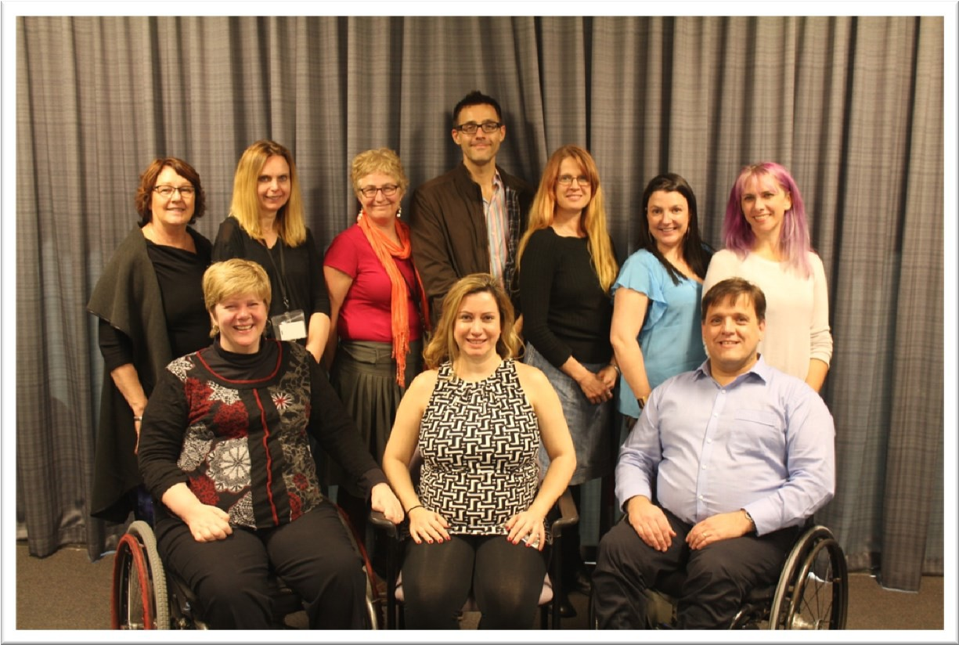
PWdWA Staff

Back Row: Debra Sommerfeld, Faye Hicks, Lisa Hook, Gio Terni, Rachael Cox, Bronwyn Lines, Peta Green
Front Row: Samantha Jenkinson, Carmen Pratts-Hincks, Stuart Jenkinson Absent: Judy Russell, Christina Wright, Natalie Turner, Carol Franklin

Annual Report 2014 – 2015
Page 19

Information, Communication and social media
PWdWA has continued to provide information and engage with members and the wider community through its website, eNews, Facebook and Twitter. The Website has recently been updated with various changes throughout the site to make it easier to find information. The most notable being changes to the About Us page to enable the general public to be able to find information about the organisation faster and easier. The Submissions page under Publications has been updated with all the latest submissions completed by the Systemic Advocacy team. The membership page has also been updated with an online membership application process.
The PWdWA Facebook page has more than doubled its reach meaning that more people are hearing about the services provided by the Individual Advocacy and Systemic Advocacy teams at PWdWA. Over 1000 people can potentially receive information and engage with us through Facebook and this is increasing weekly. Referrals, comments and information we can share often come through our Facebook page and it is an effective way of spreading information to key members and groups quickly. A number of the peer support groups we support also have Facebook pages which provide further means of communicating broadly to people with disability.

Self Advocacy WA (SAWA)
SAWA continue to meet monthly in order to share information, experiences, discuss current disability issues and learn new skills. All members participate in the meetings and each person’s input is respected. Membership has increased this year. Over the past year SAWA members have invited several guest speakers to work on enhancing their skills and discuss opportunities in the community. They had two public speaking workshops, a CPR training day and Curtin University representatives talked about their Pedestrian Safety in Share Traffic Zones Project which some SAWA members decided to participate in. SAWA has also taken part in the Disability Support Organisation Capacity Building Project from NDIS.
SAWA still have their information shared on the PWdWA website. Members decided on the information they wanted included on the website. To view this information, please go to: www.pwdwa.org . Finally, SAWA continue to meet for their annual breakfast in July and December. SAWA is funded by the Disability Services Commission.

Annual Report 2014 – 2015
Page 20

Projects

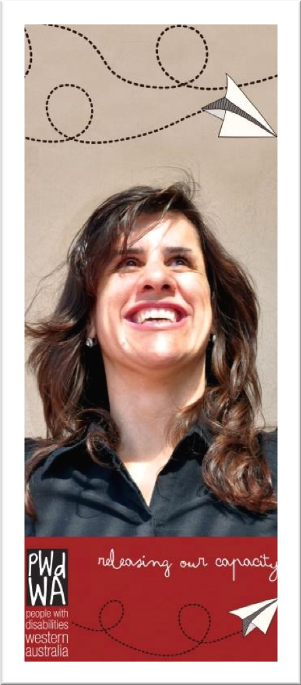
Releasing our Capacity – National Disability Insurance Agency Disability Support Organisation Project
In late 2014, People With disabilities WA were successful in receiving funding from the National Disability Insurance Agency to act as a Disability Support Organisation (non provider). PWdWA is currently working with people with disability to support 20 local support (peer support) groups to make the most of the opportunities presented by the NDIS and engage effectively with the scheme.
The support groups will provide information, resources and build community networks between participants and with others. The project is funded for two years and in the first year PWdWA will fund 10 peer support groups run for and by people with disability to carry out this work. In November, a 'showcase' event will be held where the first groups profile some of their activities.
Consumers of Mental Health WA (CoMHWA) is partnering with PWdWA to fund four groups for consumers with psychosocial disability. The two other organisations funded in WA to support peer support groups are Down Syndrome WA and Developmental Disability WA. We are working closely with both groups to ensure family members have access to peer support groups while our focus is on groups by and for people with disability.
As part of the project, a website – www.releasingourcapacity.com - was developed as an information channel for people with disability living in WA. Events and information are being disseminated through the website and a series of dedicated Facebook groups. The groups who are being supported in the first year are: First Peoples' Disability Advocacy Network WA, Youth Disability Advocacy Network, Blind Citizens' WA, Self Advocacy and Peer Support WA, Amputees WA, Spinal Injuries Chatter, Women with Disabilities WA, Self Advocacy WA and an online group for people with disability who also identify as LGBTIQ. Four Community Hub Leaders have been employed within the project to identify and connect participants - they are Douglas Milne, Zel Iscel, Jo Russell and Eamon Guilfoile. As part of building resources and sustainability into the future for the groups we have an MOU with Connect Groups to share resources.

Annual Report 2014 – 2015
Page 21

Thank you to Samantha Connor, our project officer, and Danielle Lobo at CoMHWA for their hard work on this project.

Family Leadership Project
In 2014, Diverse Leadership Inc (DLI) received a grant through DDWA under the DSC Family Leadership Funding round. People with Disability WA (PWdWA) auspiced the grant for DLI, and E-QUAL took on management of the project. The aim of the project was to develop a group of presenters, with lived experience of disability, and seek opportunities for the speakers to present their stories to parents of young adults with disability. Five speakers were selected who underwent training in public speaking skills. Nine speaking sessions were organised with speakers presenting in total to over 160 families and staff. Feedback from the project showed it was very successful. Thanks to Diverse Leadership Inc and E-QUAL for running a successful project.

Australian Housing Urban Research Institute Project - Accommodating NDIS: maximising housing choice in a reformed disability sector
PWdWA was approached in 2013 to be a partner organisation with People With Disability Australia, the University of New South Wales and RMIT in an application to the Australian Housing Urban Research Institute (AHURI) to do research on housing and successful community living options foe people with individualised funding. The application was successful and in 2014 PWdWA engaged Samantha Jenkinson to do the WA research and participate in the project on behalf of PWdWA. In the project the researchers analysed ABS data and interviewed staff of disability and housing agencies. They also interviewed people with disabilities—most with individualised funding packages—who moved, or planned to live more independently in the community. Interviews were conducted in New South Wales, Victoria and Western Australia, with PWdWA doing all of the WA interviews.
The study highlights the benefits of choice and flexibility in funding, but also recognises that strategies in the NDIS will also need to integrate sufficient advocacy, information and tenancy management assistance to prepare and support people into new living arrangements. Separate program funding to build capacity in formal and informal support networks will also be required. The report was published in August 2015 and is available here http://www.ahuri.edu.au/publications/projects/p71040

Annual Report 2014 – 2015
Page 22

Systemic advocacy

Our project staff include Faye Hicks and Stuart Jenkinson who have focused on systemic advocacy issues.

Transport and Taxis
In August 2014 PWdWA supported the Self Advocacy and Peer Support group (SAPS) to hold a forum titled “Taking Back Transport”. The forum was an opportunity for people with a disability to share their experiences and challenges in using transport services in Western Australia. Attendees also had the opportunity to understand their rights and responsibilities as a service user and how to make a complaint about a transport service. In the lead up to the forum a survey was designed by members of the Self Advocacy and Peer Support Group with the aim of identifying areas of concern relating to public transport in Western Australia for people living with disabilities. Survey respondents identified issues relating to buses, trains, taxis, ferries and planes as areas of concern. The results of the survey along with issues raised at the forum formed the basis of a report produced by members of the Self Advocacy and Peer Support Group. PWdWA presented the findings of the report at a meeting with representatives of the Department of Transport and discussions are ongoing about addressing the concerns of people with a disability. Thank you to the SAPS members in particular Lisa Burnette, Jordan Steele-John and Monica McGhie.
There have been ongoing issues for people with disability accessing trains and train stations across Perth. The two main reasons are lifts and escalators being out of service due to mechanical breakdown as well as upgrading the infrastructure. The impact of being unable to access trains and stations on people with a disability is significant and PWdWA has sought to address these issues through direct representation to the Public Transport Authority, voicing our concerns to members of Parliament as well engaging mainstream media to highlight the problem to the broader population. Effective use of social media has also allowed PWdWA to inform people with disability of the issues and gain feedback on the impact these outages have on people’s ability to go about their daily lives. As part of our submission to the Review of the Access to Premises Standards PWdWA strongly advocated for access to public transport facilities to be enhanced by having multiple lifts that run independently, independent ramp access that’s adheres to the Access Standards as well as escalators.
The Public Transport Authority has ceased or altered some suburban bus routes which has negatively impacted on people with disabilities ability to safely access the community. PWdWA has raised these issues directly with the Public Transport Authority as well as contacting Members of Parliament who have in turn asked questions in Parliament of the Minister for Transport. PWdWA continues to monitor the impact of bus route changes on people with disability and their ability to interact independently with their local communities.
Annual Report 2014 – 2015
Page 23

People with disability are often reliant on taxis as their only mode of transport. In particular Multi-Purpose Taxis (MPT’s) are a crucial transport option for many people with a disability. PWdWA regularly hears from people with a disability as well as drivers of MPT’s that the current system of two booking services for MPT’s does not work efficiently. PWdWA was very pleased to see the issue of a “single desk” ‘MPT booking system highlighted in the recently released “On- demand Transport - A discussion paper for future innovation”.

Abuse and neglect
In early 2015, PWdWA partnered with Developmental Disability WA to carry out a systemic advocacy project around violence, abuse and neglect against people with disability. The project ran over 25 weeks, employed three people with disability and interviewed fifty one participants to find out what happened when people with disability in WA are abused or neglected. Engaging with a wide range of stakeholders, including the Disability Services Commission, National Disability Services (NDS) and the Health and Disability Services Complaints Office (HaDSCo), the final report 'Behind Closed Doors' directly informed a number of responses to abuse, including the Senate Inquiry into violence, abuse and neglect against people with disability in institutionalised settings, the serious incident reporting scheme in WA and the Safer Services collaboration between NDS and Curtin University.
As a part of the project PWdWA developed resources on identifying and raising awareness of abuse and neglect that were sent to all funded service providers as part of ‘Disability Safe Week”.
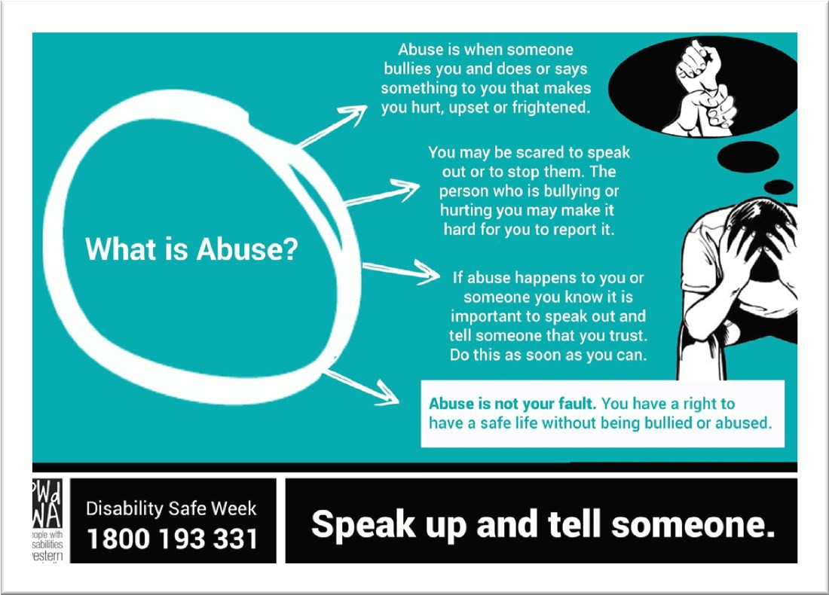
Annual Report 2014 – 2015
Page 24

The project was also supported by union United Voice and a number of information sessions and events were held, including a handover of the report to Senator Linda Reynolds and forum with Senator Rachel Siewert and former Disability Discrimination Commissioner Graeme Innes. Upon the release of the report, HaDSCO issued a press release which underlined the importance of this work as a means to open up discussions about safeguarding standards across the disability sector. The final report is available on the PWdWA website.
Thank you to Samantha Connor, Amber Arazi and Ben Keely who were engaged by PWdWA and DDWA to do this project.
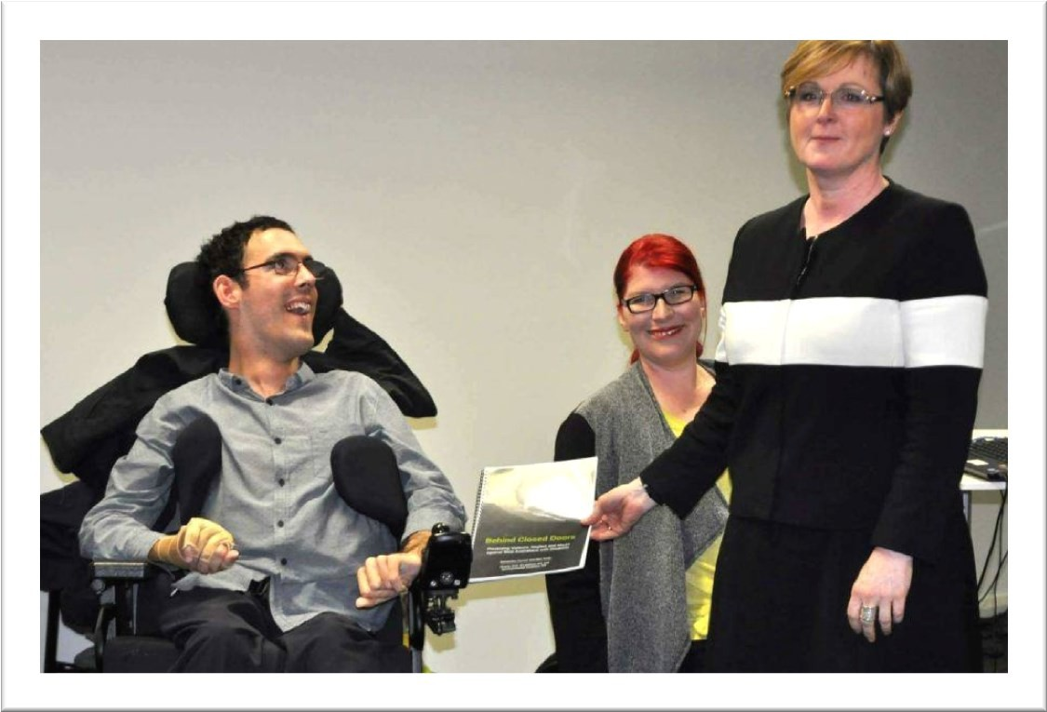
Senator Linda Reynolds accepting a copy of ‘Behind Closed Doors’ from Ben Keely and Samantha Connor

Housing
PWdWA has been part of the Housing Advisory Round Table (HART) for a considerable period of time and has used this forum to raise housing issues affecting people with disability with both the Department of Housing, the Community Housing sector and other key stakeholders. A functional review of HART was instigated by the Department of Housing earlier this year and meetings have been postponed until the outcome of the review is known. PWdWA contributed to the review and strongly advocated for the continuation of the HART or a similar forum. It is disappointing that the review is not yet complete and the future of HART remains unknown.
In the latter part of 2015 PWdWA will be commencing a project to review the existing research and publications about the housing issues affecting people with
Annual Report 2014 – 2015
Page 25

disabilities. The project aims to identify gaps that exist in actions about housing and people with disability with a view to establishing a campaign or campaigns in these areas. The project will be led by PWdWA staff and committee of management with input sought people with disability who have a strong interest in this area as well as relevant experiences.

Education
PWdWA and DDWA met in June 2015 and discussed current trends of Individual Advocacy education issues in the WA region. It was discussed that schools in WA were using restraint or restrictive practices, suspending children with disabilities, and some families were being driven to do home schooling.
Research was conducted and compiled to identify any hot spots and develop a plan of action. The data collected did not show specific ‘hot spots’ rather it highlighted the issues occurring across the broader Metropolitan area. Recommendations from this report included further advertising within education and disability networks regarding Individual advocacy, positive behaviour strategies (PBS), functional behaviour analysis, and person centred planning training for teachers and Education Assistants.

NDIS
PWdWA was invited last year to be on the reference group for NDIS May Way and the Advisory group for the NDIS Perth Hills trial site. In these positions PWdWA is a consumer representative organisation bringing the voice of lived experience to the table and feedback to the groups is provided from that perspective. Where possible other advocacy and consumer groups can raise issues to PWdWA who can tell the NDIA and DSC through these groups.
As PWdWA was providing advocacy for people with disability and families in the NDIS Perth Hills, we thought it important that the NDIA staff were aware of advocacy and the issues that were being raised. Along with EDAC, MIDLAS and other advocacy groups we arranged an advocacy catch up with key NDIS staff to occur on a regular basis. Similar meetings are being arranged with NDIS My Way.
PWdWA has also been playing a role as an independent consumer representative organisation in discussions on increasing choice of planners in the NDIA Perth Hills trial site.

Service provision and funding issues
When a number of individuals come across similar issues such as a reduction in funding or change to guidelines on who can provide services, individual advocates raise those issues with the Executive Director who contacts DSC to raise these as policy issues. This year we have had discussion on changes to non-recurrent funding for people with complex behaviour, sub-contracting
Annual Report 2014 – 2015
Page 26

arrangements and requirements where a funding application is put in by advocacy organisations. Often these issues are partly resolved through discussion or are flagging a change to policy which we can then potentially provide advice on.

Submissions
As part of PWdWA’s systemic work we provide written submissions on a variety of issues that affect people with disability. All our submissions are based on evidence from people with disability whether it is our clients or members experience. The recommendations we provide in our submissions are based on a wide consultation with people with disability. PWdWA has an extensive network to channel and receive information to ensure that submissions are grounded in ‘real’ experience and consider current and relevant research on the subject matter. Sometimes we collaborate with other consumer driven organisations to develop a combined approach to our submissions. All submissions are available on our website.

During 2014 – 15 PWdWA provided submissions on:

Submission on the Review of the Criminal Law Mentally Impaired Accused Act 1996.
Response to State Government Green paper - Options to add No-Fault Catastrophic Injury Cover to Western Australia’s Compulsory Third Party Insurance Scheme.
Australian Senate Inquiry into the Adequacy of Existing Residential Care Arrangements Available for Young People with Severe Physical, Mental or Intellectual Disability in Australia. Joint submission PWdWA and DDWA
Submission on Information, Linkages, and Capacity Building Framework for NDIS

Submission on the Proposal for a National Disability Insurance Scheme (NDIS) Quality and Safeguarding framework
Australian Senate Inquiry into Abuse and Neglect of people with disability – Report prepared “Behind closed doors - Prevention of violence, abuse and neglect against Western Australians with disabilities” in partnership with DDWA.
Review of the National Disability Advocacy Framework Response to the National Disability Employment Framework
Review of the Disability (Access to Premises – Building) Standards 2010 Review of the Disability Standards for Education June 2015

Annual Report 2014 – 2015
Page 27

Representation and participation

In 2014-15 PWdWA staff and members contributed to committees and reference groups covering a broad range of issues affecting the lives of people with disability.
These included;

- Positive Behaviour Framework Guiding Committee
- Zero Tolerance Reference group - Preventing and responding to abuse and neglect of people with disability in non-government services
- Disability Justice Centres advice provided – an alternative to prison for those deemed unfit to plead
- Supported Decision Making Project Steering Group
- Transition - Disability Services Commission Accommodation Support Directorate and independent review panel member
- NDIS WA - NDIA Perth Hills Advisory Group Hills
- NDIS WA – My Way Reference Group
- Disability Health Network
- Disability Discrimination Unit Reference Group
- Housing Advisory Roundtable
- NDS Pre-budget Submission Reference Group Meeting
- WA Peaks Forum Quarterly Meeting
- Perth Stadium Access Meetings
- EDAC Interagency Network Meetings
- 2015 Disability Support Awards Judging Panel
- Attended Women with Disability and Governance forum
- National Quality and Safeguarding framework consultation
- HADSCO community organisation meeting
- National Disability Employment Framework Forum People with Disability
- Beyond The Quad Centre Project
- Health and Older Australians, Disability and Carers Forums
- WA Housing Hub Launch
- Disability Employment Services Focus Group Meeting
- State Parliament Inquiry into Accommodation and Intensive Family Support Funding for People with Disabilities
- Joint Parliamentary Standing Committee on the NDIS hearing
- Self Advocacy, Peer Support Networks – practical and administrative support to initiatives lead by people with disability
- Liaising and facilitating meetings with First Peoples Disability Advocacy Network WA and being on the Steering Committee for organisation development
- Transport – various forums and working groups

Annual Report 2014 – 2015
Page 28

  - Meeting with Ministers, advisors and providing MP briefings
  - Disability Coalition – State funded Advocacy Orgs, Disability and Mental Health Service Provider peaks, WA Carers, Mental Health Consumer Peaks, and CASA
  - Hosted Diverse Leaders Inc. meetings and training

Community Education & Promotion
All staff contributes to our community education and promotion of advocacy in various ways. This year specific promotion was done by:
  - Presentations to Disability Service Providers
  - Presentation to Volunteer Guardians at OPA
  - Presentation to Parents Place in Mandurah
  - Presentation at West Coast TAFE for International Womens Day
  - HADSCO Advocate and Community Leader event
  - Shared booth at Disability Services Expo with DDWA & EDAC
  - Presentation at two WAIS Isolated Families Forum
  - Presentation to Granny Spiers parents and carers of children with disabilities
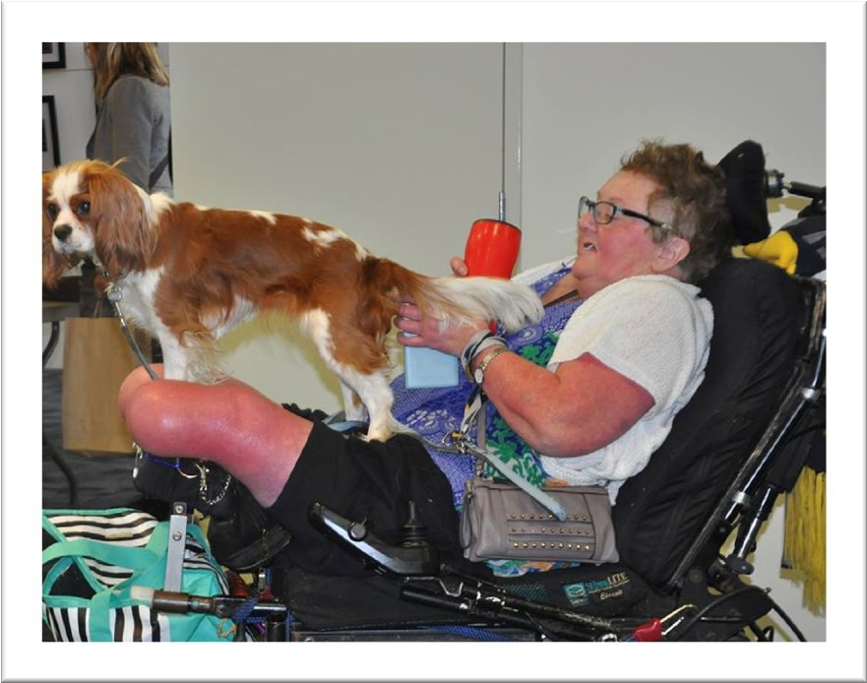
  - Presentation on panel Women with Disability and Governance

PWdWA member Trish with companion at peer forum

Annual Report 2014 – 2015
Page 29

PEOPLE WITH DISABILITIES (WA) INC

SPECIAL PURPOSE FINANCIAL STATEMENTS

FOR THE YEAR ENDED

30 June 2015

PEOPLE WITH DISABILITIES (WA) INC

FINANCIAL STATEMENTS FOR THE YEAR ENDED

30 June 2015

INDEX

- Auditor's Report

- Statement by President

- Income Statement

- Balance Sheet

- Statement of Cashflows

- Notes to and forming part of the accounts Notes 1 - 10

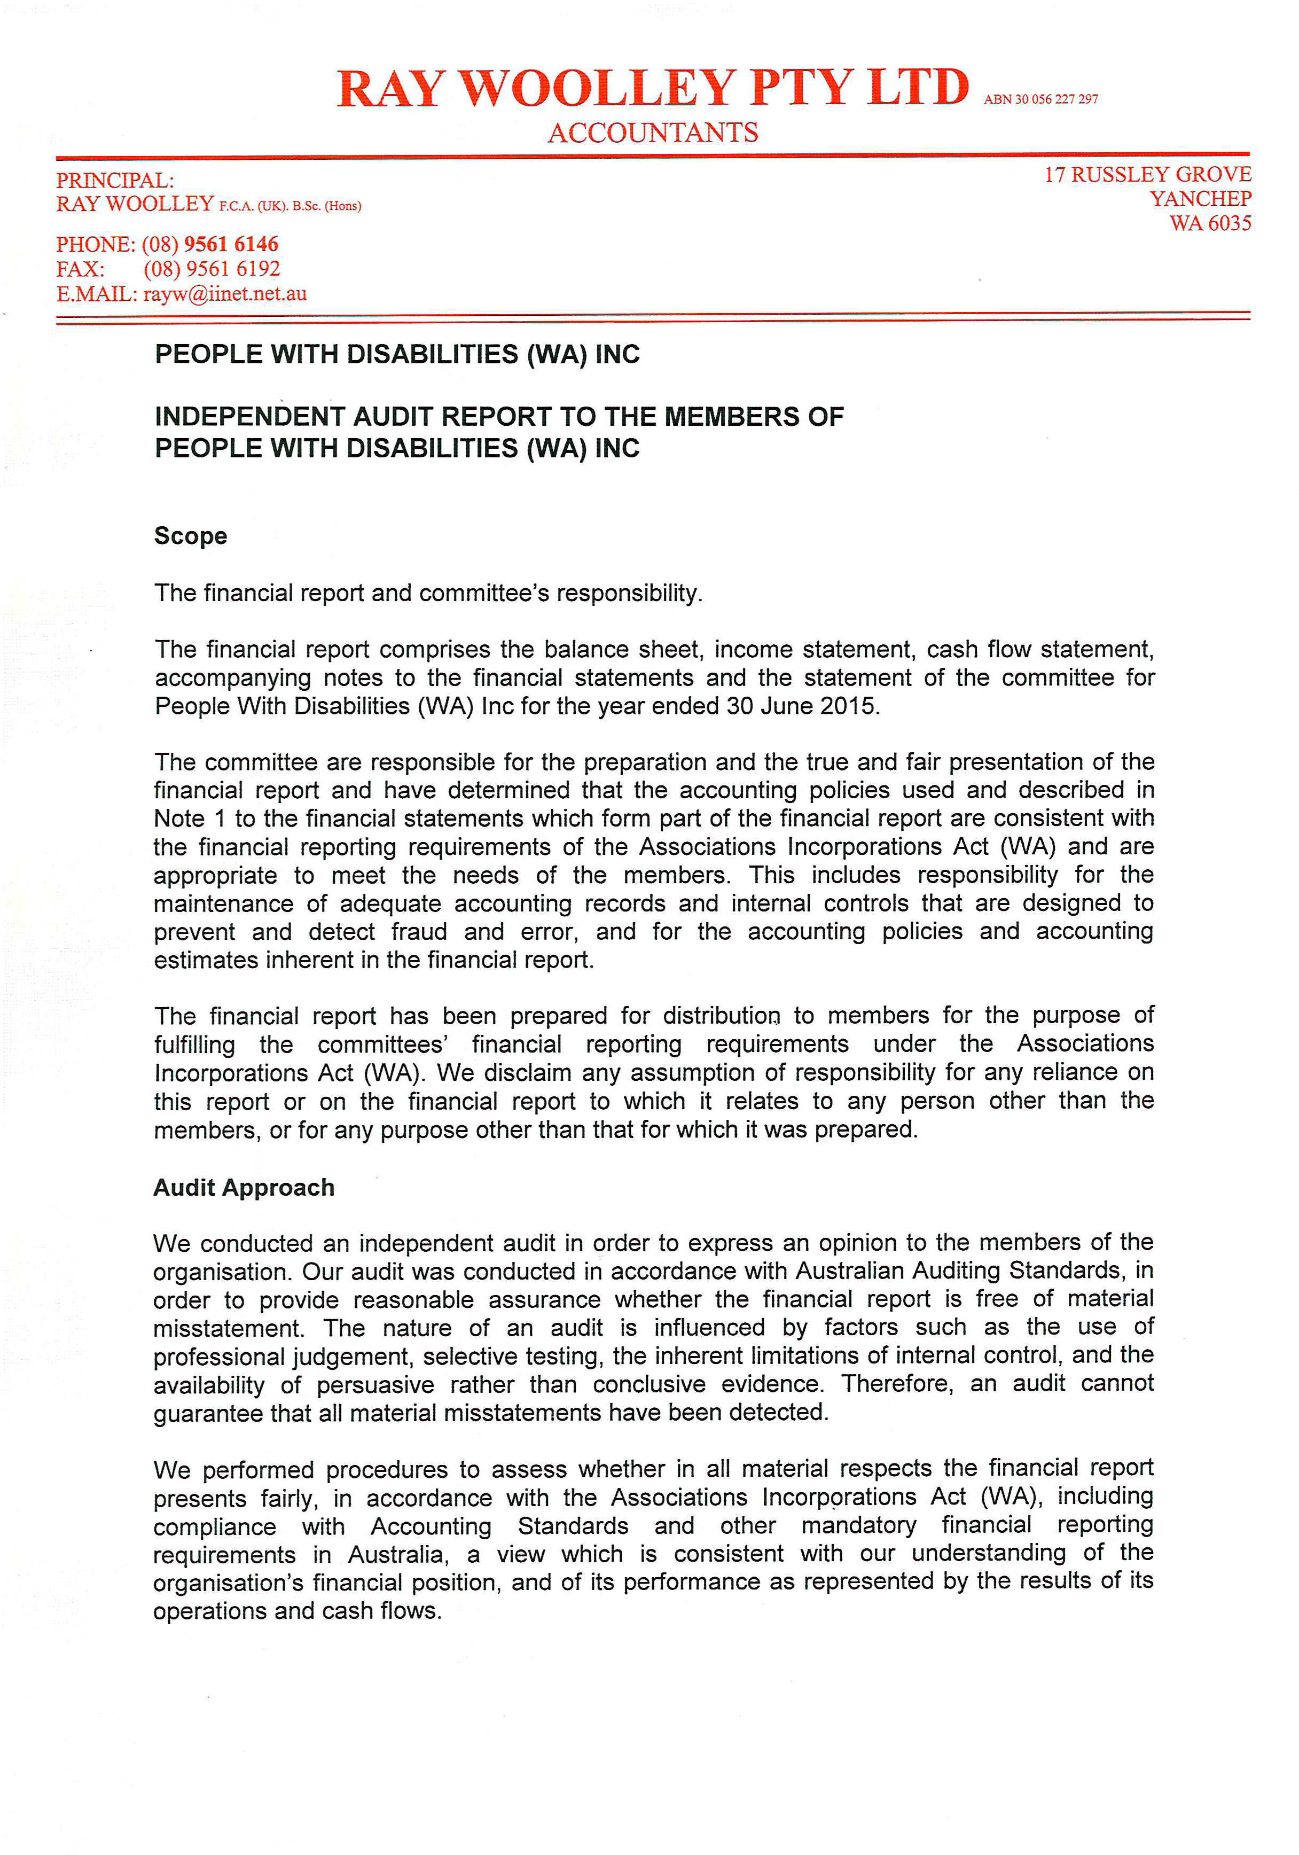

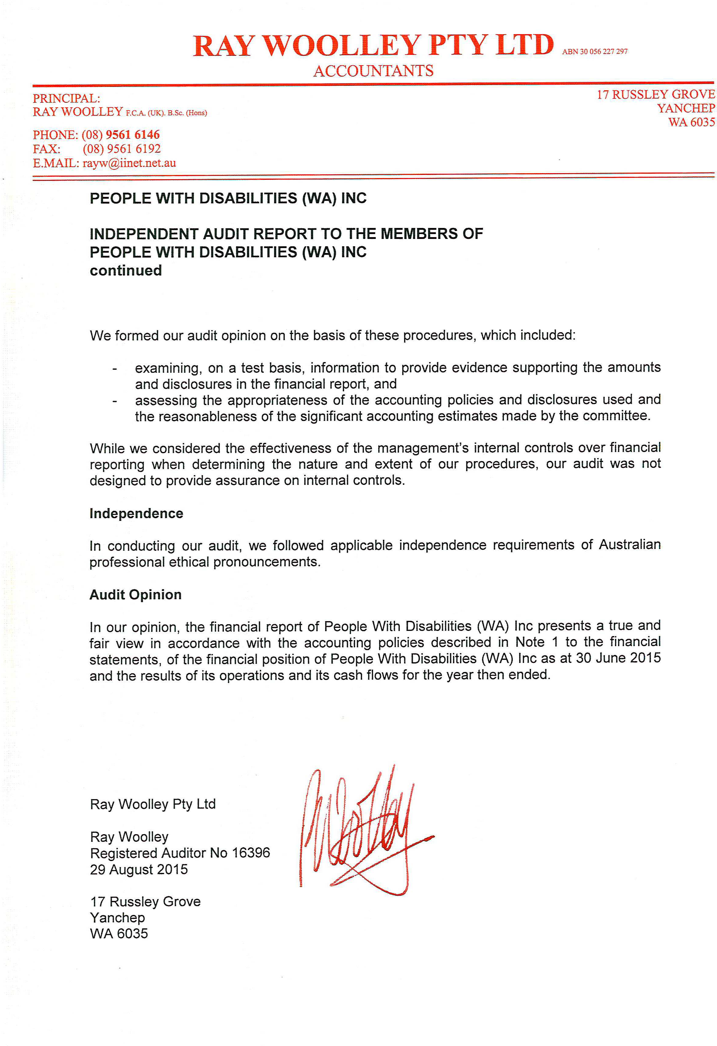

PEOPLE WITH DISABILITIES (WA) INC

STATEMENT BY PRESIDENT

For The Year Ended 30 June 2015

The Board of Management declare that:

- The attached financial statements and notes thereto comply with accounting standards

- The attached financial statements and notes thereto give a true and fair view of the financial position and performance of the association; and

- In the Board of Management's opinion, there are reasonable grounds to believe that the Association will be able to pay its debts as and when they become due and payable.

Signed on behalf of the Board of Management
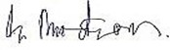

Gregory Madson President

Date: 02 September 2015

PERTH, WA

PEOPLE WITH DISABILITIES (WA) INC
Balance Sheet As at 30/06/2015

 | Note | 2015  $ |  | 2014  $
Current Assets
Cash at Bank and on Hand | 3 | 768,857 |  | 547,570
GST - Input Tax credits |  | 8,298 |  | 2,973
Debtors and Prepayments |  | 10,329 |  | 6,936
Total Current Assets |  | 787,484 |  | 557,479
Non-current Assets
Plant/Equipment |  | 76,130 |  | 76,130
Less Accumulated depreciation |  | 76,130 |  | 75,576
Motor Vehicle |  | 18,540 |  | 56,830
Less Accumulated depreciation |  | 18,540 |  | 43,099
Total Non-current Assets |  | 0 |  | 14,285
Total Assets |  | 787,484 |  | 571,764
Liabilities
Sundry Creditors and Accrued Expenses | 4 | 48,123 |  | 29,764
Income Received in Advance | 5 | 217,650 |  | 53,953
GST - collected |  | 13,087 |  | 20,197
Provisions - Annual Leave & Sick Leave | 6 | 39,397 |  | 50,540
Long Service Leave | 6 | 59,287 |  | 71,449
Motor Vehicle Replacement |  | 14,000 |  | 14,000
Total liabilities |  | 391,544 |  | 239,901

Net Assets | 395,940 |  | 331,863
Accumulated funds | 395,940 |  | 331,863

2015 2014
$ $ $ $

Inflows (Outflows)
Inflows (Outflows)

Cash flows from operating activities

Grant Income 1,043,386 837,511
Interest Received 16,640 12,604
Membership and Donations 6,468 1,913
Other Income 5,292 2,119 Payments to Suppliers and Employees (861,071) (730,549)

Net cash provided by/(used in) operating activities 210,715 123,598 Cash flows from investing activities
Non-operating income/loss 0 0
Proceeds from sale of property, plant and equipment 10,572 0
Payment for property, plant and equipment 0 0

Net cash provided by/(used in) or from investing activities 10,572 0 Net increase/decrease in cash held 221,287 123,597
Cash at beginning of the financial year 547,570 423,972

Cash at the end of the financial year 768,857 547,570

- Reconciliation of Cash 2015 2014
$ $
For the purposes of the statement of cash flows, cash includes cash on hand and in banks and investments in money market instruments, net of outstanding bank overdrafts. Cash at the end of the financial year as shown in the statement of cash flows is reconciled to the related items in the balance sheet as follows:

Cash 368,765 410,479
Deposits at Call 400,091 137,091
768,857 547,570

- Financing Facilities  No facilities are in place as at 30 June 2015  - Reconciliation of net cash provided by operating | 2015 | 2014
activities to operating surplus. | $ | $
Operating surplus/(deficit) | 64,077 | 45,217
Profit/Loss on disposal of non-current assets | (2,097) | 0
Depreciation and amortisation of non-current assets | 1,617 | 7,030
Non operating income  Changes in net assets and liabilities Decrease/(Increase ) in current receivables | (8,718) | 0  (4,831)
Increase / (decrease) in current creditors | 11,250 | 21,344
Increase/ (decrease) in current provisions | (23,303) | 13,702
Increase /(decrease) in income in advance | 163,697 | 41,136
(Increase )/decrease in Fixed assets 14,766 0
Net Cash provided by/(used in) operating activities 221,287 123,598

PEOPLE WITH DISABILITIES (WA) INC

Income Statement
For the financial year ended 30/06/2015

 | Notes | 2015  $ |  | 2014  $
Revenue from Ordinary Activities
Grants
- Disability Services Commission |  | 525,182 |  | 516,682
- Department of Social Services |  | 274,585 |  | 262,176
- Other Grants |  | 79,923 |  | 17,517
Interest |  | 16,640 |  | 12,604
Donations & fundraising |  | 6,450 |  | 1,605
Membership |  | 18 |  | 308
Sundry Income |  | 5,292 |  | 2,119
Total Revenue from Ordinary Activities |  | 908,090 |  | 813,011
Expenses from Ordinary Activities
Accounting and Audit fees |  | 16,979 |  | 13,056
Advertising and recruitment |  | 6,232 |  | 76
AGM and General Meeting costs |  | 4,401 |  | 1,802
Depreciation |  | 1,617 |  | 7,030
Equipment Expenses |  | 6,978 |  | 1,738
Insurances - General & Motor Vehicle |  | 6,296 |  | 7,172
I.T. Expenses |  | 12,851 |  | 15,692
Postage |  | 629 |  | 483
Printing and Stationery |  | 11,571 |  | 7,557
Rent |  | 26,854 |  | 24,119
Repairs and Maintenance |  | 3,092 |  | 1,797
Salary and wages costs |  | 598,579 |  | 588,842
Subscriptions |  | 4,733 |  | 3,813
Telephones |  | 11,184 |  | 11,961
Transport Costs |  | 8,748 |  | 31,656
Workshops/consultants |  | 83,996 |  | 21,706
Other Expenses |  | 37,178 |  | 29,295
Total Expenses from Ordinary Activities |  | 841,916 |  | 767,794
Operating surplus/(deficit) |  | 66,174 |  | 45,217
Non-Operating Expenses
Profit/ Loss on Sale of Assets | 7 | (2,097) |  | 0
Total surplus/(deficit) |  | 64,077 |  | 45,217

PEOPLE WITH DISABILITIES (WA) INC

Notes to and Forming Part of the Accounts For the year ended 30/06/2015

1 Summary of Accounting Policies

The principal accounting policies of the Association, which are set out below, have been consistently followed in all material aspects.

- The accounts are prepared in accordance with the historical cost convention.

- The provision for long service leave is calculated at current rates of pay for all staff from their date of commencement. Long service leave entitlement is due after 7 years service for the first and subsequent terms.

The Association’s Performance Agreement with the Disability Services Commission now requires it to make provision for Long Service Leave as per its employee entitlement policy.

- Holiday pay is accrued based upon holiday entitlement and pro-rata at current rates of pay plus 17.5% loadings, Superannuation and Workers Compensation liabilities for applicable staff.

- Provision for Sick Leave has been accrued on the basis of 50% of the outstanding

balance as at 30 June 2015 for applicable staff.
, plus superannuation and workers compensation liabilities

- Depreciation is calculated on a straight line basis so as to write of the net cost of each fixed asset during its expected life. The depreciation rates used are:

Plant and Equipment | 20%
Furniture & Fittings | 20%
Motor Vehicles | 20%
Computers | 33%

Since June 2000 it has been the policy of the Association to not capitalise items less than
$5,000 in value. These amounts are written off wholly in the year of purchase. The Association is not funded for capital replacement within it's current grant structure and does not have the capacity to put aside cash reserves to cover these expenses.
Component parts will be grouped together to determine the value to be used in determining the $5,000 limit.

PEOPLE WITH DISABILITIES (WA) Inc

NOTES TO AND FORMING PART OF THE ACCOUNTS
For the year ended 30/06/2015

 |  | 2015  $ |  | 2014  $
2 | Cash at bank and on hand  Cash on hand | 627 |  | 297
 | Cash at bank - Bankwest General Account | 5,948 |  | 1,251
 | Gold Cash Management Account | 269,039 |  | 341,250
 | Bankwest - Term Deposits | 400,091 |  | 137,091
 | ANZ - Cheque | 35,773 |  | 13,885
 | ANZ - Interest Bearing | 5,386 |  | 5,304
 | NH Trust Account | 51,992 |  | 48,492
 |  | 768,857 |  | 547,570
3 | Sundry Creditors  Creditors general | 24,172 |  | 12,590
 | Accrued expenses | 23,951 |  | 17,173
 |  | 48,123 |  | 29,763
4 | Income Received in Advance
 | Individual Funds | 0 |  | 5,000
 | Disability Services Commission | 91,573 |  | 48,953
 | National Disability Insurance Agency | 126,077 |  | 0
 |  | 217,650 |  | 53,953
5 | Current Provisions  Employee Entitlements:  Long Service Leave - Current | (1,469) |  | 14,136
 | Long Service Leave - Non Current | 60,756 |  | 57,313
 |  | 59,287 |  | 71,448
 | Annual Leave | 29,349 |  | 37,317
 | Sick Leave | 10,048 |  | 13,222
 |  | 39,397 |  | 50,540

PEOPLE WITH DISABILITIES (WA) Inc

Notes to and forming part of the accounts For the year ended 30/06/2015

2015 2014
$ $

  - Non Operating Income
Loss on Sale of Assets (2,097) 0

(2,097) 0

  - Related Party Disclosure
The members of the Committee of Management during the 2014/15 year were; Greg Madson (President)
Kerrie Duff (Vice President)
Mallika Macleod (Secretary) Monica McGhie (Treasurer) Kelly-Anne Blanch
Jordon Steele-John Ryan Gay

Samantha Jenkinson (non-voting member) Erika Webb (Secretarial support)
  - Superannuation

The Association sponsors the following superannuation plan for employees, the details of which are set out below:

Funds Vary based on personal choice.

Type of Benefits Accumulation of contributions of employee and employer.
Covering all employees earning in excess of $450 per calendar month and providing benefits on retirement, death or permanent disability.

Contributions by :

Employee Nil to Unlimited based on personal choice

Employer 9.5% based on Government Legislation.
The Association has a legal obligation to contribute as set out in the Superannuation guarantee legislation, but has the right to vary the rate of, or terminate, contributions upon giving notice as prescribed in the deed, subject to superannuation
guarantee conditions.

Each fund is self administered by the Superannuation Company

FIND US ON

PeopleWithDisabilityWA pwdwa4
Email: info@pwdwa.org
Website: www.pwdwa.org

Oasis Lotteries House 1/37 Hampden Road Nedlands WA 6009
Ph: (08) 9485 8900 Fax: (08) 9386 1011
Country: 1800 193 331

