Contents

Pages
- Mission, Vision & Values 1
- President’s Report 2-4
- Committee of Management 5
- Executive Director’s Report 6-9
- Treasurer’s Report 10
- Services
  - Individual Advocacy 11-12
  - Peel Individual Advocacy 13
  - Information, Communication and Social Media 14
  - Self Advocacy WA 15-16
  - Systemic Advocacy 17-19
  - Zero Tolerance Project 20-21

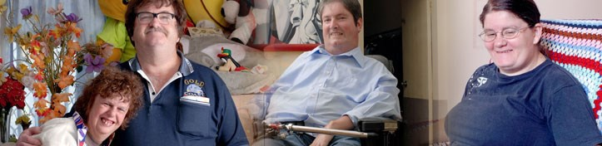

Mission: Empowering the voices of people with disabilities in Western Australia.

Vision: A community where all people have a full and valued life with the freedom to make their own choices.

Values:

- We embrace diversity and participation to ensure inclusion for all
- We believe respect is fundamental to all positive relationships
- We seek to enhance opportunity and remove barriers to ensure real choice
- We are committed to every citizen’s right to equality

PWdWA is funded by the Disability Services Commission and the Department of Social Services.

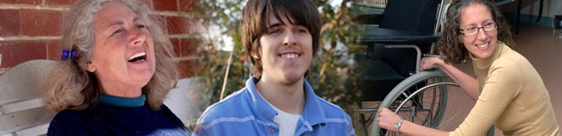

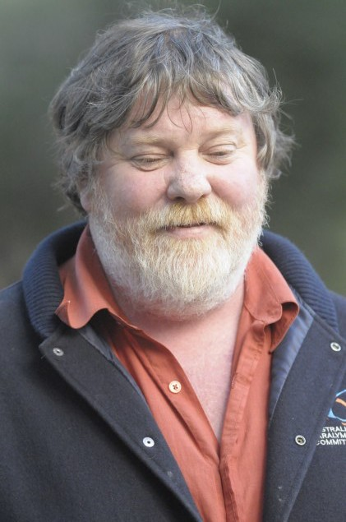President’s Report

My first year as President has been an enlightening experience. I now have a fuller understanding of the volume of work PWdWA undertakes.

Over the past year PWdWA has continued its work of systemic and individual advocacy, information dissemination, peer support, advice to government, submission and policy development and support of its members and the wider disability community. The organisation has been through two assessments to measure the
quality of service provided by us to people with disability in WA. Both those assessments, one state and one federal, have endorsed the great work we do, and given us some positive feedback on how we can improve.

Our People

The strong consistent service we provide is a direct result of the dedication of the people that make up PWdWA.

I would like to thank our fantastic advocates, communication and administrative people for their on-going enthusiasm, compassion, and work ethic which gives the organisation its strength.

A strong working relationship between the Executive Director and President is crucial for any organisation; I would like to formally thank Andrew Jefferson for his dedication and support throughout the year. Andrew’s passion for the organisation cannot be disputed; it is that passion that led Andrew to his decision to stand down as Executive Director in a belief that an organisation for people with disability should be run and led by people with a disability. Andrew is a great loss to the organisation but I am sure he remains one of our strongest advocates.

Committee of Management

Any great organisation needs strong reliable governance, and we have plenty of that. It has been my privilege to work with a team of such calibre as makes up the People with Disability Committee of Management. We are fortunate to have such a breadth of knowledge, youth and experience to call upon.

To fully benefit from the Committee of Managements skills and knowledge we have developed sub-committees to spread the work load.

Continued on page 3

Those Sub-committees are:

- Finance Audit and Risk– Chair, Greg Madson
- Membership Profile and Engagement– Chair, Sam Connor
- Strategic and Future Direction- Chair, Mallika Macleod
- PWdWA DAIP- Chair, Sam Connor
- Policy and Constitutional- Chair, Kerrie Duff
- Housing- Chair, Samantha Jenkinson

I would like to thank all those committee members who have willingly given their time, commitment and advice in governing the organisation.

Our Members

A strong membership organisation needs strong membership engagement and PWdWA has continued its member engagement throughout the year.

Earlier this year, members of Self Advocacy WA travelled to Victoria to participate in the “Having a Say” conference. Self Advocacy WA (SAWA) is an independent group managed by a committee elected from the membership. SAWA has been meeting regularly throughout the year with their catch-up breakfasts being a very popular get-together.

Self-Advocacy and Peer Support, and Spinal Chatter are peer support groups assisted by PWdWA.

Just recently, “Diverse Leadership (Inc.)”, with PWdWA support, has been formed. The purpose of the Association is to develop the capacity of people with disability to act as leaders in business, government, community or wherever their interests lie.

In June this year PWdWA was able to assist one of our members, Joel Wilson, by
nominating him as one of Australia’s young disability advocates to attend the United Nations Conference of States Parties (COSP) held in New York. Joel was successfully chosen to be one of 7 across Australia to attend the conference.

PWdWA again this year renewed the Memorandum of Understanding with People with Disability Australia. This MOU strengthens links with PWDA and provides opportunity for the two organisations to share resources and collaborate on issues of mutual interest.

Funding

PWdWA is funded at the state level by the Disability Services Commission (DSC). I would like to thank the WA disability Services Commission for their ongoing support throughout the year. Access to DSC run forums, meetings and events has given us opportunity to ensure people with a disability have a voice in issues that affect their lives.

Federally, PWdWA receives funding from the Department of Social Services (DSS); we thank DSS for that support.

Over the past few years the disability sector has been one of great change; the need for a strong, reliable, and flexible disability advocacy organisation has possibly never been greater. With the NDIS, My Way, a changing aged care sector and changes to how the federal government is funding disability advocacy, we will need to stay focused on our task. There is great opportunity here to mould a disability support system that will enhance the lives of people with a disability and PWdWA will be there to ensure it happens.

Greg Madson President

2013-2014 Committee of Management

Joanne Woolhouse Treasurer

Greg Madson President

Kerrie Duff Vice President

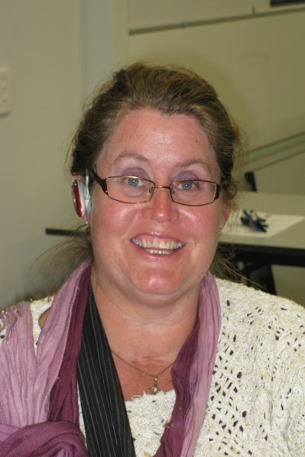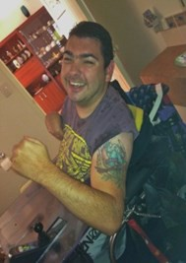

Mallika MacLeod Secretary
Ryen Songhurst Member
Kelly–Ann Rasmus Member
Ryan Gay Member

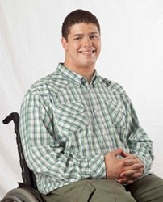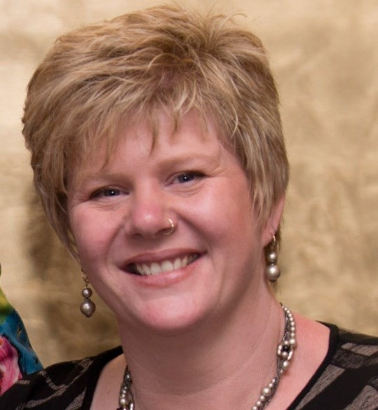

Samantha Connor Member
Jordan Steele-John Member
Samantha Jenkinson Co-opted Member

Executive Director’s Report

It has been another a remarkable twelve months. Despite the complexity of the task and the challenging timeframes Western Australia will have two National Disability Insurance Scheme (NDIS) trial sites starting on 1 July 2014. The commitment of both the Commonwealth Government and the Western Australian Government to achieve this outcome deserves recognition.
Campaigning by self-advocates, disability activists and ‘Every
Australian Counts’ members was very important in ensuring that the
NDIS was not compromised during the Federal Election process and maintained bipartisan political support . While there have been huge achievements this year many more will be required in the future. People with a disability and their supporters must remain actively involved. Participation by people with a disability in implementing, evaluating and further developing the NDIS will be central to its success.

I wrote to the Director General of the WA Disability Services Commission in June 2014 to congratulate him on the high state of preparedness attained for the NDIS/My Way trial site launch in the Lower South West. This readiness is testament to the Commissions ability to provide effective leadership in the Sector, include people with a disability, and manage complex tasks. PWdWA has supported the My Way approach since its inception and expect that the independent evaluation of the two 2 year trials in Western Australia (WA) will provide evidence of improvements to the national scheme that have been informed by the experience of people with disability and their families. PWdWA will continue to represent people with disability at advisory group level for both the My Way and the National Disability Insurance Agency (NDIA) and provide individual advocacy to participants as required.

One of the most exciting developments in the last 12 months has been the growth in people with disabilities coming together in person and on-line to learn from each other, share experiences and strategies, build relationships, and organise events.
There has been a strong commitment to include people from across the disability community in these activities. Social media platforms have allowed many more people with disability to share their views and to debate issues. There is greater awareness about the politicisation of disability and the importance of a human rights approach.
Parents and other family members of people with disability also are meeting with their peers and finding value in these networks. The individuals who initiated, maintained or contributed to these networks last year did an amazing job.

There is no doubt that the NDIS has been a distraction from many other important matters that affect people with disabilities. Physical, psychological and systemic barriers continue to block the progress of people with a disability. Low expectations and lack of opportunities still limit peoples’ personal and professional development.

There needs to be a refocus on the United Nations Convention on the Rights of persons with a Disability, and the National Disability Strategy in addressing these issues. It is now time for Advocacy agencies, peer support groups and others to come together to develop campaign strategies to ensure that each barrier is being challenged with conviction in every State and Territory.

PWdWA has continued to progress its strategic aims. Time and resources have been committed to both local and national disability advocacy issues. As can be seen in the Systemic Advocacy report, PWdWA has and is addressing a wide range of barriers, challenges and discrimination that limit the opportunities of people with disability to have successful lives. There are many more issues than PWdWA has the resources to address each year. The Committee of Management members and staff have again committed time to developing relationships and collaborating with other organisations and individuals to achieve shared goals. Consumers of Mental Health WA (CoMHWA) has become an organisation that PWdWA now routinely partners with.

PWdWA has continued to work closely with Developmental Disability WA on several important matters (see Systemic Advocacy Report). The campaign in support of the development of Disability Justice Centres has remained central to our joint work.
Collaboration with the National Disability Services WA (NDS WA) and West Australia Association Of Mental Health (WAAMH) has been important in achieving the required outcome.

On a national level PWdWA has continued to meet and liaise with People with Disabilities Australia (PWDA), Disability Advocacy Network Australia (DANA), and the Australian Federation of Disability Organisations (AFDO). I also served on the National Disability Services facilitated Zero Tolerance Project Reference Group. The project was concerned with preventing and responding to abuse and neglect of people with disability in non-government services.

PWdWA’s Individual Advocacy service provides opportunities for Advocates to engage with a broad church of people with disabilities and their representatives. While the reason for the contact usually relates to a matter of concern any opportunity to meet with people with a disability is welcome. Every person’s story is important and our learning from individual advocacy casework helps to inform our systemic advocacy campaigns.

PWdWA is well served by an informed and dedicated Committee of Management. Members have a broad range of experience and insight. Their understanding of disability is personal and their experience within the disability sector is telling. They provide PWdWA with a wealth of knowledge about good governance practice.

The role of the President of the Committee of Management is central to the work of our organisation. Greg Madson was elected to this role in October 2013. Greg’s extensive experience of the Disability Sector and in governance roles has served PWdWA well. Greg is a leader with an extraordinary capacity for work. Greg’s strong
calm approach is well received by managers, advocates and admin staff. I am indebted to him for his resolute support.

PWdWA services are provided by experienced advocates and informed by very capable advisors. It was pleasing that the high standards achieved were recognised in two separate quality assessment processes earlier in the year. The strength of the whole organisation was acknowledged. Being credited for good work maintains motivation. I am grateful to Senior Advocate Carmen Pratts-Hinks for facilitating the evaluations on top of her considerable workload. I also want to thank the people that volunteered to share their experience of our services with evaluators.

The excellent evaluation reports have not provided PWdWA with confidence about the continuation funding for Disability Advocacy beyond June 2015. The level of requests for individual advocacy remains high and the number of systemic issues grows as people with disability increasingly recognise that they do not have to tolerate discrimination or accept second best. Every opportunity should be taken by members and supporters to inform politicians and funders about the importance of Disability Advocacy services.

PWdWA has worked with the Disability Services Commission on many areas of important reform. The Commission have been very open to the involvement of consumer representatives in developing legislation, policy and initiatives. The health of people with disabilities remains a shared concern. PWdWA was one of many organisations disappointed that the opportunity to introduce a no-fault injury insurance scheme for Western Australians this year was not taken.

PWdWA was supported by both the Disability Services Commission, and the Department Social Services. I thank our two main funders along with our members and other supporters for their continuing assistance. It is this support that enables us to serve the people who are most vulnerable, and the wider disability community.
PWdWA is grateful to have Steven Heath and Geraldine Mellet serve as our Vice Patrons.

I want to mark the end Graeme Innes’s tenure as the Disability Discrimination Commissioner. Graeme was a strong advocate and undertook his role with great integrity. He was a regular visitor to WA and to our offices in Nedlands.

A final thank you goes to the legal companies who assisted PWdWA in its advocacy work last year. Legal assistance can be crucial in helping people with disabilities achieve justice. Their support is appreciated.

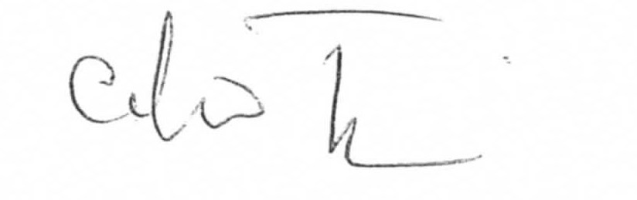

Andrew Jefferson Executive Director.

Treasurer’s Report

In the 2013-2014 financial year, PWdWA operated within its budget and fulfilled the contractual requirements of service level agreements with our core funding agencies, the West Australian Disability Services Commission, and the Department of Social Services.

PWdWA received supplementation funding from the Department of Social Services. This was to fulfil previously unfunded obligations to our staff employed under the SACs award scheme.

PWdWA was the grateful recipient of additional non recurrent funds from Disability Service Commission in the final quarter of the financial year. The funds were granted to assist with the sustainability of our organisation.

The Committee of Management has remained active in overseeing the financial operation of the association. The audited accounts demonstrate that the organisation remains financially stable.

The Committee of Management and operational staff would like to express thanks to Nulsen Independent Administration who have supported us with payroll and financial management throughout the year.

Individual Advocacy
The Individual Advocacy Team provides one to one, non-legal and issue based advocacy for people with disabilities living in Western Australia. PWdWA focus on advocating alongside people with disabilities who are most vulnerable to express their views, have their voice heard and to have their rights upheld.

The Individual Advocacy Team consists of staff with a broad range of skills and experiences which complement each other and allows for quality of service to be provided. Our team develop their skills and knowledge by participating in ongoing supervision, training opportunities, forums, conferences and networking with stakeholders from the community sector.

Achieving positive outcomes for people with disabilities and their families remains the priority of PWdWA. Individual Advocates assist people to consider options and make their own informed decisions. With each case, advocates work closely with the person to develop an action plan which outlines the roles and responsibilities of all stakeholders involved and actions to be followed.

As part of their role, individual advocates research information, communicate with stakeholders and provided support at meetings. Our service can extend to
pre-meeting preparation, taking notes and ensuring that agreements are reached. Meanwhile with the support of their individual advocate, the person with a disability learns about their rights, services that are available to them and develops self advocacy strategies that they can use in the future.

Providing contemporary and up to date information continues to be an integral aspect of service delivery at PWdWA. Information is provided to individuals, family members and any other person that wants to know more about the services that PWdWA and other agencies in the community can offer. Information is made available by phone, face to face, email and social media. PWdWA continue to liaise with service providers and government workers such as Local Area Coordinators, allied health professionals and local government officers in order to keep our information accurate and current.

This year, Individual Advocates assisted people with disabilities to achieve in many areas. Services, education, employment and finances were the main focus of service delivery in 2013-2014.

PWdWA ensured a smooth transition between service providers for people who were not satisfied with the supports in place. Individual Advocates also assisted people through complaints processes and worked with people to have their issues raised and resolved.

Individual Advocates also worked closely with parents of school age children with disabilities to ensure that schools work in collaboration with parents, make reasonable adjustments and put supports in place for children who require additional support.
Parents were informed of the complaints procedures relevant to their issue and supported to attend school meetings if required. Advocates also directed parents to other community services so all children had the opportunity participate in an inclusive education.

Access to employment continues to be a barrier many people with disabilities still encounter. Individual Advocates supported people with disabilities at meetings with their employers to ensure that reasonable adaptations were provided in the workplace. The common goal was to promote the right to work on an equal basis with others taking into consideration the adjustments that have to be made.

Finance was an issue which was repeatedly brought to the attention of PWdWA this year. Advocates assisted people to liaise with agencies regarding reducing debt and supported people with Centrelink issues.

Finally, people with disabilities were supported at hearings at the State Administrative Tribunal. The advocates assisted people to have their say and ensure that they understood the process, prepare for the hearing, and were heard.

PWdWA’s Individual Advocacy programs are funded by both the Disability Services Commission (DSC), and the Department of Social Services (DSS).
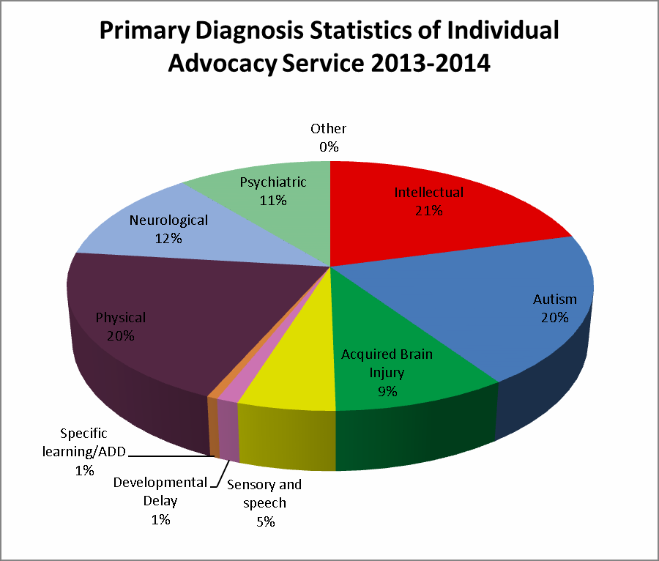

Peel Individual Advocacy
Now in the sixth year of operation, the service in Peel provides individual advocacy to people with disability across the Peel Region. The service is currently funded for
22.5 hours per week. PWdWA extends its thanks to the Department of Social Ser- vices for their continued support of this important resource.

The Individual Advocacy Service based in Mandurah has continued to provide strong advocacy support for people with a lived experience of disability. This has involved working alongside people with disability to communicate and connect with appropriate services, consider available options, plan, prepare for and provide sup- port at meetings. Where appropriate, progress towards self-advocacy is facilitated by providing information and encouragement that will assist the person with disability with decision making and developing self-confidence.

Issues that emerged as most prominent in Peel in 2013/2014 included education, employment, access to services, transport and housing. In one case, PWdWA assisted a person with a priority housing issue by attending meetings with Tenancy Advice Service in Mandurah and liaising with Centrelink. As a result, the person was place on the housing priority list and accessed a home within eight weeks of applica- tion.

The Peel Advocate also supported people with disabilities to liaise with service providers in order to promote greater choice and control over how services are delivered and to negotiate for better living arrangements. In order to do this, the Peel Advocate undertook research, communicated with relevant stakeholders, provided pre-meeting preparation and attended meetings alongside people with disabilities, ensuring their voice was heard.

As with previous years, important strategic relationships have been developed and maintained. The last year has seen an increased involvement between PWdWA and local service providers, clubs and organisations, which has resulted in weekly
contact, networking and information sharing. PWdWA’s contact with Local Area
Co-ordinators (LAC) has particularly strengthened in the last year, resulting in a close working relationship between the LAC office and PWdWA in the Peel region.

PWdWA continue to operate from the Parents Place in Mandurah. The Parents Place aims to provide an integrated service for families in the one building and the agencies work closely together to provide the best possible support for the people who access the Centre. The Individual Advocate for Peel has continued to attend meetings with a variety of agencies in the Peel region and was also present at Mandurah City Council Fun Run on the Foreshore which is targeted to raise awareness of people with disabilities.

Information, Communication and Social Media

Throughout 2013-2014, PWdWA continued to respond to telephone, email and social media enquiries from people with disabilities, their families and carers, service providers and the wider community. Many enquiries involved PWdWA staff providing current information, advice and contact details for disability services throughout Western Australia.

PWdWA has continued to communicate with people with disabilities and the broader community via eNews, Facebook and our email list. The feedback received by stakeholders and the general public has been positive. Stakeholders have made contact with the Communication Officer to discuss current articles and information that may be of interest. The Committee of Management are working on a strategy to use social media as a means of providing the public with more information about what PWdWA does both in the Individual Advocate and Systemic levels.

The information email address has remained a successful form of communication for PWdWA. Over the last year, the number of referrals coming into the office via the information email address has significantly increased. Members are also using this email address to inform the organisation about systemic issues.

This year, PWdWA created a new website using a free website developing software called Wordpress. The website underwent a comprehensive redesign process and is now more accessible, easier to navigate and is mobile device friendly so it can be accessed using a smart phone or tablet. The new website has been checked for accessibility issues using the webAIM (web Accessibility In Mind) tool WAVE, which is a web accessibility evaluation tool. Rather than providing a complex technical report, WAVE shows your original web content with embedded icons and indicators that reveal the accessibility information within your page. Our thanks go to Erika Webb (from Erika Webb Consulting) and Glenn Beall (from IQPC) for their input and services when designing the new website.

PWdWA has seen a growth in visibility and activity this year on their social media pages. Contacting the office by this method can be an easier way of discussing issues for some people. Social media has become a powerful tool for individuals and social movements around the world to campaign, raise awareness and influence change. It allows for people to take action both on and off line and enables campaigners across Australia to link with others and feel a sense of ownership and community.

Self Advocacy WA
The Self Advocacy Western Australia group had a very productive year and experienced several changes. SAWA wish to congratulate Ian on his election as Chair Person for the group and would like to welcome two new members; Heather and Ingrid.

It is with sadness that SAWA announce the retirement of Joyce from the group. Joyce has made valuable contributions to SAWA over the years and will be missed. SAWA wishes Joyce a very happy retirement.

This year, SAWA members were given the opportunity to attend the “Having a Say Conference” which was held in Geelong and hosted by Valid. Ian and Fraser at- tended the conference to represent SAWA. “Having a Say” is an annual conference which aims to empower people with a disability. Participants have the opportunity to discuss issues that affect their lives, celebrate achievements and have their views heard. Ian and Fraser provided feedback on their experience of the conference and the issues discussed to SAWA members.

SAWA members were also asked to participate in the Zero Tolerance Project, run by NDS and facilitated by PWdWA. Erica, Steven, Fraser and Heather attended the forum. The purpose of the forum was to collate the views people with disabilities have about safety and what they think service providers can do to ensure people feel safer when using their services. The information provided will be used to develop a national framework to improve the sector’s response to cases of abuse, neglect and violence to people with disability.

SAWA continue to meet monthly in order to share information, experiences and discuss current disability issues. All members participate in the meetings and each person’s input is respected. Over the past year SAWA members have continued to advocate for their rights to access employment, education and community facilities. This year, SAWA agreed for an Independent Evaluator from the Disability Services
Commission to attend one of their meetings. Several members took the opportunity to speak on a one to one basis with the evaluator regarding their views about the value of SAWA.

SAWA now have their information shared on the PWdWA website. Members decided on the information they wanted included on the website. To view this information, please go to: www.pwdwa.org and click on the SAWA tab.

Finally, SAWA continue to meet for breakfast in July and December. They are joined by friends, PWdWA employees and Committee of Management members.

SAWA is funded by the Disability Services Commission.

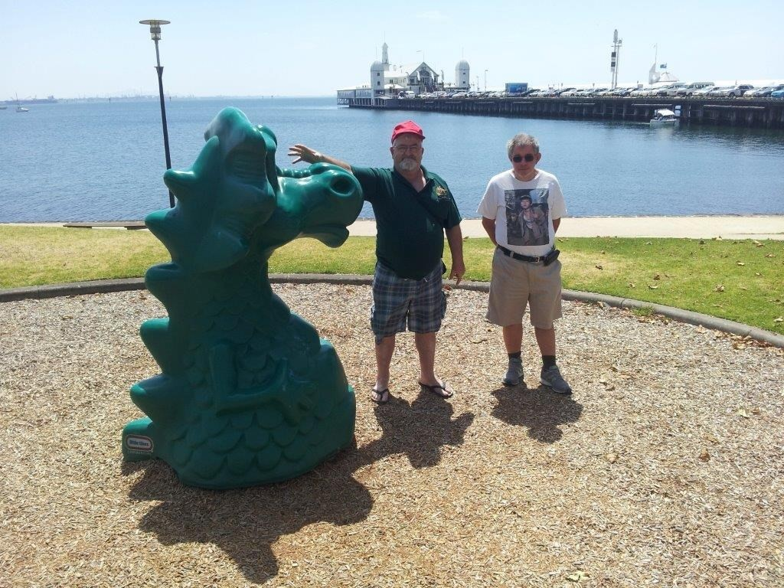

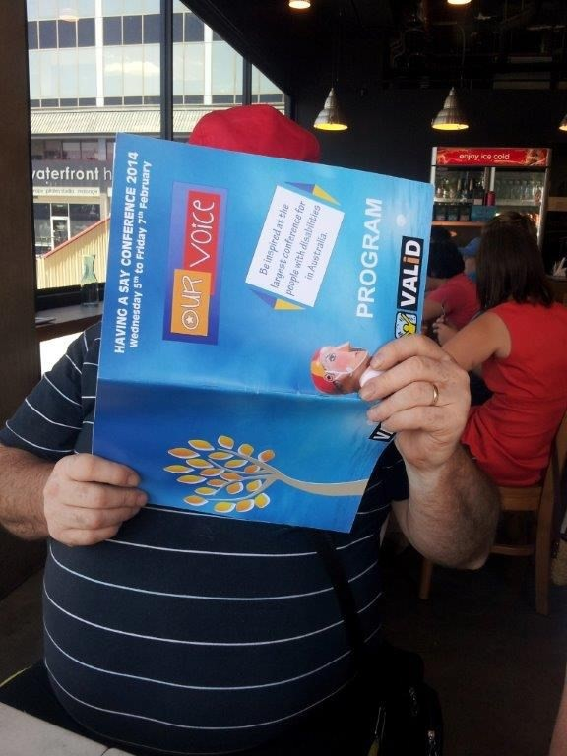Photographs from the Having A Say Conference

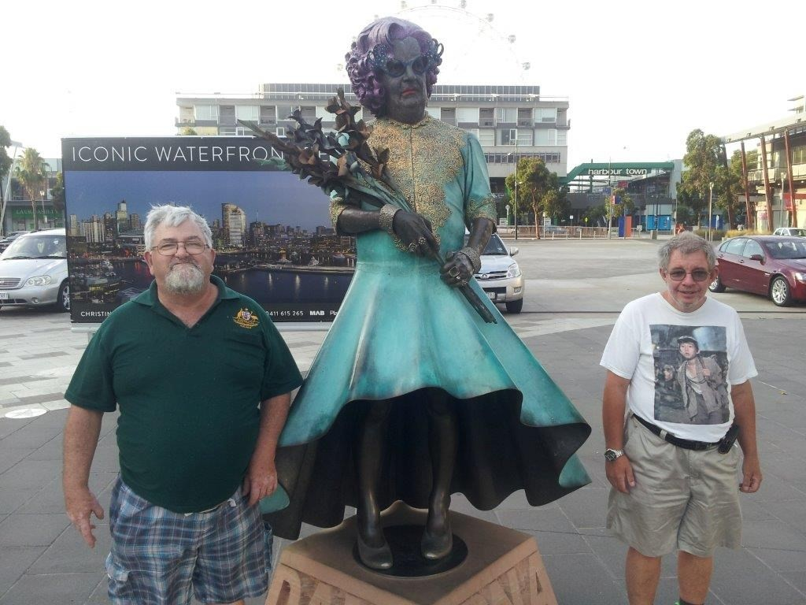

Systemic Advocacy
Systemic advocacy aims to influence and secure positive long term changes that remove barriers and address discrimination, to ensure the rights and interests of people with disability are upheld.

In 2013 - 2014, PWdWA worked in partnership with people with disability, their families and supporters, non-government organisations and government departments, to influence legislation, policy and service practices.

We would like to thank everyone for their important contributions and participation in committee work, forums, submissions and surveys. These activities continue to raise awareness of the rights, interests and aspirations of people with disability, in both Western Australia and at national level.

Representation and Participation

In 2013 - 2014 PWdWA staff and members contributed to committees and reference groups covering a broad range of issues affecting the lives of people with disabilities.

These included:
- Positive Behaviour Framework Guiding Committee
- Elimination of Restrictive practice – ‘Is there a better way” training consortium
- Zero Tolerance - Preventing and responding to abuse and neglect of people with disability in non-government services
- Shut In Campaign - toward the closure of institutions and the provision of adequate support so that people with disability can live wherever they choose.
- Disability Justice Centres – an alternative to prison for those deemed unfit to plead
- Supported Decision Making Project Steering Group
- Independent Support and Safeguarding Reference Group
- Self Advocacy, Peer Support Networks – practical and administrative support to initiatives lead by people with disability
- Liaising with First Peoples Disability Advocacy Network

- Transition - Disability Services Commission Accommodation Support Directorate, and independent review panel member

- Housing - Affordability Ownership Research
- NDIS WA - Supporting and participating in numerous NDIS forums, information sessions and events

- NDIS WA - NDIA Perth Hills Advisory Group Hills
- NDIS WA – My Way Reference Group
- Inquiry into Accommodation and Intensive Family Support Funding for People with Disabilities

- Accessible Mental Health Services for People with an Intellectual Disability group
- Health, Mental Health & Intellectual Disability Symposium and Seminar Series
- Disability Health Network
- Health and Older Australians, Disability and Carers Forums
- City of Perth Access Working Group
- Inclusive Disability Research with both WA and Eastern States Universities
- Beyond the Quad Centre Project – stakeholder engagement
- Disability and Sex workers group
- Transport – various forums and working groups
- Disability Coalition – State funded Advocacy Orgs, Disability and Mental Health Service Provider peaks, WA Carers, Mental Health Consumer Peaks, and CASA

- Western Australian Council of Social Service Peaks Forum

Community Education
- Presentation to Mandurah Autism Parents Group
- Leaders for Tomorrow events
- Presentation to Bentley Consumer Advisory Group
- Presentation to Disability Service Providers
- Stall at ‘Live It Up’ Festival
- Meeting with Ministers, advisors and providing MP briefings
- Presentation at Department of Immigration and Border Protection for International Day of People with Disability
- Signs of safety workshop
- Thrive Parents Group presentation
- Radio interview and newspaper article

Submissions

In 2013 - 2014 PWdWA provided submissions re:

- WA Parliament Community Development and Justice Standing Committee’s Inquiry into Accommodation and Intensive Family Support Funding for People with Disabilities

- Submission to the Australian Law Reform Commission’s Discussion Paper: Equality, Capacity and Disability in Commonwealth Laws

Zero Tolerance Project

Zero Tolerance is a National Disability Services (NDS) Australia-wide project to prevent and better respond to abuse of people with disability in non-government services. NDS is working with service providers, advocacy organisations, governments and universities to develop a national framework and resources to improve the sectors response to cases of abuse, neglect and violence of people with disabilities.

The right of people with disability to live free from abuse and neglect is a fundamental human right and enshrined in Australian and international policy and legislation.
Despite this, there is considerable evidence that people with disability continue to be at greater risk of neglect, abuse and violence than people without a disability. The Zero Tolerance project aims to build the capacity of service providers so people with disability can exercise choice and control whilst remaining safe from the risk of abuse, exploitation and neglect.

NDS recognises that people with disabilities know best about what makes them feel safe. The project identifies that the voice of people with a disability is often missing when talking about ways services can perform better in cases of abuse, neglect and violence. The Zero Tolerance project wanted to hear from people with disability about their views of safety and what they think services can do things to help people feel safer.

The aim of the project was for one focus group to be held in each state throughout Australia. PWdWA represented Western Australia and were responsible for facilitating and recording outcomes from the focus group for feedback to the Zero Tolerance project. The event was held on 04/04/2014 at the PWdWA building in Nedlands. The group varied in age, disability and residential status and consisted of two females and three males. The focus group ran from 2pm-4:00pm.

The focus group began with an open discussion about the definition of abuse and the many ways abuse can be experienced. The group then discussed what made them feel unsafe in the community, leading to a conversation about safety. In an open group setting, participants then provided feedback on the five key questions the NDS had set for the group to answer. Participants identified and provided recommendations about what services can do to make people feel safer. Some responses included; ongoing and regular staff training, allowing people with disabilities to be involved in the recruitment and selection process, undertaking regular police checks, having a regular review and performance appraisal process, employing staff with a mature outlook, allowing people with disabilities to deliver training and having staff that listen and who are honest and trustworthy.

In order to support and assist the group, PWdWA used a PowerPoint presentation, flip board, pictures and role play. Three staff members were used as facilitators of the focus group and worked with people in pairs or individually to ensure all participants had the opportunity to contribute to each of the set questions. Participants were also given a clip board to write or draw their answers if they did not wish to speak out in front of the group.

PWdWA created a report outlining the responses of the participants and this was sent to the NDS.

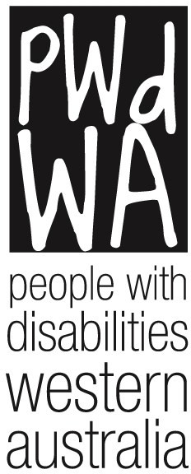

People With Disabilities WA Inc.

Financial Statements 30 June 2014

