Contents

Pages
- Mission, Vision & Values 1
- President’s Report 2-3
- Committee of Management 4
- Executive Director’s Report 5-6
- Services 7
  - Individual Advocacy 7-8
  - Peel Individual Advocacy 9-10
  - Disability First Stop 11-12
  - Self Advocacy WA 13
  - Systemic Advocacy 14-15
  - Projects 16-17
- Financial and Treasurer’s Report

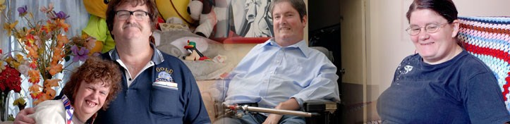

Mission: Empowering the voices of people with disabilities in Western Australia.

Vision: A community where all people have a full and valued life with the freedom to make their own choices.

Values:

- We embrace diversity and participation to ensure inclusion for all
- We believe respect is fundamental to all positive relationships
- We seek to enhance opportunity and remove barriers to ensure real choice
- We are committed to every citizen’s right to equality

PWdWA is funded by the Disability Services Commission and the Department of Families, Housing, Community Services and Indigenous Affairs.

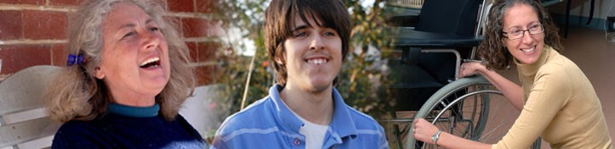

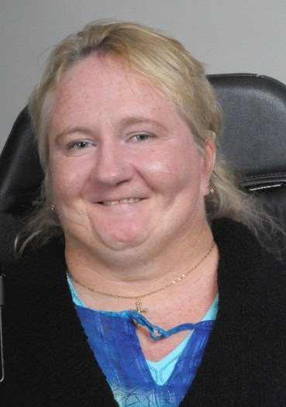President’s Report

My first year as President of PWdWA has been as busy and demanding as I expected. I was very conscious of the high standards set by my predecessor Mary-Anne Bath. I have worked to my strengths and enjoyed great support from a very principled Committee of Management and a strong and busy staff team. Under Executive Director Andrew Jefferson’s leadership the team has been stable and focussed to task. Everyone has been clear about our organisations purpose and committed to achieving better outcomes
for the people we serve.

This year has been awash with change here in Western Australia and across the country. Many of the reforms that were progressed in the last year have the potential to allow people with disabilities to take more control of their lives. PWdWA has
continued to work to influence the development of these reforms to ensure that the rights of people with disabilities are respected.

People with disabilities, their families and supporters have continued to inform the design and development of social policies. Last year people from the disability community collaborated with the Disability Services Commission in WA to pilot new approaches to funding and service delivery that aspire to remove barriers to a good life for people with disabilities. Some other people with disabilities stood for and were elected as Councillors in Local Government. Other people nominated to serve on company boards and advisory groups, took part in consultations or completed surveys. I congratulate all of the people who got involved. They demonstrate through their participation in influencing decision making that people with disabilities have important contributions to make to the whole of our society. Their commitment to improving the lives of people with a disability and the wider community is invaluable. Here at PWdWA we have continued to voice our belief that there is a huge resource of knowledge, talent and courage within the disability community that is not recognised, not encouraged and not valued. We called upon the leaders of organisations who provide funded services for people with disabilities and their families to do more to increase opportunities for the people they support to influence strategic plans and operational approaches. PWdWA continued to promote people with disabilities and
their families as able partners in life planning and not passive recipients of services designed by others.

For the past six years PWdWA has benefitted greatly from the extraordinary knowledge and energy of Committee of Management stalwart Greg Madson. Greg will be standing down at the forthcoming AGM as he has completed the maximum term permitted by our constitution. I take this opportunity to thank Greg on behalf of all
those who have served with him for his dedication to PWdWA. He is by nature a strong advocate and has heavily influenced the development of our organisation in recent times.
(Continued on page 3)

(continued from page 2)

Finally, I would like to thank our dedicated Committee and staff for all the support they have given me in fulfilling my role this year.

Monica McGhie President

2011-12 Committee of Management

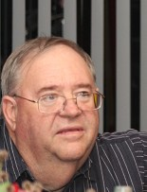

Monica McGhie President
Greg Madson Vice President
Robert Bath Treasurer

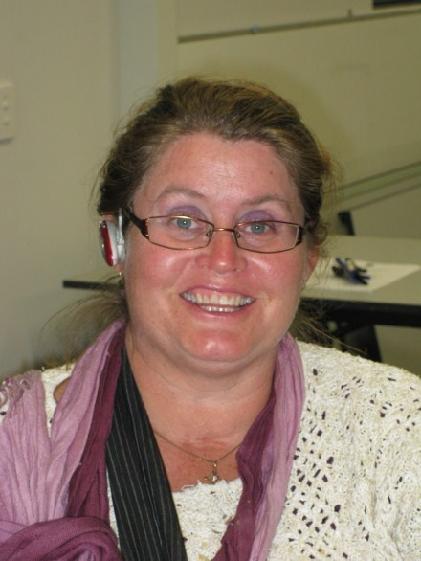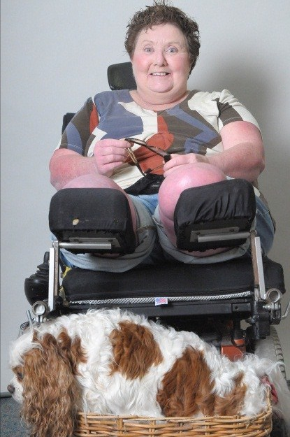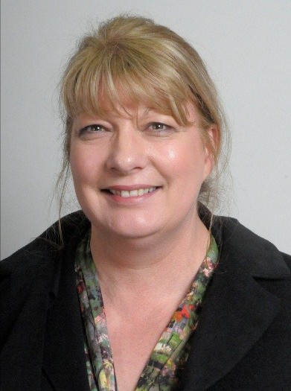

Kelly –Ann Rasmus
Trish Anderson
Sharon Vanderlaan

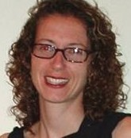

Samantha Neylon Leah Thomlinson-Clements

Executive Director’s Report

In the past year PWdWA has made steady progress towards achieving many of it’s strategic aims. Time and resources have been committed to progressing national agendas and strengthening relationships with contemporaries in the other States and Territories. The development of a National Disability Insurance Scheme (NDIS) that will work for and with people with disabilities has been at the
forefront of this work. PWdWA has been representing the views of people with disabilities from Western Australia on a national level
particularly through our active membership of the Australian Federation of Disability Organisations (AFDO), our close working relationship with People with Disabilities
Australia (PWDA), and my role as a Board member of the Disability Advocacy Network Australia (DANA).

Our work in Western Australia has been directed towards helping people with disabilities (and their families) achieve more control in their lives. Under the leadership of the Partnership Forum government departments, non-government organisations and other key decision makers have come together to progress work to permit
disadvantaged communities and individuals to have the opportunity to co-design their
futures . PWdWA’s representatives, members and staff have been involved in some of the discussion, debate and design approaches that are required to reduce red tape and permit more self-direction.

PWdWA continued to work closely with other disability organisations through it’s involvement in the Disability Coalition of Western Australia . Meetings provide the opportunity for disability and mental health advocacy and consumer organisations along with Carer’s WA and the National Disability Services(NDS) to explore issues and achieve shared goals.

PWdWA has worked with both the Disability Services Commission and the Mental Health Commission on many areas of important reform. The Commissions’ have been very open to the involvement of consumer representatives in developing legislation, policy and new initiatives. PWdWA is fortunate to have a range of insightful advocates, members and supporters that provided a consumer perspective in a vast range of advisory groups, and guiding committees.

The advocacy and admin staff at PWdWA have benefitted from our commitment to training, learning opportunities, and career development. People were given the opportunity to vary their roles within the team and we have been rewarded with
enthusiasm and renewed commitment. The Committee of Management supported a pay increase to reflect the professional performance of the staff and their value to our organisation. The team has remained stable throughout the year as we had hoped and we have been able to employ additional people as need demanded. I credit Carmen Pratts- Hincks in her new role as Senior Advocate for making this strategy a success.

PWdWA is grateful to have Steven Heath and Geraldine Mellet serve as our Vice
Patrons. Geraldine Mellet ‘s role in the successful ‘Every Australian Counts’ campaign for the establishment of a National Disability Insurance Scheme has been something
to behold over the past year. Geraldine has a great ability to connect people who need a decision with people who make decisions. I believe that people with disabilities and
their families and carers in WA have been fortunate to have Geraldine involved in the campaign.

The role of the President is central to the work of our organisation. Monica McGhie has been tireless in her pursuit of better outcomes of people with disability. She has an amazing ability to engage with people. Some of the members of the Committee of Management have been affected by ill health this year. I hope that these important members of our organisation have better fortune in the coming year.

PWdWA continued to be supported the Disability Services Commission, and the department of Families, Housing, Community Services and Indigenous Affairs (FaHCSIA). We thank our two main funders along with our members and other supporters for their continuing assistance. It is this support that enables us to serve the people who are most vulnerable and the wider disability community.

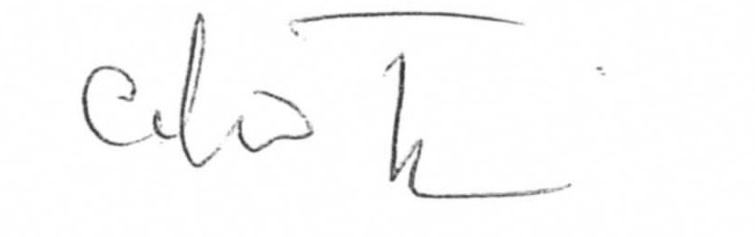

Andrew Jefferson Executive Director.

Individual Advocacy

In 2011-2012 PWdWA provided one to one, issue based, non-legal advocacy for people with disabilities living in Western Australia. We focused on advocating alongside people who are most vulnerable or at risk. We advocated with people with disabilities to express their views, be heard and for their rights to be upheld.
The Individual Advocacy Team retained all their staff; consequently we were able to provide continuity and quality of services to everybody supported by our advocates. Our team furthered their skills and knowledge by participating in ongoing supervision, training opportunities, forums, conferences and networking with stakeholders from the community sector.

We provided contemporary and up to date information to individuals, family members and any other person that wanted to know more about the services that PWdWA and other agencies in the community can offer them. The information was made available by phone, face to face, email and social media. Our website and Facebook page have provided up to date news, with both global and local events thus keeping the members informed. In addition, PWdWA have received contact from service providers and government workers such as local area coordinators, allied health professionals, and local government officers.

PWdWA provided individual advocacy when it was determined that we were the most appropriate agency to advocate for the person with a disability seeking support. The person in conjunction with the advocate worked together to develop an action plan which included the distribution of roles and responsibilities of all stakeholders involved and actions to be followed. As part of their role the individual advocate researched information, communicated with stakeholders and provided support at meetings. Our service can extend to pre-meeting preparation, taking notes and ensuring that agreements are reached. Meanwhile with the support of their individual advocate, the person with a disability learnt about their rights, services available for them and developed self-advocacy strategies that they can use in the future.

Parents of school age children with disabilities have been informed about complaints procedures relevant to their issue and supported at school meetings. The aim has been to ensure that schools work in collaboration with parents, make reasonable adjustments and put supports in place so all children participate in an inclusive education.

The Convention of the Rights of Persons with Disabilities and Optional Protocol article 19 ‘recognise the equal right of all persons with disabilities to live in the community, with choices equal to others’. However the number of people assisted to negotiate
their living arrangements with their service provider have increased due to lack of flexibility, choices and person centred services.

PWdWA have ensured a smooth transition between service providers for people who were not satisfied with the supports in place and who decided to move to another service provider who they believe will listen and respect their choices while maintaining high standards of personal care and support.

Individual Advocates supported people with disabilities at meetings with their employers to ensure that reasonable accommodation was provided in the workplace.
The common goal was to promote the right to work on an equal basis with others taking into consideration the adjustments that have to be made.

People with disabilities were supported at hearings at State Administrative Tribunal. The advocates assisted people to have their say and ensure that they understood the process.

PWdWA’s Individual Advocacy programs are funded by both the Disability Services Commission (DSC), and the Department of Families, Housing, Community Services and Indigenous Affairs (FaHCSIA).

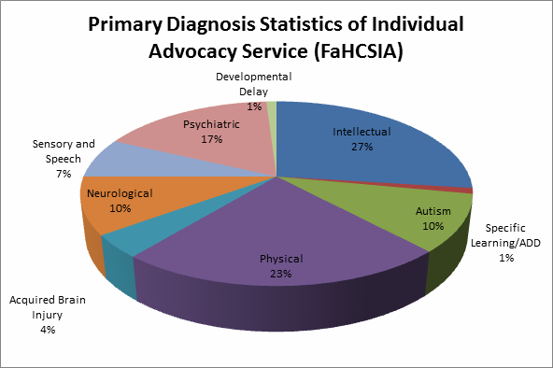

Peel Individual Advocacy

Now in the fourth year of operation, the Individual Advocacy Service in Peel, is
funded by the Federal Department of Families, Housing, Community Services, and Indigenous Affairs (FaHCSIA) to provide and individual advocacy service to people with disability in the Peel Region. The service is currently funded for 22.5 hours per week. PWdWA extends it’s thanks to FaCHSIA for their continued support for advocacy for people with disabilities in the Peel Region.

2011/12 was the first full year of operation of the Individual Advocacy Service from the Peel Office at The Parents Place, Mandurah. After 3 years of operating the service from home, the new office has provided a stable base of operation from which to continue to expand our individual advocacy service in the Peel Region.
Being co-located with a number of other agencies at 63 Ormsby Terrace, including several disability services, has resulted in better promotion of our advocacy service, and the opportunity to develop working relationships with the other agencies located in the building. The Parents Place aims to provide an integrated service for families in a single location, and this then facilitates agencies to work closely together to provide the best possible support for clients accessing the Centre. This means a higher level of service and support for service users of PWdWA. It has been a wonderful experience being a part of this innovative program on behalf of PWdWA. The Individual Advocate for Peel was proud to have had the opportunity to talk about PWdWA’s role at The Parents Place at the recent WACOSS Annual Conference in Perth.

Despite the considerable time and effort involved in setting up the new Peel Office, the Individual Advocacy Service in Peel has continued to provide strong advocacy support to people with a lived experience of disability in the Peel Region. This has involved working alongside people in activities that included; preparing for and providing support at meetings, consideration of options, action planning, communication with Government Departments and other agencies, connection with
appropriate services, and general support. Where appropriate, progress towards self
-advocacy is facilitated by providing information and encouragement that will assist the client with decision making and developing self-confidence.

Although there are a number of areas within which clients are provided with advocacy support; employment, finances, access to services, and transport to name a few, it is the issues of housing and education that have emerged as the most prominent in Peel in 2011/12. The high cost of housing, although trending downwards, continues to negatively impact on people living with disability. There are still very long waiting times for public housing, even for those who are placed on the priority list. There has been significant progress within the education system in providing opportunities for students with a disability, however some children with disabilities still face considerable challenges at local schools, and Parents have
often sought advocacy support in communicating with the school administration to ensure their child’s rights are being observed.

As with previous years, important strategic relationships have been developed and maintained. These positive, collaborative relationships with relevant agencies, increase the probability of positive outcomes for service users of PWdWA. The Individ- ual Advocate for Peel has continued to attend meetings with a variety of agencies including; the Peel Network Service Providers Group, local Council staff, drug and alcohol workers, mental health professionals, Department of Housing, The Disability Services Commission, Midway Community Care, Peel Community Living, and
Baptistcare. People with Disabilities (WA) Inc. has continued to be actively involved in the organisation of Peel Mental Health Week, organised a well-attended DisabiliTea event supporting the proposed National Disability Insurance Scheme. PWdWA also
facilitated a forum in Mandurah where local service providers had the opportunity to discuss issues facing clients accessing Centrelink services directly with the Centrelink Disability Advisor.

Disability First Stop

Disability First Stop at PWdWA continued to collaborate with the other three partner organisations for Disability First Stop: Ethnic Disability Advocacy Centre, Headwest and Kalparrin during the financial year. Each organisation caters for a specific client group with PWdWA targeting adults with a newly acquired disability.

Disability First Stop Advocates from the four partner organisations met formally on two occasions during the year to share information and resources to assist in the
continuous improvement of the program. All partner agencies now have Disability First Stop pages on their websites.

Disability First Stop continues to provide information and a support service for people with disability and their families within first 18 months of diagnosis or where people:

- Are transitioning from hospital to community-based services
- Are newly arrived in Australia and diagnosed with disability in their country of origin
- Have a deteriorating medical condition that requires disability support services
- With a diagnosed disability receive a second diagnosis that requires assessment, information and support.

During the period July 2011 to July Disability First Stop at PWdWA assisted people newly diagnosed with a disability with the provision of information, supported referral and advocacy. One of the strengths of this program is that it has the capacity to take the time needed to offer a holistic approach and work with all stakeholders to address any number of issues of concern to the individual who has recently acquired his/her
disability. It is also very satisfying for the Disability First Stop Advocate in being able to work productively with people across the health and disability sectors to ensure the wishes of the person with a disability are respected and any issues are resolved in a
timely manner.

An example of a Disability First Stop Case Study follows: (identifying details have been changed to protect the person’s privacy)

SITUATION: PWdWA were contacted by a health professional concerned about a hospice cancelling their services to a person with a disability. This person required ongoing support due to multiple heath issues. This person resided with his ageing parents who were no longer able to meet his health and support needs.

TASK: Obtain consent to act. Referee contacted family and advised family of the service provided by the Disability First Stop Advocate at PWdWA. The family indicated they were happy to be contacted regarding a home visit to discuss actions required and the development of an action plan.

ACTIONS:

- Assistance to family in drafting a letter to previous provider of Hospice Care Services and to the Director General of the Health Department, regarding the efficacy of that service and the need for it to be reinstated in this situation.
- Identifying the family’s Local Area Co-ordinator (LAC), Disability Services Commission, and provision of a supported referral in order to link the person with a disability and his family to the Local Area Co-ordinator for ongoing assistance in getting their needs met as and when required.
- Alerting the State Head Injury Unit (SHIU) in regard to this family’s current situation and the need for a review and provision of additional services.
- Provision of information about the Energy Subsidy for persons with a thermo-regulatory disorder.

RESULT: Hospice Care Services reinstated giving family access to 24 hour specialist healthcare advice and support when necessary therefore alleviating family’s stress and demands on Hospital Emergency Services. Social Work Support through SHIU was reinstated to determine current supports required, such as communication review for client of SHIU and access to respite services. LAC engaged with family and encouraged to work in partnership with SHIU to ensure best outcomes for all stakeholders. LAC determined to assist family to look at funding options so their family member could access meaningful daytime activities. Person being cared for granted energy subsidy.

OUTCOME: Family supported to be able to continue in caring role as per their wishes and the wishes of their adult child for whom they are caring.

Self Advocacy WA

This year has been a very eventful year for SAWA, with a move to a new venue for the group meetings, new roles and responsibilities for members, and greater involvement in the important issues affecting people with disabilities.

- August 2011 - At the SAWA AGM members elected Rita Grose as the new Chairperson.
- September 2011 - SAWA became hi-tech with the introduction of computer technology with text-to-speech to make the meetings more accessible and interactive.
- October 2011 - Rita and Ian Grose represented the SAWA group at the PWdWA AGM and provided feedback to the SAWA members.
- November 2011 - SAWA members attended a Meeting Planning Workshop.
- In November Bobby Smith, SAWA's Minute Taker and admin assistant retired. PWdWA and SAWA would like to express a special thank you to Bobby for her assistance at the SAWA meetings and wish her all the very best in her retirement.
- December 2011 - SAWA members enjoyed a Christmas breakfast in Perth with friends, PWdWA staff and members of the Committee of Management.
- January 2012 - SAWA monthly meetings moved to a new venue at Oasis Lotteries House in Nedlands. A new location meant new roles, with members nominated and elected for the roles of Occupational Health and Safety Officer and Refreshments Person.
- March 2012 - SAWA discussed networking more closely with other self-advocacy groups and the Self Advocacy Resource Unit based in Melbourne, Victoria.
- April 2012 - SAWA members joined PWdWA staff at the National Disability
Insurance Scheme (NDIS) Rally in Perth. Members actively campaigned with thousands of other supporters across the country for the rights of people with disabilities to receive the essential equipment, support, therapy and early intervention they need.
- May 2012 - SAWA members attended a Self Advocacy Workshop and discussed how they could speak up for their rights and help others to do the same. SAWA members contributed to the Perth Transport Forum held at PWdWA, actively discussing the issues they had with the current public transport system.

Over the past year SAWA members have continued to advocate for their rights to access employment, education and community facilities. SAWA members are looking forward to being involved in more systemic advocacy over the coming year and are planning to develop a SAWA webpage for the PWdWA website.

Systemic Advocacy

In 2011 - 2012 PWdWA continued work in successfully influencing positive changes in policy, legislation and service delivery. We would like to thank everyone who
contributed their feedback through participation on committees and contributions to
forums, submissions and research. Your participation has helped improve access and inclusion, and helped raise awareness of the rights of people with disabilities.

RESEARCH
To assist in obtaining direct feedback from members and other stakeholders, PWdWA conducted several surveys and forums this year, including:
Companion Card Survey Library Access Survey
My Way Forum - Self Directed Services Public Transport Forum

CONSULTATIONS

PWdWA staff and members contributed to a number of State-based and National committees, reference groups, forums and workshops, covering a broad range of issues affecting people with disabilities. These included:
- Australian Federation of Disability Organisations
- CaLD and Disability Interagency Network
- Commonwealth People's Forum
- Disability Advocacy Network Australia
- Disability Coalition of Western Australia
- Disability Inclusive Research Collaboration Conference Steering Committee
- Disability Services Commission Guiding Committee
- Disability and Sex Worker Project Group
- Health Consumers' Council Reference Groups
- Housing Advisory Roundtable WA
- Inequalities in Healthcare Research Reference Group
- Kimberley Advocacy Service Steering Committee
- Mental Health Commission Advocacy Forum
- National Disability Insurance Scheme Forums and Consultations
- National Disability Services WA Outcomes Workshops
- Positive Behaviour Framework Forum
(Continued on page 15)

(Continued from page 14)

- Quality Management Framework Outcomes Workshops
- Restrictive Practice Policy Discussion Group
- Road Trauma Support Service for WA Reference Group
- Self Directed Services Reference Group
- Synergy Consumer Committee
- WA Individualised Services Leadership Forum
- Western Australian Council of Social Services
- You're Welcome Access WA State Reference Network

SUBMISSIONS

Based on feedback from people with disabilities, their families and supporters, PWdWA was able to put together a list of issues that matter the most to people with disabilities in Western Australia. PWdWA provided direct feedback to Governments and other bodies through meetings with Ministers and submissions.

In 2011 - 2012 PWdWA provided submission feedback on the following draft documents:

- Inclusive Communication Guidelines for Emergency Managers
- National Disability Strategy: Laying the Groundwork Implementation Plan
- National Human Rights Action Plan
- Western Australia Mental Health Bill
In addition, PWdWA made a submission to the Committee on the Rights of Persons with Disabilities on the Implementation of Article 9 (Accessibility) of the Convention on the Rights of Persons with Disabilities.

PWdWA receives many requests to provide feedback for reviews of Disability Access and Inclusion Plans (DAIPs). To assist in providing feedback, PWdWA put together standard guidelines for DAIP reviews. In 2011 - 2012 PWdWA provided submission responses for DAIP reviews in the areas of health, education, employment and recreation.

PWdWA's submissions are available in accessible electronic formats at www.pwdwa.org and in hard copy formats upon request.

Projects

2031 Public Transport Forum

PWdWA, in partnership with the Department of Transport, held a forum on the
18/05/2012 regarding the upcoming and future changes to the public transport system.

The purpose of the forum was twofold, firstly to inform people with disabilities about
the changes and accessibility modifications being made to the public transport system, and secondly, for people with disabilities to provide feedback and offer suggestions regarding the proposed changes to the Department of Transport, while the 2031 plan is still in the planning stage.

The invitation to this event was extended to PWdWA members, PWdWA committee
of management, the post school options group and members of SAWA. The event was held at the PWdWA offices in Nedlands and was attended by 11 people.

The presentation was delivered by Carol-Ann Prinsloo, the Transperth Education
Officer at the Department of Transport. Carol-Ann provided information on the 2031 public transport plan, advising the plan will play a vital role in addressing congestion and accessibility issues as Perth grows to an expected population of 2.5 million by 2031. Key initiatives of the plan include the development of rapid transit corridors, expansion of the rail network and the introduction of more buses and trains in order to better support public transport and improve the quality of services.

Carol-Ann then went on to discuss the Department’s plans to increase accessibility in public transport. It is proposed that 16 stations shall be upgraded over the next 8 years, all work aiming to be completed by June 2017. Key work includes: platform upgrade to address the gap between the train platform and the train door; providing/ upgrading tactile paving at stations, upgrading slopes and ramps to ensure safety and enhancing all stations shelter. Lights and information signs shall also be implemented in all stations. Carol-Ann stated that all new buses must now meet accessibility standards and the public transport authority is trying to make all buses accessible by 2014. Current accessible buses are identified by a wheelchair symbol on the bus
timetable. By 2022 all train stations in Perth must be accessible.

All participants who attended the forum had the opportunity to express their opinion and contribute to the discussion while at the forum. Most participants advised of their personal issues and concerns regarding public transport and were given a response to their concerns.

Most participants completed the evaluation form and stated that they were happy with the forum and the information provided. People who attended the forum were given a copy of the Department of Transport’s “Access and Inclusion Plan.”

My Way Workshops

In 2011 the Disability Services Commission partnered with the Department of Premier and Cabinet in the ‘My Life, My Way project’ to promote the concept of self-directed support and services. The My Way project will provide people with disability and their families and carers with the opportunity to exercise genuine choice and control over
the supports and services they require to live a good life in their local community.

In order to provide clear and extensive information about the My Way project, PWdWA, in partnership with the Disability Services Commission, held two “My Way” workshops. The purpose of the workshops were to explain the aims and objectives of the My Way project to people with disabilities and their families, provide background information on the My Way project and receive views and feedback from the group on the intended project outcomes and model.

PWdWA decided that two forums should be held, one in the Mandurah area and one in Perth in order to give more people the chance to attend. The invitation was sent out to all PWdWA members who are eligible for registration at the Disability Services Commission. In Mandurah, the Peel Advocate at PWdWA distributed the flyer to local agencies and contacts that he suggested may be interested. Eleven people attended the Perth workshop and twenty-six people attended the Mandurah workshop.

Both workshops were presented and delivered by Robyn Massey, Executive Director of the My Way Project at the Disability Services Commission. Information regarding
the My Way Project was provided and well explained at the forum. Robyn advised that the My Way Project will be piloted in two metropolitan areas and two regional areas of WA. One by one people who are registered or eligible for registration with the DSC will be invited to participate in the project. All people will have a choice whether or not they would like to take part. The project will be piloted for 3 years.

All participants had the opportunity to express their opinion and contribute to the discussion while at the forum. Most participants advised of their personal issues and concerns regarding the My Way Project and were given a response to their concerns.

People who attended the forum were provided with written information regarding the My Way forum to take away.

For more information regarding the My Way project, please visit the DSC website:
http://www.disability.wa.gov.au/disability_reform/my_way.html

Or email: myway@dsc.wa.gov.au

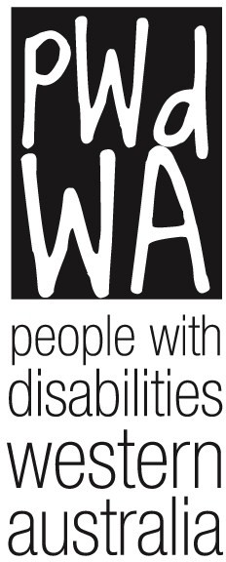

People With Disabilities WA Inc.

Financial Statements and Treasurer’s Report for the Year Ended 30 June 2012

