ANNUAL REPORT 2010/11

Empowering the voices of people with disabilities in WA

Contents

Pages
- Mission, Vision & Values 1
- President’s Report 2-3
- Treasurer’s Report 4
- Committee of Management 5
- Executive Director’s Report 6-7
- Services 8
  - Individual Advocacy 8-9
  - Peel Individual Advocacy 10
  - Disability First Stop 11
  - Primary Diagnosis
Statistics of Individual Advocacy Service 12
  - Information Advocacy 13
  - Self Advocacy WA 14
  - Systemic Advocacy 15-16
  - Your Rights Your Voice 17
- Financial Statements 18-30

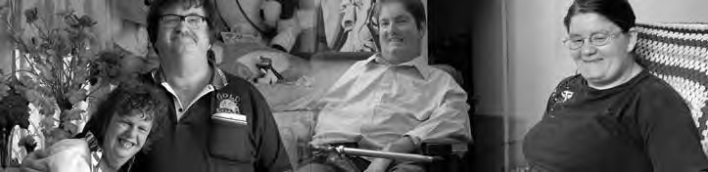

Mission: Empowering the voices of people with disabilities in Western Australia.

Vision: A community where all people have a full and valued life with the freedom to make their own choices.

Values:

- We embrace diversity and participation to ensure inclusion for all
- We believe respect is fundamental to all positive relationships
- We seek to enhance opportunity and remove barriers to ensure real choice
- We are committed to every citizen’s right to equality

PWdWA is funded by the Disability Services Commission and the Department of Families, Housing, Community Services and Indigenous Affairs.

President’s Report

This year I am writing my last President’s Report as I have held this position for six years and it is time for me to step down. I take this opportunity to thank all members for electing me to this important position. It has been a wonderful learning experience, at times challenging but always an honour to serve and lead such a highly regarded advocacy organisation. During the year PWdWA has achieved a great deal, none of which would have been possible without the efforts of the dedicated staff and Committee of Management.

Last year I reported that Mark Goerke had been appointed as Executive Director. Unfortunately, Mark was unable to continue in the position and resigned last August. Andrew Jefferson, stepped into the position of Acting Executive Director at the request of the Committee of Management. Andrew maintained stability and undertook a review of the roles of staff and the future of PWdWA. In December 2010 the Committee was pleased to appoint Andrew to the position of Executive Director. Following Andrew’s appointment Carmen Pratt-Hincks was appointed as Acting Senior Individual Advocate. Carmen performed well in this position and at the end of June 2011 was appointed as Senior Advocate. This position carries more responsibility than that of Senior Individual Advocate and has been redesigned to take on the role of deputy to the Executive Director. Congratulations and thanks to both Andrew and Carmen.

One of the highlights of the past year was the Your Rights, Your Voice course which was run by PWdWA for younger people with a disability wanting to expand their experience, outlook and knowledge. This project was supported by the Disability Services Commission (DSC). Six people attended the course, requiring a great commitment on their part. The course included guest speakers, activities and new challenges which promoted discussion and understanding. All participants are to be commended on successfully completing the course.
Along with many other organisations and individuals PWdWA addressed the Productivity Commission regarding a National Disability Insurance Scheme (NDIS). Along with Andrew Jefferson and Kerrie Duff I spoke to the Productivity Commissioners in Perth prior to its draft report. PWdWA spoke again after reflecting on the content in the draft report . PWdWA’s contribution was well received and we were able to make important points regarding the need for independent advocacy in any new system. PWdWA also submitted a written submission. The discussion surrounding the NDIS led to a number a forums being held around Perth to further the exchange of information. PWdWA hosted a forum in conjunction with the Australian Federation of Disability Organisations (AFDO) in Mandurah. Andrew Jefferson was also able to attend a forum in Broome. Andrew was in Broome for the opening of the Kimberley Advocacy Service.
(continued page 3)

(continued from page 2)

PWdWA are members of the steering group that supports this important service that is managed by the Ethnic Disability Advocacy Centre (EDAC).

PWdWA has also continued to work with People with Disability Australia (PWDA) based in Sydney. I have served as an elected member of the PWDA Board for two years as well as being a member of their sub-committees. Last year I reported that the two agencies were working on a Memorandum of Understanding (MOU). I am pleased to report that in May this year the President of PWDA, Jan Daisley and I signed a MOU between the two consumer led organisations. This is an important partnership that will strengthen the voices of people with disabilities across Australia.

Many members will be aware that PWdWA now has a Facebook page. It is another vehicle that permits the exchange of information with members, individuals and other organisations. PWdWA Information Advocate, Stuart Jenkinson maintains our Facebook page and website. PWdWA is also using Skype to assist with communication with other agencies, members and people using our services. PWdWA will continue to explore other developments in information technology to improve communication.

PWdWA was pleased that the Federal Government has continued to fund our services, particularly the Individual Advocacy Service in the Peel Region. Advocate Keith Read has developed important links with community organisations and individuals in the area. People welcome an advocate based in their own area who is aware of local issues. I am pleased to report that after a long search for a suitable location we have secured an office for our service in Mandurah.

It has been a year of consolidation. A lot of unseen work has gone into strengthening the systems and infrastructure that supports our organisation. PWdWA has seen staffing changes and the development of new roles which have enhanced the organisation’s ability to operate effectively. PWdWA has been involved in both systemic and individual advocacy and has strived to be a voice for those in the community who are most vulnerable.

My thanks again to all staff, members of the Committee of Management, general members and all others who have given me so much support during my time as President. I offer my particular thanks to Kaye Regan, Luke Garswood, Andrew Jefferson and Dr Ron Chalmers, the Director General of the Disability Services Commission, who have so willingly shared their time, advice and wealth of experience. I wish the incoming President every success and great pleasure in carrying out the duties of President for such a wonderful organisation.

Mary-Anne Bath President

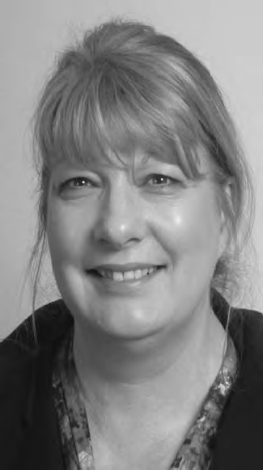Treasurer’s Report

During the past financial year, PWdWA has maintained its many activities and has had a highly successful year. We have been involved in major events such as National Disability Insurance Scheme (NDIS), the opening of the Kimberley Advocacy Project and represented the needs of people with disabilities at a number of events.

Project money that was carried over from 2009-2010 financial period was used to run a very successful Your Rights Your Voice course, which enabled younger people with a disability to further their confidence and potential. Other monies carried over were used to purchase vital software to assist with more accessible technology. These monies have now been acquitted fully with all programs and projects were very successful.

The Committee has remained active in overseeing the financial operation of the organisation. During the year an analysis of our financial controls was undertaken and implementing the recommended improvements identified in this review will be an ongoing assignment in the coming year.

I would like to express thanks Graham Holman and the staff at Independent Administration who provided professional accounting services and advice throughout the year. I also wish to acknowledge and thank the staff of PWdWA, and of course our Executive Director, Andrew Jefferson, who worked closely with the Committee to ensure that PWdWA kept within its budget.

On behalf of the Committee and members of PWdWA we acknowledge the ongoing support of our core funding bodies Disabilities Services Commission (DSC) and the Commonwealth Department of Families, Housing, Communities and Indigenous Affairs (FaHCSIA).

It is very clear that PWdWA's standing in the disability area is well known and the organisation’s strength both financially and strategically will ensure that we are well placed to meet future challenges.

Sharon Van der Laan Treasurer

2010-11 Committee of Management

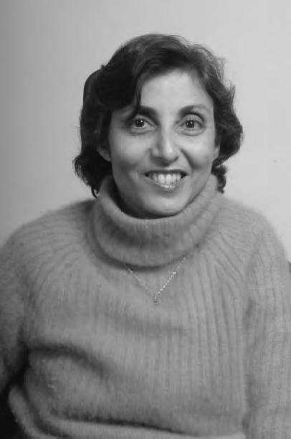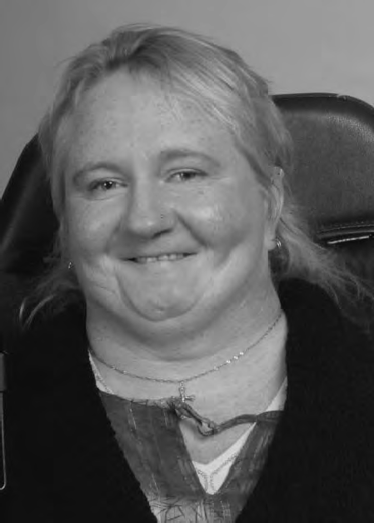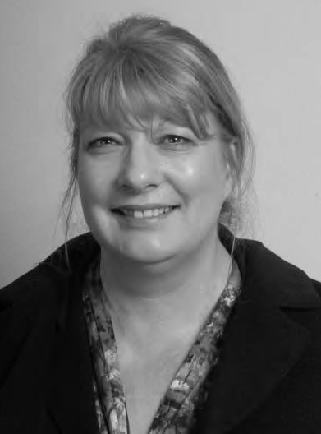

Mary-Anne Bath President
Monica McGhie Vice President
Sharon Vanderlaan Treasurer

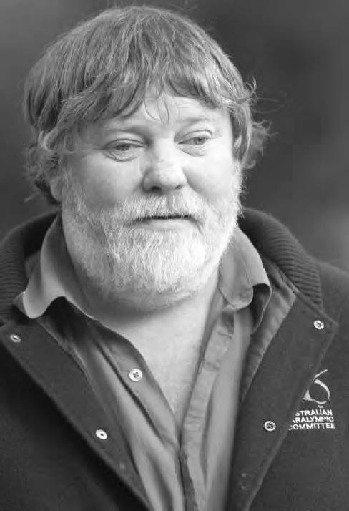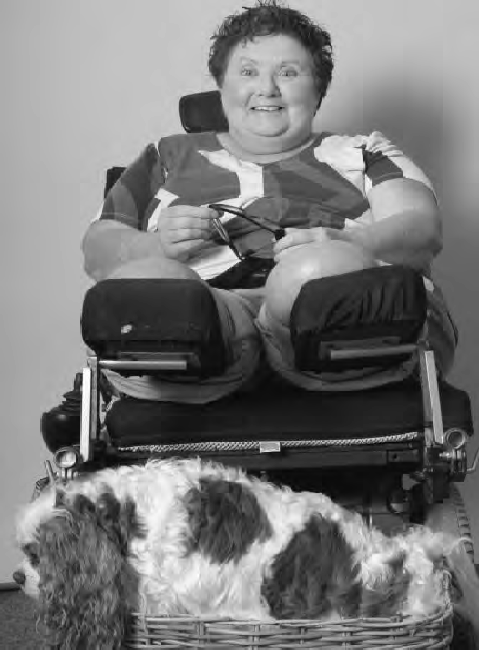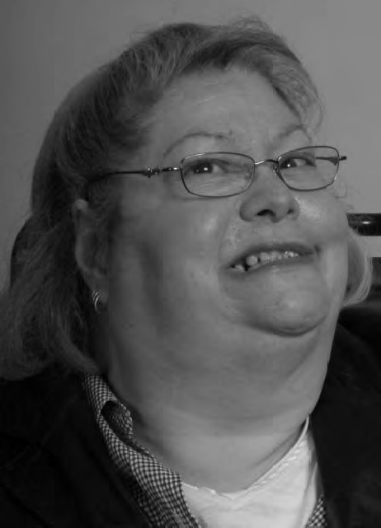

Greg Madson Secretary
Trish Anderson
Carme Elliot

David Hides
Samantha Neylon
Leah Thomlinson-Clements

Executive Director’s Report

The financial year began with a full staff complement following Mark Georke’s return to the Executive Director role. Unfortunately, Mark was unable to continue beyond August 2010. The Committee of Management asked me to take on the role in an acting capacity and undertake a review of the organisation. I became Executive Director permanently in December 2010. I am pleased to have been given the opportunity to contribute further to People With Disabilities(WA). It has a rich history of self-determination and advocacy with a deep commitment to those with a lived experience of disability.

In the first part of the year the staff team returned from our temporary home in West Perth to Oasis Lotteries House in Nedlands. Everyone worked to minimise the disruption to our services. The refurbished offices and large meeting room were a great boost to morale. The working environment has improved particularly as the result of the new equipment also generously funded by Lotteries West.

A large focus for everyone involved in the disability sector was the Productivity Commission’s Inquiry into Long term care and support. It was good that the Productivity Commission listened to what people with a lived experience of disability said and concluded what many of our members already knew. Service provision is unfair and fragmented. PWdWA is excited at the prospect of a fair go for every Australian. The work to make the Productivity Commission’s final report a reality will be long and detailed. This opportunity cannot be missed for people with disabilities to participate in shaping their future. The ‘Every Australian Counts’ campaign for a national disability insurance scheme (NDIS) has been well organised and inclusive. I commend the organisers and participants for their successes to date.
While there was a big focus on the NDIS our Individual and Disability First Stop Advocates, made sure that PWdWA was not distracted from the challenges that people with disabilities currently face each day. Advocates have continued to support people with the most pressing needs over the past 12 months. As ever Housing, Education, Health Services, support funding, and Centrelink were areas that were a challenge for many people. Western Australia has many excellent services that assist people with problems. I especially want to highlight the work of financial counselling services. They are a great asset and everyone at PWdWA values the real difference that they make.
Three new people have joined us in recent times. Dr Amber Arazi was welcomed to Oasis House earlier this year. Amber has a background in research and brings a set of skills that has added to the team’s strengths. She has a keen interest in Education that is accessible for everyone. Amber has assisted us to explore accessible information and the developing technologies that can permit this.
(continued page 7)

(continued from page 6)

Carol Franklin joined the Individual Advocacy service. Her new colleagues have benefited from Carol’s considerable experience as a campaigner for the rights of people with disabilities, their families and carers. Deborah Sommerfeld also joined us to assist with administration.
Many of you will know Senior Systemic Advocate, Kerrie Duff. Kerrie has served the organisation in various roles over several years. I am pleased to report that Kerrie left PWdWA in June to undertake studies in human rights. Everyone at PWdWA wishes her continued success.

In early 2011 Stuart Jenkinson, PWdWA’s longest serving Advocate took some well-deserved long service leave. We hosted a student on placement while Stuart was on leave. Michiko was a great asset and made valuable contributions to our work.

The role of the Committee of Management in providing good governance is central to the success of PWdWA. The fact that the majority of members have a lived experience of disability gives the organisation strength. There was great sadness earlier this year when Carme Elliot passed away. She greatly valued her role on the Committee of Management and will be dearly missed.

The Committee of Management are preparing for President Mary-Anne Bath to retire from her important role after six years in October 2011. She has made an invaluable contribution and her achievement will be celebrated. Mary-Anne has helped our organisation forge strong relationships with other organisations and agencies. PWdWA has benefited from the continuing membership of the Australian Federation of Disability Organisations (AFDO) and the cooperative working relationship we have with People with Disabilities Australia (PWDA). Our involvement in the Western Australian Disability Coalition continues to provide benefits for members and the people each represents. I was pleased to attend the opening of the Kimberley Advocacy Service(KAS) earlier this year in my role as a steering group member. I learned a lot during my visit to Broome from the great people that I met there. I have more insight into the challenges that people living and working in remote parts of the country experience. I am grateful that I was invited and thank the community representatives that made me so welcome.

The last 12 months has been very exciting for the organisation. We had our DSC funded services evaluated and receive positive feedback. We were informed that we had benefitted from a substantial increase in funding from the State Government over the next two years. I thank all my colleagues for their great work and support over the past year.

Andrew Jefferson Executive Director

Individual Advocacy

In 2010-2011 the Individual Advocacy Team provided , one to one, issue based, non- legal advocacy for people with disabilities living in Western Australia in a broad range of issues that affect their lives. Our priority is to focus on people who are most vulnerable or at risk. We tailor our service according to each individual’s needs by developing an action plan that reflects what the person wants to achieve and how PWdWA can support them to achieve their goals. We recognise that each case is different, but the principal of ensuring that people with disabilities and their families are heard and their rights upheld is shared in all cases.

PWdWA’s Individual Advocacy programs are funded by both the Disability Services Commission (DSC), and the Department of Families, Housing, Community Services and Indigenous Affairs (FaHCSIA).

Our services start when a person with a disability or someone who knows them approaches PWdWA because they are concerned about one or several issues that affect them. As part of the intake process PWdWA assess their eligibility for our services. When it is determined that Individual Advocacy from PWdWA is not required the caller is provided with information relevant to their issue or is referred to another agency that has the expertise in the area of concern. We also refer them to other advocacy services offered in their community, if required.

Once it is decided that PWdWA is the most appropriate agency to provide services an individual advocate will be allocated to the case. The client in conjunction with the advocate will decide roles and responsibilities of all stakeholders involved and actions to be followed. There is no guarantee that all our clients will have the positive outcome desired. However it has been proven that with the support of their individual advocate they learn about the services available for them and develop self-advocacy skills that they can use in the future.

Individual advocates always ensure that their clients have the opportunity to have their say. This can be achieved by assisting at meetings, researching information and facilitating the communication with people involved in their case. The service can extend to pre-meeting preparation, taking notes and ensuring that agreements are reached.

We also provide information about different complaints processes available according to the issue faced by the person with a disability. If necessary we support them through the process and help them to put together the complaint. We encourage our clients to speak for themselves and the advocate can facilitate that process, if necessary.

During the year, a successful outcome was achieved when an Individual Advocate supported the mother of child with multiple disabilities to secure funding to transport her child to a school that was not in their catchment area. This enables the child to attend the only school which meet his educational needs.
(continued page 9)

(continued from page 8)

Parents of children with disabilities have been supported at school meetings to ensure that schools make reasonable adjustments and put supports in place to guarantee the development of the child’s fullest potential.

A higher education student was supported to ensure that her study materials were given in alternative formats. These effective individualised measures maximised her academic performance.

Individual Advocates through Accommodation Advocacy have assisted people to negotiate with their service provider. Their aim is to improve their living arrangements and to ensure their wellbeing without compromising their decision making capacity and rights. PWdWA has also ensured a smooth transition between service providers for people who were not satisfied with the supports in place and decided to move with a service provider who listens and respects their choices while maintaining high standards of personal care and support.

An Individual Advocate accompanied a client to a meeting with her employer to ensure that they were taking into consideration her abilities and needs when doing her job. This has given the client the opportunity to have paid employment and inclusive participation in society.

People with disabilities were supported at hearings at the State Administrative Tribunal. The hearing could be a very stressful and intimidating situation for the person with a disability. Part of the individual advocate’s job is to ensure that they understand the process and have a say in the hearing.

The commitment showed by all Individual Advocates during 2010/2011 has translated into positive outcomes for people with disabilities in a wide range of issues. PWdWA will keep offering the advocates professional development opportunities that will strength our personalised services.

Peel Individual Advocacy

Now in the fourth year of operation, the Individual Advocacy Service in Peel, is funded by the Federal Department of Families, Housing, Community Services, and Indigenous Affairs (FaHCSIA) to provide and individual advocacy service to people with disability in the Peel Region. The service is currently funded for 22.5 hours per week; having been increased from 10.5 hours in early 2009. PWdWA extends it’s thanks to FaCHSIA for their continued support for advocacy for people with disabilities in the Peel Region.

The 2010/11 year saw individual advocacy support provided to clients involving working alongside people in activities that included; preparing for meetings, consideration of options, action planning, communication with Government Departments and other agencies, connection with appropriate services, and general support. It is important to note that, where possible, emphasis is placed on encouraging self-advocacy by providing information and encouragement that will assist the client with decision making and developing self-confidence.

There are a number of areas within which clients are provided with advocacy support; employment, finances, education, access to services, and transport to name a few. Interestingly in Peel however, it has been in the areas of housing and accommodation that has accounted for a significant number of cases. This coincides with other local agencies reporting increased housing pressures on lower income families and ongoing concerns about homelessness in the Region. There is certainly considerable demand for public housing in the Peel Region, reflecting the high cost of housing.

An important part of running a successful service in a regional area is developing good working relationships with other local community service organisations, Government Departments, and Local Government Authorities. By developing such positive, collaborative relationships with relevant agencies, there is a greater possibility of positive outcomes for clients. In keeping with this principle, the Peel Individual Advocate has attended meetings with a variety of agencies including; the Peel Network Service Providers Group, local Council staff, drug and alcohol workers, mental health professionals, Department of Housing, The Disability Services Commission, Midway Community Care, Peel Community Living, and Baptistcare. People with Disabilities (WA) has also been actively involved in the organisation of Peel Mental Health Week, and organised a well-attended forum in Mandurah on the proposed National Disability Insurance Scheme.

After a long and extensive search, PWdWA have finally been able to secure office accommodation for the Individual Advocate for Peel. Prior to this, the advocate has been operating from a home office. The new office is located at 63 Ormsby Terrace within The Parents Place, a family resource centre, and is ideally located for access. This office will provide the platform for an expanding disability advocacy program in the Peel Region and PWdWA, and especially the Peel Individual Advocate are very excited about the future of this service. We offer sincere thanks to the City of Mandurah for their cooperation and support in acquiring this office space.

Disability First Stop

Disability First Stop finally achieved a web presence on the Disability Services Commission website on 16 June 2011. Our thanks go to Richard Orr, Service Contract and Development Officer, for all his efforts in ensuring this long-awaited web-presence finally happened.

The four partner organisations for Disability First Stop include Ethnic Disability Advocacy Centre, Headwest, Kalparrin and People With disabilities WA. Each organisation caters for a specific client group with PWdWA targeting adults with a newly acquired disability. The four partner organisations meet quarterly to share information and resources to assist in the continuous improvement of the program.

Disability First Stop continues to provide information and support service for people with disability and their families within the first 18 months of diagnosis or where people:

- Are transitioning from hospital to community-based services.
- Are newly arrived in Australia and diagnosed with disability in their country of origin
- Have a deteriorating medical condition that requires disability support services.
- With a diagnosed disability receive a second diagnosis that requires assessment, information and support.

An example of a Disability First Stop Case Study follows: (identifying details have been changed to protect the person’s privacy)
Fred’s elderly mother was referred to Disability First Stop by the Disability Services Commission which she had contacted as she was concerned for her son who had sustained a disability as a result of various medical conditions. The son had been a patient in a tertiary hospital for over four months and had transferred to a rehabilitation facility where he had been for around two months when his mother contacted Disability First Stop.

The Disability First Stop Advocate organised a visit to the rehabilitation facility and met with the son. The Disability First Stop Advocate assisted in developing an Action Plan and following through with the required actions. These included liaison with Allied Health Professionals at the rehabilitation facility; liaison with the previous employer in regard to an application for release of a Total and Permanent Injury Insurance Payment; contact with Centrelink to clarify eligibility criteria for the Disability Support Pension, researching current information as to options for trialling independent living in accessible accommodation; assisting in the completion of paperwork and advocacy support to gain access to a Local Area Coordinator upon discharge into the community.

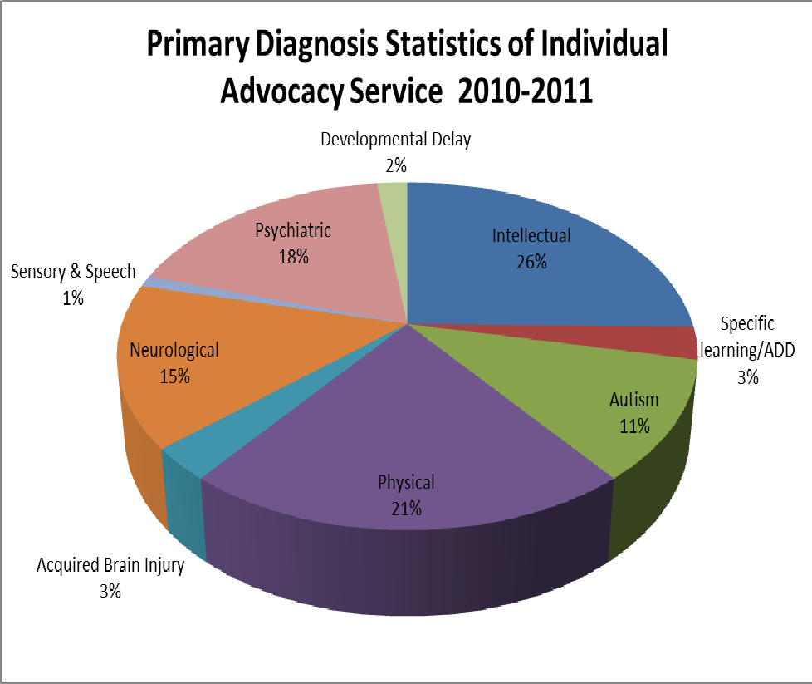

"At a time when every other door had been shut in my face in an attempt to right a very serious long standing wrong done to my family member with a disability, in desperation I turned to People with Disabilities.

Immediately my case was referred to an individual advocate and with her support, input and recording everything discussed with the agency concerned, the matter was righted.

Throughout the 35 days from initial contact with PWdWA until the resolution of everything, my advocate kept closely in touch with me, phoning regularly and visiting when appropriate. She was such a calming influence and very aware that the point of no return for me was very close.

I cannot speak highly enough of PWdWA and the service it provides. This is the third time they have supported me through very difficult situations with happy resolutions each time."

Information Advocacy

During 2010-2011 the advocacy team at PWdWA dealt with in excess of 550 requests for information via telephone and email. This represents a significant increase from the previous year. Whilst a large number of information enquires were from individuals with lived experience of disabilities, many enquires were received from people supporting people with disabilities in the community, both support workers and family members. Additionally a number of contacts were received from professionals such as Social Workers, Local Area Coordinators, Disability Service Providers and Local Government Officers.
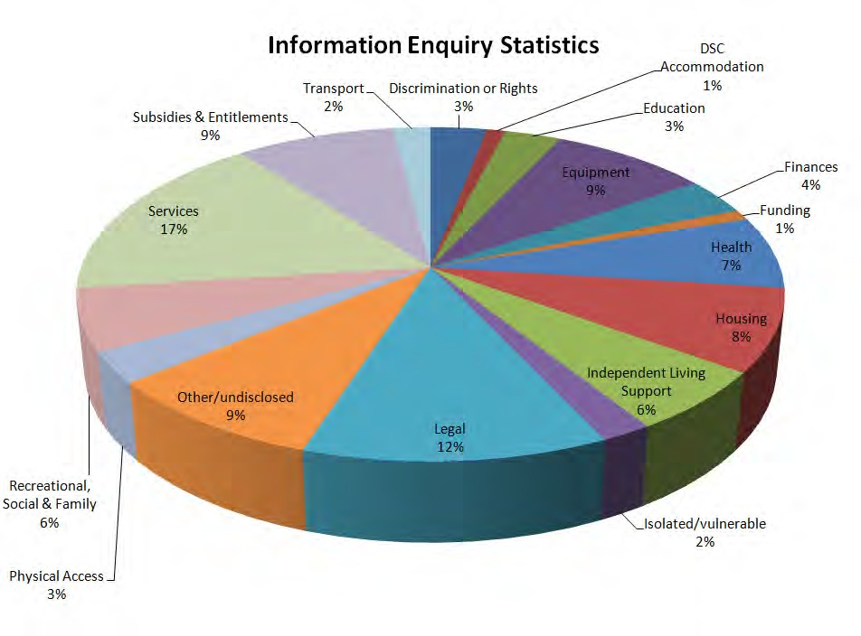

The PWdWA website www.pwdwa.org continues to be a powerful and effective tool in disseminating information about PWdWA’s activities to the community. During the year there was on average over 3000 visits per month to the website. PWdWA is now utilising Facebook as another way of sharing information with individuals and the wider community. Combined with the PWdWA website, Facebook allows PWdWA to keep members and others in the community up to date with current activities of the organisation, current issues in the media relevant to people with disabilities as well as upcoming events important to people with disabilities. PWdWA has trialled providing information in audio format and is continually looking at ways to provide information that meets the needs of people with disabilities in an ever changing world.

Self Advocacy WA

The Self Advocacy Western Australia group had an eventful year. There was a healthy mix of regular activities, some new people and interesting ideas. The monthly meetings were chaired by Karen Evans and involved a selection of members’ personal experiences with information sharing and discussion. PWdWA Executive Director Andrew Jefferson has attended some of the meetings. This has allowed for discussion and feedback about some of the current issues for people with a disability. The National Disability Insurance scheme, self-directed services, and employment are examples.

As part of a conversation about what the members might like to do in the future one meeting was spent reflecting on previous achievements using a large collection of photographs from years past. This session stimulated many memories and lead the group to invite some of the people involved to their Xmas in July breakfast. This event was a great success and has put old friends back in contact with each other. Looking at the photographs has increased members appetite to re-engage with other self-advocacy groups across the country.

Establishing and maintaining regular communication between people with an intellectual disability or other learning difficulties who are usually on limited incomes is a great challenge. SAWA members were quick to invite Amber Arazi to their meeting following her appointment with PWdWA earlier this year. Amber has started to introduce members to some of the developing technologies that may assist people to communicate with others, to help people with limited speech or literacy skills or people who have limited community access. Group members too had experience of computers and courses and they have shared how these have assisted their understanding and improved their communication skills. PWdWA have committed to support the group to address the costs of equipment and applications when they have been identified for each person.

As part of the evaluation of PWdWA services funded by the Disability Services Commission SAWA invited an Independent Evaluator to attend one of their meetings earlier this year. The evaluator appreciated the opportunity and thanked members for allowing her to participate. Several members took the opportunity to speak on a one to one basis with evaluators over the course of the evaluation process.

The SAWA group recognises that group members are getting older and that they need to plan for the future. Ill-health lead several members to be absent from meetings this year. The group was pleased to have a new member join this year and discussions about attracting younger people to the group continue. SAWA was effectively administered throughout the year through the commitment of Ian, Joyce and Bobby. Vice Chairperson Erica was invited to participate in a personal development course run by PWdWA for people aged under forty years. Erica’s great commitment to the course and important contributions were commented on by the facilitators. She reported that she had enjoyed participating and learned about many things. Erica was advised about the power of a smile. She has been smiling ever since.

Systemic Advocacy
2010 - 2011 has been a busy year for systemic advocacy. We value the PWdWA members, colleagues and associates who have helped to bring about positive changes for people with a lived experience of disability. Some work that has taken a lot of people and organisations across Australia many years of committed campaigning has finally been realised. It has been empowering to see different communities joining forces with a shared mission to improve universal access and services for all people with disabilities in Australia.

DISABILITY COALITION OF WA
PWdWA has continued to work in collaboration with our disability sector partners: Advocacy South West; Carers WA; Committed About Securing Accommodation; Developmental Disability Council; Ethnic Disability Advocacy Centre; Headwest; National Disability Services WA; Ministerial Advisory Council on Disability; and WA Association for Mental Health. The Coalition gives organisations within the disability sector the opportunity to discuss matters affecting people with a lived experience of disability and speak with one strong voice on matters where there is a common agenda.

The Coalition focus has been to address key issues affecting the lives of people with disabilities in Western Australia. These include: the Productivity Commission’s inquiry into long term care and support; self-directed services; services for people experiencing both an intellectual disability and a mental health condition, and health services.

CONSULTATION
In addition to our work with our Coalition partners, PWdWA members and staff have contributed to a number of other committees, reference groups and forums this year. These include:
- Accessible Public Transport Standards Review
- Australian Federation of Disability Organisations
- Australian Network for Universal Housing Design
- CaLD and Disability interagency network
- Clinical Senate of WA
- Education Forum: Parents as Partners
- Health Review Inform
- Housing Advisory Roundtable
- Medicare Consumer Committee
- National Disability / Injury Insurance Scheme Forums
- National Disability Service Standards Focus Group
- Office of Health Review (continued page 16)

- Post School Options Parent Group
- Synergy Consumer Committee
- Kimberley Advocacy Service reference group
- EAC review outcomes
- WACOSS peaks forum
PWdWA has also contributed to the review of several Disability Access and Inclusion Plans, and we are planning to set up a reference database including all the Disability Access and Inclusion Plans from the different WA councils, departments and agencies.

SUBMISSIONS TO GOVERNMENT
This year, PWdWA made several independent submissions to Government. These included submissions to:
- The Productivity Commission’s Inquiry into Disability Care and Support – National Disability Insurance Scheme (NDIS) and National Injury Insurance Scheme (NIIS).
- The Department of Education, Employment and Workplace Relations’ Review of the Disability Standards for Education 2005.
- The Department of Education, Employment and Workplace Relations’ Review of Higher Education Base Funding.
The full submission reports are available in alternative formats on PWdWA’s website www.pwdwa.org and in hard copy upon request.

PREPARE FOR TAKE OFF
In April 2011, PWdWA, together with the Ministerial Advisory Council on Disability and Disability Services Commission, launched the ‘Prepare for take off: air travel tips for people with disability’ booklet. The booklet offers a very useful guide for anyone with a disability planning to travel by air and includes a checklist to help ensure travellers have a safe and problem-free flight.
The ‘Prepare for take off’ booklet could not have been possible without the valued feedback received from air travellers with disability, their families, carers and travel companions.

NATIONAL DISABILITY STRATEGY
We are very pleased to report that this year saw the endorsement of the National Disability Strategy 2010-2020 by the Council of Australian Governments (COAG). The Strategy sets out six priority areas to improve the lives of people with disabilities, their families and carers: 1) inclusive and accessible communities; 2) rights protection, justice and legislation; 3) economic security; 4) personal and community support; 5) learning and skills; and 6) health and wellbeing.
PWdWA will continue to monitor the outcomes of the National Disability Strategy to help ensure that these priority areas are put into action.

Your Rights, Your Voice

Your Rights, Your Voice was a carefully designed project with the purpose of empowering adults with a disability under the age of 40. Six very committed participants and various presenters joined us in twelve weekly workshops that started in March and concluded in June 2011.

Workshops topics ranged from personal leadership, human rights, public speaking, communication skills, talent development, employment law and self-advocacy.

The participants learned goal setting strategies and discussed the importance of personal leadership in small group activities. This was followed by practicing their public speaking skills and sharing their stories. They consolidated their learning in communication skills with activities related to their body language, positive thinking and the power of the smile.

As part of the project the participants engaged in activities that prompted them to identify their interests, hobbies and strengths. They learned they can use their abilities to find a career pathway meaningful and enjoyable.

The Convention on the Rights of People with Disabilities, discrimination and Employment Law were topics that provoked very interesting discussions. The participants reflected on their experiences and shared their views. They also clarified their concerns and gained new knowledge.

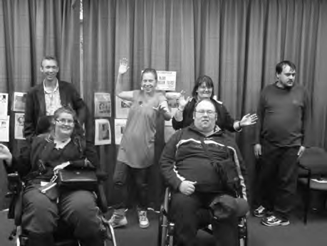An award ceremony was held on the 9th June 2011. The participants celebrated their achievements with friends and presenters. We would like to thank all the participants for their commitment and dedication to the project. Presenters spoke of a deeper appreciation of the challenges that participants face and greater respect for their efforts to understand concepts and the honesty of their approach to learning. The whole PWdWA organisation were energised and motivated to do more to empower people with disabilities and consult more with people about what they do and how they do it, as result of this experience.

PWdWA thanks The Disability Services Commission for funding Your Rights, Your Voice.

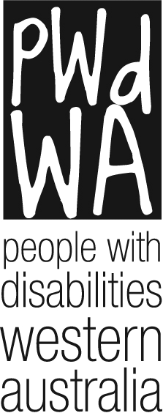

People With Disabilities WA Inc.

Financial Statements for the Year Ended 30 June 2011

19

PEOPLE WITH DISABILITIES {WA) INC

FINANCIAL STATEMENTS FOR THE YEAR ENDED

30 June 2011

  - Auditor's Report

  - Statement by President

  - Income Statement

  - Balance Sheet

  - Statement of Cashflows

  - Notes to and forming part of the accounts Notes 1 -10

20

PRINCIPAL:

RAY WOOLLEY PTY LTD

ACCOUNTANTS

ABN 30 0:56'll 1 1

19 BAYPORT CIRCUIT

RAY WOOLLEY f.C.A. (UK \, B.S.:. (lio ns)
PHONE: (08) 9408 5155
FAX: (08) 9408 5166
E.MAIL: rayw@iinet.net.au
MINDARIE WA 6030

PO BOX20l7
CLARKSON WA 6030

PEOPLE WITH DISABILITIES (WA) INC

INDEPENDENT AUDIT REPORT TO THE MEMBERS OF PEOPLE WITH DISABILITIES (WA) INC

Scope

The financial report and committee's responsibility.

The financial report comprises the balance sheet, income statement, cash flow statement, accompanying notes to the financial statements and the statement of the committee for People With Disabilities (WA) Inc for the year ended 30 June 2011.

The committee are responsible for the preparation and the true and fair presentation of the financial report and have determined that the accounting policies used and described in Note 1 to the financial statements which form part of the financial report are consistent with the financial reporting requirements of the Associations Incorporations Act (WA) and are appropriate to meet the needs of the members. This includes responsibility for the maintenance of adequate accounting records and internal controls that are designed to prevent and detect fraud and error, and for the accounting policies and accounting estimates inherent in the financial report.

The financial report has been prepared for distribution to members for the purpose of fulfilling the committees' financial reporting requirements under the Associations Incorporations Act (WA). We disclaim any assumption of responsibility for any reliance on this report or on the financial report to which it relates to any person other than the members, or for any purpose other than that for which it was prepared.

Audit Approach

We conducted an independent audit in order to express an opinion to the members of the organisation. Our audit was conducted in accordance with Australian Auditing Standards, in order to provide reasonable assurance whether the financial report is free of material misstatement. The nature of an audit is influenced by factors such as the use of professional judgement, selective testing, the inherent limitations of internal control, and the availability of persuasive rather than conclusive evidence. Therefore, an audit cannot guarantee that all material misstatements have been detected.

We performed procedures to assess whether in all material respects the financial report presents fairly, in accordance with the Associations Incorporations Act (WA), including compliance with Accounting Standards and other mandatory financial reporting requirements in Australia, a view which is consistent with our understanding of the organisation's financial position, and of its performance as represented by the results of its operations and cash flows.

PRINCIPAL:

RAY WOOLLEY PTY LTD

ACCOUNTANTS

i\BN JO Ol 227 297

19 BAYPORT CIRCUIT

RAY WOOLLEY F.CA (UK1. B , (HonJl
PHO E: 08) 9408 515
FAX: (08) 9408 5166
E.MA lL: rayw@iinet.net.au
MlNDARIE WA 6030

PO BOX 2017
CLARKSON WA 603

PEOPLE WITH DISABILITIES (WA) INC

INDEPENDENT AUDIT REPORT TO THE MEMBERS OF PEOPLE WITH DISABILITIES (WA) INC
continued

We formed our audit opinion on the basis of these procedures, which included:

examining, on a test basis, information to provide evidence supporting the amounts and disclosures in the financial report, and
assessing the appropriateness of the accounting policies and disclosures used and the reasonableness of the significant accounting estimates made by the committee.

While we considered the effectiveness of the management 's internal controls over financial reporting when determining the nature and extent of our procedures, our audit was not designed to provide assurance on internal controls.

Independence

In conducting our audit, we followed applicable independence requirements of Australian professional ethical pronouncements.

Audit Opinion

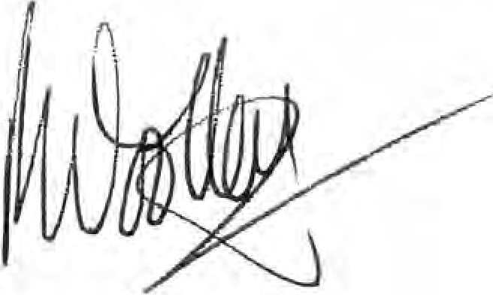
In our opinion, the financial report of People With Disabilities (WA) Inc presents a true and fair view in accordance with the accounting policies described in Note 1 to the financial statements, of the financial position of People With Disabilities (WA) Inc as at 30 June 2011 and the results of its operations and its cash flows for the year then ended.

Ray Woolley Pty Ltd Ray Woolley
Registered Auditor No 16396
27 September 2011

19 Bayport Circuit Mindarie
WA 6030

PEOPLE WITH DISABILITIES (WA) INC

STATEMENT BY PRESIDENT

For The Year Ended 30 June 2011

The Board of Management declare that:

- The attached financial statements and notes thereto comply with accounting standards

- The attached financial statements and notes thereto give a true and fair view of the financial position and performance of the association; and

- In the Board of Management's opinion, there are reasonable grounds to believe that the Association will be able to pay its debts as and when they become due and payable.

Signed on behalf of the Board of Management
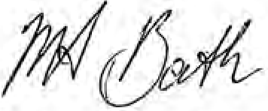
Mary-Anne Bath President

Date: 1/ /10/f
PERTH, WA

PEOPLE WITH DISABILITIES (WA) INC
Balance Sheet
As at 30/06/2011

 | Note | 2011 2010  $ $
Current Assets
Cash at Bank and on Hand | 3 | 335,105 297,813
GST - Input Tax credits |  | 3,065 8,465
Debtors- and Prepayments |  | 400 3,3 46
Total Current Assets |  | 338 ,570 309,624
Non-current Assets
Plant/Equipment and Vehicles | 2 | 29,641 26,066
Total Non-current Assets |  | 29,641 26,066
Total Assets |  | 368,211 335,691
Current Liabilities
Sundry Creditors and Accrued Expenses | 4 | 17,605 12,687
Income Rece ived in Advance | 5 | 37,950 81,875
GST - collected |  | 14,120 18,630
Provisions - Annual Leave & Sick Leave | 6 | 41,371 28,711
- Long Service Leave  - Refurbishment | 6 | 16,218 10,063  21,580 '21,580
Total current liabilities |  | 148,844 173,546
Non Current Liabilities
Provisions - Long Service Leave | 6 | 28,123 28,123
Total Non Current liabilities |  | 28,123 28,123
Total Liabilities |  | 176,967 201,669
Net Assets |  | 191,244 134,022
Accumulated funds |  | 191,244 134,022

PEOPLE WITH DISABILITIES {WA) INC

Income Statement
For the financial year ended 30/06/2011

 | Notes |  | 2011  $ |  | 2010  $
Revenue from Ordinary Activities
Grants
- Disability Services Commission |  |  | 371,153 |  | 344,972
- FAHCSIA |  |  | 250,647 |  | 206,981
- Lotterywest |  |  | 13,114 |  | 76,214
- Other Grants |  |  |  |  | 0
Interest |  |  | 9,043 |  | 8,941
Donations & fundraising |  |  | 50 |  | 640
Membership |  |  | 833 |  | 2,301
Profit on Sale of Assets |  |  |  |  | 630
Sundry Income |  |  | 10,064 |  | 33,029
Total Revenue from Ordinary Activities |  |  | 654,904 |  | 673,708
Expenses from Ordinary Activities
Accounting and Audit fees |  |  | 5,012 |  | 5,073
Advertising and recruitment |  |  |  |  | 6A64
AGM and General Meeting costs |  |  | 2,206 |  | 6,665
Depreciation |  |  | 11,595 |  | 9,609
Equipment Expenses |  |  | 9,559 |  | 31,008
Insurances - General & Motor Vehicle |  |  | 9,423 |  | 8,068
I.T. Expenses |  |  | 9,371 |  | 15,229
Newsletter |  |  | 886 |  | 836
Postage |  |  | 722 |  | 1,403
Printing and Stationery |  |  | 14,074 |  | 17,204
Rent |  |  | 23,161 |  | 60,108
Repairs and Maintenance |  |  | 1,481 |  | 4,963
Salary and wages costs |  |  | 464,710 |  | 431,827
Subscriptions |  |  | 2,892 |  | 701
Telephones |  |  | 8,342 |  | 12,715
Transport Costs |  |  | 10,029 |  | 9,617
Workshops/consultants |  |  | 4,341 |  | (7,102)
Utilities |  |  | 285 |  | 1,631
Other Expenses |  |  | 19,593 |  | 19,996
Total Expenses from Ordinary Activities |  |  | 597,682 |  | 636,015
Operating surplus/(deficit) |  |  | 57,222 |  | 37,693
Non-Operating Revenue | 7
Total surplus/(deficit) |  |  | 57,222 |  | 37,693

$
STATEMENT OF CASH FLOWS
 | 2011 | 2010
 | i  Inflows | $ i  Inflows
 | (Outflows) | (Outflows)
Cash flows from operating activities
Grant Income | 590,989 | 676,522
Interest Received | 9,043 | 8,941
Membership and Donations | 883 | 2,941
Other Income | 10,064 | 33,029
Payments to Suppliers and Employees | (558,518) | (722,371)

Net cash provided by/(used in) operating activities 52,462 (938) Cash flows from investing activities
Non-operating Income  Proceeds from sale of property, plant and ec |  | 8,636
Payment for property, plant and equipment (15,170)  Net cash provided by/(used in) or from investing activities | (15,170) | (16,657) | (8,021)
Net increase in cash held | 37,292 |  | (8,959)
Cash at beginning of the financial year | 297,813 |  | 306,772
Cash at the end of the financial year | 335,105 |  | 297,813

STATEMENT OF CASH FLOWS

(a) Reconciliation of Cash

For the purposes of the statement of cash flows, cash includes cash on hand a,nd in banks a,nd investments in money market instruments, net of outstanding bank overdrafts. Cash at the end of the financial year as shown ,in the statement of cash flows is reconciled to the related items in the balance sheet as follows:

Cash

212,360

180,994

Deposits at Call

- Financing Facilities

No facilities are in place as at 30 June 2011
122,745 116,819
335,105 297,813

- Reconciliation of net cash provided by operating 2011 2010
activities to operating surplus. i 1
Operating surplus/(deficit) 57,222 37,693

Profit on disposal of non-current assets {630)
Depreciation and amortisation of non-current assets 11,595 9,609 Non operating income
Changes in net assets and liabilities
Decrease/(fncrease ) in current receivables 8,346 (6,139}
Increase/ (decrease) in current creditors 408 (23,739)
Increase/ (decrease} in curtent provisions 18,815 (3,270)
Increase /(decrease) in income in advance (43,925) (14,462) Net Cash provided by/(used in) operating activities 52,462 (938}

PEOPLE WITH DISABILITIES (WA) INC

Notes to and forming part of the accounts For the year ended 30/06/2011

1 Summary of Accounting Policies

The principal accounting policies of the Association, whtch are set out below, have been consistently followed in all material aspects.

- The accounts ate prepared in accordance with the historical cost convention.

- The provision for long service leave is calculated at current rates of pay for all staff from their date of commencement Long service leave entitlement is due after 7 years servfce for the first and subsequent terms.

The Association's Performance Agreement with the Disability Services Commission now requires it to make provision tor Long Service Leave as per its employee entitlement policy.

- Holiday pay is accrued based upon holiday entitlement and pro-.rata at current rates of pay plus 17.5% loadings, Superannuation and Workers Compensation liabilities for applicable staff.

- Provision for Sick Leave has been accrued on the basis of 50% of the outstanding balance as at 30 June 2011 , plus superannuation and workers compensation liabilities for applicable staff.

- Depreciation is calculated on a straight line basis so as to write of the net cost of each fixed asset during its expected life. The depreciation rates used are:

Plant and Equipment 20°/c
Furniture & Fittings 20%
Motor Vehicles 20%
Computers 33%
Buildings 2.5'¾

Since June 2000 it has been the policy of the Association to not capitalise items less than
$5 ,000 in value. These amounts are written off wholly in the year of purchase. The Association is not funded for capital replacemeht within it's current grant structure and does not have the capacity to put aside cash reserves to cover these expenses.
Component parts will be grouped together to determine the value to be used in determining the $5,000 limit.

PEOPLE WITH DISABILITIES (WA) Inc

NOTES TO AND FORM ING PART OF THE ACCOUNTS
For the year ended 30/06/2011

2 | Plant/Equipment and Vehicles  Gross Carrying Amount | Plant/equip | Vehicles | Total
 | Balance as at 30 June 2010 | 60,960 | 33,714 | 94,674
 | Additions | 15,170 |  | 15,170
 | Disposals
 | Balance as at 30 June 2011 | 76,130 | 33,714 | 109,844

Accumu lated Depreciation

Balance as at 30 June 2010 (60,615) {7,993) (68,608)
Disposals
Depreciatioh Expense {4,852} (6,743} p1,5952
Balance as at 30 June 2011 (65,467} {14,736} {80,203}

Net Book Value

Balance as at 30 June 2010 345 25,721 26,066

Balance as at 30 June 2011 10,663 18,978 29,641

2011 2010
$ $
3 | Cash at bank and on hand
 | Cash on hand | 300 | 300
 | Cash at bank - Bankwest General Accou nt | 78,133 | 49,613
 | Gold Cash Management Account | 133,927 | 131,081
 | Bankwest - Term Deposits | 122,745 | 116,819

335,105 297,813

4 | Sundry Creditors
 | Creditors general | 8,438 | 5,448
 | Accrued expenses | 9,167 | 7,240
 |  | 17,605 | 12,687
5 | Income Recei ved in Advance
 | FAHCSIA | 17,000 | 24,708
 | Disability Services Commission | 1 6,350 | 38,471
 | Lotterywest  Redress |  | 14,096
COFA 4,600 4,600
37,950 81,875

6 | Current Provisions  Employee Entitlements:
 | Long Service Leave - short term | 16,218 | 10,063
 | Long Service Leave - long term | 28,123 | 28,123
44,341 38,186
Annual Leave |  | 32,513 | 23,081
Sick Leave |  | 8,857 | 5,630
 |  | 41,371 | 28,711

PEOPLE WITH DISABILITIES (WA) Inc

Notes to and forming part of the accounts
For the year ended 30/06/2011

2011
$
2010
$

- Non Operating Income

Disability Services - vehicle FAHCSIA

- Related Party Disclosure

The members of the Committee of Management during the 2010/2011 year were;

Ms Mary-Anne Bath (President}
Ms Monica McGhie (Vice Presiden t) Ms Sharon Van der Laan (Treasurer} Ms Carmeline Elliot
Ms Trish Anderson
Mr David Hides (Resigned} Mr Greg Madson (Secretary} Ms Leah Tomlinson-Clemens Ms Samantha Neylon

- Superannuation

The Association sponsor.. the following superannuation plan for employees, the de1ails of which are set out below:

Funds Vary based on personal choice.

Type of Benefits

Contributions by :

.Employee

.Employer
Accumulation of contributions of employee and employer. Covering all employees earning in excess of $450 per calendar month and providing benefits on retirement, death or permanent disability.

Nil to Unlimited based on personal choice 9% based on Government Legislation.
The Association has a legal obligation to contribute as set out in the Superannuation guarantee legislation, but has the right to vary the rate of, orterminate, contributions upon giving notice as
prescribed in the deed, subject to superannuation guarantee conditions.

Each fund is self administered by the Superannuation Company

pwd
������ ����
������������
�������
���������
People With disabilities (WA) Inc.

Email: info@pwdwa.org Website: www.pwdwa.org
Oasis Lotteries House 1/37 Hampden Road Nedlands WA 6009 Ph: (08) 9485 8900 Fax: (08) 9386 1011
Country: 1800 193 331 TTY: (08) 9386 6451

