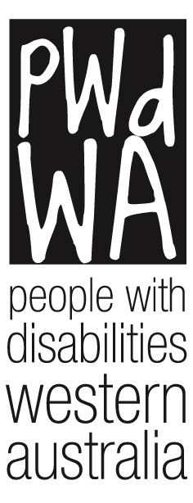

**People with disabilities WA**

**Annual Report 2018-2019**

Acronyms used in this report

AAT Administrative Appeals Tribunal

AFDO Australian Federation of Disability Organisations

AGM Annual General Meeting

AT Assistive Technology

CEO Chief Executive Officer

CoMHWA Consumers of Mental Health Western Australia

DFO Diversity Field Officer

DoC DS Department of Communities – Disability Services

DSP Disability Support Pension

DSS Department of Social Services

HACC Home and Community Care

ILC Information, Linkages, and Capacity Building

NDS National Disability Services

NDIA National Disability Insurance Agency

NDIS National Disability Insurance Scheme

PWdWA People With disabilities (WA) Inc.

SACS Social and Community Services Award

SAWA Self Advocacy WA

WA Western Australia

WA NDIS Western Australian NDIS

WWDWA Women with Disabilities Western Australia

**Contents**

About Our Organisation

From Our President

Committee of Management

From Our Executive Director

PWdWA Staff

PWdWA Members

Key Achievements

Individual Advocacy

Trends and Case Studies

Systemic Advocacy

Projects

Key Relationships

Treasurers Report

Financial Statements

**About Our  
Organisation**



**Our Vision**

People with disability are equal and valued citizens.

**Our Mission**

Advocating for the rights, and empowering people with disability in WA.

**We value**

* Human rights
* The unique experiences of people with disability
* Self-empowerment- supporting people to take control of their own lives

**Guiding principles**

**We will:**

* Be passionate, innovative and fearless in defending and promoting the rights and interests of people with disability.
* Be available to people to listen and respond to their needs.
* Adapt our services to suit people’s individual needs and circumstances.
* Be well researched and think carefully about our advice and actions.
* Work and maintain relationships with other organisations who have similar aims and objectives.
* Be open and honest about everything we do.
* Use resources in the most efficient way possible.
* Involve people with disability in everything we do.
* Value our staff, committee and volunteers**.**

**PWdWA is funded by the Department of Communities - Disability Services WA (formerly DSC) and the Department of Social Services**

**From Our   
President**

2019 has been an effective and industrious year for People with disabilities WA. We continued our ongoing core work of providing individual advocacy to the WA community, and furthermore we have successfully achieved funding for, and undertaken, a number of successful projects as detailed in our Executive Director’s report. We have tried to be involved in issues wherever possible, ever mindful of our financial restraints. After efforts by the Committee and Executive Director to locate suitable office space, we were very happy to move into the City West Lotteries House in May to larger, more appropriate premises with only two days’ disruption.

We continue to strive to our strategic goal of wider recognition as the peak disability rights and advocacy organisation in WA. Our membership increased by 11% and will continue to grow with the commencement of our membership capacity building project. Our social media reach has doubled since our last AGM and the committee have remained focused on including all people with disabilities by attending events and expositions to share with and hear from our community.

We continue to provide high quality advocacy programs to people across WA thanks to our hard working staff, alongside our consortium partners. PWdWA have been vocal in the media regarding a range of systemic issues, and our committee have engaged with members on issues affecting them.

In May 2019 we underwent a Quality Evaluation surveillance under the National Standards for Disability Services as a requirement of our DSS funding. We are proud to have earned positive feedback:

“All of the Interviewees felt that People With disabilities WA went beyond the bounds of what one would consider to be normal operations. They also gave notable comment that they felt that the Management and Staff Members did so much with very little financial resources to deliver advocacy services to people in all areas”

Our co-design and board capacity projects allowed us to achieve our strategic goal of building the capacity of people with disability and the community. The outcomes of our projects, which are conducted as an adjunct to our core individual advocacy work, remains impressive for the small size of our team.

Finally, the committee continued to maintain responsible and strong governance, including a special general meeting to review our new constitution and our members meeting to seek ideas on future projects for our community. We are appreciative to our committed, approachable and diverse group of people living with disability on our committee who are actively involved in all organisational decisions and events. Thank you for your work Janine, Karen, Simon, Bob, Adam, Ness, Matt and Erika our secretariat.

This year we say farewell to Elizabeth Edmondson who participated on our committee in the secretary role for some years. Our other farewell is Ingrid Moore who after six years on the committee has earned a well deserved rest. A heartfelt thank you Elizabeth and Ingrid.

On behalf of the PWdWA committee, I would like to thank all the highly skilled PWdWA staff for an astounding effort this year. Special thanks to Samantha Jenkinson, our knowledgeable and approachable executive director.

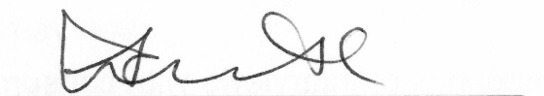

Lisa Burnette

President

Committee of Management 2018-2019

**Lisa Burnette** – President

**Janine Neu** – Vice President

**Karen Anderson** - Treasurer

**Adam Hewber** – Committee Member

**Bob Johnson** – Committee Member

**Ingrid Moore** – Committee Member

**Matthew Lee** – Committee Member

**Simon Chong** – Committee Member

**Vanessa Vlajkovic** – Committee Member

**Erika Webb** – Secretariat

**From Our   
Executive Director**

PWdWA has grown as an organisation over the past year and is reaching the strategic objectives set by members of having an increased profile, quality advocacy services, and successful projects all aimed at the rights, and empowerment of people with disability. We have been working on multiple projects and seen a 70% increase in the number of people supported through advocacy, with an office move adding an extra workload this year.

Our core business remains as Individual Advocacy with good outcomes for many people particularly in NDIS reviews and in DSP Appeals (see Individual Advocacy report for case studies and trends). Last year was the first time we reported needing to put in place a waiting list. The NDIS and the Disability Royal Commission have both raised the profile of disability issues in the community, with a lot of increased demand related to NDIS reviews and issues with transition. Even with increased funding from the Department of Communities that allowed us to employ another 4 day a week advocate in 2018-19, we have continued to have a waiting list and priority process due to demand. Our consortium partners, Advocacy WA and Sussex St Community Law Service IDAS have also experienced increased demand.

Although we have actively been raising our profile through collaboration with peer groups, involvement with broad projects, and attendance at expos and events, we have not specifically advertised our advocacy services. The role and need for independent advocacy is being recognised more by the sector with referrals for advocacy continuing to come by word of mouth, but also through providers, the NDIA, and LACs. As yet we are not seeing a commitment from either State or Commonwealth governments for funding of advocacy beyond 2020. This is of grave concern for people with disability in WA, and we hope our members will support us in advocating for future funding.

PWdWA receives some funds from DSS to undertake systemic advocacy, and in 2019 was successful in a Systemic Advocacy grant from the state as part of the Disability Coalition to work on issues of NDIS transition. Working collaboratively the Disability Coalition is having a wide reach in the engagement work to gather evidence on the issues affecting people.

At a systemic level, we are working to influence policy and practice to better cater to and reflect the needs of people with disability. This year I have been involved in meetings, advisory, and reference groups on topics like housing, self-management, and NDIS Industry issues. Our report highlights the areas where we prioritised the systemic advocacy work we do and some of our achievements. The trends and case studies from our consortium and individual advocacy work also feed into our systemic advocacy. The NDIS and transition to NDIS continues to be over half of our systemic advocacy, on top of our specific NDIS systemic project.

PWdWA is often asked to present at events, provide advice, take part in advisory groups, and put in submissions to inquiries. All the submissions we make are publicly available on our website. This year the submissions have been on issues ranging from transport to short stay accommodation. Examples of areas we have been asked to present and/or provide advice on are:

* Leadership WA Leadability program
* Housing and the NDIS
* NDIS Contemporary Practice and Innovation
* NDIS Employment Taskforce
* NDIS Self Management
* NDS Training Community of Practice
* Job Access Disability Employment
* Tenancy WA Tenancy Conference
* 1800 Respect Referral Pathways
* WA Women’s Plan and Family and Domestic Violence Strategy
* Co-design of services

This is a direct result of the status of PWdWA as a peak body, and our reputation and ability to represent the diverse views of people with disability. In reality, this work is mostly done through my role as it is not adequately funded, and relies on the time available outside of organisational management. Without volunteers from the Committee of Management and support from the Individual Advocacy Manager and our Advocates this work would not be possible.

We have also had a number of projects funded and continuing for work in specific areas. These projects are detailed further in the report and include; Stage 2 of Connect with Me: co-design funded by Department of Finance; the Diversity Field Officer Service; On Board with Me (Board Disability Diversity project); and Empowering Health Consumers with Disability (partnered with Health Consumers Council) - all Information, Linkages, and Capacity Building (ILC) grants funded by Department of Communities. PWdWA is also a partner in ‘The lives we lead’ project supporting the video stories and contributing to the co-design of the format, stories and Gala Ball to be held in December 2019.

As part of increasing staff capabilities, leadership skills, and networking opportunities, I participated in and graduated from the Signature Leadership program of Leadership WA in 2018, and Brianna Lee was accepted into the Rising Leadership program this year. We both had partial scholarships thanks to the Department of Communities and Leadership WA.

This year we have aimed to provide staff with opportunities to connect with the NDIA, Legal Aid and our Consortium partners and other advocacy organisations so they are up to date on issues. When we are in times of stress due to the high demand and tensions of transition in the sector, it has become extremely important for advocates and advocacy organisations to work together.

To Tania McInness at Advocacy WA and Jane Timmermanis from Sussex St Community Law Service, thank you for continuing to work with me in our successful consortium partnership.

Thank you to all the staff, students, interns, and volunteers who have helped us reach our goals this year. The PWdWA advocates are passionate about human rights and have worked tirelessly to assist people through some stressful periods of high demand. Our administration and project staff at PWdWA have provided support, resources, and commitment to their projects. I particularly thank Brianna Lee who has provided support to the whole team and to me in my role as Executive Director.

The Committee of Management have been supportive of the organisational direction, and actively involved in engaging with members and promoting the organisation and value of lived experience of disability in governance. Special thanks to Lisa Burnette, our President, who has been an active and committed leader of PWdWA.

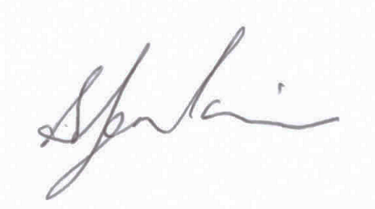

Samantha Jenkinson

Executive Director

**PWdWA Staff**

Samantha Jenkinson – Executive Director

Brianna Lee – Individual Advocacy Service Manager

Lisa Hook – Individual Advocate

Michele Frost – Individual Advocate

Rachael Cox – Individual Advocate

Elisha Johnson – Individual Advocate

Glenda Bye – Individual Advocate

Mark Hutson – Individual Advocate

Kerry Kessner – Individual Advocate

Anne Livingston – Project Officer

Jessica Eastaugh – Project Officer

Martin Duff – Project Officer

Tracy Destree – Project Officer

Sonya Gozuacik – Administration Officer

Renata Krollig – Administration Officer

Faye Hicks – Projects Manager (Resigned)

Andrew Fairbairn – Project Officer (Resigned)

Mala Saraswati – Individual Advocate (Resigned)

Nick Wilson – Individual Advocate (Resigned)

Natalie Turner – Project Officer (Resigned)

**PWdWA Members**



PWdWA values the feedback and information our members provide us. They are an integral part of our advocacy work. Members are regularly updated about our activities throughout the year and invited to participate and give feedback. People with disability are invited to become full members. Families and friends are invited to become associate members and we also offer organisational memberships.

Connect with Me project logo. Multicoloured wheel with 6 segments. Arrows pointing to the next segment suggesting a continuous loop. The words 'Co-design elements' inside wheel. Segment 1 Engage. Segment 2 Plan. Segment 3 Explore. Segment 4 Develop. Segment 5 Decide. Segment 6 Change.

**We are working with the WA State Government to help them co-design the new State Disability Plan**



**We sat on working groups for NDIS and WA NDIS. We raised key issues about how NDIS and mainstream services are working together**



**Key Achievements**



**We introduced our new Constitution to ensure we meet legislative requirements. The Constitution was accepted at a special general meeting.**

**747**

**The number of people with disabilities supported by our Individual Advocates**

**We secured Systemic Advocacy funding for NDIS Transition issues from the State Government.**



**We moved offices to City West Lotteries House. Our new office is easier to reach and more accessible.**

**We worked on transport issues including hosting a transport forum, and making a submission on Disability Standards for Transport.**

**We have received over 300 responses to our Your NDIS Experience survey. To participate see the link on our website  
www.pwdwa.org**

**The Royal Commission into Abuse, Neglect, Violence and Exploitation was announced. This is something we have fought hard for.**

**Individual Advocacy**

In 2018-2019 PWdWA provided independent, non-legal Individual Advocacy that is issues-based and client-directed to people with disability living in Western Australia. Individual Advocates work alongside people with disability when they feel they have been treated unfairly or seek a solution to a specific issue. Our services include providing information, making supported referrals and individual advocacy for standard and complex cases.

PWdWA is funded by Department of Communities Disability Services (52%) and by the Department of Social Services (48%) to provide Individual Advocacy state-wide. DSS funds both our general advocacy and our NDIS Appeals advocate.

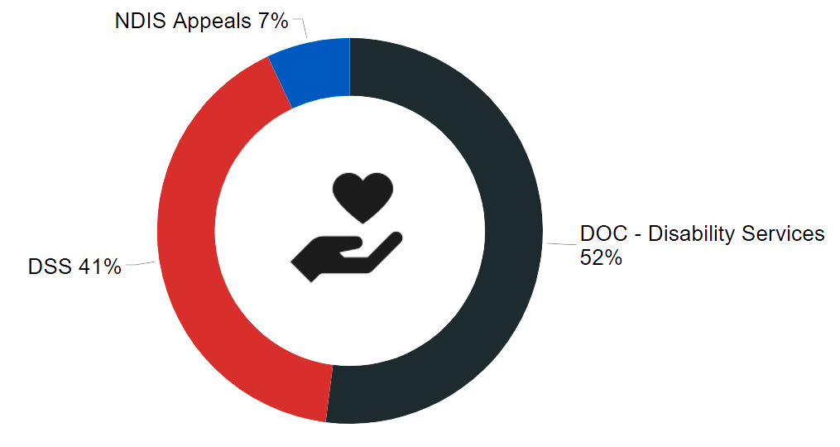

Across all our funding types we supported 747 individuals with 950 issues. This is over 200 people more than we assisted last year. It shows the increased demand for individual advocacy support we are experiencing. Because of the increased demand for support, PWdWA had a waitlist for the entire year. We also had to close our waitlist to non-urgent issues for a month. This was a first in PWdWA history. We thank our individual advocacy team for their hard work throughout the year, and their dedication to the people we support.

As part of our funding from Disability Services, PWdWA continues to work as a consortium with Advocacy WA and Individual Disability Advocacy Service (part of Sussex Street Community Law Service). The consortium advocates met in May 2019 to take part in our annual Consortium update and training in our new West Perth office. As a consortium, we have supported 985 individuals across the state.

To ensure that PWdWA are continuing to provide quality service, advocates took part in training and professional development. Training included topics such as working with people experiencing domestic violence, suicide prevention, tenancy rights, and NDIS reviews and appeals. Some of the events our staff took part in included Abilities Expo and NDIS expos and education sessions across the metro area.

The bar graph above shows the types of issue our Individual Advocates have assisted with and how frequent they were. Major issues experienced by people contacting our service during this period include: NDIS; Financial Issues and Government Payments; Service Complaints and Equipment; and Housing.

The graph above shows disability types for our clients. Physical disability, autism, neurological and Psychiatric disability were the most reported types of disability.

**Trends and Case Studies**

NDIS

NDIS continued to rollout across the state this year. People were transferred from WANDIS to NDIS but many did not receive ‘like-for-like’ supports as promised. We also saw a decrease in funded supports when transitioning to NDIS from state funded supports and following annual plan reviews. The quality of NDIS and Local Area Coordination planning services was also a significant issue faced by the people PWdWA supported. Advocates also faced difficulties communicating with NDIA on participants’ behalf.

**Cate’s Story**Cate is a 19 year old woman with a learning disorder. Cate was previously block funded and transitioned over to NDIS. Cate was not involved in her initial NDIS planning meeting and the plan that she got did not include enough funding for her to transition from school and start building her independence and connection to the community. The advocate worked with Cate to understand what she wanted from her NDIS plan, and what supports she needed to reach her goals. The advocate supported Cate and her family to gather additional evidence for an Internal Review of Cate’s NDIS plan. With the support provided by the advocate Cate was able to self-advocate at her Internal Review meeting for what she wanted and the resulting new plan included all the supports Cate needed to achieve her goals.

Disability Support Pension (DSP)

Requests for assistance with Disability Support Pension continue to be a large portion of advocacy cases. Most people who seek out the help of an advocate do not understand the complex DSP eligibility criteria, or what sort of evidence they need for an application. PWdWA referred on to Welfare Rights Advocacy services wherever appropriate and focused on supporting people with disability who had no other supports and could not access the evidence they needed without an advocate. PWdWA advocates have also developed an easy to use DSP Report Template for medical professionals to help them include all the relevant evidence for a report.

**Jayda’s Story**Jayda contacted PWdWA for assistance with an application for the DSP after Centrelink rejected her first application. Jayda’s doctors did not understand what information they had to include about her disabilities. The advocate met with Jayda and explained the information that Centrelink requires. The advocate read Jayda’s medical evidence and made notes for what information was still missing. The advocate provided a template letter to Jayda for her doctor to fill out. The advocate offered to go to the appointment and answer any questions. Jayda took this template to her doctor to complete. The doctor wrote another letter and Jayda submitted a new application to Centrelink. Centrelink approved Jayda’s DSP application three months later.

Housing

PWdWA assisted individuals who wished to make housing related complaints, and provided referrals to agencies when they were facing imminent eviction or required support from a tenant advocate. PWdWA also assisted a number of clients who were facing eviction from supported accommodation.

**Aaron’s Story**Aaron, a man in his 50s with a physical disability, lived in a Housing Authority home which was not accessible. He had requested home modifications and was unsure why the Department had declined his request. He contacted PWdWA because a tenancy advocate had said they could not help him. His advocate was able to connect him with his local tenancy advocate for support. The tenancy advocate told Aaron that his home was too old for modifications and the Department wanted to help move him to a new property which was more accessible. The PWdWA advocate supported Aaron to liaise with Housing Authority to view a new property. The Housing Authority also asked Ben to complete paperwork at very short notice which Ben did not understand. The PWdWA advocate supported Ben to understand the paperwork and negotiated an extended deadline for it to be submitted. Aaron was able to move into a new, more accessible property.

Guardianship

A concerning trend has been the increase in Guardianship applications related to NDIS. Anecdotally we have been told that the NDIA is encouraging parents and families to apply for Guardianship to make it easier to deal with NDIS. We are also continuing to see applications by service providers where other, less restrictive supported-decision making options have not been explored. Guardianship and Administration should always be a last resort option.

**Min’s Story**  
Min was supported to contact PWdWA for assistance with a Guardianship application made by her support worker. Min lives in her own home, diagnosed with an intellectual disability and receives support from the NDIS. Min’s support workers believed that she was not receiving enough support and made an application to the State Administrative Tribunal. The advocate created an easy English fact sheet on Guardianship so that Min could understand the process over two meetings. The advocate tried to contact the support worker to develop a plan to put safeguards in place. At the first hearing, the support worker declined to work with Min to put safeguards in place. The advocate was able to push for an adjournment because Min’s NDIS plan was due for a review and they could increase the support hours. The advocate attended Min’s NDIS plan review meeting and the funded supports increased. At the second hearing, the Member pushed for the application to be withdrawn. The support worker agreed to withdraw their application. Min is able to continue to live her life independently in her own home.

Service Complaints

A number of individuals sought assistance around complaints with service providers. This included issues with access to services, the quality of services, transparency around the provision of services, and disputes involving goods and services funded by NDIA. Jurisdictional issues with state based systems and a lack of regulatory powers have meant advocates and people with disability have faced difficulty in getting issues with NDIA service providers resolved. The rollout of the NDIS Quality and Safeguards Commission in July 2020 should help address this issue.

**Deb’s Story**Deb, a young woman with a disability, was employed by a small social enterprise. Although she had a contract in place, she was paid below the award rate. The Social Enterprise was also charging her for employment support funded through the NDIS. The Social Enterprise appeared to be using volunteers to provide the employment support. There was also no clear delineation between the supports funded by NDIS to find and keep a job and the normal supervision and training that an employee should be receiving from a workplace. When the woman decided to find an alternative provider for her employment supports, the Social Enterprise advised that they would no longer be employing her. They said this was because she needed employment support to keep her job, however they did not offer her the opportunity to engage another support provider. An advocate supported Deb to understand her employment rights, which resulted in some of the outstanding wages being paid. The advocate also supported Deb to make a complaint to Fair Work, and to NDIS. Deb now has another support provider in place and is working towards her goal of employment.

**Systemic Advocacy**

PWdWA worked on seven (7) key issue areas at a systemic level with research, engagement of people with disability, submissions, and provision of advice as the main activities undertaken. The largest area of time taken up on systemic work was in the area of NDIS.



communications and gaps in services. Specifically we have focused on clarification on the role of the LAC, WANDIS participant transition, greater understanding of self-management and ensuring persons with disability perspectives have been involved in forums on individual living options, self-management and employment in the NDIS space. Most issues that need addressing systemically with NDIS have come from multiple individual advocacy cases. Throughout the year, we provided information on people’s experiences to the Joint Parliamentary Standing Committee. We have also established relationships for all advocacy groups in WA to provide regular direct feedback to the local NDIA management. Regular feedback on NDIS issues have also been provided to the WA NDIA Independent Advisory Council Members. PWdWA has had input into working groups of the NDIA on innovation, employment, self-management, and housing.

Some issues were identified through PWDWA being asked to provide advice, be involved in policy development, or write a submission. Some were ongoing issues that are we are working on over the long term.

NDIS - PWdWA has been a key member of both the state Ministers Transition Advisory Group on NDIS and the local NDIA Transition Advisory Group. In both forums we have raised issues related to the NDIS transition, such as where there are poor

 NDIS State Systemic Advocacy - In March 2019, PWdWA received funding for a systemic advocacy project on the NDIS transition in WA. This project has been running a survey to get lived experience with the NDIS since May 2019 and has run a number of focus groups. The findings are being used to provide evidence for advocacy to the NDIA on issues such as the time taken to have plans and reviews completed, and the need for participants to see draft plans to pick up mistakes. By the end of June 2019, this project had heard from or engaged with over 250 people in WA who are on NDIS or in the process of doing their NDIS plan.

 Transport - In mid-2018 we ran a survey and focus group on transport issues for people with disability in Western Australia. This information then provided the basis for our submission to the National Review of Transport Standards. Our submission was also provided to the Public Transport Authority in WA where we highlighted positive changes that had occurred since our similar survey of 2014 but also those areas where change was still needed. We have supported the involvement of people with disability in national transport workshops and forums to ensure that the views and experiences of Western Australians have flowed through to the national picture. PWdWA has representatives on the Metronet Access and Inclusion working group and the Vulnerable Road Users Group where we provide detailed advice on public transport infrastructure design.



Access and Inclusion - PWdWA continue to provide advice to the Optus Stadium access users group. In the area of access and inclusion, we have also engaged with our membership to sample 10 members of Parliament’s electorate offices to check their accessibility, and provided a report to the State government. We have been active in involvement in the Perth Airport Access group providing lived experience feedback. In the inclusion space we have contributed to the State Women’s Plan consultations, the National Disability Strategy consultation, and provided advice to the WA Electoral Commission.

 Housing - PWdWA was involved again with the Housing Advisory Roundtable. Through this mechanism we were able to have input into State housing strategies and will be involved in future journey mapping activities to identify where barriers exist in housing. We provided advice and attended workshops and meetings related to the transition process that will happen for group housing in WA and how Specialist Disability Accommodation may be developed. We co-facilitated discussions with the community-housing sector on SDA with Shelter WA and Summer Foundation. We provided submissions on short stay holiday accommodation to the State Parliament and spoke at the hearing on issues related to accessible tourist accommodation. We have worked with Shelter WA on the issue of increasing understanding and information about accessible housing in mainstream rental and sales markets, with REIWA soon to have a checklist for access on their website.

Abuse and Neglect - With the calling of a Disability Royal Commission into abuse and neglect there were opportunities to raise awareness through the media of the issues currently facing people with disability. Our Executive Director was also involved on behalf of Western Australia in the first advocates’ forum for the Disability Royal Commission. PWdWA supported Women with Disabilities WA and other organisations to provide information to the WA Family and Domestic Violence 10 year strategy. We promoted the plan and took part in events and campaigns for the “16 days in WA to stop violence against women”, to ensure that women with disability were recognised as one of the cohorts of people most affected by violence, abuse and neglect.

Justice - PWdWA provided input and advice to a number of Department of Justice policies used in corrective services to ensure a human rights lens on the policies. The majority of our work in the justice space this year has been engaging with the WA Police Commissioner, at Ministerial level, and with WA Police Substantive Equality Staff to explore having an independent third person available for people with intellectual and cognitive disabilities who are interviewed by the police. This work follows on from a feasibility study done by PWdWA in 2016, and is now gaining traction due to further changes the police in WA need to make with their interview processes following the Gene Gibson case.

Health - PWdWA assisted its members to provide direct input into the Health Charter of Rights. We have also attended events around palliative care and end-of-life choices to ensure the perspective of people with disability has been included. PWdWA assisted in information sessions to the Department of Health staff on NDIS transition. We have continued to be involved with the revised model of Spinal Cord Injury care in Western Australia, which has included the closing of the Quadriplegic Centre and the establishment of the Spinal Outreach Service.

**Projects**

Connect with Me project logo. Multicoloured wheel with 6 segments. Arrows pointing to the next segment suggesting a continuous loop. The words 'Co-design elements' inside wheel. Segment 1 Engage. Segment 2 Plan. Segment 3 Explore. Segment 4 Develop. Segment 5 Decide. Segment 6 Change.

As a result of our successful Stage 1, a number of the original co-design group participants are actively taking part in other co-design projects such as access to health services, helping remove barriers to Board positions, employment projects and numerous council lead disability access groups. Stage 2 delivered coaching sessions in Perth and Mandurah, a co-design project with Activ including people with intellectual disability that has developed an Easy Read Co-design Guide, and a marketing plan with promotion occurring throughout the project. Participants reported the workshops were effective in raising awareness and understanding of co-design and were keen to apply their knowledge and grow their skills. The other main outcome reported was the establishment of a co-design group with people with an intellectual disability to develop an Access and Inclusion Plan for Activ.

The project demonstrated that meaningful involvement in decision making by people with disability using a co-design process not only promotes individual human rights and values the lived experience of people with disability, but also delivers organisational benefits. Connect with Me Co-design project has also been successful in driving interest and awareness of co-design with people with disability. Organisations are increasingly considering the use of co-design and the Connect with Me project has contributed to that shift in thinking and behaviour. The State Government has committed to incorporate co-design with people with disability in the development of the State Disability Plan. PWdWA thanks Activ, Alison Blake of Strategic Support, The Department of Finance, and all the people with disability who have been involved in co-design over the last two years for their time and commitment.

Connect with Me Stage 2

On Board With Me

Through a WA Department of Communities ILC grant, in mid-2018 PWdWA commenced the “On Board with Me” Project (OBM Project) with the aim of improving the representation of people with disability on boards in the Western Australian (WA) community services sector. The Project framework focused on developing a skill pool of Board-ready candidates from the WA people with disability community, undertaking a survey of the community services sector. The survey aimed to determine the Board membership diversity profiles, and opportunities and barriers to improving the rates of representation, for people with disability on Boards. The On Board with Me Candidate development program built a register of 28 candidates who participated in a range of development training programs and workshops that focused on core Board competencies, professional profile development and professional networking.

There is significant support for establishing targets to improve representation rates, to have a more transparent Board recruitment process and improve understanding of accessible barriers and solutions for Board participation. The Project also developed tools to support change, including a template Diversity and Inclusion Policy, template Resume for candidates, guides for Board recruitment and for candidate development and selection.

The Diversity Field Officer Service (DFOS) has been funded from a WA Department of Communities ILC grant since early 2018. The DFOS has worked with 11 local business across 15 sites to build their capacity, and support the social and economic participation of people with disability throughout Western Australia’s Perth metropolitan and Wheatbelt areas. The DFOS project was modelled on the successful Australian Federation of Disability Organisations and Deakin University project piloted in Victoria and adapted to a Western Australian context.

The project’s overall purpose was to complete the following:

* Help local business understand that it is not hard to welcome and employ a person with disability.
* Increase confidence and competence of local employers to employ a person with disability.
* Build community partnerships with organisations that could replicate in other locations.
* Develop the ‘Employment Road Map’ resource for local businesses to assist them in setting employment goals.

The DFOS project’s success has received considerable attention from community organisations and local governments throughout WA. Their ongoing promotion, recommendation and uptake of some of the DFOS content, indicates the DFOS project has the potential to be replicated across a wide range of geographical locations. In short, the outcomes of the DFOS project has resulted in lasting and precipitating change. All the business involved felt they had increased awareness of disability and increased likelihood of employing a person with disability in the next 12 months. Three businesses are in the process or have since hired a new employee with disability, with an additional business intending to hire several people with disability upon their official opening.

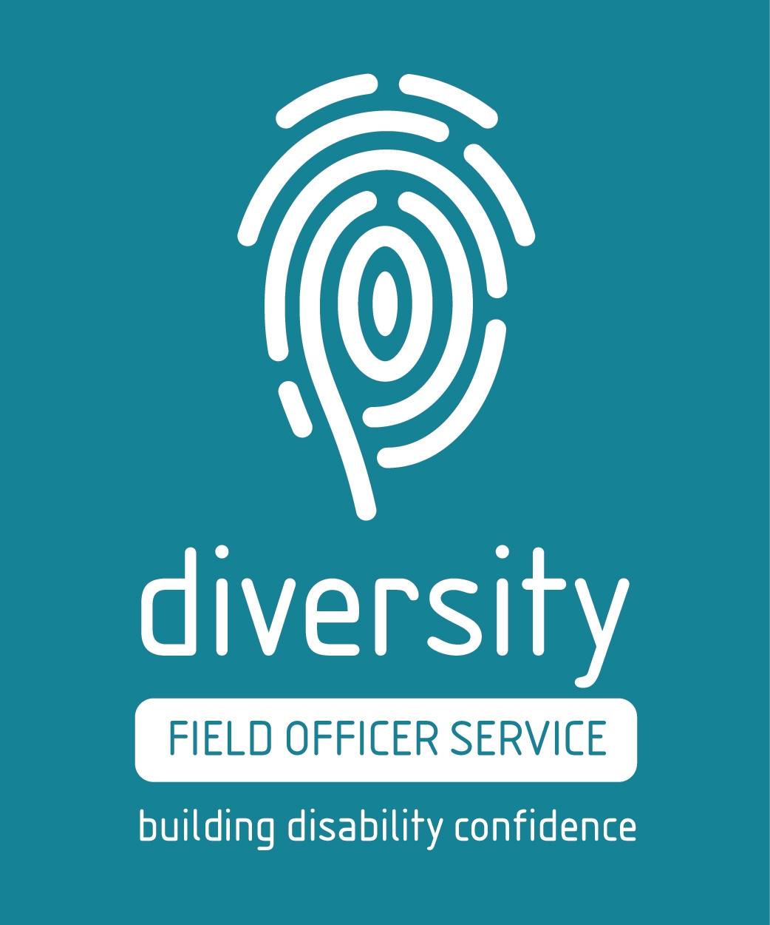

Empowering Health Consumers

Through a WA Department of Communities ILC grant in mid-2018, the Empowering Health Consumers with disabilities project has been a collaboration with Health Consumers Council to improve knowledge and skills of people with disability, their carer and families so they can effectively access a range of health services and health advocacy. The project also aimed to increase awareness of the needs of people with disability by healthcare providers. The project co-design group of people with disability actively designed an information session and information resources that were delivered across 8 sessions in Perth Metropolitan areas, Bunbury and Northam, as well as an online session. These information sessions were successful in bringing a greater understanding of people’s rights in hospital and Healthcare settings.

Three Diversity Dialogues were held with healthcare providers at Fiona Stanley Hospital, Perth Children’s Hospital and Sir Charles Gairdner Hospital. Members of the co-design group presented to professionals who found the feedback and honesty of experiences insightful for their own understanding. The resources that have been developed are available on both the PWdWA and HCC websites. HCC has also learnt and gained greater understanding of the needs and barriers faced by people with disability in the health system and will take this forward in their work.

**Key Relationships**

Thank you to the following organisations and agencies who have worked with us in various ways throughout the year!

Australian Federation of Disability Organisations

Advocacy WA

Advocare

Carers WA

Consumers of Mental Health Western Australia

Developmental Disability Western Australia

Department of Communities

Department of Social Services

Disability Advocacy Network Australia

Disability Leadership Institute

Ethnic Disability Advocacy Centre

Explorability

Health Consumers Council WA

Leadership WA

Legal Aid WA

Lotterywest

McCusker Centre for Citizenship

Midlas

National Disability Insurance Agency

National Disability Services

Self Advocacy WA and SARU

Sexual Education Counselling and Consultancy Agency (SECCA)

Summer Foundation

Sussex Street Community Law Service

WA Council of Social Service

Western Australian Association of Mental Health

WA Individualised Services

Women with Disabilities WA

Youth Disability Advocacy Network

Your Say Uniting Care West

**Treasure’s Report**

In the 2018-2019 financial year, PWdWA has fulfilled all its service agreement obligations and fully expended most funding with a surplus of $21,224 from interest and a small amount of paid consultancy.

In recognition of increased demand for advocacy, the DoCDS provided the Consortium with $200,000 non-recurrent of which $100,000 went to Consortium partners. In June 2019, we received a further $250,000 non-recurrent. PWdWA has carried forward $125,000 to use in 2019-20 and passed on $125,000 to consortium partners.

PWdWA has been delivering a number of projects from the WA DoCDS Information, Linkages, Capacity Building grants. The Diversity Field Officer Project, On Board with Me, and Empowering Health Consumers with Disabilities Projects have run through the 2018-2019 financial year and will be completed on 30 September 2019. Project funds have been carried forward as income into 2019-20 for the final three (3) months of each project.

PWdWA continued to receive funds from DSS for the National Disability Advocacy Program and NDIS Appeals Advocacy. These funds include supplementation to fulfil obligations to our staff employed under the SACS award scheme.

Our Connect with me Stage 2 Project funded by the Department of Finance Peak Body Capacity Building grant was completed successfully. This project had $10,270 unspent which has been forwarded into the 2019-20 financial year to return to Department of Finance.

Small amounts of funding were received from a number of donations, consultations, and sale of old assets. Lotterywest provided funds through the WACOSS Peaks forum for a member engagement workshop and to do work with the WCOSS Peaks Forum on co-design.

At the end of the 2018-19 year, PWdWA is in a good financial position. Project funding for the 2019-20 financial year is secure for the State Disability Plan co-design, and NDIA Disabled Persons/Family Organisations ILC funding.

The Committee of Management has remained active in overseeing the financial operation of the association. The audited accounts demonstrate that the organisation remains financially stable.

The Committee of Management and staff express thanks to Nulsen Independent Administration for payroll support and Patricia Loh Accounting for financial management services throughout the year. We also sincerely thank Sonya and Renata who have provided Administration Support to PWdWA.

Karen Andersson

Treasurer

Financial Statements

Please contact us directly for a screen reader accessible version of our financial statements.

City West Lotteries House 23/2 Delhi Street West Perth WA 6005

Ph: (08) 9420 7279

Country: 1800 193 331