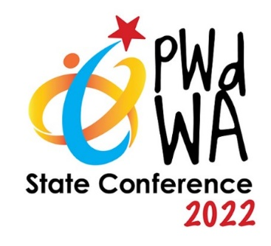
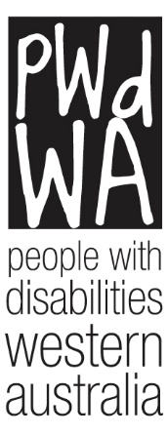

PWdWA

Newsletter

July 2022
- Message from our CEO
- Current Issues
- PWdWA Profile
- PWdWA in Action
- Upcoming

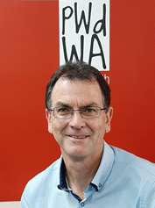
Message from our CEO

PWdWA Active in the Community
PWdWA delivers a range of projects that create connections between people with disability and the communities they live in. Projects aim to build the knowledge, skills and confidence of people with disability and improve their access to community and mainstream services.
In this newsletter, you’ll meet one of our Project Team, Melissa Higgins, who is busy facilitating and delivering online and face-to-face workshops on a range of topics.
PWdWA is also delivering a project to build the capacity and confidence of small to medium-sized businesses to be more welcoming, confident and accessible to people with disability and to link these businesses to young people with disability seeking employment in that sector.
PWdWA Advocates have also spent the past fortnight visiting communities in the Midwest and Wheatbelt regions, providing information on how to engage with the Royal Commission into Violence, Abuse, Neglect and Exploitation of people with disability.

Current Issues

PWdWA State Conference 2022 – Inclusive Communities

Wednesday 7 December and Thursday 8 December

Bendant Centre, Wembley
Registrations for our State Conference are now open, and PWdWA Full members can get a discount on their tickets. Early bird registrations close on 15 September.

​Keynote Speakers
Our keynote speakers for this year’s conference will be:
- Drisana Levitzke-Gray
- Scott Hollier
- Julia Hales
- Wayne Herbert
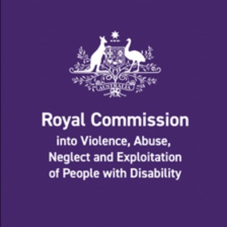

Disability Royal Commission (DRC) – Public Hearing coming to Perth
We are excited that the commission is coming to Perth from 19 – 23 September.
The topic at the public hearing will be conditions in detention in the criminal justice system.
If you have a story relating to the justice system, reach out to our DRC advocates through dutyadvocate@pwdwa.org.

PWdWA Profile

Melissa Higgins – Individual Capacity Building Project
PWdWA runs free information sessions and workshops to empower people with disabilities. These sessions are coordinated and run by Melissa, our Empowered and Connected project officer.
Melissa is passionate about the needs, participation, and education necessary for the inclusion of people with disabilities. She has previously worked with various non-profit and community organisations, focusing on disability employment, fundraising and awareness campaigns. Additionally, Melissa has over ten years’ lived experience as a disability, mental health, and aged carer.
Melissa’s project delivers online and face-to-face information sessions on Disability Support Pension (DSP), NDIS, Self-Advocacy and Co-Design.
Melissa also works alongside other PWdWA team members and members of our consortium to provide information sessions on the Disability Royal Commission and Consumer Health.
You can find what sessions Melissa has planned on our Eventbrite page.

PWdWA in Action
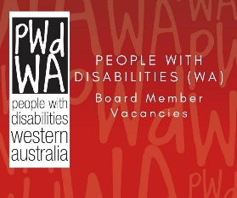

PWdWA Board Opportunities
PWdWA is seeking two members with finance/accounting and communication skills and experience to join our Board. This is a great opportunity for a person with a disability to undertake a leadership role in representing the disability community. The positions involve monthly meetings overseeing our budget, strategic plan and representing PWdWA as required. If you are interested and would like further details, please contact our CEO Brendan Cullinan at brendan@pwdwa.org or by telephone at 9420 7279.

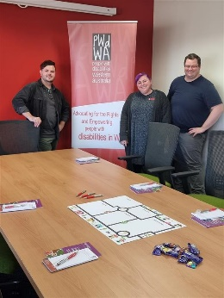
PWdWA and Explorability Roadshow
PWdWA and Explorability have been travelling to the Wheatbelt and Mid-West regions to support people engaging with the Royal Commission into Violence, Abuse, Neglect and Exploitation of people with disability (DRC).
Starting in Geraldton and visiting Jurien Bay, Lancelin, Moora, Gingin, Merredin, Quairading, Cunderdin, Dowerin, Toodyay and Northam, Oliver and Leia, our DRC advocates, were joined by Tricia from Explorability and Chris, PWdWA’s Community Advocacy Project Officer, who spoke about how communities can shape the future of people with disability.

Upcoming

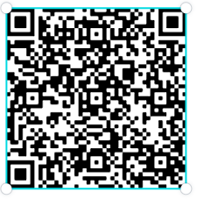
PWdWA’s Eventbrite Home Page
Do you want to know what events PWdWA has coming up? Hold your phone camera over the QR code, then click on the link. This will take you to our Eventbrite home page.

PWdWA’s Disability Royal Commission Information Session

Wednesday 27 July 2022, 10:00 am – 12:00 pm
This Information Session will explain the goals and scope of the Disability Royal Commission. Participants will learn how they can tell their story, what supports are available and who can help.
An advocate will be available after the presentation to provide general advice; if you require specific personal advice, please contact the duty advocate on 94207279 or dutyadvocate@pwdwa.org to make an appointment with the DRC advocate.
You can register for this event through Eventbrite. If you do not wish to use Eventbrite, contact Vanessa on 9420 7279 ext. 717 or email vanessa@pwdwa.org.

PWdWA’s Disability Support Pension Online Information Session

Monday 1 August 2022, 10:00 am – 12:00 pm
This session will benefit people about how to apply for the Disability Support Pension (DSP). It will help you prepare and submit a robust application for the DSP by understanding:
- If you are eligible to apply.
- The Centrelink DSP process.
- What information does Centrelink need to assess in your application.
- What is good medical evidence, and how to get it from your health professionals.
- Things you need to know about the program of Support, Job Capacity Assessment and Disability Medical Assessment.
At the end of the session, you will have a good idea of how Centrelink will assess your application. We will also provide tools and links to additional resources to help you.
You can register for this event through Eventbrite or call Vanessa on 9420 7279 ext. 717 or email vanessa@pwdwa.org.

PWdWA’s NDIS Reviews and Appeals Online Information Session

Monday 11 July 2022, 1:00 pm – 3:00 pm
- Do you want to know more about NDIS reviews and appeals?
- Do you want to understand when and how you can ask the NDIS to change their decisions?
We have produced this information session in response to requests from our membership.
This session is for Western Australians living with disability, their families, friends and carers assisting them.
You can register for this event through Eventbrite or call Vanessa on 9420 7279 ext. 717 or email vanessa@pwdwa.org.
If you cannot make our July session, our August session is also open for registration. To be held on Monday 22 August at 1:00 pm, you can register through Eventbrite.
PWdWA
PWdWA is funded by the Western Australian Department of Communities and the Australian Department of Social Services.

PWdWA is run BY and FOR people with disabilities and aims to be the voice for all people with disabilities in Western Australia.
Free membership
Being a member of PWdWA gives you the opportunity to be involved in shaping our organisation through our planning and evaluation processes. As a member, you can make sure the issues that matter to you are heard by being involved with our submissions and advocacy campaigns. Voting is restricted to full members aged 15 years and above.
Full Membership is available to persons living in Western Australia, with a disability, over 15 years who are Australian citizens or permanent residents of Australia.

