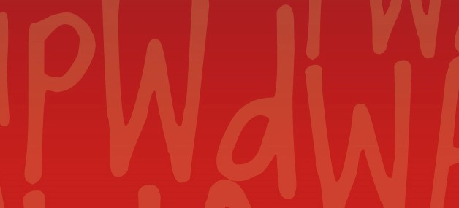
January 2021 Members Update
People With disabilities WA

Message from our Executive Director
Happy New Year to all our members.
The start of 2021 has been busy for PWdWA with several announcements and projects underway.
Being a member-based organisation, PWdWA seeks your views on a range of issues. You will see in this newsletter and on social media a number of opportunities for you to provide your comments, which I encourage you to participate in.
Two of the issues are on Independent Assessments and Personalised Budgets, with a forum and survey opportunities for members to provide feedback.
PWdWA has been successful in obtaining Lotterywest funding to upgrade our IT capabilities to be more flexible and we acknowledge and thank Lotterywest for their great support.
The Committee of Management is currently working through a review of the Constitution with further information to follow to members regarding a special general meeting to discuss the proposed changes.
The State Government recently announced additional funding for disability advocacy that PWdWA welcomes, as the need for advocacy support continues to increase. We await any further announcements by the State government before entering the caretaker period on February 3 prior to the State election on March 13, 2021.

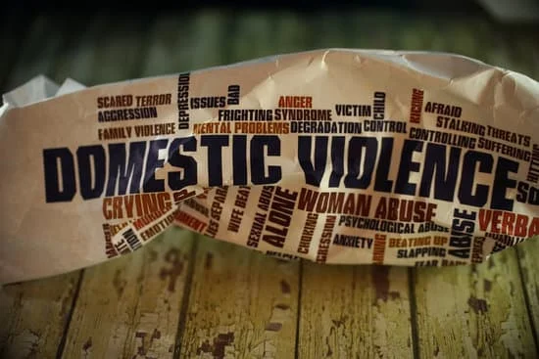

Your right to be safe
Your safety is the most important thing. If you are feeling unsafe you should tell someone you trust. If you are in danger now, call the WA Police on 000. If you want to report abuse or neglect, call the Disability Abuse and Neglect Hotline on 1800 800 052 or 1800 RESPECT (1800 737 732). For more information visit the Disability Safe Week website https://www.disabilitysafeweek.org.au/get_help.html . This website has lots of Easy English resources and a quick escape button for your protection.

COVID-19

Western Australian updates
Western Australians are still facing ongoing changes to our lives as the Government tries to keep West Australian’s protected. This means there are occasional sudden mandatory changes to how we do things. To keep up to date with these changes you can call 13COVID (13 26843) or visit https://www.wa.gov.au/organisation/department-of-the-premier-and-cabinet/covid-19-coronavirus-latest-updates

Do you have to go into self-isolation/quarantine?
If you are required to self-isolate (also called quarantine) and you are unable to prepare your own meals due to your disability, but your support workers cannot come into your home then you may be able to access NDIS funding for the preparation and delivery of meals. Please contact the NDIA on 1800 800 110 to advise them of your situation. The NDIA also recommends you complete a Change of Circumstances form.

Vaccinations
The Government has announced that Australia’s COVID-19 vaccination roll-out will begin late February, with Support Workers and People with Disabilities in care facilities in the first group to receive the vaccination. PWdWA will keep you informed as more information is released.

Building Better Homes
Building Better Homes - National Construction Code
PWdWA will be contacting Hon. Stephen Dawson MLC, Minister for Disabilities to seek his support on this matter.
If you wish to sign the petition, visit https://www.change.org/.../join-the-campaign-to-make...

#End Segregation

Disabled People’s Organisations Australia
42 disability rights and advocacy organisations have called for the end to segregation of disabled people in Australia in a position paper. If you would like to read a copy of the paper at https://dpoa.org.au/endsegregation/ if you do not have access to the internet please call Vanessa on 9420 7279 to have one posted. If you want to endorse the paper but cannot access the website Vanessa can assist you.

Forum on NDIS Policy

Access and Eligibility Policy for Independent Assessment and Planning for Flexible Personalised Budgets Policy
PWdWA together with WAiS will be holding a forum on the Access and Eligibility Policy for Independent Assessments and Planning for Flexible Personalised Budgets Policy.
Your voice is important to us, as it will assist us with our submissions. If you are unable to commit to the entire session but would still like to attend and be heard, we will have paperwork available for the activities you miss.
Starting at 10:00 am, with sign-in open at 9:30 am on Monday 8 February, you can book your seat by through Eventbrite. If you prefer not to use Eventbrite please call Vanessa on 08 9420 7279.
Light refreshments will be served.
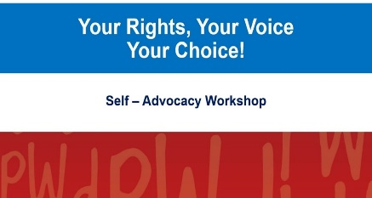

Your rights, Your Voice, Your Choice

Self-Advocacy Workshop
PWdWA will be conducting a two-part self-advocacy workshop on Saturday, February 6 and Saturday, February 13. This free workshop includes lunch. Places are limited. If you would prefer not to use Eventbrite please contact Vanessa or Tahnee on 9420 7279.

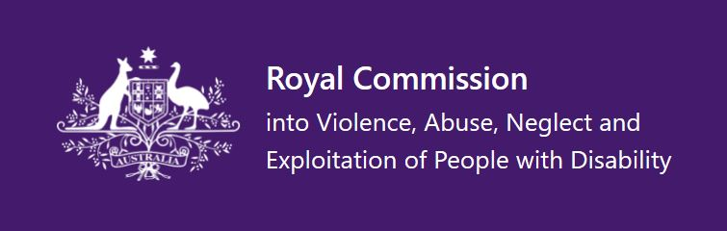

Royal Commission into Violence, Abuses, Neglect and Exploitation of People with Disability

Violence and abuse of people with disability at home

Submissions close February 26
This issues paper is looking at how violence and abuse is experienced by people with disability at home. The paper asks 13 questions and is available in Easy Read, PDF and DOCX.
https://disability.royalcommission.gov.au/publications/violence-and-abuse-people-disability-home

Promoting Inclusion

Submission close by April 2
This issues paper is asking the public to share their views on what an inclusive society looks like. The paper asks nine questions and is available in Easy Read, PDF and DOCX.
https://disability.royalcommission.gov.au/publications/promoting-inclusion

Wheatbelt Disability Information Roadshow
Mark, our Individual Advocate Regional Outreach officer, will be visiting four towns as part of the Wheatbelt Disability Roadshow.
- Kellerberrin – Monday, February 1 Centenary Park
- Merredin – Tuesday, February 2 Central Wheatbelt Visitor Centre
- Brookton – Monday, February 15 Brookton Memorial Park
- Narrogin – Tuesday, February 16 Dryandra Country Visitor Centre
Please share this information with anyone you think may be interested and contact mark@pwdwa.org or call 9420 7279 for more information

PWdWA
PWdWA is run BY and FOR people with disabilities and aims to be the voice for all people with disabilities in Western Australia.

Free membership
If you know someone with a disability who would like to join our organisation, our membership is free for people with disability to become full members https://www.pwdwa.org/get_involved/become_a_member.html

Keep up to date with our regular posts to Facebook and Twitter
https://www.facebook.com/PeopleWithdisabilityWA/?ref=aymt_homepage_panel

