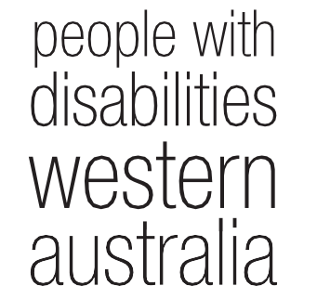wd Annual Report
2015 - 2016

People With Disabilities {WA) Inc. Annual Report 2015 - 2016

Contents
Acronyms and Abbreviations 3
Our Vision 5
Our Mission 5
We Value 5
Guiding Principles 5
PWdWA Presidents Report 6
Committee of Management 2015 - 2016 8
PWdWA Executive Director Report 9
Treasurers Report 12
Membership 13
Individual Advocacy 14
DSS Standards Audit 23
Self Advocacy WA (SAWA) 23
Projects 24
Systemic advocacy 26
Submissions 32
Representation and participation 32
Community Education & Promotion 34
Special Purpose Financial Statements 35

Acronyms and Abbreviations

AAT | Administrative Appeals Tribunal
AFDO | Australian Federation of Disability Organisations
AHRC | Australian Human Rights Commission
CALO | Culturally and Linguistically Diverse
COAG | Council of Australian Governments
CoMHWA | Consumers of Mental Health Western Australia
DAIP | Disability Access and Inclusion Plan
DANA | Disability Advocacy Network Australia
DOA | Disability Discrimination Act
DDWA | Developmental Disability Western Australia
DoH | Department of Housing
OSAWA | Down Syndrome Association of WA
DSC | Disability Services Commission
DSP | Disability Support Pension
DSS | Department of Social Services
EDAC | Ethnic Disability Advocacy Centre
EOC | Equal Opportunity Commission
FPDN | First Peoples Disability Network
FSHD | Facio scapula humeral muscular dystrophy
HACC | Home and Community Care
HaDSCO | Health and Disability Services Complaints Office
HCC | Health Consumers Council
ILC | Information, Linkages, and Capacity Building
LAC | Local Area Co-ordinator
MPT | Multi-Purpose Taxi
NDAP | National Disability Advocacy Program
NDCO | National Disability Coordination Officer
NOS | National Disability Services
NOS | National Disability Strategy
NOIA | National Disability Insurance Agency
NDIS | National Disability Insurance Scheme
NSDS | National Standards for Disability Services

OPA PA5 PWDA PWdWA SACS SARC SAPS SAWA SECCA SAT SSCLS TUSS
WACOSS WAAMH WAIS WANDIS WWDWA YDAN
Office of the Public Advocate
Perth Autistic and Aspergers Association People with Disability Australia
People With Disabilities (WA) Inc. Social and Community Services Award Sexual Assault Referral Centre
Self Advocacy and Peer Support WA Self Advocacy WA
Sexuality Education Counselling Consultancy Agency State Administrative Tribunal
Sussex Street Community Law Centre Taxi Users' Subsidy Scheme
WA Council of Social Service
Western Australian Association of Mental Health WA Individualised Services
Formerly My Way NDIS, trial run by state Women With Disabilities Western Australia
Youth Disability Advocacy Network

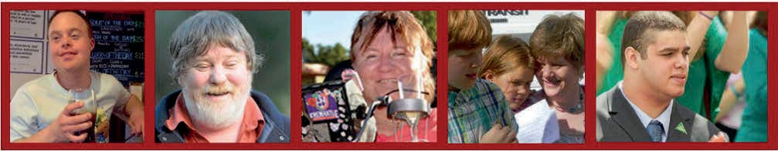

Our Vision
People with disability are equal and valued citizens.

Our Mission
Advocating for the rights and empowering the voices of people with disability in WA

We Value
Human rights
The voices and unique experiences of people with disabilities

Guiding Principles
Wewill:
- Be passionate, innovative and fearless in defending and promoting the rights and interests of people with disability.
- Be accessible, responsive to and inclusive of our diverse community.
- Be mindful, flexible, agile, responsive and innovative in a rapidly changing sector and world.
- Value and facilitate the involvement of people with disability in our governance and management.
- Collaborate with the disability and mental health sector.
- Maintain supportive relationships with advocacy and support organisations.
- Be transparent and accountable in everything we do.
- Act with honesty and integrity.
- Be resourceful and efficient regarding the resources we need to do our work.
- Recognise and value everyone who works with us to achieve our vision, including our committee, staff and volunteers.

PWdWA is funded by the Disability Services Commission WA (DSC) and the Department of Social Services (DSS)

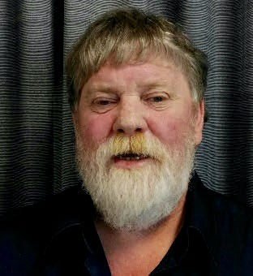
PWdWA Presidents Report
Since my last report the work of People with disabilities WA has continued to provide a voice for Western Australian's with a disability. We have increased our reach throughout the state, and continue to provide a high quality service.

The work undertaken by the PWdWA Committee of Management, employees and volunteers has been extensive Greg Madson and I will touch on some of that work in my report; with further
details in other parts of this annual report.

Although a little challenging to get three busy groups of people together to meet, our new consortium arrangement with Advocacy South West and Sussex Street Community Law Service will provide great opportunity for the governing teams of the three organisations to come together for an exchange of strategic thought. I look forward to those meetings as we move forward together through a changing disability sector.
Over the past year PWdWA Committee of Management members have continued their work on strategic goals of the organisation through systemic advocacy, providing advice to government, submission and policy development, and engagement of members and the wider disability community. That work includes the following;
- Joint governance meetings between Consumers of Mental Health WA and People with disabilities WA
- Holding a member's forum regarding changes to on-demand transport
- Providing advice on access for people with a disability for the now operational Perth BusPort
- Representation on the Perth Stadium Access and Inclusion Working Group
- Representing people with a disability on the On-demand Transport Advisory Group
- Representation on the Perth Airport Access and Inclusion Working Group
- Representation on the Main Roads Cycling and Pedestrian Advisory Group, and Main Roads WA Disability Advisory Group
- Representation on the RACWA and Road Safety Commission, vulnerable Road Users Advisory Group
- Regular attendance at Disability Sport and Recreation Forums - run by Department of Sport and Recreation
- Regular attendance at Disability Services Commission Board Chairs forums
- Attendance at the ASID Research Forum
- Media representations on issues for people with a disability.
It has been my privilege to work with a team of such calibre as makes up the People with disabilities WA Committee of Management.

Over the past year the Committee of Management has focused on growth of its governance skills, reviewing governance policies, and focusing on the strategic plan goals. We are fortunate to have such a breadth of knowledge, youth and experience to call upon.
I would like to thank, Monica McGhie, Mallika Macleod, Kelly-Anne Blanch, Ingrid Moore, Lisa Burnett, Ryan Gay, Jordon Steele-John, Prue Hawkins and Ian Mansfield, who have willingly given their time, commitment and advice in governing the organisation.
I would like to also thank those organisations we have worked with throughout the year. Organisations such as Developmental Disability WA, Consumers of Mental Health WA, Carers WA and Health Consumers Council WA have worked alongside PWdWA to develop submissions and advice to government regarding issues faced by people with disability.
Throughout the year Samantha and I continued our strong working relationship; Sam's extensive experience in the disability sector and strong management skills have provided the organisation with a solid foundation. Samantha's management of the organisation is reflected in the report we received from a National Standards for Disability Services quality assurance assessment this year. The final report from that assessment congratulated PWdWA on the work it is undertaking, and the processes used to undertake that work.
I would like to formally thank Samantha Jenkinson for her leadership and support throughout the year.
Our PWdWA employees strive to ensure our members and Western Australians with a disability have access to good reliable advocacy advice, a listening ear, or support if needed. I would like to thank our terrific advocates, administration people, and volunteers for their dedication to the organisation.

Funding

Without the funding support we receive PWdWA would be restricted in what it could achieve. PWdWA is funded at the state level by the Disability Services Commission (DSC). I would like to thank the WA Disability Services Commission for their ongoing support of our individual advocacy and consortium work. Access to DSC run forums, meetings and events has also given us opportunity to assist in directing the right change for the sector.
Federally, PWdWA receives funding from the Department of Social Services (DSS); that support is greatly appreciated, allowing PWdWA to continue its Individual advocacy work State-wide and in the Peel area, and through funds from the National Disability Advocacy Program continue our systemic advocacy work. We thank DSS for that support.

Our Members

The membership of PWdWA is increasing, giving us opportunity to engage more people with a disability, canvas their views, and use those views to give clear direction as to where our organisation could best use our resources. We have continued working alongside self-advocacy, leadership and peer support groups such as; Self-Advocacy WA, PA5, Spinal Chatter, Diverse Leadership and many others.
Finally, I would like to thank PWdWA members for their ongoing support, your engagement in member forums, participation on disability advisory groups, membership on the Committee of Management and many other supporting aspects ensures that People with disabilities WA is a relevant voice for Western Australian's with a disability.
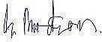

Greg Madson President

Committee of Management 2015 - 2016
President Greg Madson Vice President Monica McGhie Treasurer Mallika Macleod
Secretary Prue Hawkins Ordinary Member Jordan Steele-John Ordinary Member Ryan Gay
Ordinary Member Kelly-Anne Blanch Ordinary Member Ingrid Moore Ordinary Member Lisa Burnette Ordinary Member Ian Mansfield

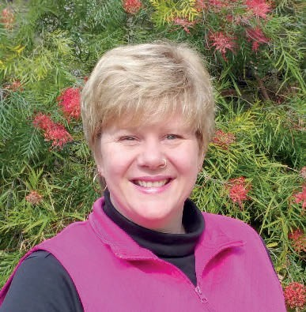
PWdWA Executive Director Report
It has been another year of change for PWdWA in the reform environment we are currently working in. In the 2015 to 2016 financial year PWdWA underwent further adjustments to our organisational structure due to the new funding and reporting requirements. As an organisation we view these changes as opportunities to improve our practice of advocacy. However, it feels that a lot of our time has been spent justifying the need
for advocacy and our services with these changes at state saman th01en k inson
level, and with the current review of the National Disability
Advocacy Program. I am pleased to report that it did not stop us providing high quality systemic and individual advocacy as evidenced in our standards audit.
At the end of last financial year, we put in a consortium bid for the Disability Services Commission (DSC) Individual Advocacy Tender with Advocacy South West and Sussex St Community Law Service. This bid was successful, with PWdWA taking on the role of lead agency, although not necessarily an increase in real terms for our organisation. The consortium has been in place since February 2016 and is working well with the Executives meeting regularly and all staff benefitting from joint training. I would like to thank Adam Johnson and Annette Dix from Advocacy South West, and Jane Timmermanis from Sussex St Community Law Service who have worked with me to make this a successful transition. It has also benefitted people with disability, particularly those in regional areas covered by our partners, with our opportunity to refer across organisations and provide consistency of advocacy state-wide.
The change in funding from DSC meant that we said goodbye to long term employee Stuart Jenkinson who was the Equity Officer, a position funded by DSC for systemic advocacy. In December 2015 we farewelled Stuart with cake and a small memento to remember us by every time he has a 'cold one'. Our systemic advocacy capacity essentially was halved with this removal of funding, and this has meant a reduction in issues we can prioritise to work on.
Apart from our core funding for individual and systemic advocacy from DSC and Department of Social Services (DSS), we have also had project funding for work in specific areas. These projects are detailed further in the report and include support for leadership and peer support by and for people with disabilities (Releasing Our Capacity); and advocacy for those people and their families transitioning from DSC Accommodation to providers in the non-government sector. We also undertook a research study for DSC on the need and scope for a service to provide independent third party support to people with cognitive disability if they are being interviewed by the police.

PWdWA thank Lotterywest for providing funding for us to replace some of our computers and servers. This ensures our staff and volunteers have access to up to date technology for research and reporting.
We have actively been connecting with peer groups and other organisations led by and representing people with disability, their families and carers. This is part of our role as the peak body representing people with disability. We are often sought out by government and other bodies to be involved with advisory groups or make comments on policy. This representational work is extremely important in ensuring the voice of people with disability is heard at the policy and decision making levels. Where possible we ensure it is people with disability who are speaking and being heard in these representational roles.
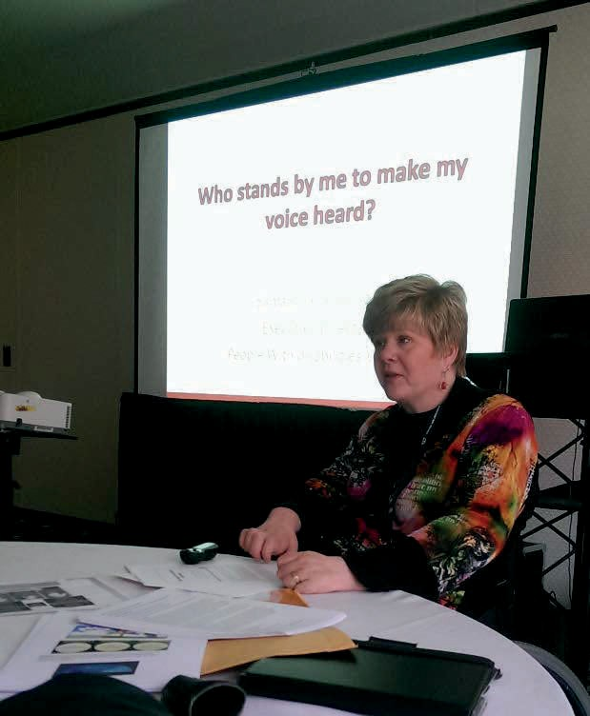
I was fortunate last October to attend the 'Claiming Full Citizenship' conference in Vancouver, Canada which had presenters from around the world discussing individualised funding, self-determination, supported decision making and policies to implement these concepts. Thank you to PWdWA and the Committee of Management for supporting me to take this opportunity. I was able to connect with people with disability in Canada and learn of research that can assist our systemic work here in WA. In January we supported and took part in a Perth forum which shared the findings and experience of those who attended the
Samantha presenting in Vancouver conference. Information and videos
from the conference can be seen here http://cic.arts.ubc.ca/claiming-full­ citizenship-conference-video-series/
In June 2016 our service was due for a full recertification under the National Standards for Disability Services. This is a requirement of our Department of Social Services funding. We complied with all six standards and the standards auditors were particularly impressed with our systemic advocacy work.
"The organisation is providing effective Individual Advocacy support for people with disabilities and is also bringing about significant positive changes and improvements to disability service delivery in WA through its Systemic Advocacy Campaigns, in particular through the WA Disability Abuse Inquiry."

The Individual Advocacy team experienced a number of changes and staff transitions during the 2015 / 2016 period. Senior Advocate, Carmen Pratts-Hincks, went on maternity leave in September 2015 until July 2016, and Gio Terni stepped into the role during this time. Individual Advocate Christina Wright retired in March 2016 after many years of providing advocacy to people with disabilities in Western Australia. Christina was a passionate, knowledgeable advocate. The Peel office of PWdWA also saw changes, with Individual Advocate Judy Russell leaving in May 2016. Judy brought her wealth of experience to all that she did as an advocate. PWdWA would like to thank both Christina and Judy for all the great work that they did in providing advocacy to people with disabilities in Western Australia. The executive acknowledge and thank all the staff within the organisation for their hard work and in creating a warm and friendly work environment we are often complimented on.
It is with great sadness however that I would like to pay respects and our condolences to the families of some of PWdWA's great supporters who have passed away over the last year. Anne Healey, life member; Lois Gatley, long term supporter and wife of Patrick McGurk one of our founders; and Robert Ellis, father of a client who we worked closely with over many years.
Thanks go to our Committee of Management and our other volunteers who all play a part in keeping PWdWA going strong. In particular, I thank Greg Madson our President who has worked closely with me this year on how we continue to keep PWdWA sustainable into the future. Together we took part in an Action Learning program run by the Centre for Social Impact where we were able to reflect on how we can lead and grow our organisation and our vision.
It has been a busy but fulfilling year here at PWdWA and the future holds possibilities for us to provide more advocacy and continue advocating for the rights and empowering the voices of people with disability in WA.
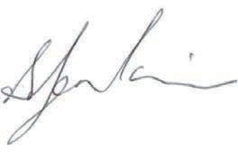

Samantha Jenkinson Executive Director

Treasurers Report
In the 2015-2016 financial year, PWdWA operated within its budget and fulfilled the contractual requirements of service level agreements with our core funding agencies, the Western Australian Disability Services Commission (DSC), and the Australian Government Department of Social Services (DSS).
PWdWA received funding from the Department of Social Services to assist with the cost of our standards audit, and
supplementation to fulfil obligations to our staff employed under Mallika Macleod
the SACs award scheme.
PWdWA and the consortium were the recipient of additional non recurrent funds from DSC in the third quarter of the 2015-2016 financial year to assist with consortium set up costs such as database and IT adjustments for the new reporting regime and joint staff training. These funds have not yet been fully expended and are being carried over into the 2016-17 financial year as they are used and IT projects are put in place.
Non-recurrent funds were received for the DSC Accommodation Transition advocacy we are providing. This funding started in December 2014 and continues until December 2016.
Sustainability funding from DSC in 2013-14 is slowly being used and carried forward each year.
PWdWA is in the second year of our two-year project grant from the National Disability Insurance Agency.
Vehicle replacement also occurred this year with funds from DSC.
The Committee of Management has remained active in overseeing the financial operation of the association. The audited accounts demonstrate that the organisation remains financially stable.
The Committee of Management and operational staff express thanks to Nulsen Independent Administration for payroll support and Patricia Loh Accounting for financial management services throughout the year. We also sincerely thank Debra Sommerfeld, PWdWA Administration Assistant who keeps everything and everyone organised.

Mallika Macleod Treasurer

Membership
During the year PWdWA has had two member's events and put out three member updates to keep our members informed. Due to the change in our membership criteria and membership becoming free there has been an increase in membership of people with disability.
Full Membership - is available to persons living in Western Australia, with a disability, over the age of 18 years who are Australian citizens or permanent residents of Australia.
Associate Membership - is available to persons who identify with the aims of the Organisation, but who are ineligible to be full members, including family and friends of people with disability. Associate members can support a full member.
Organisational Membership - incorporated organisations within Australia where the membership and governing body are each comprised of at least 75% of persons with a disability, or the parents of children with a disability, or which have a substantial involvement in representing the interests of persons with a disability from the consumer perspective.

August 2016
11 | Life Members
118 | Full Members
150 | Associate Members
5 | Organisations
284 | Members
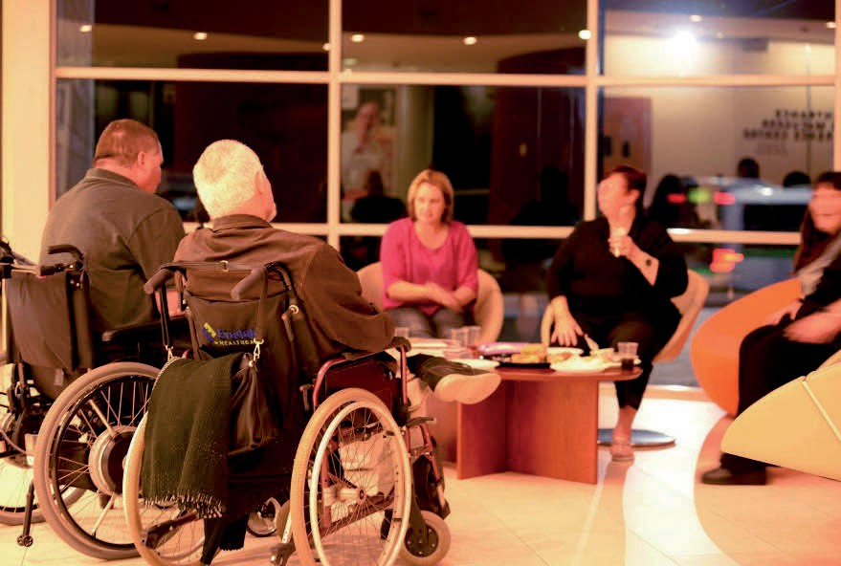
FSHD Peer Meeting

Individual Advocacy

Our individual advocacy staff for 2015 - 2016 included Carmen Pratts-Hincks and Gio Terni as Senior Advocate, and Carol Franklin, Lisa Hook, Christina Wright, Natalie Turner, Judy Russell, Rachael Cox, Bronwyn Lines, Nick Wilson, Nicole /kin and Maggie Visser as Individual Advocates.
In 2015-2016 PWdWA provided independent, non-legal Individual Advocacy that is issue-based and confidential to people with disability living in Western Australia. Individual Advocates work alongside people with disability when they feel they have been treated unfairly or they seek a solution to a specific problem or issue. PWdWA focuses on advocating with those who are most vulnerable or at risk, with an empowerment based model of advocacy.
As part of our services, advocates provide information to individuals, family members and others who want to know more about the services that PWdWA and other agencies in the community can offer. Information is made available by phone, face-to-face, email and social media which includes Facebook and Twitter.
People with disability and PWdWA Advocates work closely to develop an individualised action plan which outlines the person's goal for the advocacy, objectives, the roles and responsibilities of stakeholders involved, and the actions to be followed. As part of their role, Individual Advocates communicate with relevant stakeholders and attend meetings. They also do pre-meeting preparation and ensure agreements are reached. Through this process the person with a disability learns about their rights, what is available to them, makes informed decisions, and develops self-advocacy strategies they can use in the future.
From 1 July 2015 to 31 January 2016 PWdWA were funded by the Disability Services Commission (DSC) to provide Individual Advocacy state-wide. On 1 February 2016 PWdWA entered into a consortium funded by the Disability Services Commission (DSC) with two other advocacy organisations, Advocacy South West and the Sussex Street Community Law Service Individual Disability Advocacy Service to provide Individual Advocacy state-wide and in regional areas. This partnership aims to provide a stronger, consistent and collaborative approach to advocacy for people with disability in Western Australia.
The Department of Social Services (DSS) provided funding for Individual Advocacy state-wide and in the Peel region. The funding allowed us to work on a broad range of issues that are faced by people with disabilities in Western Australia.
Our advocates have supported people in both the NDIS trial sites by working with individuals and families to prepare for the planning meetings. Together they look at their current needs, the services they are receiving and their gaps in services, so they know what to ask at the planning meeting. Following the preparation meeting some clients felt empowered to go to the planning meeting on their own

and others preferred to have an advocate alongside. PWdWA advocated at three appeals processes one in the Hills trial site, where we collaborated with MIDLAS and WAIS and two in the lower South-West trial site.

Individual Advocacy funded by DSC

PWdWA advocated with 338 individuals across Western Australia. The individuals contacting PWdWA seeking advocacy include people from a range of age groups, backgrounds, disabilities, geographical areas, as well as those participating in the NDIS and WA NDIS (formerly My Way) Trial Sites. The majority of people contacting PWdWA come from the metropolitan area of Perth. Of these, most live in the Perth Metro non-NDIS area. In terms of ages, the majority of people were in the 31 to 54 age range.
In this reporting year, individuals with physical disability make up the main disability of those contacting PWdWA. This includes people with spina bifida, cerebral palsy, quadriplegia, and many of the people contacting us use wheelchairs for mobility. People with intellectual disability, is the next highest. Some self-referred, with others being referred to PWdWA by family members or service providers. Followed by people with neurological disability, including people experiencing neurodegenerative disorders such as spinal cerebellar ataxia and fibromyalgia.
The majority of people contacting us were self-referred, a small number from service providers, and some from family members, friends, DSC staff and word of mouth. At all times, the Advocates ensured they contacted and communicated with the person with the disability to gain their consent and clarification of their wishes before taking any action.
Out of the 338 people who contacted PWdWA, 445 issues were identified. The major issues experienced by people contacting our service during this period include:
- Service provision - some of the issues were communication breakdown between the person with a disability and the service provider; people getting less service hours than they should be getting or need; delays of implementation of service plans; lack of compatibility with support staff and service coordinators; people not being part of the decision making process in regards to their services (e.g. staff recruitment and training); and lack of information about their rights as clients.
- Housing - issues of being on the waiting list of Department of Housing (DoH) for too long and putting people at risk of becoming homeless; needing assistance to complete forms required; maintenance issues with the DoH; and attendance at court regarding evictions.
- Discrimination or Rights (including legal) - advocacy at State Administrative Tribunal (SAT) hearings (Guardianship and Administration orders);

supporting people to make complaints to the Australian Human Rights Commission (AHRC) and Equal Opportunities Commission (EOC); linking people with appropriate community legal services and attending meetings as required.

Individual Advocates work with people with disability to ensure that they are able to raise their concerns to their service providers without fear of retribution and reach outcomes that meet their expectations and improve the quality of services received.
Due to the changes in our funding and subsequently the reporting requirements mid-financial year, we are unable to provide comparative data across our funded programs.

Case Study

Ben contacted PWdWA because they were experiencing issues with his support staff. Ben wanted to attend his local community sports centre a number of times a week, which included support with transferring into the pool and while swimming; however, two of the support staff were not prepared to do this, even though the employment contract stated that this was part of Ben's individual plan. An advocate met with Ben, worked on an action plan with him and, with his consent, contacted the service provider to seek more information, which the advocate then passed on. Ben, with his advocate alongside, then arranged a meeting with senior staff from the service provider where he raised his concerns as well as his desire to find staff, who would support him in achieving his desired outcome of swimming. Ben then interviewed and chose staff, who were able to support him in his goal of participating more in his community.

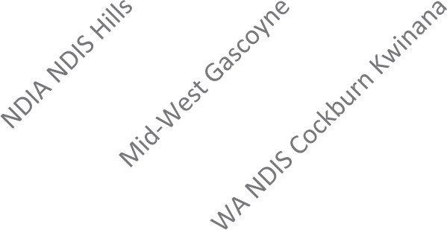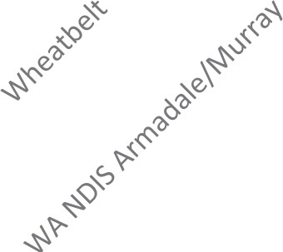
0
1
3
4
1
1
9
8
100

80

60

40

20
109
120
DSC Clients per Area Feb 2016 - July 2016

Abuse/Neglect | 5
Accommodation/Housing | 22
Discrimination/Rights | 32
Education | 7
Employment | 8
Equipment/ Aids | 9
Finances | 13
Health | 5
Legal | 18
Recreation/Social or Family | 13
Services | 40
Transport | 5
Vulnerable/Isolated | 5
Funding | 6
Eligibility | 3
Independent Living Support | 10
Subsidies and entitlements | 3
Universal Access | 1
Utilities | 3

DSC Client Transition Independent Advocate Project

PWdWA continue to provide independent advocacy to raise concerns about issues that could be affecting residents during the handover period of the transition from DSC accommodation services to alternative service providers. As part of this project, experienced Individual Advocates attended meetings at houses that were commencing the handover process to explain their role to staff and residents. The main purpose of this project is to ensure residents, families and staff had an additional, structured pathway to raise their concerns.
Due to PWdWA's ongoing involvement in this process some residents and family members contacted us for advocacy during their transition period. The main issue raised was the uncertainty of receiving services from a new provider because they have been long term residents of DSC accommodation services. PWdWA advocates assisted residents and family members to prepare for meetings and attended meetings with them. This enabled people to ask questions relevant to their specific needs and concerns. As a result, residents and families were able to have their say and make informed decisions.

Individual Advocacy State-Wide funded by the DSS

In 2015-2016 most of the people we supported came from the metropolitan area of Perth, although there were a number from the southwest. In regards to their age, the majority of people were in the 31 to 54 age range, followed by school age children. The majority of people contacting our DSS Sate-Wide services were individuals with autism followed by people with intellectual and neurological disability.
PWdWA provided advocacy to 100 people with disability experiencing a wide range of issues. The top issues during the reporting period included:

- Service provision - issues on individuals not receiving services that met their specific needs; support staff not respecting individual's choices or facilitating their inclusion; and lack of communication with the individual when staff were unavailable for shifts.
- Education system issues - such as a lack of reasonable adjustment for the needs of a child to ensure they had the same opportunities for learning as other children (such as where a child with disabilities is seated within the classroom; the use of assistive technology; changes to the school curriculum; and communication with a child).
- Legal processes - advocacy at guardianship and administration hearings with the State Administrative Tribunal (SAT); and connecting individuals with legal services and attending the first meeting with them.

SERVICE: D55 NEDLANDS
Psychiatric
9% Intellectual

Autism
25%
Developmental Delay
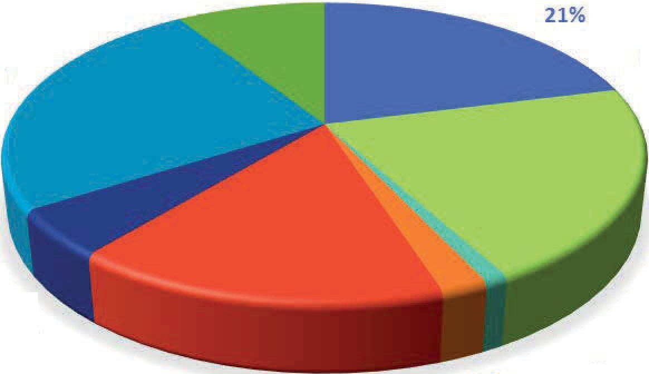
0%

Specific Learning/ADD 5%

Physical
16%

ABI
2%

N urologi al 21

Sensory or Speech
1%

DSS Advocacy Issues 2015-2016 | Number
Abuse/Neglect | 4
Accommodation/Housing | 9
Discrimination/Rights | 5
Education | 11
Employment | 5
Finances | 6
Health | 5
Legal | 15
Physical Access | 1
Recreation/Social or Family | 5
Services | 36
Transport | 3
Vulnerable/Isolated | 1
NDIS | 6
Funding | 4
Independent Living Support | 2
Subsidies and entitlements | 2

Case Study

Karen, who is non-verbal, contacted PWdWA seeking advocacy for a number of issues. Karen had been admitted to hospital after a fall.

She was experiencing a number of issues with staff at the hospital as she was unable to communicate verbally, so decisions about her care were being made without direct input from her. The hospital had also made an application to the SAT for guardianship over Karen. The SAT hearing was heard and Karen was given a public guardian, in spite of the fact that she was unable to have her voice heard at this hearing.

The advocate began by securing an iPad for Karen to ensure that their voice was heard in all decisions regarding their health care. The public guardian and the advocate then applied to have the SAT decision reversed; they attended another SAT hearing, where Karen was able to express her desire to maintain her independence and ability to make decisions for herself. This SAT decided that there was no need for an independent guardian and the decision was reversed, allowing the individual to regain their independence and dignity.

Individual Advocacy Peel funded by the DSS

The Individual Advocacy service in Peel worked alongside 37 individuals to address the issues affecting their quality of life. Education still continues to be a priority in the Peel region followed by service provision and individuals experiencing financial issues.
A large portion of the referrals received were from other agencies, word of mouth and members of the local community. PWdWA promoted our services at meetings with school parents, information sessions with families, individuals and service providers, and forums. We also visited and provided pamphlets and contact details to a number of community centres, government departments, service providers, and other stakeholders in the Peel region. We also attended the parents' drop-in morning at the Parents Place to talk with members of the public about our advocacy services.
An example of the PWdWA Individual Advocate from Peel in practice can be seen with the assistance provided to a family whose child used a motorised wheelchair due to their disability. The child had been excluded from attending school because of concerns about the speed of the motorised wheelchair. The Individual Advocate provided information to the family, and with their consent, contacted the Disability Discrimination Unit and the Department of Transport for further clarification. The Department of Transport advised that the school had incorrect information

regarding their legislation on the wheelchair. The family received placement at a new school.
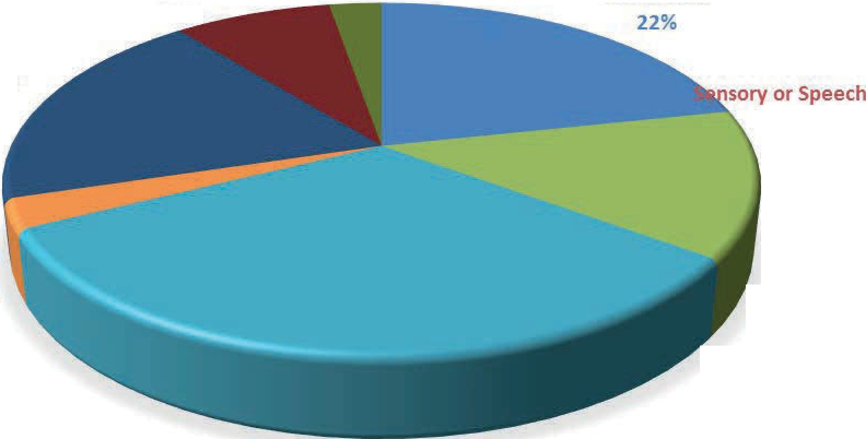
Neurological
8%
SERVICE: PEEL
Developmental Delay
3%
Intellectual
Psychiatric
19%
0%
AB!
3%
Physical
13%

Specific
Learning/ADD 0%
0%
Autism
32%

DSS Peel Advocacy issues 2015-2016 | Number
Accommodation/Housing | 4
Discrimination/Rights | 2
Education | 15
Employment | 2
Finances | 6
Legal | 3
Services | 9
Funding | 2
Eligibility | 1

All examples and case studies have been de-identified.

Case Study

A child had been reprimanded a number of times for poor behaviour at school. The parents felt that their child was being unfairly punished by the school, and had a number of meetings with the school to discuss the support that their child needs in the classroom. The school told the parents they thought that the problem was that the parents were not teaching their child how to behave in the home environment, which was then causing the difficulties at school. The parents felt that their child was being discriminated against because of their disability. The advocate linked the parents in with the Disability Discrimination Unit (DDU), and attended the first meeting with them. The lawyer at the DDU then supported the parents in taking their claim of discrimination further.
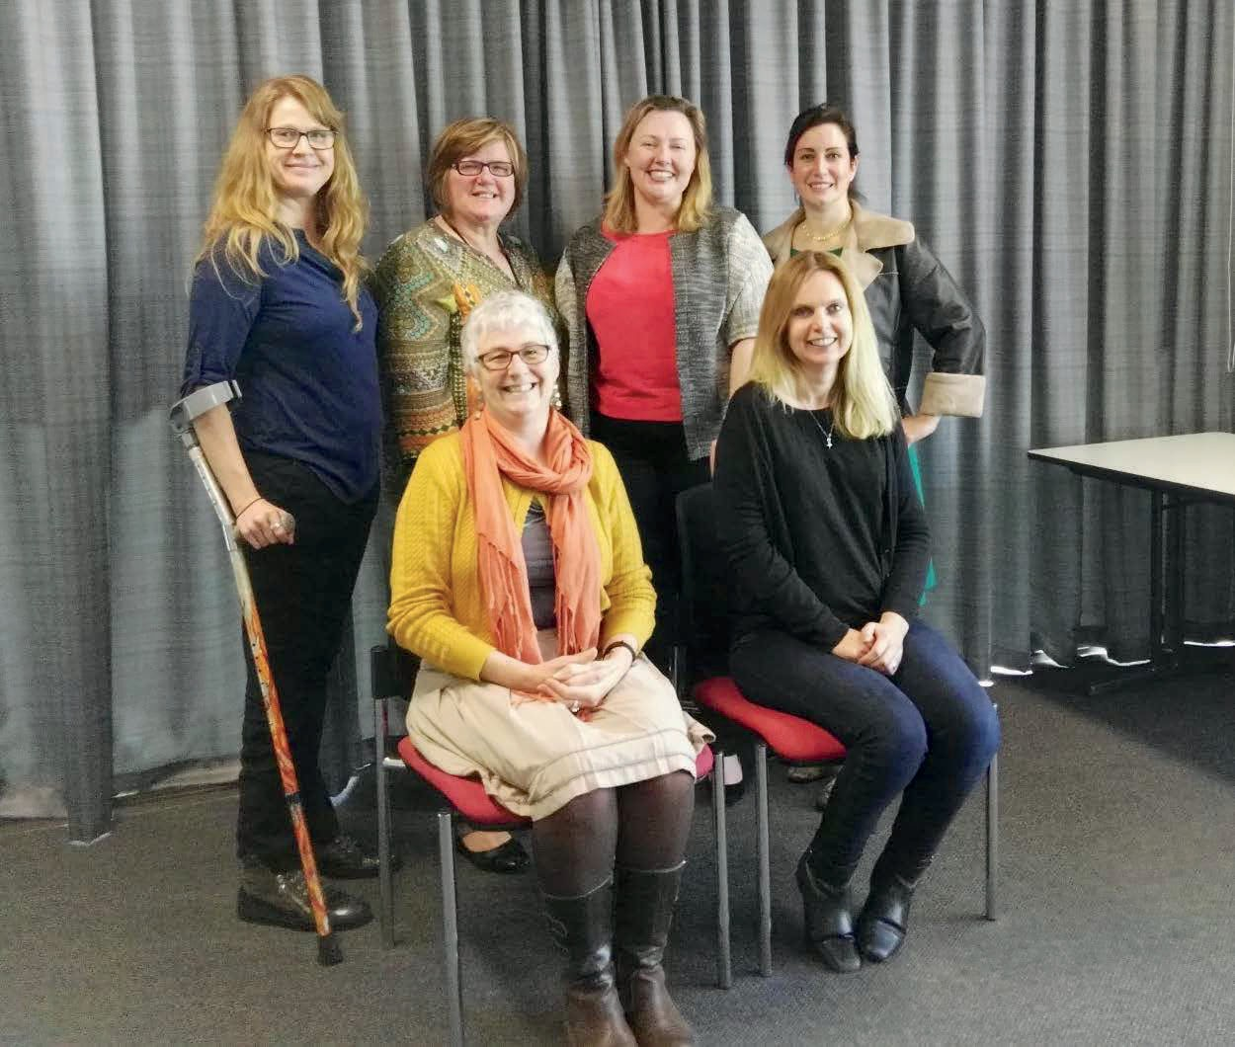
Back row - Rachael Cox, Carol Franklin , Nicole /kin, Carmen Pratts-Hinks Front row - Lisa Hook , Faye Hicks

DSS Standards Audit
PWdWA Individual Advocacy services in Nedlands and Mandurah were audited in June 2016 against the National Standards for Disability Services (NSDS). At the completion of the Recertification Audit PWdWA was found to be compliant to all six National Standards for Disability Services with no non-conformances. Client interviews were generally very positive at the Nedlands office regarding the support they had received from their Advocates and also about the outcomes that had been achieved. Clients at the Nedlands Office provided very positive feedback about the Individual Advocacy support they had received including that the "support received from the Advocate at PWdWA has been wonderful and is the best thing they had stumbled upon". Other comments included that "the Advocates have a lot of compassion", "they were able to build rapport quickly", "were very knowledgeable" and had helped their family members understand the advocacy process.

Self Advocacy WA (SAWA)
Over the past year SAWA members have invited several guest speakers to work on enhancing their skills and to discuss opportunities in the community, including a speaker from the National Disability Insurance Agency and the Employment Law Centre. The Members engaged with a consultant to provide feedback and ideas around having a service that provides an independent support person to assist people with disabilities while talking to the police. The Members also attended a number of forums and then shared information with the other SAWA members. As part of their meetings all members shared experiences and discussed issues that matter to them. They also met for their traditional twice yearly breakfast in July and December.
SAWA has taken part in the Disability Support Organisation Capacity Building Project from PWdWA, and received a small seed grant from the National Disability Insurance Agency (NOIA). This funding is being used to meet and share strategies on how to increase their membership and prepare members for the NDIS roll out.
SAWA still have their information shared on the PWdWA website. Members decided on the information they wanted included on the website. To view this information, please go to: www.pwdwa.org .

SAWA would like to thank the Disability Services Commission for the funding they provided to the group, which ended in December 2015. This funding has allowed SAWA to build their self-advocacy skills and networks for over 20 years.

Projects

Releasing our Capacity - National Disability Insurance Agency Disability Support Organisation Project, Project Officer and Peer Leader Samantha Connor.
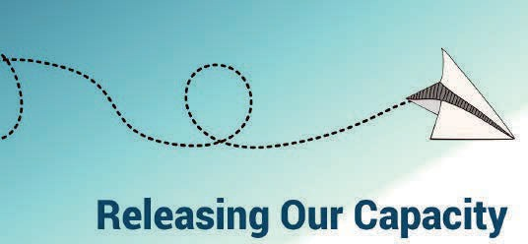
In late 2014, People with disabilities WA were successful in receiving funding from the National Disability Insurance Agency to act as a Disability Support Organisation (non-provider) and support and develop 20 peer support groups. This project is due to continue till early January 2017.

People with disabilities WA made an early commitment to focus on capacity building for disabled people. Our groups are made up of 100% disabled people, including both cross disability organisations and diagnostic specific organisations. In addition, our project partners Consumers of Mental Health WA have worked to support four additional groups of people with psychosocial disability.

To date, through this project we have funded and supported the following groups;
- Self Advocacy and Peer Support WA
- Self Advocacy WA
- Blind Citizens WA
- Amputees WA
- First Peoples Disability Advocacy Network
- FSHD Support Group Australia
- Perth Autistic and Asperger's Association (PA5)
- Spinal Chatter
- WANDIS My Way online peer group
- Youth Disability Advocacy Network
- Women with Disabilities WA

In addition, we have recently funded and are supporting four groups:
- Inside Out (Quadriplegic Centre)
- Access Toodyay
- Wheatbelt Disability Action Group
- NDIS Grassroots Discussion Group

PWdWA has successfully partnered with a number of grassroots and peak bodies to ensure the ongoing success of the program. They include our WA DSO partners, CoMHWA, DDWA and OSAWA, as well as Connect Groups, The Growing Space, and WA Individualised Services. We have worked with Connect Groups to convert their resources into plain English resources and to connect with groups directly to ensure sustainability. Our peer leader is also on their consultative group and Connect Group events are being directly promoted to our peer support groups.

Many of the peer support group members have also been successful in increasing their profiles as disabled people and experts in their own right, speaking at community events and disability events. One of the biggest issues that disabled people in WA face is a lack of support to develop their own distinct cultural identities and overcome the shame and stigma associated with disability, especially for Aboriginal people in WA. This project is directly contributing to increased pride, resilience and identity for those in peer support groups.

Our projects groups (with our support) and our project officer have:
  - Held a number of public events around NDIS themes
  - Held targeted events in regional areas, including two events in the Wheatbelt (which the NDIS trial is expanding into in January, 2017)
  - Developed and disseminated information and resources including preplanning and advocacy resources
  - Assisted groups to identify their own priorities and develop their own identities
  - Developed material with groups to use for capacity building activities
  - Made short video montages of 'quick tips' by and for disabled people.

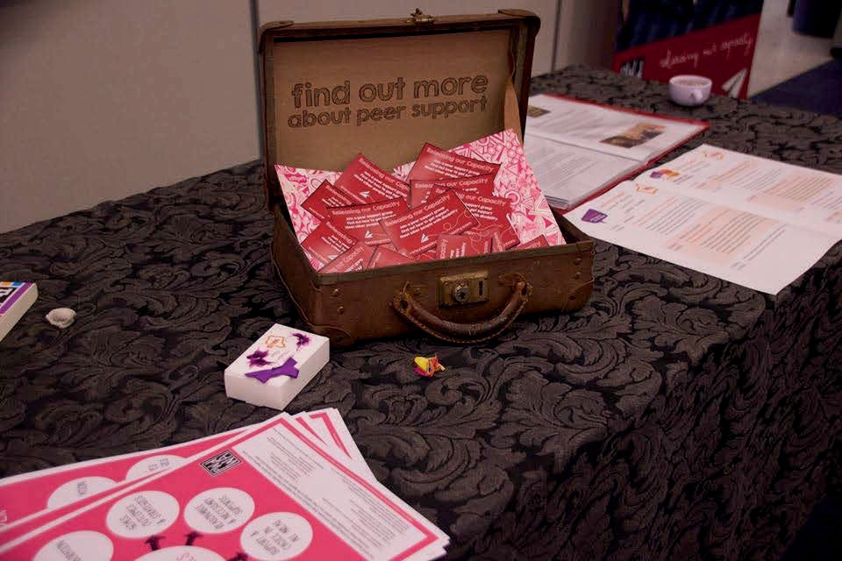
PWdWA remains committed to providing in kind support wherever possible to peer groups after the project has been completed. Our thanks to Samantha Connor, Project Officer, and the Community Hub Leaders.

Peer support resources

Systemic advocacy

Our systemic advocacy is undertaken by our Project Manager Faye Hicks and our Executive Director Samantha Jenkinson with funding from DSS. Stuart Jenkinson was our Equity Officer working on systemic representation from July 2015 to December 2015, however his role ended when our state funding for systemic advocacy ended.

Abuse and Neglect

In early 2015 a report entitled 'Behind closed doors' was written as a collaboration between PWdWA and DDWA which identified a number of key recommendations to counter abuse and neglect for people with disability in WA. To drive forward a number of these recommendations, an Abuse and Neglect Taskforce was formed in November 2015 which is being chaired and resourced by PWdWA. The aim of the taskforce is to provide strategic direction and leadership in

White lily representing those who died from abuse
reviewing the recommendations from 'Behind Closed Doors' and seeks to achieve the following:
- Map current activity across the membership of the taskforce in preventing abuse and neglect to produce a gap analysis and develop a strategy to minimise these gaps
- Review current practice in minimising abuse and neglect across WA
- Review the specific recommendations as stated in the report 'Behind Closed Doors' and other current relevant publications such as NDIS Quality and Safeguarding Framework and the Senate inquiry report on abuse, violence and neglect against people with disability in institutional and residential settings
- Identify opportunities to measure effectiveness, influence best practice and hold organisations to account.
- Advise and engage with appropriate stakeholders to deliver change
- Share and exchange systemic findings with other organisations that are linked to but not in scope as determined by the definitions of this Terms of Reference such as the drug and alcohol misuse and aged care sectors.
The taskforce comprises of a number of cross sector organisations including representatives from PWdWA, Carers WA, CoMHWA, Department of Education, DDWA, Department of Health, Disability Health Network, DSC, Health and Disability Services Complaints Office, National Disability Services, Sexual Assault

Resource Centre, Sexuality Education Counselling and Consultancy Agency, WA Individualised Services, WA Police, WAAMH, and WWDWA.
PWdWA as part of its ongoing work to reduce abuse and neglect for people with disability has been invited onto a number of groups who are doing complementary work in this area. For example, the Safer Services steering group which is a project being run by National Disability Services and Doors to Safety Advisory group; a project aimed to increase safety for women with disabilities experiencing domestic and family violence.

Housing

PWdWA has been involved in a range of systemic advocacy actions around housing. Earlier this year the Department of Housing notified public housing tenants that the way their income is assessed would be changed. This change would mean an increase in their rent if they received any of the allowances and supplements from Centrelink such as
mobility allowance and the pharmaceutical allowance. We worked with Consumers of Mental Health WA and Carers WA to raise the issue of what that would mean in terms of the impact for people with disabilities and with mental health issues who receive specific allowances to cover the extra cost of living that they incur. We were not successful in halting the change however we did raise awareness of the extra costs of living with disability and hope this will be reviewed in future.
A major piece of work this year was our submission to the NDIS Joint Parliamentary Standing Committee on accommodation. This was important as the policy and structure of funding for Specialist Disability Accommodation will shape what the future relationship will be between housing and support. Since the 1990's PWdWA has strongly advocated for a clear separation of housing (tenancy and ownership) from disability support provision. This may finally be embedded in policy and practice. After this submission our Executive Director was invited to participate in the NOIA Independent Advisory Council Housing Innovation Working Group.
PWdWA have also been supporting the work of the Australian Network for Universal Housing Design in their push to get the Building Code changed to make it mandatory for all housing to provide minimum access. We wrote to our State Planning Minister and the State Attorney General requesting their support at COAG for the proposal. Both Ministers were supportive of the proposal, however the Australian Building Codes Board rejected the request to change the codes. This is likely to be a continuing issue for systemic advocacy.

National Disability Insurance Scheme
PWdWA holds positions on both the NOIA and WANDIS/My Way Advisory Groups as the peak body representing people with disability in WA, and as a user led organisation. In these positions we raise issues of concern, give feedback on policy direction and gather information. Through our national contacts we have also been asked to participate in further development of the Housing policy and Information, Linkages, and Capacity Building Framework.
We believe it is extremely important that the information we present to influence policy and the rollout of the NDIS in Western Australia is based on the real experiences of people who are in the trial sites. Last year we collaborated with a number of disability advocacy organisations, consumer, and carer led groups to assess the benefits and shortcomings of NDIS based on peoples' direct experiences in all WA trial site areas. PWdWA lead this collaboration and in November 2015 published a report based on results from two forums in Perth and Busselton and an online survey examining peoples' experience of NDIS in WA. The aim of the project has been to provide government with a set of recommendations based on evidence of good practice and issues for improvement from all trial site areas. We want this work to bring the best from both models that are on trial, and learn what is important for people with disability, their family and carers to go into the model for full rollout in WA. The Organisations involved in this collaboration were also mindful that the feedback should only include evidence from consumers and not those providing services. Therefore, the evidence embodied in the report is based solely on experiences from people participating in NDIS, their families and carers.
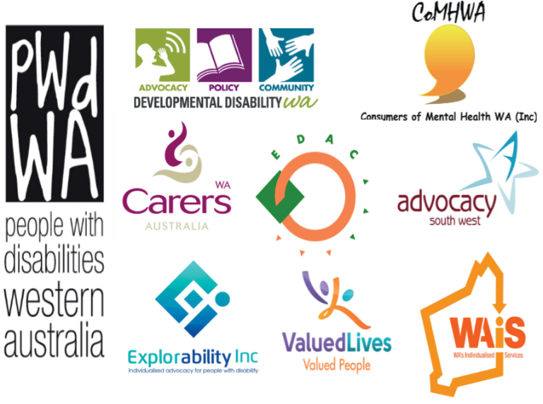
The results of the consultation indicate that there is no one preferred model and that there are strengths and weaknesses in all the NDIS trial sites currently in Western Australia. There are issues and trends that are emerging as the trials progress which need to be analysed and considered, such as the reality of how much flexibility people really
have and how much support they are getting to make informed choices. It is strongly recommended that that these are considered in any system re-design.
PWdWA was invited to present this report to the Commonwealth and the State government and in particular Department of Premier and Cabinet who are leading the

negotiations with Federal
Logos of partners for NDIS Experiences report

Government. We were also invited to represent people with disabilities at a roundtable with the then Minister for Mental Health, Disability Services and Child Protection, Hon Helen Morton, to discuss the WA NDIS negotiations with the Commonwealth representatives. The report on NDIS experiences was well received by both Federal and State Government. The Ministerial Advocacy Council on Disability WA is using the findings of the report to develop discussion papers to consult with people with disability in WA.
Based on the success of the first consultation, a second report is being produced which will build on the findings of the first report. In April this year the second survey was launched and again forums were held in the Perth metropolitan area and in Busselton. The second survey is finding some similarities, but also an increased level of stress as people are moving into the review cycle of the planning process. This second survey closed in June 2016 and the report on its findings is now being finalised.
The NDIS is a major change in our disability services system and it is expected that we will continue to do systemic work in this area over the next few years. We thank all of our partner organisations who are supporting our work and helping us to connect with those people experiencing the changing system.

Beyond the Quad Centre
Over the last five years PWdWA has worked at an individual level and at a systemic level to address concerns raised about the building conditions at the Quadriplegic Centre and a need to change to a more contemporary model of housing and support for people with spinal cord injury. In June 2015 the Department of Health undertook a review of spinal cord injury services in WA after hospital discharge, including a review of the Quadriplegic Centre. PWdWA supported the Queensland Spinal Unit which completed the review to hold forums and connect with people with spinal cord injury.
As a result of this review and ongoing issues with the state of the infrastructure at the Quadriplegic Centre, a commitment was made by the state government to look at alternative built options for people with spinal cord injury. In February this year our Executive Director, Samantha Jenkinson and our committee member Mallika Macleod, both of whom have spinal cord injury, were invited to be members of the "Enhanced Spinal Cord Injury Services Steering Committee". The remit of this committee is to give advice on implementation of a more integrated approach for people with spinal cord injury leaving hospital, this includes what will be happening with the Quadriplegic Centre. The steering committee has representatives from the Department of health, the Disability Services Commission, the NOIA and the Department of Housing. A business case and model is being put forward which is contemporary in its approach to housing and support for people with spinal cord injury and we look forward to seeing a commitment from the state government to this approach.

Early last year and the year before our advocates were working with individuals at the Quadriplegic Centre to support them in applying for funding and housing in the community. We are now supporting a series of events to support the current residents at the centre in thinking about their future planning with regards to housing and support using a peer support model. For those residents who have called the Quadriplegic Centre home for many years this will be a challenging transition. We will continue to support residents through the process with the assistance of our peer support partners.

Transport
Our focus in transport this year has been around 'on-demand' services. These include Taxi's, Uber and other ride-sharing services, and limousine and charter services. We wrote a submission to the state government Green Paper and were subsequently invited to be on the 'On-demand Transport Advisory Group'. Monica McGhie, PWdWA's Vice President, has been our representative on this committee. Our main areas of focus have been advocating for a more efficient multi-purpose taxi service that can benefit all users of the service; safety in all on-demand transport; and changing the Taxi User Subsidy Scheme to have an increased cap with swipe cards that can be used across services.
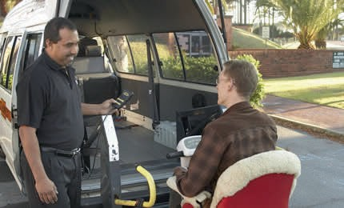

Other systemic issues
Person boarding a multi-purpose taxi

With our loss of State funding for systemic work mid-way through the financial year and the subsequent reduction in staff capacity, we have made a decision to be focused on two or three larger projects. We know there are many areas where we believe more systemic change is needed relating to access and inclusion, education, employment and justice. Where these issues are taken up by our peer organisations we support that work. This year we have raised the issues of how the state government will continue to implement Count Me In and the National

Disability Strategy; the decrease in funding to financial counselling services; the need to change the Criminal Law Mentally Impaired Accused Act; and the need for ongoing systemic funding in the disability advocacy sector. PWdWA and EDAC are the only organisations funded to do systemic advocacy under the National Disability Advocacy Program in WA, and we understand that if there is funding for systemic work from the state government it will be for project work only.

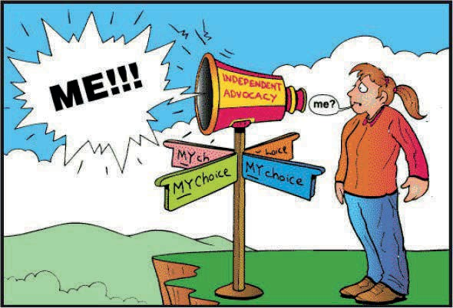

Submissions
As part of PWdWA's systemic work we provide written submissions on a variety of issues that affect people with disability. All our submissions are based on evidence from people with disability whether it is our clients or members experience. The recommendations we provide in our submissions are based on a wide consultation with people with disability. PWdWA has an extensive network to channel and receive information to ensure that submissions are grounded in 'real' experience and consider current and relevant research on the subject matter. Sometimes we collaborate with other consumer driven organisations to develop a combined approach to our submissions. All submissions are available on our website.

During 2015- 16 PWdWA provided written submissions on:
- Disability Employment Framework
- On-demand transport reform Green Paper
- Independent review of the National Disability Insurance Scheme (NDIS) Act 2013
- National Disability Insurance Scheme Inquiry into accommodation for people with disabilities and the NDIS
- Review of the National Disability Advocacy Program (NDAP)
- Information linkages and capacity building (ILC) Commissioning Framework

Representation and participation
In 2015-16 PWdWA staff and members contributed to committees, reference groups, and consultations covering a broad range of issues affecting the lives of people with disability.
These included;
- Working with MIDLAS, EDAC, SSCLS IDAS and others to connect individual advocates to the NDIS trial sites and provide information about advocacy to staff, and collect information to feedback to the NDIS Perth Hills Advisory group, and WANDIS Advisory Group.
- NDIS Perth Hills Advisory group
- WANDIS/My Way Advisory Group
- NOIA Planning Alliance Steering Committee
- NOIA Independent Advisory Council Housing Innovation Working Group
- NOS Pre-budget Submission Reference Group
- NOS WA Safer Services Steering Group
- Disability Coalition WA
- Housing Advisory Roundtable
- Disability Health Network Executive Advisory Group
- Enhanced Spinal Cord Injury Services Steering Group
- On-demand Transport Advisory Group
- Disaster resilience working Group

  - Perth Airport Universal Access Consultative Group
  - Department of Sport and Recreation Stadium Access Users Group
  - FPDN Australia and the NDCO officer to support the building of an advocacy group for aboriginal people with disability.
  - Consumers of Mental Health WA with Health Consumers Council and Carers WA on issues of accessing complaints services.
  - PWdWA collaborates with cross sector community advocacy groups to support the WA Advocacy Network
  - PWdWA contributes to DANA and PWDA on systemic issues.
  - PWdWA collaborates with WACOSS and others through the WA Peaks forum.
  - WA Research to Action Seminar
  - WA Disability Health Framework consultation
  - COAG Advisory Panel on reducing domestic violence - Disability Sector consultation
  - Electronic voting trial for people with specific disabilities consultation
  - Department of Planning social analysis of Perth and Peel Region consultation
  - Office of Road Safety regarding cycling on footpaths consultation
  - National Employment Framework Melbourne consultation
  - Tenancy WA regarding boarding and lodging protections paper consultation
  - NDIS Assistive Technology consultation
  - MercyCare and Curtin University regarding systemic advocacy and self­ advocacy consultation
  - Anglicare Tasmania regarding advocacy and peer support models consultation
  - Perth International Arts Festival Access Issues
  - Australian Consumer Law Review consultation
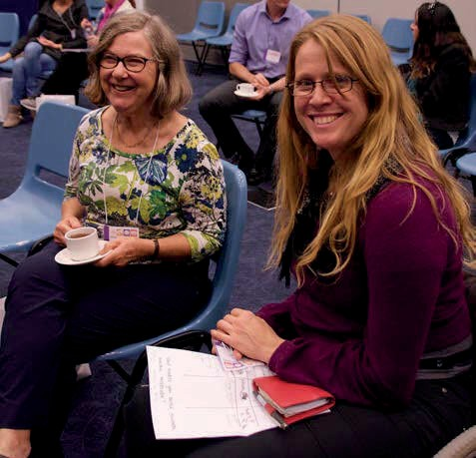
Advocate Rachael Cox at a conference

Community Education & Promotion
All staff contributes to our community education and promotion of advocacy in various ways. This year specific promotion was done by:
- Presentations on advocacy to NOS Disability Service Providers
- Perth forum presentation Learnings from Vancouver Conference
- Rockingham Beach school in Rockingham about forming a parent network for all the families of children with disabilities
- Presentation on advocacy to Mental Health community of practice Cockburn Kwinana
- National Disability Advocacy Summit Melbourne
- Presentation and Q and A on NDIS status to Genetic and Rare Diseases Network
- NOS Conference, panel and workshop presentations on Abuse and Neglect issues
- WA Individualised Services Conference stall
- Presentation to Diverse Leadership Inc.
- Presentation to Leadability participants

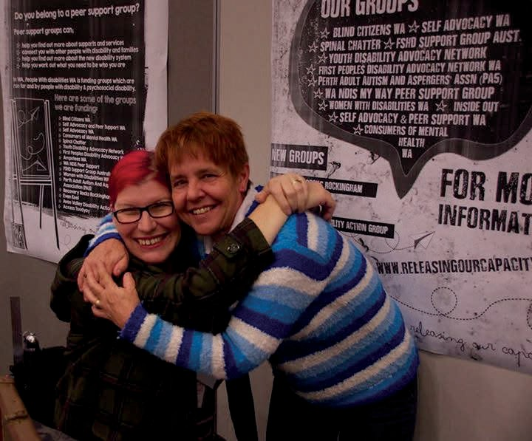
Sam Connor and Jo Russell

PEOPLE WITH DISABILITIES (WA) INC

SPECIAL PURPOSE FINANCIAL STATEMENTS

FOR THE YEAR ENDED

30 June 2016

PEOPLE WITH DISABILITIES (WA) INC

FINANCIAL STATEMENTS FOR THE YEAR ENDED

30 June 2016

- Auditor's Report

- Statement by President

- Income Statement

- Balance Sheet

- Statement of Cashflows

- Notes to and forming part of the accounts Notes 1 - 9

- Statement of changes in equity

RAY WOOLLEY PTY LTD ACN 30 05 6 227 297
CHARTERED ACCOUNTANTS

PRINClPAL:RAY WOOLLEY FCA (UK) BSc (Hons)
ASSOCI ATE: JAMES FISH FCCA BSc (Hons)

ray@raywoolleyaccounting.com.au james @raywoolleyaccounting .com.au
17 RUSSLEY GROVE
YANCHEP
WA6035 PHONE: (08) 9561 6146
FAX: (08) 95616192

PEOPLE WITH DISABILITIES (WA) INC

INDEPENDENT AUDIT REPORT TO THE MEMBERS OF PEOPLE WITH DISABILITIES (WA) INC

Scope

The financial report and committee's responsibiltiy.

The financial report comprises the balance sheet, income statement, cash flow statement, statement of changes in equity, accompanying notes to the financial statements and the statement of the committee for People With Disabilities (WA) Inc for the year ended 30 June 2016.

The committee are responsible for the preparation and the true and fair presentation of the financial report and have determined that the accounting policies used and described in Note 1 to the financial statements which form part of the financial report are consistent with the financial reporting requirements of the Associations Incorporations Act (WA) and the Australian Charities and Not-for­ profits Commission Act 2012 (ACNC Act 2012) and are appropriate to meet the needs of the members. This includes responsibility for the maintenance of adequate accounting records and internal controls that are designed to prevent and detect fraud and error, and for the accounting policies and accounting estimates inherent in the financial report.

The financial report has been prepared for distribution to members for the purpose of fulfilling the committees' financial reporting requirements under the Associations Incorporations Act (WA). and the Australian Charities and Not-for-profits Commission Act 2012 (ACNC Act 2012). We disclaim any assumption of responsibility for any reliance on this report or on the financial report to which it relates to any person other than the members, or for any purpose other than that for which it was prepared.

Audit Approach

We conducted an independent audit in order to express an opinion to the members of the organisation. Our audit was conducted in accordance with Australian Auditing Standards, in order to provide reasonable assurance whether the financial report is free of material misstatement. The nature of an audit is influenced by factors such as the use of professional judgement, selective testing, the inherent limitations of internal control, and the availability of persuasive rather than conclusive evidence. Therefore, an audit cannot guarantee that all material misstatements have been detected.

We performed procedures to assess whether in all material respects the financial report presents fairly, in accordance with the Associations Incorporations Act (WA) and the Australian Charities and Not-for-profits Commission Act 2012 (ACNC Act 2012), including compliance with Accounting Standards and other mandatory financial reporting requirements in Australia, a view which is consistent with our understanding of the organisation's financial position, and of its performance as represented by the results of its operations and cash flows.

RAY WOOLLEY PTY LTD ACN 30 056 227 297
CHARTERED ACCOUNTANTS

PRINCIPAL:RAY WOOLLEY FCA (UK) BSc (Hons)
ASSOC IATE: JA MES FISH FCCA BSc (Hol)s)

ray@raywoolleyaccounting.com .au james@raywoolleyaccounting.com.au
17 RUSSLEY GRO VE
YANCHEP WA 6035
PHONE: (08) 9561 6146
FAX: (08) 9561 6 192

PEOPLE WITH DISABILITIES (WA) INC

INDEPENDENT AUDIT REPORT TO THE MEMBERS OF PEOPLE WITH DISABILITIES (WA) INC

continued

We formed our audit opinion on the basis of these procedures, which included:

examining, on a test basis, information to provide evidence supporting the amounts and disclosures in the financial report, and
assessing the appropriateness of the accounting policies and disclosures used and the reasonableness of the significant accounting estimates made by the committee.

While we considered the effectiveness of the management's internal controls over financial reporting when determining the nature and extent of our procedures, our audit was not designed to provide assurance on internal controls.

Independence

In conducting our audit, we followed applicable independence requirements of Australian professional ethical pronouncements.

Audit Opinion

In our opinion, the financial report of People With Disabilities (WA) Inc presents a true and fair view in accordance with the accounting policies described in Note 1 to the financial statements, of the financial position of People With Disabilities (WA) Inc as at 30 June 2016 and the results of its operations and its cash flows for the year then ended.

Ray Woolley Pty Ltd Ray Woolley
Registered Auditor No 16396 1 September 2016

17 Russley Grove Yanchep WA6035

PEOPLE WITH DISABILITIES (WA) INC

STATEMENT BY PRESIDENT

For The Year Ended 30 June 2016

The Board of Management declare that:

- The attached financial statements and notes thereto comply with accounting standards

- The attached financial statements and notes thereto give a true and fair view of the financial position and performance of the association; and

- In the Board of Management's opinion, there are reasonable grounds to believe that the Association will be able to pay its debts as and when they become due and payable.

Signed on behalf of the Board of Management

Gregory Madson President

Date: 14 September 2016 PERTH, WA

PEOPLE WITH DISABILITIES (WA) INC
Balance Sheet As at 30/06/2016

 | Note | 2016  $ |  | 2015  $
Current Assets
Cash at Bank and on Hand | 3 | 913,640 |  | 768,857
GST - Input Tax credits |  | 15,662 |  | 8,298
Accrued Income and Prepayments |  | 8,817 |  | 10,329
Total Current Assets |  | 938,119 |  | 787,484
Non-current Assets
Plant/Equipment |  | 76,130 |  | 76,130
Less Accumulated Depreciation |  | (76,130) |  | (76,130)
Motor Vehicle |  | 21,383 |  | 18,540
Less Accumulated Depreciation |  | (23) |  | (18,540)
Total Non-current Assets |  | 21,360 |  | 0
Total Assets |  | 959,479 |  | 787,484
Liabilities
Sundry Creditors and Accrued Expenses | 4 | 45,508 |  | 48,123
Income Received in Advance | 5 | 371,016 |  | 217,650
GST - collected |  | 27,204 |  | 13,087
Provisions - Annual Leave & Sick Leave | 6 | 40,415 |  | 39,397
Long Service Leave | 6 | 40,041 |  | 59,287
Motor Vehicle Replacement |  | 0 |  | 14,000
Total liabilities |  | 524,184 |  | 391,544

Net Assets | 435,295 |  | 395,940
Accumulated funds | 435,295 |  | 395,940

STATEMENT OF CASH FLOWS

$ $ $ $

Inflows (Outflows)
Inflows (Outflows)

Cash flows from operating activities

Grant Income Interest Received
Membership and Donations Other Income
Payments to Suppliers and Employees

Net cash provided by/(used in) operating activities
1,351,469
16,430
20
28,310
(1,237,790)
1,043,386
16,640
6,468
5,292
(861,071)

158,439 210,715

Cash flows from investing activities

Non-operating income/loss 0
Proceeds from sale of property, plant and equipment 7,727 Payment for property, plant and equipment (21,383)
0
10,572
0

Net cash provided by/(used in) or from investing activities (13,656) Net increase/decrease in cash held 144,783
Cash at beginning of the financial year 768,857 Cash at the end of the financial year 913,640
10,572

221,287

545,570

768,857

STATEMENT OF CASH FLOWS

- Reconciliation of Cash

For the purposes of the statement of cash flows , cash includes cash on hand and in banks and investments in money market instruments, net of outstanding bank overdrafts. Cash at the end of the financial year as shown in the statement of cash flows is reconciled to the related items in the balance sheet as foll ows:

Cash | 568,505 | 368,765
Deposits at Call | 345,135 | 400,091
 | 913,640 | 768,856
b) Financing Facilities
No facilities are in place as at 30 June 2016
c) Reconciliation of net cash provided by operating | 2016 | 2015
activities to operating surplus. | $ | $
Operating surplus/( deficit) | 39,355 | 64,077
Profit/Loss on disposal of non-current assets | 0 | (2,097)
Depreciation and amortisation of non-current assets | 0 | 1,617
Non operating income
Changes in net assets and liabilities
Decrease/(lncrease) in current receivables | (5,852) | (8,718)
Increase/ (decrease) in current creditors | 11,502 | 11,250
Increase/ (decrease) in current provisions | (32 ,229) | (23,303)
Increase /(decrease) in income in advance | 153,366 | 163,697
(Increase )/decrease in Fixed assets | (21 ,360) | 14,766
Net Cash provided by/(used in) operating activities 144,783 221,289

PEOPLE WITH DISABILITIES (WA) INC

STATEMENT OF CHANGES IN EQUITY
As at 30th June 2016
RESERVES | General  $
Balance as at 30th June 2014 | 331,863
Surplus /(Deficit) for the year | 64,077
Balance as at 30 June 2015 | 395,940
Surplus /(Deficit) for the year | 39,355
Balance as at 30 June 2016 | 435,295

PEOPLE WITH DISABILITIES (WA) INC

Income Statement
For the financial year ended 30/06/2016

Notes | 2016  $ |  | 2015  $
Revenue from Ordinary Activities
Grants  - Disability Services Commission | 758,788 |  | 525,182
- Department of Social Services | 276,374 |  | 274,585
- Other Grants | 148,261 |  | 79,923
- Other Grant - Lotterywest | 14,680 |  | 0
Interest | 16,430 |  | 16,640
Donations & fundraising | 20 |  | 6,450
Membership | 0 |  | 18
Sundry Income & reimbursements | 14,310 |  | 5,292
Total Revenue from Ordinary Activities | 1,228,863 |  | 908,090
Expenses from Ordinary Activities
Accounting and Audit fees | 35,758 |  | 16,979
Advertising and recruitment | 2,386 |  | 6,232
Office and Staff amenities, General Meeting costs | 1,645 |  | 4,401
Depreciation | 23 |  | 1,617
Furniture & Equipment Expenses | 500 |  | 6,978
Insurances - General & Motor Vehicle | 6,895 |  | 6,296
I.T. Expenses | 37,904 |  | 12,851
Postage | 2,250 |  | 629
Printing and Stationery | 8,670 |  | 11,571
Rent | 29,069 |  | 26,854
Repairs and Maintenance | 3,249 |  | 3,092
Salary and wages costs | 743,519 |  | 598,579
Subscriptions | 2,624 |  | 4,733
Telephones | 5,725 |  | 11,184
Transport Costs | 18,314 |  | 8,748
Workshops/consultants | 36,620 |  | 83,996
Other Expenses | 276,084 |  | 37,178
Total Expenses from Ordinary Activities | 1,211,235 |  | 841,917
Operating surplus/(deficit) | 17,627 |  | 66,174
Non-Operating Income 7  Profit/ Loss on Sale of Assets | 7,727 |  | (2,097)
Transfer of Provision | 14,000
 | 21,727 |  | (2,097)
Total surplus/(deficit) | 39,355 |  | 64,077

PEOPLE WITH DISABILITIES (WA) INC

Notes to and Forming Part of the Accounts For the year ended 30/06/2016

1 Summary of Accounting Policies
This financial report is a special purpose financial report prepared in order to satisfy the financial reporting requirements of the Association Incorporated Act of WA, and the Australian Charities and Not-for-profits Commision Act 2012 (ACNC Act 2012). The Board has determined that the incorporation is not a reporting entity

The financial report has been prepared on an accrual basis and is based on historical costs and does not take into account changing money values or, except where specifically stated, current valuations of non-current assets

The following significant accounting policies, which are consistent with previous period unless stated otherwi se, have been adopted in the preparation of this financial report.

- The provision for long service leave is calculated at current rates of pay for all staff from their date of commencement. Long service leave entitlement is due after 7 years service for the first and subsequent terms.

The Association's Performance Agreement with the Disability Services Commission now requires it to make provision for Long Service Leave as per its employee entitlement policy.

- Holiday pay is accrued based upon holiday entitlement and pro-rata at current rates of pay plus 17 .5% loadings, Superannuation and Workers Compensation liabilities for applicable staff.

- Provision for Sick Leave has been accrued on the basis of 50% of the outstanding balance as at 30 June 2016 , plus superannuation and workers compensation liabilities for applicable staff.

- Depreciation is calculated on a straight line basis so as to write of the net cost of each fixed asset during its expected life. The depreciation rates used are:

Plant and Equipment Furniture & Fittings Motor Vehicles Computers
20%
20%
20%
33%

Since June 2000 it has been the policy of the Association to not capitalise items less than
$5,000 in value. These amounts are written off wholly in the year of purchase. The Association is not funded for capital replacement within it's current grant structure and does not have the capacity to put aside cash reserves to cover these expenses.
Component parts will be grouped together to determine the value to be used in determining the $5,000 limit.

PEOPLE WITH DISABILITIES (WA) Inc

NOTES TO AND FORMING PART OF THE ACCOUNTS
For the year ended 30/06/2016

2 | Plant/Equipment and Vehicles  Gross Carrying Amount | Plant/equip |  | Vehicles |  | Total
 | Balance as at 30 June 2015 | 76,130 |  | 18,540 |  | 94,670
 | Prior Year adjustment | 0 |  | 0 |  | 0
 | Additions | 0 |  | 21,383 |  | 21,383
 | Dispo sals | 0 |  | (18,540) |  | (18,540)
 | Balance as at 30 June 2016 | 76,130 |  | 21,383 |  | 97,513
 | Accumulated Depreciation
 | Balance as at 30 June 2015 | (76,130) |  | (18,540) |  | (94,670)
 | Prior Year adjustment | 0 |  | 0 |  | 0
 | Disposals | 0 |  | 18,540 |  | 18,540
 | Depreciation Expense | 0 |  | (23) |  | (23)
 | Balance as at 30 June 2016 | (76,130) |  | (23) |  | (76,153)
 | Net Book Value
 | Balance as at 30 June 2015 | 0 |  | 0 |  | 0
 | Balance as at 30 June 2016 | 0 |  | 21,360 |  | 21,360
3 | Cash at bank and on hand | 2016  $ |  | 2015  $
 | Cash on hand | 370 |  | 627
 | Cash at bank- Bankwe st General Account | 1,105 |  | 5,948
 | Gold Cash Management Account | 556,259 |  | 269,039
 | Bankwest - Term Depo sit s | 345,135 |  | 400,091
 | ANZ- Cheque | 6 |  | 35,773
 | ANZ - Interest Bearing | 7 |  | 5,386
 | NH Trust Account | 10,758 |  | 51,992
 |  | 913,640 |  | 768,856
4 | Sundry Creditors  Creditors general | 18,989 |  | 24,172
 | Accrued expenses | 26,520 |  | 23,951
 |  | 45,508 |  | 48,123
5 | Income Received in Advance
 | Individual Funds | 0 |  | 0
 | Disability Services Commission | 281, 200 |  | 91,573
 | National Disability Insurance Agency | 89,816 |  | 126,077
 |  | 371,016 |  | 217,650
6 | Current Provisions  Employee Entitl ement s: Long Service Leave - Current | 270 |  | (1,469)
 | Long Service Leave - Non Current | 39,771 |  | 60,756
 |  | 40,041 |  | 59,287
 | Annual Leave | 31,679 |  | 29,349
 | Sick Leave | 8,736 |  | 10,048
 |  | 40,415 |  | 39,397

 | PEOPLE WITH DISABILITIES (WA) Inc
 | Notes to and forming part of the accounts
 | For the year ended 30/06/2016
 | 2016  $ | 2015  $
7 | Non Operating Income
 | Gain/(Loss) on Sale of Assets 7,727 | (2,097)
 | Transfer of Provision 14,000
 | 21,727 | (2,097)
8 | Related Party Disclosure
 | Greg Madson (President)
 | Monica McGhie (Vice President)
 | Mallika Macleod (Treasurer)
 | Prudence Hawkins (Secretary)
 | Ingrid Moore
 | Ryan Gay
 | Jordon Steel-John
 | Ian Mansfield
 | Lisa Burnett
 | Samantha Jenkinson (non-voting member)
 | Erika Webb (Secretarial support)
9 | Superannuation
 | The Association spon so rs the following superannuation plan for employees, the | details
 | of which are set out below :
 | Funds Vary based on personal choice.

Type of Benefits Accumulation of contributions of employee and employer .
Covering all employees earning in excess of $450 per calendar month and providing benefits on retirement , death or permanent disability .

Contributions by :

Employee Nil to Unlimited based on personal choice

Employer 9.5% based on Government Legislation.
The Association has a legal obligation to contribute as set out in the Superannuation guarantee legislation, but has the right to vary the rate of, or terminate, contributions upon giving notice as prescribed in the deed, subject to superannuation
guarantee conditions.

Each fund is self administered by the Superannuation Company

FIND US ON

PeopleWithDisabilityWA pwdwa4
Email: info@pwdwa.org
Website: www.pwdwa.org

Oasis Lotteries House 1/37 Hampden Road Nedlands WA 6009
Ph: (08) 9485 8900 Fax: (08) 9386 1011
Country: 1800 193 331

