Contents

Pages

• Mission, Vision & Values 1

• President’s Report 2-3

• Committee of Management 4

• Executive Director’s Report 5-7

• Treasurer’s Report 8

• Services 9

• | Individual Advocacy | 9-10
• | Peel Individual Advocacy | 11
• | Communication Officer | 12
• | Disability First Stop | 13
• | Self Advocacy WA | 14
• | Systemic Advocacy | 15-16
• | Individual Funding Model Project | 17-18

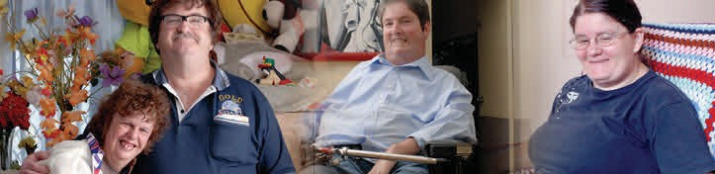

Mission: Empowering the voices of people with disabilities in Western Australia.

Vision: A community where all people have a full and valued life with the freedom to make their own choices.

Values:

• We embrace diversity and participation to ensure inclusion for all
• We believe respect is fundamental to all positive relationships
• We seek to enhance opportunity and remove barriers to ensure real choice
• We are committed to every citizen’s right to equality

PWdWA is funded by the Disability Services Commission and the Department of
Families, Housing, Community Services and Indigenous Affairs.
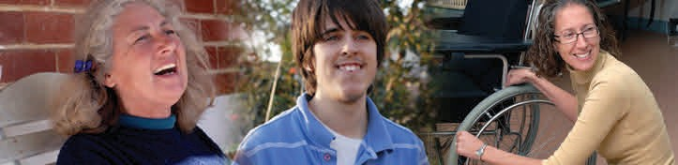

President’s Report
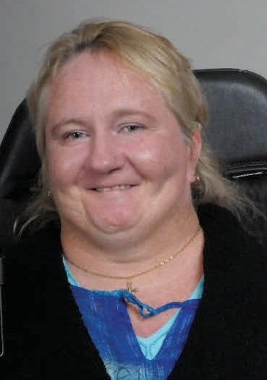

As I approach the end of my two year term as President of
PWdWA I write this report with a mix of pride in an organisation
that is clear about it’s values and committed to advancing the rights of people with disabilities, and sadness at leaving a role that has provided me with opportunities to meet some great people, and to make a difference.

The development of a National Disability Insurance Scheme (NDIS)
capable of providing contemporary individualised services to people with disabilities was a very large part of everyone's focus again last year. PWdWA members and staff
have committed many hours to various strategies, engagements and campaigns to achieve this. I expect that there will be many more years of similar work to come. It is
important that people with a disability and their supporters do not settle for a ‘good enough’ system. There will be evidence based learning resulting from the Disability Services Commission’s ‘My Way’ trial sites and we need to ensure that this more self-
directed approach influences the development of the National Scheme. It needs to be understood by the designers that people with disabilities are capable of so much
more. Expectations need to be raised, trust needs to be established, and opportunities for success need to be supported. I meet dynamic, determined and talented people
with disabilities every day.

PWdWA has continued to voice concern about people with disabilities that are not seen or heard. The fight for justice for the most powerless within our community continues. People who are subject to unfair treatment in the justice system, in institutions or subjected to restraint must not be forgotten.

I am immensely proud of the many people who serve our organisation and the disability community with passion, and determination. The Committee of Management members have been a source of knowledge and advice in the governance of PWdWA. I thank them for their support. I have continued to work closely with Executive Director Andrew Jefferson in the past year. His work reflects his appreciation of the challenges and barriers that people with a disability have to manage every day. He is supported by a great team. Their work makes a difference. Their relationship building and advocacy can lead to good outcomes for individuals quickly. Many other issues involve a more sustained approach. PWdWA benefits from the commitment of several members who serve on special interest groups and advisory committees on our
behalf. This work is important and appreciated. Members and constituents who provide us with information and complete surveys are a valued resource and I thank
everyone who participates.

(Continued on page 3)

Succession planning by the Committee of Management lead to a Special General Meeting on the 28th of June. At this meeting I welcomed Kerrie Duff, Ryen Songhurst and Ryan Gay as Committee of Management Members. I also took the opportunity to introduce co-opted member Jordan Steel-John to the attendees. The voice of younger people is now well represented in this group and I am confident that the new members will take PWdWA forward with confidence in the future. The experience and passion of the members who are required to stand down at the coming Annual
General Meeting will be missed. Sharon Van Der Laan and Trish Anderson have served on the Committee with me for the past six years. They have each made significant contributions to the development of PWdWA and have been a pleasure to work with.

Monica McGhie
President

2012-13 Committee of Management

Monica McGhie
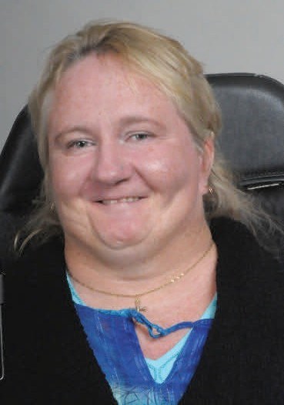

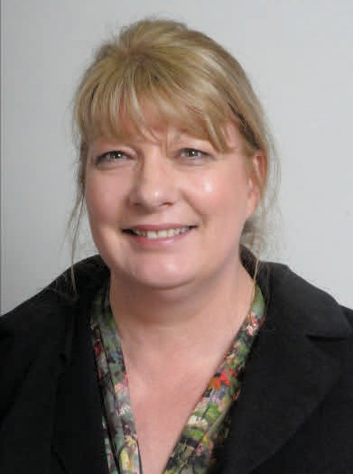

President
Sharon Van der laan
Secretary
Kerrie Duff

Kelly–Ann Rasmus
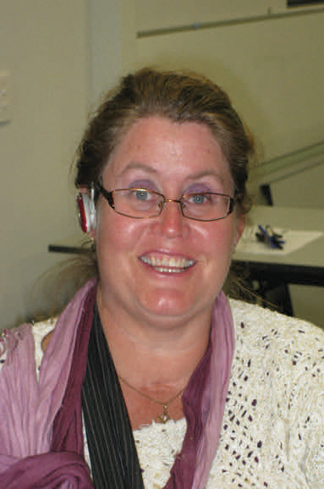

Trish Anderson
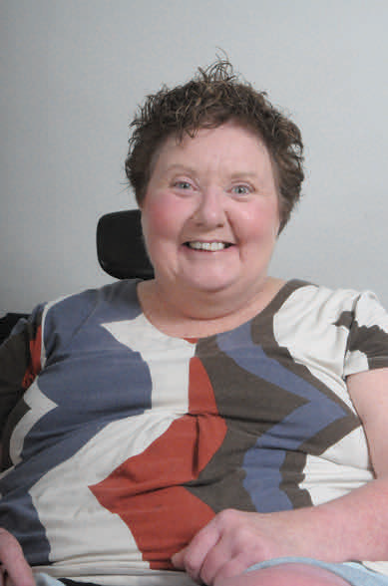

Ryan Gay

Ryen Songhurst

Executive Director’s Report

It has been a remarkable twelve months. The sustained efforts of the ‘Every Australian Counts’ campaign and its many supporters has achieved a National entitlement scheme to provide long term care and support for all individuals with severe or profound disabilities. DisabilityCare Australia recognises the important role of family
carers. The West Australian Government has expressed concern with several aspects of the scheme, particularly the governance arrangements, however, the Premier has made a commitment that
Western Australia will join the scheme at a future point. The certainty that ‘signing up’
will bring is very important to Western Australians with disabilities. It is clear that independent Advocacy will be required for years to come to ensure that DisabilityCare
is fully funded and works for and with people with disabilities.

PWdWA has continued to support the implementation of the West Australian Government’s ‘My Way’ approach. This approach will permit people with disabilities and family carers greater opportunity to be aspirational when planning and directing services. While ‘My Way’ has been a key focus of the Disability Services Commission PWdWA has encouraged the State Government to continue to be actively engaged in the development of DisabilityCare Australia. If the national scheme is to be the best it
that it can be, wide consultation is essential and this should include the experiences of all State and Territory Governments.

In the last 12 months PWdWA has continued to progress its strategic aims. Time and resources have been committed to both local and national disability advocacy issues. As can be seen in the Systemic Advocacy report (page 15 and 16 ) PWdWA has and is addressing a wide range of barriers, challenges and discrimination that limit the opportunities of people with disabilities to have successful lives. There are many more issues than an organisation like ours can meet on its own. In recognition of this PWdWA has committed time to developing relationships and working in collaboration with other associations and individuals who share our values and importantly reflect these values in their practice.

PWdWA has been pleased to provide practical encouragement and administrative assistance to new peer support groups and self-advocacy networks. The growth in this area and the use of Social Media as a vehicle for dialogue and debate in the
community are very positive developments on the road to having the voice of people with disability heard. PWdWA commends the people with disabilities who have been the instigators and leaders of these initiatives.

PWdWA collaborated with the Developmental Disability Council and other organisa- tions to attain funding to roll out the State-wide training for organisations and individ- uals relating to the ‘Voluntary Elimination of Restrictive Practices’. The success of the workshops was in no small part due to quality of the facilitators from Vela Microboards and E-Qual. A funding bid has also been made with two other organisations to explore challenges in ‘Supported Decision Making’.

PWdWA continued to work closely with the Disability Coalition of Western Australia. Meetings provided the opportunity for disability and mental health advocacy and consumer organisations along with Carer’s WA and the National Disability Services (NDS) to explore issues and work together to achieve shared goals.

On a national level PWdWA has continued to develop our close working relationship with People with Disabilities Australia (PWDA). PWdWA has been a partner in an active research project with PWDA and the University of New South Wales. The
CARDS project brought together people with disabilities with an interest or experience of self-managed support. PWdWA continues to work closely with both the Australian Federation of Disability Organisations (AFDO) and the Disability Network Australia (DANA). These relationships have increased importance at a time when State and Federal Governments are considering the future of funded Advocacy services in light
of the DisabilityCare Australia roll out.

PWdWA’s Individual Advocacy service allows Advocates to engage with some great people. Each person’s story is important. While every experience is unique it is clear that there are commonalities. People feel powerless and everyone is subject to low expectations. Advocates help people address their issues, develop self-advocacy skills and build resilience but the discrimination experienced is embedded in our culture. This needs to be addressed at a high level through the United Nations, and the Australian Human Rights Commission with the support of a united voice from the disability rights community.

PWdWA has worked with the Disability Services Commission on many areas of important reform. The Commission have been very open to the involvement of consumer representatives in developing legislation, policy and initiatives. People with disabilities experience in the health system had significant focus this year. Curtain University have been active in promoting this and this is welcomed. The potential for improvement is clear and the benefits for people with disabilities could be great.

(Continued on page 7)

PWdWA has once again been fortunate to have a range of insightful advocates, consultants, members and supporters that provided a consumer perspective in a wide range of advisory groups, guiding committees and the like. These people are very important to PWdWA. The Advocacy and Admin team experienced some changes in the last year. I am pleased to report that long service leave, exciting career opportunities, and having a baby were the reasons for this. As ever I am indebted to Senior Advocate Carmen Pratts-Hincks for managing these events and many others seamlessly.

PWdWA is grateful to have Steven Heath and Geraldine Mellet continue to serve as our Vice Patrons. Geraldine’s energy and passion in the ‘Every Australian Counts’ campaign was one of the standouts of the last 12 months.

The role of the President is central to the work of our organisation. Monica McGhie’s term will end in October 2013 but her pursuit of better outcomes for people with disability will continue. Monica has used her amazing ability to engage with people for the benefit of PWdWA. She had an eye to the future and encouraged younger people with disability to become involved in the work of PWdWA. Monica has built on the achievements of her predecessors and has strengthened a value driven and engaged organisation through her leadership and commitment.

PWdWA is supported by both the Disability Services Commission, and the department of Families, Housing, Community Services and Indigenous Affairs (FaHCSIA). I thank our two main funders along with our members and other supporters for their continuing assistance. It is this support that enables us to serve the people who are most vulnerable, and the wider disability community.

A final thank you goes to the legal companies who assisted PWdWA in its advocacy work last year. Legal assistance can be crucial in helping people with disabilities
achieve justice. This support is appreciated.

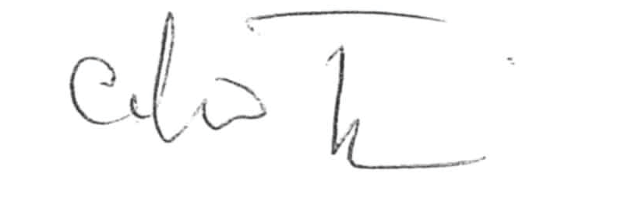

Andrew Jefferson
Executive Director.

Treasurer’s Report

During the past financial year, PWdWA has operated within its budget and fulfilled the contractual requirements of service level agreements with our core funding agencies, the West Australian Disability Services Commission, and the Commonwealth Department of Families, Housing, Communities and Indigenous Affairs (FaHCSIA).

Additional non recurrent funds from FaHCSIA was expended in achieving National
Disability Advocacy Program (NDAP) certification.

PWdWA received an unexpected and very much appreciated donation from Law Firm
Ashurst.

The Committee of Management has remained active in overseeing the financial operation of the association. The audited accounts demonstrate that the organisation remains financially stable.

The Committee of Management and operational staff would like to express thanks to Nulsen Independent Administration who have supported us with payroll and financial management throughout the year.

Individual Advocacy

In 2012-2013 PWdWA provided one to one, issue based, non-legal advocacy for people with disabilities living in Western Australia. We focused on advocating alongside people who are most vulnerable or at risk. We advocated with people with disabilities to express their views, be heard and for their rights to be upheld.

The Individual Advocacy Team consists of staff with a broad range of skills and experiences which compliment each other and allows for a good quality of service to be provided. Our team continues to further their skills and knowledge by participating in ongoing supervision, training opportunities, forums, conferences and networking with stakeholders from the community sector.

Throughout the year, PWdWA have provided contemporary, researched information to individuals with disabilities, family members and others who wanted to know more about the services that PWdWA and other community agencies can offer. The infor- mation was made available by telephone, skype, facebook, in person and via written formats. PWdWA continues to liaise with service providers and government workers such as Local Area Coordinators, allied health professionals and local government of- ficers to ensure our information is both accurate and current.

This year, PWdWA provided individual advocacy when it was determined that we were the most appropriate agency to support the person seeking advocacy. In each case, the advocate worked in partnership with the person to develop an action plan which outlined the roles and responsibilities of all stakeholders involved and actions to be undertaken. As part of their role the individual advocate researched infor-
mation, communicated with stakeholders and provided support at meetings. Our ser- vice also included pre-meeting preparation, and assistance to ensure that agreements
are reached. Advocates work to facilitate the person with a disability gaining
knowledge of their rights, services available to them and to develop self-advocacy strategies that they can use in the future.

The Disability Service Standards, the Convention of the Rights of Persons with Disabilities, and Optional Protocol article 19 all recognise the ‘equal right of all per- sons with disabilities to live in the community, with choices and decision making
equal to others.’ This year the number of people PWdWA assisted to renegotiate their support arrangements with service provider increased. This was in response to people
reacting to their service providers inability to provide greater flexibility, choices and person centred services. The impact of ‘service agreements’ between housing and
service providers have resulted in some individuals being unable to change service provider without being required to move from their home. This not only limits choice
but can lead to social isolation when the person has to move from their home to re- ceive better support when they have built networks and friendships in that area.

PWdWA supported people to negotiate with housing providers and service providers, attend meetings and contact relevant agencies to assist in resolving their issues. PWdWA helped facilitate organised transitions between service providers for people who were not satisfied with the service provided or wanted to relocate to a new area.

Individual Advocates also worked closely with parents of school age children with disabilities to ensure that schools work in partnership with parents, make reasonable adjustments and put supports in place for children who require additional assistance. Parents were informed of the complaints procedures relevant to their issue and supported to attend school meetings if required. Advocates also directed parents to other community resources so that their children had the opportunity to participate in a more inclusive education.

Access to employment continues to be a barrier many people with disabilities still encounter. Individual Advocates supported people with disabilities at meetings with their employers to ensure that reasonable adaptations were provided in the workplace. The common goal was to promote the right to work on an equal basis with others taking into consideration the adjustments that have to be made.

People with disabilities were supported at hearings at State Administrative Tribunal. The advocates assisted people to participate, express their views and better under- stand the process.

PWdWA’s Individual Advocacy programs are funded by the Disability Services Commission (DSC), and the Department of Families, Housing, Community Services and Indigenous Affairs (FAHCSIA).

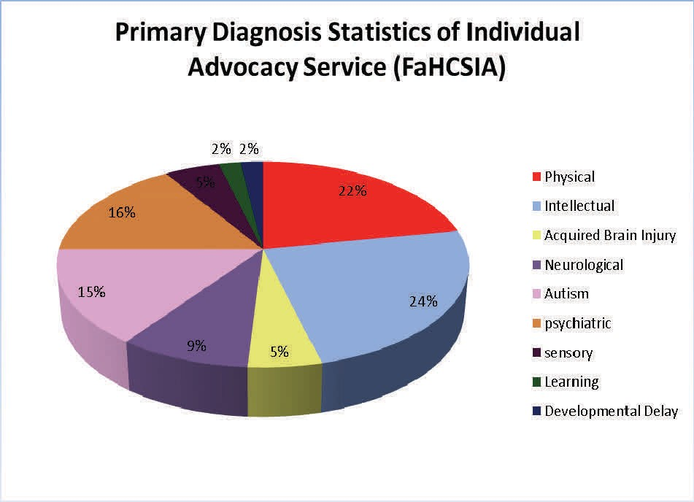

Peel Individual Advocacy

This year, the Individual Advocacy Service in Peel underwent some staffing changes. We saw the departure of Keith Reid who worked in the area for the past 4 years. PWdWA would like to thank Keith for his valuable contribution and for the work he undertook to establish and represent our service in the Peel region. We wish him all the best in his new endeavours. PWdWA welcomed Judy Russell as our new Individ- ual Advocate for Peel. While firmly established in Mandurah Judy has been working closely with her colleagues in Perth to provide an informed and effective service in the Peel region.

Despite the change of advocate, the Individual Advocacy Service in Peel has continued to provide strong advocacy support to people with a lived experience of disability. This has involved working alongside people with disability to communicate and connect with appropriate services, consider available options, action plan and prepare for and provide support at meetings. Where appropriate, progress towards self-advocacy is facilitated by providing information and encouragement that will assist the person with disability with decision making and developing self-confidence to have their voice heard.

Issues that emerged as most prominent in Peel in 2012/2013 included education, employment, access to services and transport. There was an increased trend in education referrals. Some parents felt that they had little option but to home school their children due to schools being unable or unwilling to make the required adjust- ments to maintain the children in school. The Peel Advocate assisted parents with meetings and preparing complaints to the education authority.

Important strategic relationships have been strengthened and developed. These positive, collaborative relationships with relevant agencies increase the probability of positive outcomes for service users of PWdWA. The Individual Advocate for Peel has continued to attend meetings with a variety of agencies including; the Peel Autism Network Support Group, the Disability Services Commission, Fairbridge, the Aborigi- nal hospital in Mandurah and continues to uphold the relationship with other agen- cies in the Parents Place building by attending regular meet and greets. The Peel In- dividual Advocate also attended events such as the Peel Youth Forum and other community activities as part of the youth forum including topics such as aboriginal communication, culture and community in the Peel Region.

The Individual Advocacy Service in Peel is funded by the Federal Department of Families, Housing, Community Services, and Indigenous Affairs (FaHCSIA) for 22.5 hours per week. PWdWA extends it’s thanks to FaHCSIA for their continued support regarding advocacy for people with disabilities in the Peel Region.

Communication Officer

The rise of information technologies particularly social media has bought about an uncomplicated way to communicate with people in real time. This means that news and information can be disseminated as it happens to far more people than ever
before. As a result, PWdWA formulated a strategy that resulted in the introduction of a new Communication Officer post to action and develop this in July 2012. The post was
taken up by Lisa Hook. She was tasked to work towards three main objectives.

1. Manage and develop the PWdWA website
2. Replace the quarterly newsletter with a monthly multi media news report
3. Administer social media platform.

Website accessibility was the first priority. While the website had reasonable accessibility it needed updating. After some research a set of guidelines the W3C Web Accessibility Initiative called the Web Content Accessibility Guidelines (WCAG) were used as the basis for creating the accessible structure of the site. The website is updated with news, information, workshops, training and the eNews on an ongoing basis with information relating to community living and disability specific issues.

‘The Advocate’ was a quarterly newsletter sent out via post. In the quarterly format it was difficult to keep the information up to date and the reach was relatively small. The new newsletter called the PWdWA eNews is posted out monthly via email to over
200 people in both pdf and word formats. It is also sent out via the PWdWA Facebook page and is added to the PWdWA website. Access to such technologies has increased the reach of the PWdWA eNews tremendously.

Social media is a way for people to interact with each other in which they create, share, and exchange information and ideas. Social media has introduced substantial and widespread changes to communication between PWdWA, its members, communities, and individuals. PWdWA has a facebook page that is updated daily with all the latest news and information relating to disability locally, nationally and internationally.

Over the course of the year that the Communication Officer role has been in operation the number of people interacting with PWdWA has increased dramatically. Due to this increase PWdWA has a better perspective and understanding of disability related is- sues. PWdWA has entered the 21st century and we are proud of the journey that we have made.

Disability First Stop

During the period of July 2012 to June 2013, Disability First Stop at PWdWA assisted people with a new diagnosis, with information, advocacy and supported referral. The Disability First Stop program helped individuals and families in the early days and months of facing the challenge of a new disability. The shock of a diagnosis or injury, the new experience of seeking help in unfamiliar service systems and the effort and cost of adjusting to a significant change all justify the special focus of this Disability First Stop program. People With disabilities WA had been operating this program in partnership with other disability advocacy agencies, developing the skill and knowledge base to enhance responsiveness and collective expertise.

The Disability First Stop program in this period highlighted two critical themes that face many people who have been eligible to receive assistance under this program:

1. Moving from the Health system to the Disability Services system
A diagnosis or a medical or trauma event, such as a stroke, cancer surgery, and acquired brain injury, can lead to disabling effects that change a person's capacity to
function in their daily life. This disabling effect may be temporary, permanent or progressively worsening. All of these variations in the likely course of an injury or illness will vary eligibility for services in the Health or Disability Service systems.

The assistance of an advocate can save many hours of trial and error for individuals and their families. Information and research provided under the Disability First Stop program can relieve the worry that options are being missed or that one course of action chosen may cut off other options at a later time.

2. Making sure that the Rights of a person with a disability are being respected
There are many entitlements that are owed to a person with a disability though the values that are held in our community regarding services, respect and dignity, access
and support. Many people only truly understand the importance of these Rights when they personally experience their loss or see the impact on someone they love, of the
denial of Rights.

The Disability First Stop advocates assisted with the identification of the processes and avenues for challenging the denial of Rights. Just as important is the 'walking beside' people through these processes so that the questions of fairness and entitlement are well tested and understood.

The Disability First Stop program came to an end in June 2013. PWdWA would like to thank the Disability Services Commission for the funding they provided to the service while it was operating.

Self Advocacy WA

The Self Advocacy Western Australia group had a busy and exciting year. There was a healthy mix of regular activities, some new people and interesting ideas. The monthly meetings were chaired by Rita Grose and involved a selection of members’ personal experiences with information sharing and discussion. Every member had the opportunity to participate in the meeting and each person’s input continues to be respected. Over the past year SAWA members have continued to advocate for their rights to access employment, education and community facilities.

Due to other commitments, Amber is no longer the support person for the group. SAWA members want to thank Amber for her contribution to the meetings. Carmen and Lisa now take the minutes of the meetings while PWdWA Executive Director, Andrew Jefferson facilitates the meetings. This has allowed for discussion and feedback about some of the current issues for people with a disability. The National Disability Insurance scheme, self-directed services, disability justice centres, transport and employment are examples.

SAWA members agreed that they would like information about SAWA on the reinforce website. Reinforce is a self advocacy organisation for people with an intellectual disability and their website contains lots of useful links and information. SAWA members are working together to create the information they would like included on the website and some members are going to send in their photo. It is hoped this will provide more people with information on the work SAWA do and will maybe attract some new members to the group.

The rights and responsibilities of SAWA have been reviewed by the members. They had a presentation and discussion about what the rights and responsibilities are and what should and should not be included in the new document.

SAWA members were offered the opportunity to read and provide feedback on the
‘Restrictive Practice Document.’ Some members decided to have a look at the document and provided feedback. They also had representatives at important events in the disability sector such as the Peer Support and Self Advocacy Forum and at the Perth Transport Hearing.

Finally, SAWA met for their breakfast in July and December. They invited friends, PWdWA staff and committee of management to the breakfast.

SAWA is funded by the Disability Services Commission.

Systemic Advocacy

Systemic advocacy seeks to influence and secure positive long term changes that remove barriers and address discrimination, to ensure the rights and interests of people with disability are upheld.

In 2012 - 2013, in partnership with people with disability, their families and carers, organisations and government departments, PWdWA influenced positive change to legislation, policy and service practices.

We would like to thank everyone who contributed their feedback through participation on committees and contributions to forums, submissions and surveys.

Your participation has continued to improve access and inclusion and raise awareness of the rights and interests of people with disabilities, at both a state and national lev- el.

Consultations
In 2012 - 2013 PWdWA staff and members contributed to peak organisations, committees and reference groups covering a broad range of issues affecting the lives of people with disabilities.

These included:
• Australian Federation of Disability Organisations
• City of Perth Access Working Group
• Curtin University's Access Advisory Body
• Department of Human Services Consultative Forum
• Disability Advocacy Network Australia
• Disability Coalition of Western Australia
• Disability Discrimination Unit Network
• Disability Services Chief Executive Officer Roundtable
• Disability Sex Worker Project Group
• Elimination of Restrictive Practices Reference Groups
• Health Experiences Reference Group
• Housing Advisory Roundtable WA
• Independent Support & Safeguarding Project
• Individual Funding Policy Committee
• Learn & Grow Reference Group
• Partnerships Forum WA
• Self Directed Services Reference Group

• Synergy Consumer Committee WA
• WA Study of Health & Intellectual Disability
• You're Welcome Access WA State Reference Network

Submissions
In 2012 - 2013 PWdWA provided submission feedback to government departments for the following reviews:

• Assurance in Accommodation for People with Disability
• Department of Culture & the Arts Disability Access & Inclusion Plan
• Department of Education Disability Access & Inclusion Plan
• Disability Standards for Accessible Public Transport
• Homelessness Bill (Draft)
• WA Museum Disability Access & Inclusion Plan

PWdWA also contributed to joint submissions made by peak bodies and other organisations for the reviews of the draft National Disability Insurance Scheme Bill (NDIS) and Rules.

PWdWA's submissions are available online at www.pwdwa.org, and in alternative formats upon request.

We value your feedback on PWdWA's individual and systemic advocacy services. Our
Community Feedback Form can be accessed online at:

www.surveymonkey.com/s/PWdWA_Community_Feedback_Form

Alternatively, you may wish to provide feedback by telephone by contacting the PWdWA office, or request the form to be posted to you in a standard or EasyRead format.

Individual Funding Model Project

PWdWA held a variety of forums in relation to the Individual Funding Model including a forum for carers and people with disabilities in order to further explore this funding concept and what it could mean for people with disabilities. PWdWA held two forums, one in February for Carers and one in March for people living in shared
accommodation.

The group that attended the first forum comprised of carers including parents and siblings. Each of whom were of a variety of ages and their family member was receiving a variety of support. Carers had many concerns and issues that they wished to raise. The common theme was a lack of communication by the agencies, promises being made and consistently broken. Carers see support staff not receiving adequate support from agency managers. There is a lack of follow up by agencies and a
complete lack of recognition of family members being experts in the care of the person with a disability. Carers are tired of fighting agencies and support workers, and are
tired of being ignored as being seen as being difficult. Carers are frustrated at the rigidity that comes with funding. Carers suggested a housing scheme for carers as
they often have to give up work to support their family member who has a disability. Carers are concerned that group homes are institutions and people living in them are at a high risk of abuse and neglect. Group Homes often disempower the person with a
disability and their families. There were suggestions that ACDC should be linked to outcomes to justify funding and any overspend. Carer’s are concerned at the crisis
driven nature of the disability sector. Planning doesn’t seem to be a priority it’s the people making the most noise and in the most perceived danger that gets funded. Carer’s were open to the new funding model but are hesitant as they often see new
initiatives never come to fruition.

It was discussed that a regular forum for carers to work through any issues and learn from others experiences may be beneficial in the future. It was acknowledged that the focus was taken off the funding as they had so much they wanted to discuss and they are not given an appropriate setting to do this regularly. Carers are open to new funding models especially if they are more flexible and give the person with a disability a better quality of life.

PWdWA had difficulty recruiting participants for the second forum and found there was reluctance by service providers to facilitate participation in the forum. This then led to clients not being given the opportunity to partake. PWdWA staff contacted six different agencies and emailed directly to staff at a variety of levels including CEO’s. Reason’s included a lack of resources or that the clients would not be interested. Some agencies advised us up to two days before the forum that they were sending people but we
were given no numbers or any advice of dietary/access requirements (no one turned up from these agencies). This resulted in only two participants attending the forum.

The Forum was adapted to focus on choice. As PWdWA knew both people who were attending the activity was able to be tailored to their needs. The Choice activity was centred on people making a choice of their favourite out of 3 to 4 items or pictures. The reasons for the choice did not matter and this was later explored as a group. Items included, flowers, fruit and textural items there was also a wide variety of photographs, pictures and colours. PWdWA found that people with an intellectual disability can and want to make their own choices. People with an intellectual disability can make considered choices and will take time to think about their options when required. The right support, environment and information needs to be made available so people can make an informed decision. An example of this was when
participants were asked which out of a $10, $20 and $50 had the most value. Although participants may not initially recognise the note, when they were told the name of
each note one participant was then able to make her decision.

Some training may be required so support workers will give the person time to make their own choice and so that the support worker does not influence the person’s choice. The two participants came with an open mind and had no preconceptions about what the day would be about or why the activity was taking place. If a participant felt unsure or uncomfortable they could communicate that and were not
forced to make a choice. The decision not to pick an item was also available to people. The participants could have been heavily influenced by their support workers and initially they did look to them for assistance in decision making. This dissipated once they realised it was something they could work on themselves in their own time. There needs to be more recognition of people’s communication styles and skills, and adaptation to meet this. Participants felt comfortable to refuse a task if they were unsure. PWdWA focussed on having a safe space for discussion but also having fun in
a respectful way which was central to the activity being a success. Both participants would often be perceived by the general public as not having the ability to make choices or be heard but had very strong views and opinions within the exercise. Both participants were comfortable when there was consensus across the group on a choice but were also comfortable to be the only person choosing a certain item or picture.

It was felt that the activity was a success and that if people were exposed to more decision making opportunities in their own lives that they can develop their skills within this area. There was a clear sense of joy and excitement throughout the activity and people were clear on what was asked of them and of their own decisions. It was felt that this activity could be conducted without much cost or man hours in a variety of settings and could facilitate empowering people with disabilities to have confidence
and skills in their own decision making. This would also be true when working with people with limited communication and these people are possibly the ones in the most
need of an outlet to demonstrate their abilities.

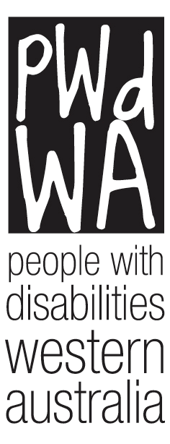

People With Disabilities WA Inc.

Financial Statements

30 June 2013

